**CHIKKANNA GOVERNMENT ARTS COLLEGE**

**TIRUPUR-641602**

**(AFFILIATED TO BHARATHIAR UNIVERSITY)**



**TEAM MEMBERS NAME AND REGISTER NUMBER:**

LOGANADHAN V [2022K0029]

GOKUL RI[2022K0020]

MAHESH S [2022K0032]

SANJAY S [2022K0046]

THARUNESH RP [2022K0058]

**DEPARTMENT OF COMPUTER SCIENCE**

**CHIKKANNA GOVERNMENT**

**ARTS COLLEGE**

**NAAN MUDHALVAN PROJECT WORK**

**(AFFILIATED TO BHARATHIAR UNIVERSITY)**

**TIRUPUR-641602**

**TITLE : Intelligent Customer Retention: Using Machine Learning for Enhanced Prediction of Telecom Customer Churn**

This is to certify that this is a bonafide record of work done by the above students of III B.Sc (CS) Degree**NAAN MUDHALVAN PROJECT** during the year ……….

Submitted for the Naan Mudhalvan  project work held

on………….20

**CLASS TUTOR HEAD OF THE DEPARTMENT**

**INDEX**

|  |  |  |  |
| --- | --- | --- | --- |
| **S.No.** | **Date** | **Contents** | **Page No.** |
| **1** |  | INTRODUCTION |  |
| **2** |  | PROBLEM DEFINITION&DESIGN THINKING |  |
| **3** |  | RESULT |  |
| **4** |  | ADVANTAGES & DISADVANTAGES |  |
| **5** |  | APPLICATIONS |  |
| **6** |  | CONCLUSION |  |
| **7** |  | FUTURE SCOPE |  |
| **8** |  | APPENDIX |  |

**INTRODUCTION**

**1.1 OVERVIEW:**

* The telecom industry is known for high customer churn rates, which leads to a significant loss of revenue for service providers. In an effort to reduce customer churn, companies have traditionally relied on manual customer retention efforts such as discounts, loyalty programs, and personalized offers. However, these efforts can be costly and often not effective enough.

* In recent years, the use of machine learning techniques has shown promising results in predicting customer churn and identifying the factors that contribute to it.This project aims to develop an intelligent customer retention system that uses machine learning algorithms to enhance prediction of telecom customer churn.

**1.2 PURPOSE:**

* The purpose of the "Intelligent Customer Retention: Using Machine Learning for Enhanced Prediction of Telecom Customer Churn" project is to develop a predictive model using machine learning algorithms that can accurately identify customers who are likely to churn or leave a telecom company's services.

* Customer churn is a significant problem for telecom companies, as losing customers can have a significant impact on their revenue and profitability.By accurately predicting which customers are likely to churn, the telecom company can take proactive measures to retain these customers by offering them personalized promotions, discounts, or other incentives to stay with the company.

* Overall,the project's goal is to help telecom companies reduce customer churn and improve customer retention by leveraging the power of machine learning and predictive analytics.

**PROBLEM DEFINITION&DESIGN THINKING**

**2.1 EMPATHY MAP:**

An empathy map is a collaborative visualization used to articulate what we know about a particular type of user. It externalizes knowledge about users in order to 1) create a shared understanding of user needs, and 2) aid in decision making.

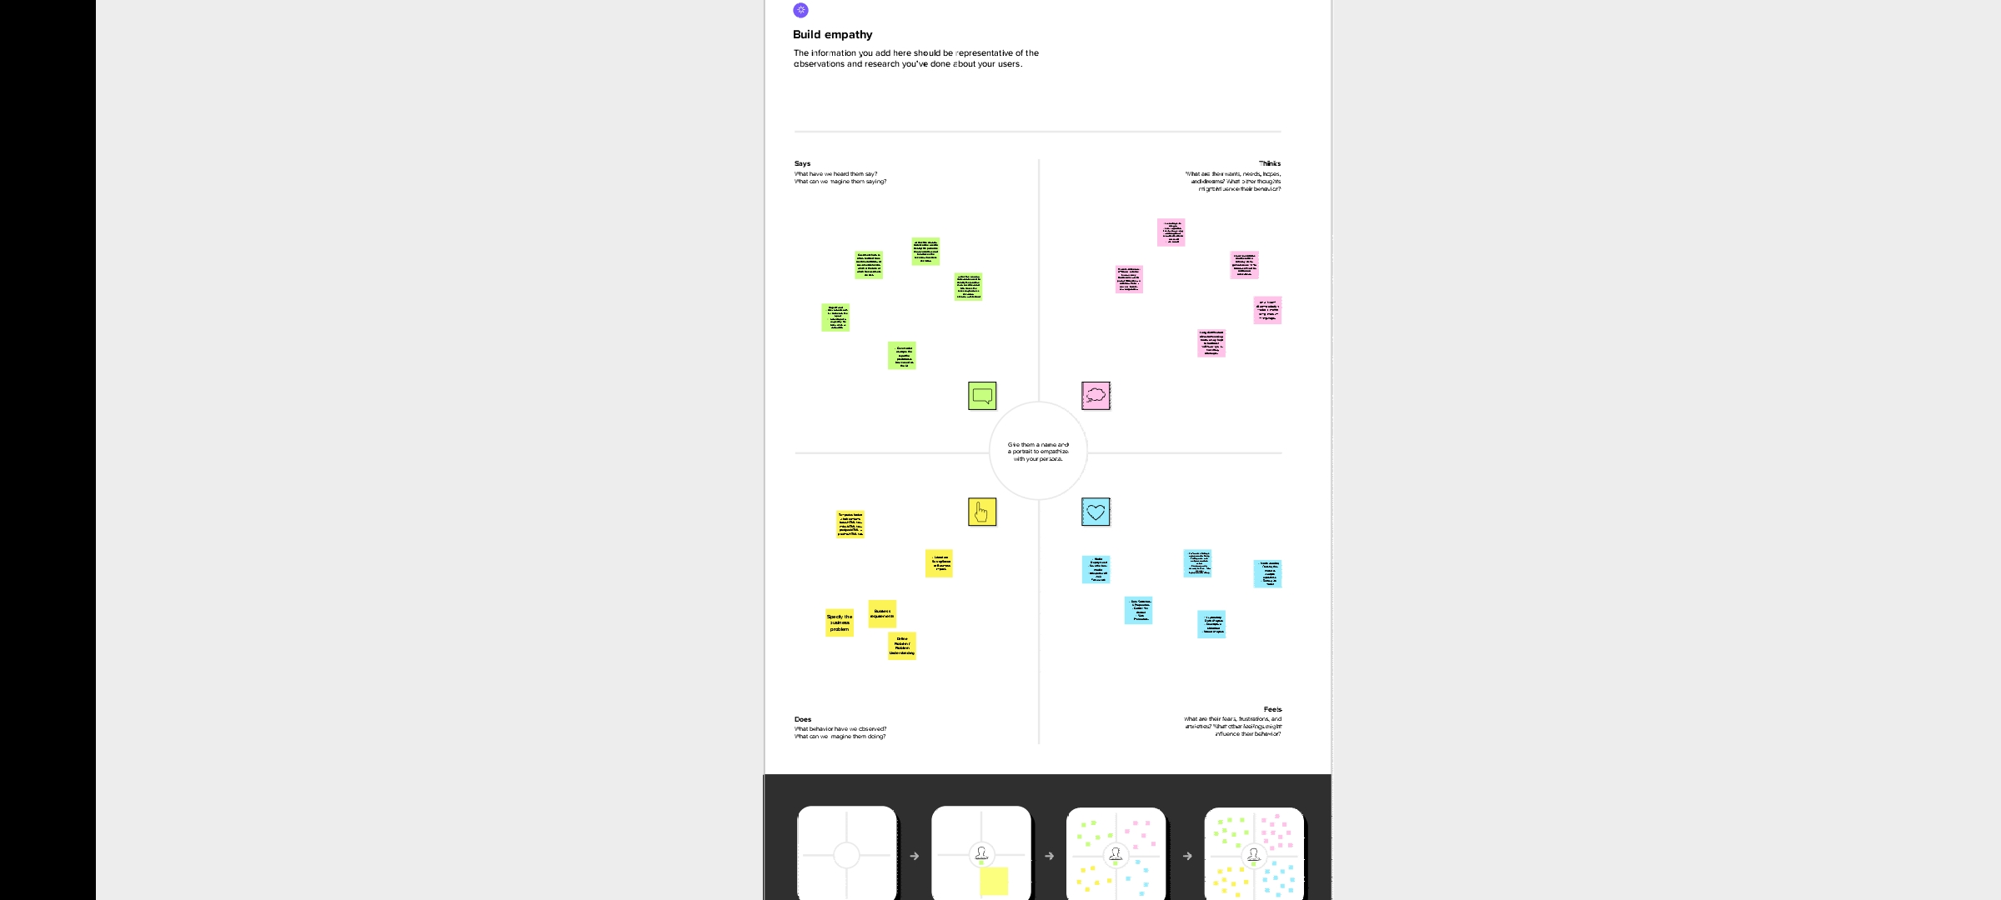

**2.2 IDEATION AND BRAINSTROMING :**

Ideation is often closely related to the practice of brainstorming, a specific technique that is utilized to generate new ideas. A principal difference between ideation and brainstorming is that ideation is commonly more thought of as being an individual pursuit, while brainstorming is almost always a group activity.

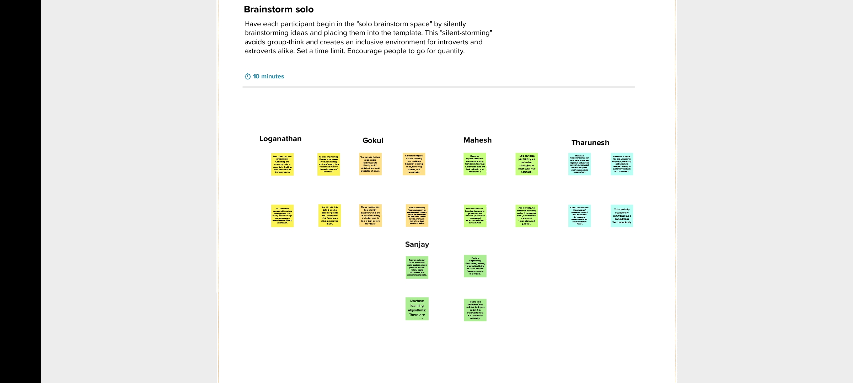

**RESULT**

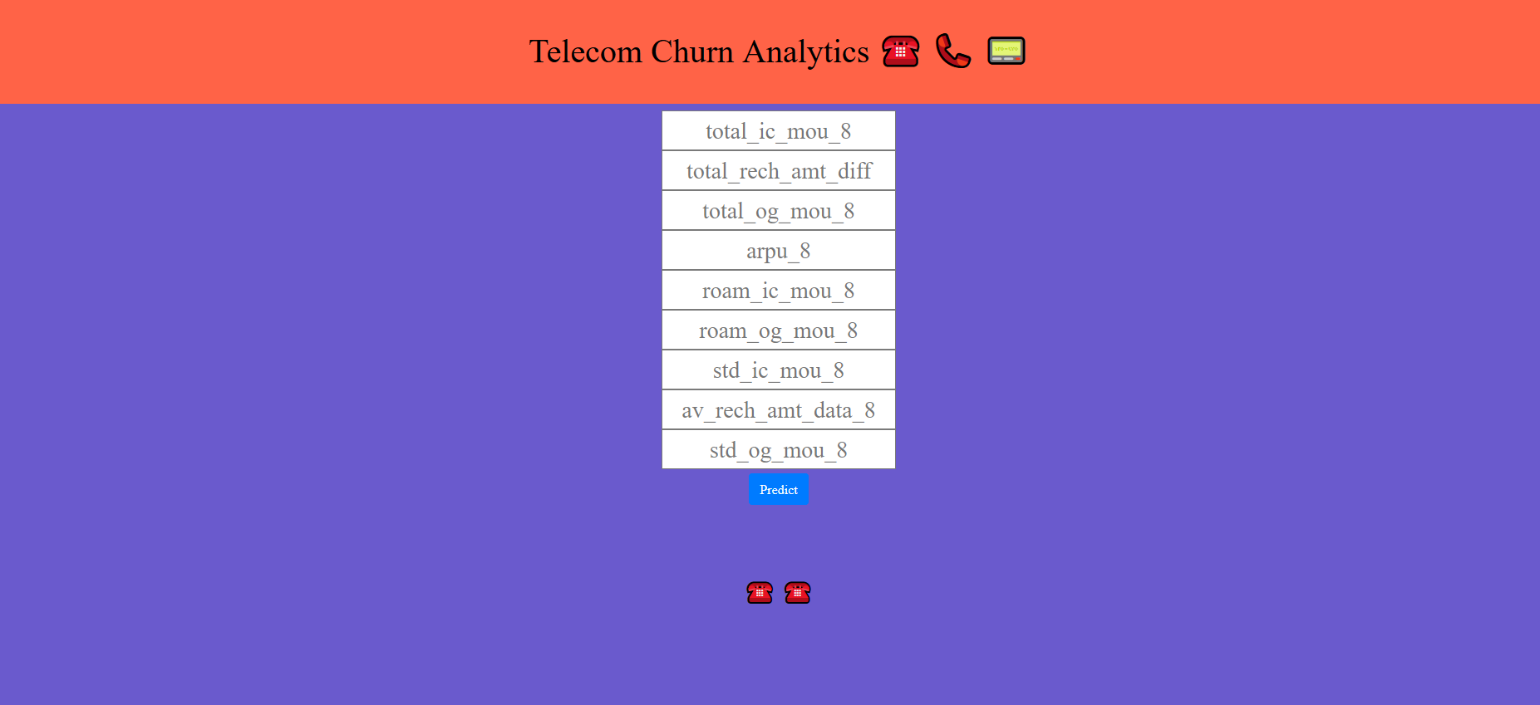

**SAMPLE CODING**



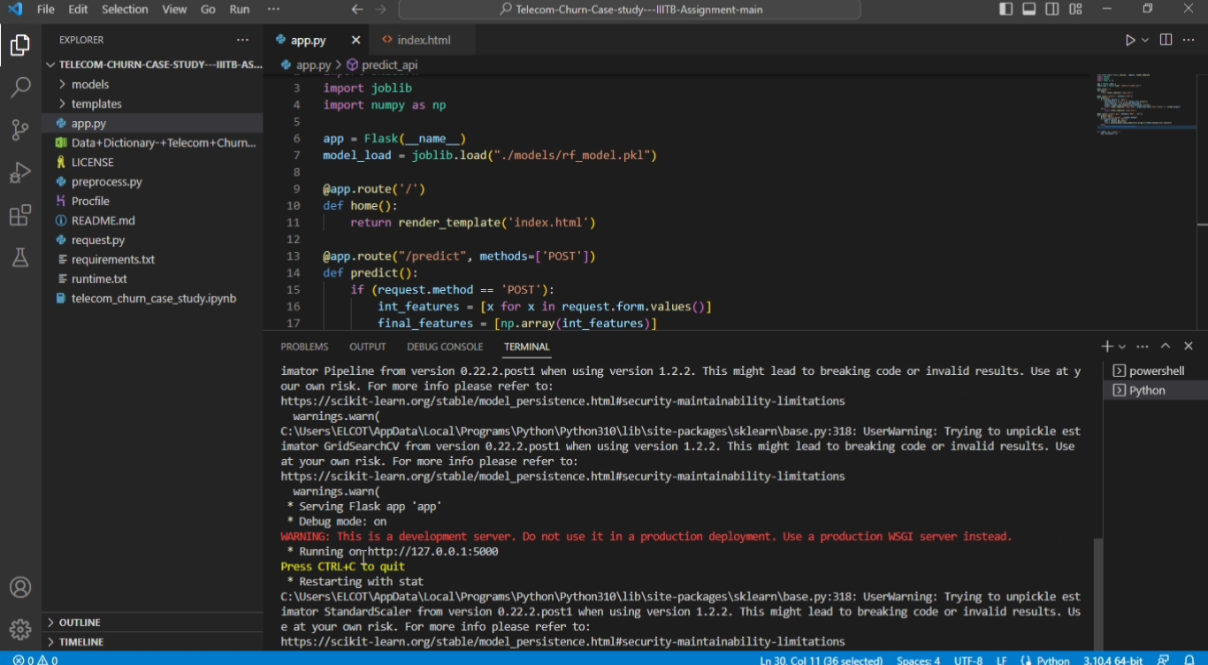

**ADVANTAGES:**

* **The project "Intelligent Customer Retention:**Using Machine Learning for Enhanced Prediction of Telecom Customer Churn" has several advantages, including:

* **Improved customer retention:** By accurately predicting which customers are at risk of churning, the telecom company can take proactive steps to retain them. This can include offering targeted promotions, improving customer service, or making product changes.

* **Cost savings:** Acquiring new customers is more expensive than retaining existing ones. By reducing churn rates, the telecom company can save on marketing and acquisition costs.

* **Better decision-making:** Machine learning algorithms can analyze large amounts of data and identify patterns that may not be immediately obvious to humans. This can lead to more informed and data-driven decision-making.

* **Personalized customer experiences:** By understanding individual customer behaviors and preferences, the telecom company can tailor its offerings and communication to meet their specific needs.

* **Competitive advantage:** Companies that can effectively predict and reduce customer churn will have a competitive advantage in the market. They can provide better customer experiences and offer more targeted products and services.

**DISADVANTAGE:**

* There are several potential disadvantages or challenges that may be encountered when implementing a project focused on using machine learning for customer retention in the telecom industry.

* **Data quality:** Machine learning models rely on high-quality data to make accurate predictions. In the case of telecom customer retention, data may be incomplete, outdated, or inaccurate,which can reduce the effectivenes on the model.

* **Overfitting:** Machine learning models can sometimes be too complex, leading to overfitting, where the model performs well on training data but poorly on new, unseen data.

* **Ethical concerns:** Predictive modeling can raise ethical concerns, particularly if it is used to make decisions that impact customers’ lives, such as determining who should be targeted for retention offers. Biascan be introduced into models, leading to unfair or discriminatory practices.

**APLLICATIONS**

The application of machine learning for predicting and preventing customer churn in the telecom industry is a promising field that can significantly improve customer retention and reduce business costs. Here are some potential project applications:

*  **Developing a predictive churn model:** Using historical customer data, a predictive model can be built that uses machine learning algorithms to analyze customer behavior and identify patterns that indicate potential churn. This model can then be used to predict which customers are at risk of churning, allowing telecom companies to intervene and retain those customers before they leave.

* **Implementing personalized retention strategies:** Based on the predictions from the churn model, telecom companies can create personalized retention strategies for each customer at risk of churning. These strategies could include targeted promotions, discounts, or personalized communication that addresses the specific reasons why the customer is considering leaving.

**\* Identifying key drivers of churn:** Machine learning algorithms can help identify the key drivers of churn, such as poor network quality, customer service issues, or pricing concerns. This information can then be used to improve the telecom company's overall operations and customer experience.

**\* Automating customer outreach:** Machine learning can also be used to automate customer outreach efforts, such as sending personalized emails or text messages to customers at risk of churning. This can help streamline the retention process and make it more efficient.

* **Analyzing customer sentiment:** By analyzing customer feedback and sentiment data, machine learning can help telecom companies identify common pain points and improve their overall customer experience. This can help reduce churn rates and improve customer satisfaction.

* Overall, the application of machine learning for customer retention in the telecom industry has the potential to significantly improve business outcomes and customer satisfaction.

**CONCLUSION**

* The use of machine learning algorithms has significantly improved the accuracy and efficiency of customer churn prediction in the telecom industry. By analyzing historical data on customer behawhichvior and interactions with the company, machine learning models can identify patterns and make predictions about customers are most likely to churn.

* By using these predictions, telecom companies can develop targeted retention strategies for at-risk customers, such as offering promotions or discounts, improving customer service, or providing personalized recommendations.

* Overall, the use of machine learning for customer retention is a promising approach that has the potential to benefit both companies and customers. By reducing churn rates andimproving customer satisfaction, companies can increase their profitability and improve their reputation, while customers can enjoy better experiences and more personalized services.

**FUTURE SCOPE**

The project "Intelligent Customer Retention: Using Machine Learning for Enhanced Prediction of Telecom Customer Churn" has a promising future scope in the telecom industry. The application of machine learning algorithms can help telecom companies to predict which customers are likely to churn, and take proactive measures to retain them.

**Here are some potential future scope for this project:**

Enhanced prediction accuracy: As the project continues to gather more data over time, the machine learning algorithms can be further trained to improve their prediction accuracy. This will help telecom companies to make more informed decisions on customer retention strategies.

**Real-time analytics**: By implementing real-time analytics, the project can provide insights on customer churn as it happens. This will enable telecom companies to take immediate action to prevent customer churn.

**Personalized retention strategies:** By using machine learning algorithms to analyze customer behavior, the project can help telecom companies to develop personalized retention strategies for each customer. This can help to improve customer satisfaction and loyalty.

**Integration with other systems:** The project can be integrated with other systems such as customer relationship management (CRM) and billing systems. This will provide a holistic view of each customer's interactions with the telecom company and help to identify patterns that may lead to churn.

**Application to other industries:** The machine learning algorithms used in this project can be applied to other industries beyond telecom, such as banking, healthcare, and e-commerce. This will enable these industries to predict customer churn and take proactive measures to retain customers.

**APPENDIX**

**Intelligent Customer Retention: Using Machine Learning for Enhanced Prediction of Telecom Customer Churn.**

**VIDEO LINK ABOUT THIS PROJECT**

**[https://youtu.be/IpBQKWDjwII](https://youtu.be/IpBQKWDjwII" \t "https://youtu.be/IpBQKWDjwII)**