Assignment_4

Logan Luchs

2025-02-26

Table of Contents

[Link to Published Manuscript](https://doi.org/10.1094/PDIS-06-21-1253-RE)

[Link to my Github](https://github.com/Logz1n/Reproducibility_Class)

# Question 1

#a) YAML Headers are the output files at the top that has the "title, author, date and output".  
 #b) Literate programming is making it both readable for humans and readable for the computer. By including the YAML header export it makes it easier for people to understand exactly what your code does!

# Loading libraries and color pallettes

#Loading Libraries  
library(ggplot2)   
library(knitr)  
library(readr)  
library(ggpubr)  
  
#Colorblind pallette  
cbbPalette <- c("#56B4E9", "#009E73", "#F0E442",  
"#000000", "#D55E00", "#CC79A7", "#E69F00","#0072B2" ) #loading a color pallette

# Reading in Data

MycotoxinData <- read.csv("MycotoxinData.csv", na = "na" ) #loading in the data so that R understands na is na so the column is numeric  
  
MycotoxinData$Cultivar <- as.factor(MycotoxinData$Cultivar)#since we are going to facet wrap it makes life easier to make the column a facter instead of a character.  
  
MycotoxinData$Treatment <- as.factor(MycotoxinData$Treatment) #same as above

# Creating Figures

## DON vs Treatment Plot

DON5a_Plot <- ggplot(MycotoxinData, aes(x = Treatment, y = DON, group = Treatment, fill = Cultivar)) +   
 # Create separate panels for each level of the 'Cultivar' variable  
 facet_wrap(~Cultivar) +  
 # Add a boxplot layer without outlier points  
 geom_boxplot(outlier.shape = NA) +  
 # Add jittered points to the plot for better visibility of individual data points  
 geom_point(position = position_jitterdodge(dodge.width = 0.9), shape = 21, alpha = 0.6) +  
 # Add pairwise comparison results using t-test  
 geom_pwc(method = "t.test", label = "{p.adj.format}.{p.adj.signif}") +  
 # Label the y-axis  
 ylab("DON (ppm)") +  
 # Label the x-axis (left blank in this case)  
 xlab(" ") +  
 # Manually set the fill colors using a predefined palette  
 scale_fill_manual(values = cbbPalette, aesthetics = "fill") +  
 # Apply a classic theme to the plot  
 theme_classic()  
  
DON5a_Plot

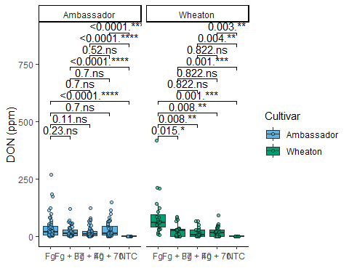

## x15ADON vs Treatment Plot

DON5b_Plot <- ggplot(MycotoxinData, aes(x = Treatment, y = X15ADON, group = Treatment, fill = Cultivar)) +   
 # Add a boxplot layer without outlier points  
 geom_boxplot(outlier.shape = NA) +  
 # Add jittered points to the plot for better visibility of individual data points  
 geom_point(position = position_jitterdodge(dodge.width = 0.9), shape = 21, alpha = 0.6) +  
 # Add pairwise comparison results using t-test  
 geom_pwc(method = "t.test", label = "{p.adj.format}.{p.adj.signif}") +  
 # Label the y-axis  
 ylab("15ADON") +  
 # Label the x-axis (left blank in this case)  
 xlab(" ") +  
 # Manually set the fill colors using a predefined palette  
 scale_fill_manual(values = cbbPalette, aesthetics = "fill") +  
 # Apply a classic theme to the plot  
 theme_classic() +  
 # Create separate panels for each level of the 'Cultivar' variable  
 facet_wrap(~Cultivar)  
  
DON5b_Plot

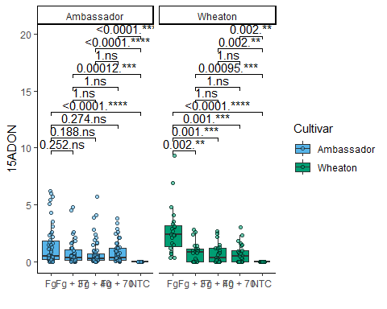

## Mass per Seed vs Treatment

DON5c_Plot <- ggplot(MycotoxinData, aes(x = Treatment, y = MassperSeed_mg, group = Treatment, fill = Cultivar)) +   
 # Add a boxplot layer without outlier points  
 geom_boxplot(outlier.shape = NA) +  
 # Add jittered points to the plot for better visibility of individual data points  
 geom_point(position = position_jitterdodge(dodge.width = 0.9), shape = 21, alpha = 0.6) +  
 # Add pairwise comparison results using t-test  
 geom_pwc(method = "t.test", label = "{p.adj.format}.{p.adj.signif}") +  
 # Label the y-axis  
 ylab("Seed Mass (mg)") +  
 # Label the x-axis (left blank in this case)  
 xlab(" ") +  
 # Manually set the fill colors using a predefined palette  
 scale_fill_manual(values = cbbPalette, aesthetics = "fill") +  
 # Apply a classic theme to the plot  
 theme_classic() +  
 # Create separate panels for each level of the 'Cultivar' variable  
 facet_wrap(~Cultivar)  
  
DON5c_Plot

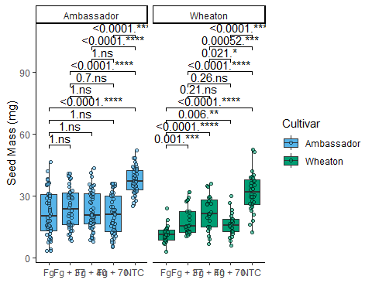

## Combining the Above Plots

CombinedPlot1 <- ggpubr::ggarrange(DON5a_Plot,  
 DON5b_Plot,  
 DON5c_Plot,  
 labels = "AUTO",  
 nrow = 3, ncol = 1, common.legend = T)  
  
CombinedPlot1

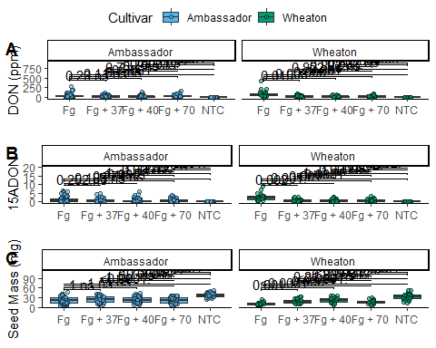

#Common legend makes it so theres only 1 legend for all of the figures; if it is set to F, each figure has their own respective legend. Arranging the plots so DON1 is A, DON3a is B. AUTO in capital yields ABC, where auto yields abc (lowercase) 3 rows, 1 column.

```