Assignment_5

Logan Luchs

2025-02-26

Table of Contents

[Link to my Github](https://github.com/Logz1n/Reproducibility_Class)

# Loading libraries and color pallettes

#Loading Libraries  
library(ggplot2)   
library(knitr)  
library(readr)  
library(ggpubr)  
library(dplyr)

##   
## Attaching package: 'dplyr'

## The following objects are masked from 'package:stats':  
##   
## filter, lag

## The following objects are masked from 'package:base':  
##   
## intersect, setdiff, setequal, union

library(tidyverse)

## ── Attaching core tidyverse packages ──────────────────────── tidyverse 2.0.0 ──  
## ✔ forcats 1.0.0 ✔ stringr 1.5.1  
## ✔ lubridate 1.9.3 ✔ tibble 3.2.1  
## ✔ purrr 1.0.2 ✔ tidyr 1.3.1

## ── Conflicts ────────────────────────────────────────── tidyverse_conflicts() ──  
## ✖ dplyr::filter() masks stats::filter()  
## ✖ dplyr::lag() masks stats::lag()  
## ℹ Use the conflicted package (<http://conflicted.r-lib.org/>) to force all conflicts to become errors

library(markdown)  
  
#Colorblind pallette  
cbbPalette <- c("#56B4E9", "#009E73", "#F0E442",  
"#000000", "#D55E00", "#CC79A7", "#E69F00","#0072B2" ) #loading a color pallette

# Reading in Data

Diversity <- read.csv("DiversityData.csv", na = "na" ) #loading in the data so that R understands na is na so the column is numeric  
  
Metadata <- read.csv("Metadata.csv", na = "na" ) #loading in the data so that R understands na is na so the column is numeric

# Joining Data Frames Together

alpha <- left_join(Metadata, Diversity, by = "Code") # Join Metadata and Diversity data frames based on the "Code" column

# Calculating Pielou’s evenness index

alpha_even <- alpha %>%  
 mutate(logRich = log(richness)) %>% # Add a column for the logarithm of richness  
 mutate(even = (shannon/logRich)) # Add a column for evenness as the ratio of Shannon diversity to log richness

# Calculating mean and standard error

alpha_average <- alpha_even %>%  
 group_by(Crop, Time_Point) %>% # Group data by Crop and Time_Point  
 summarise(Mean.even = mean(even), # Calculate the mean of evenness  
 n = n(), # Count the number of observations  
 sd.dev = sd(even)) %>% # Calculate the standard deviation of evenness  
 mutate(std.err = sd.dev/sqrt(n)) # Calculate the standard error

## `summarise()` has grouped output by 'Crop'. You can override using the  
## `.groups` argument.

# Calculating difference of evenness in crops

alpha_average2 <- alpha_average %>%  
 select(Time_Point, Crop, Mean.even) %>% # Select relevant columns  
 pivot_wider(names_from = Crop, values_from = Mean.even) %>% # Pivot data to have Crop names as columns  
 mutate(diff.cotton.even = Soil - Cotton) %>% # Calculate difference in evenness between Soil and Cotton  
 mutate(diff.soybean.even = Soil - Soybean) # Calculate difference in evenness between Soil and Soybean

# Plotting

Plot <- alpha_average2 %>%  
 select(Time_Point, diff.cotton.even, diff.soybean.even) %>% # Select relevant columns for plotting  
 pivot_longer(c(diff.cotton.even, diff.soybean.even), names_to = "diff") %>% # Pivot data to long format for plotting  
 ggplot(aes(x = Time_Point, y = value, color = diff)) + # Create a ggplot with Time_Point on x-axis and value on y-axis, colored by diff  
 geom_line() + # Add line geometry to the plot  
 theme_classic() # Apply classic theme to the plot

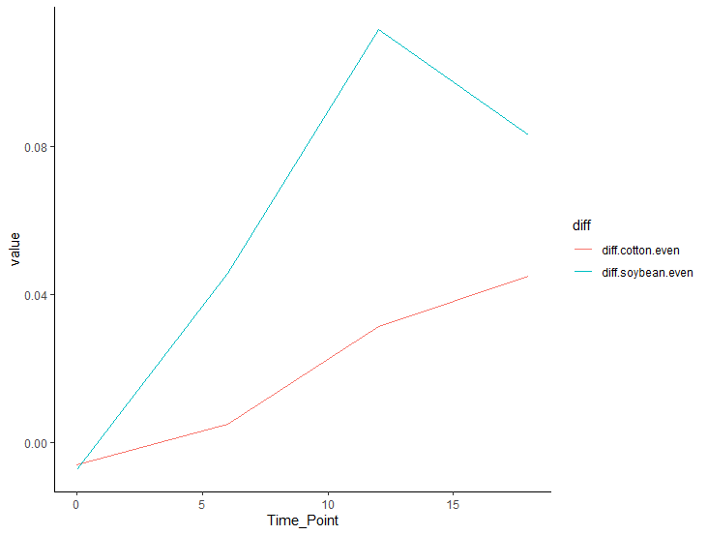

Image