Lab 3 File Management Using Windows Command Line & PowerShell (5%) & Journal Wiki 3 (2.5%)

W24 OSM620, section: cc
Lohan vaddepally, 150115236,

I declare that the attached assessment is wholly my own work in accordance with Seneca Academic Policy. No part of this assignment has been copied manually or electronically from any other source (including web sites) or distributed to other students.

Part 1: Working from the Command Line on Server 1 –

  - Create a text file named file1.txt in the 2008 directory. In your lab report, write the command(s) that you used.
    - Type: cd\ (to take you back to the root C:)
    - Type C:\>cd <your vm name> directory && cd SALES && cd REPORTS && cd 2008 (to take you to the 2008 subdirectory - please note the use of the “&” twice for chaining)
    - Type copy nul file1.txt (to create the text file in the 2008 subdirectory)
  - Create a text file named file2.txt in the ADOBE directory. In your lab report, write the command(s) that you used.
C:\>cd Srv1lohanvcc && cd SOFTWARE && cd APPS && cd ADOBE
copy nul file2.txt
  - Create a text file named file3.txt in the MARYK directory. In your lab report, write the command(s) that you used.
C:\>cd Srv1lohanvcc && cd USERS && cd MARYK
copy nul file3.txt
Server 1 Directory Tree-

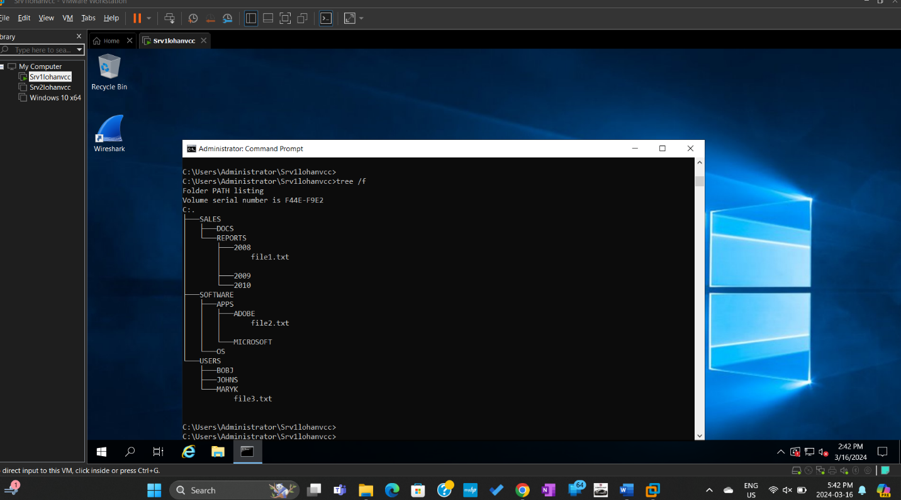

Part 2: Absolute and Relative Paths on Server 1

- You are in the USERS directory. Move file3.txt to the JOHNS directory and rename it file4.txt.
A | move C:\<Srv1lohanvcc>\USERS\MARYK\file3.txt C:\<your VM name>\USERS\JOHNS\file4.txt  OR  move \<Srv1lohanvcc>\USERS\MARYK\file3.txt \<your VM name>\USERS\JOHNS\file4.txt  Note: Including C: is optional for Absolute paths
R | move .\MARYK\file3 .\JOHNS\file4.txt  OR  move MARYK\file3 JOHNS\file4.txt  Note: Including .\ is optional for Relative paths

- You are in the SALES directory. Create a new file called January.txt in 2009.
A | echo. > C:\Srv1lohanvcc\SALES\2009\January.txt
R | echo. > .\2009\January.txt

- You are in the SOFTWARE directory. Create a new directory called SUN under OS.
A | Mkdir c:\Srv1lohanvcc\SOFTWARE\OS\SUN
R | Mkdir OS\SUN

- You are in the <your VM name> directory. Delete the 2008 directory.
A | Rmdir /s/q C:\Srv1lohanvcc|SALES\REPORTS\2008
R | Rmdir /s/q .SALES\REPORTS\2008

- You are in the USERS directory. Create a directory listing of REPORTS, showing all files, organized by date.
A | Dir /o-d C:\srv1lohanvcc\USERS\REPORTS
R | Dir /o-d .\REPORTS

Part 3: Introduction to PowerShell
Customize a Shortcut to Point to a Home Directory (Server 1) –
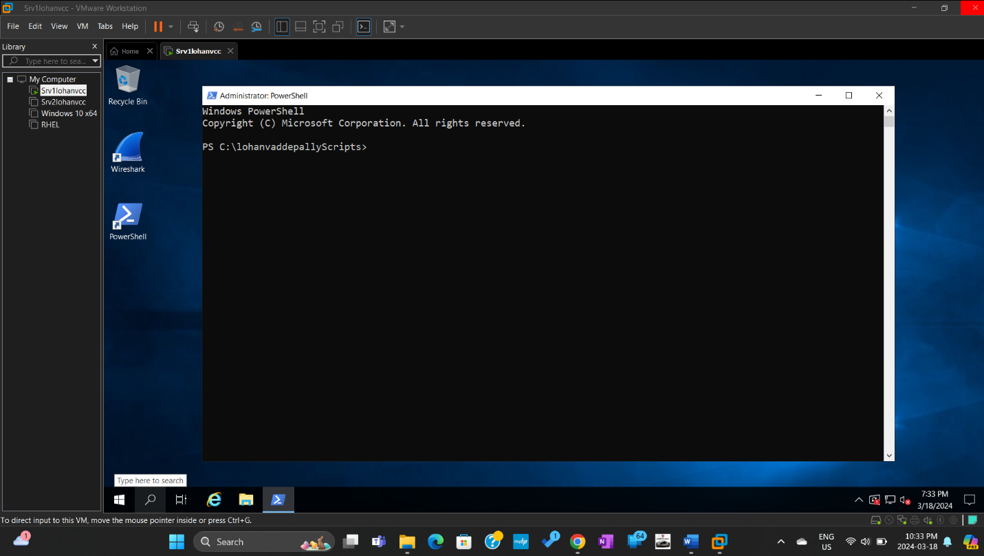 PS-custom-dir.jpg
Changes made – Font size changed to 18, increased layout size, Color to red,

PowerShell cmdlets – Get Commands
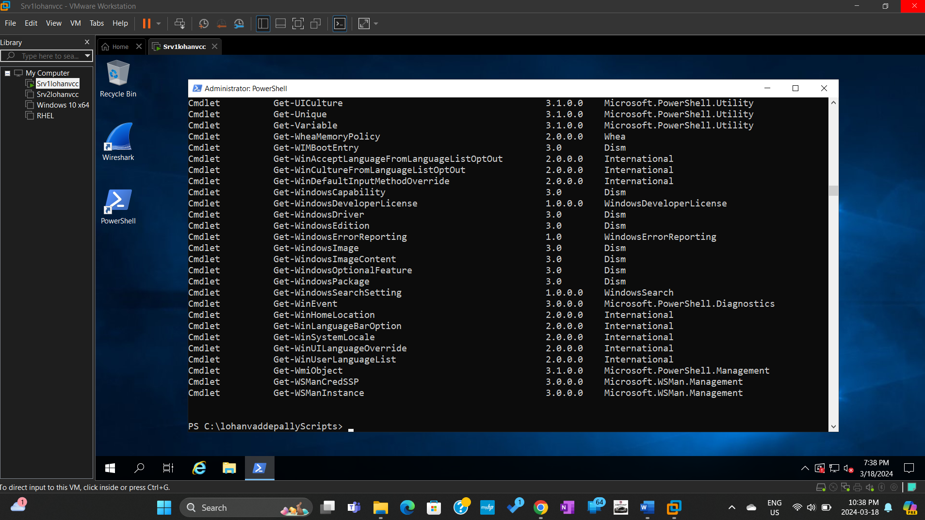
PS-getcommands.jpg

- How many cmdlets are available on your server? Copy/paste this question and your response in your lab report under the subheading Number of Cmdlets on my Server

Ans: 707
Getting Help –
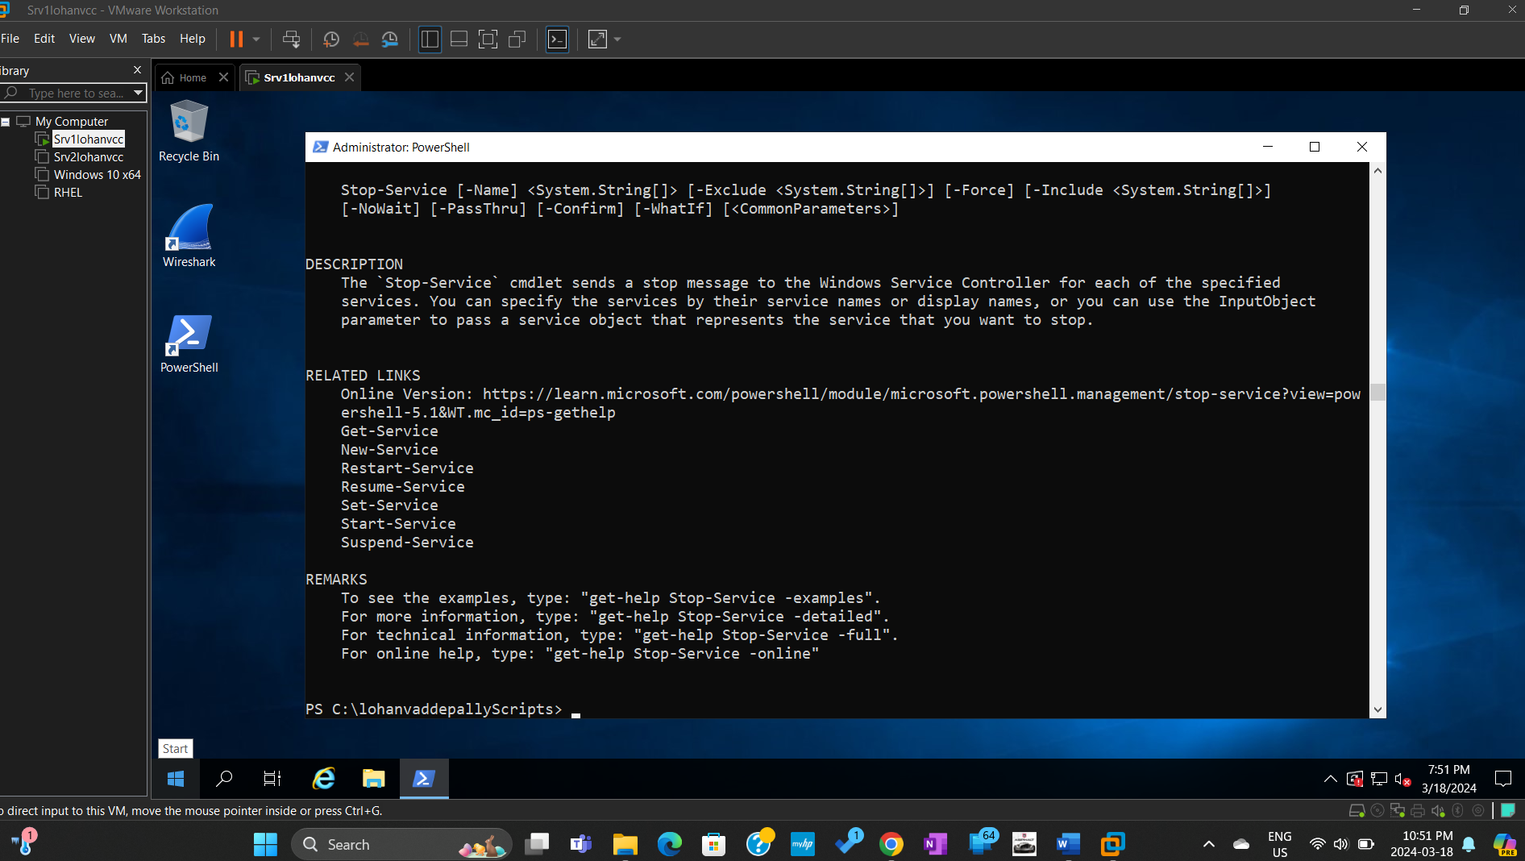
PS-gethelpstopservice.jpg

Stopping and Starting a Service
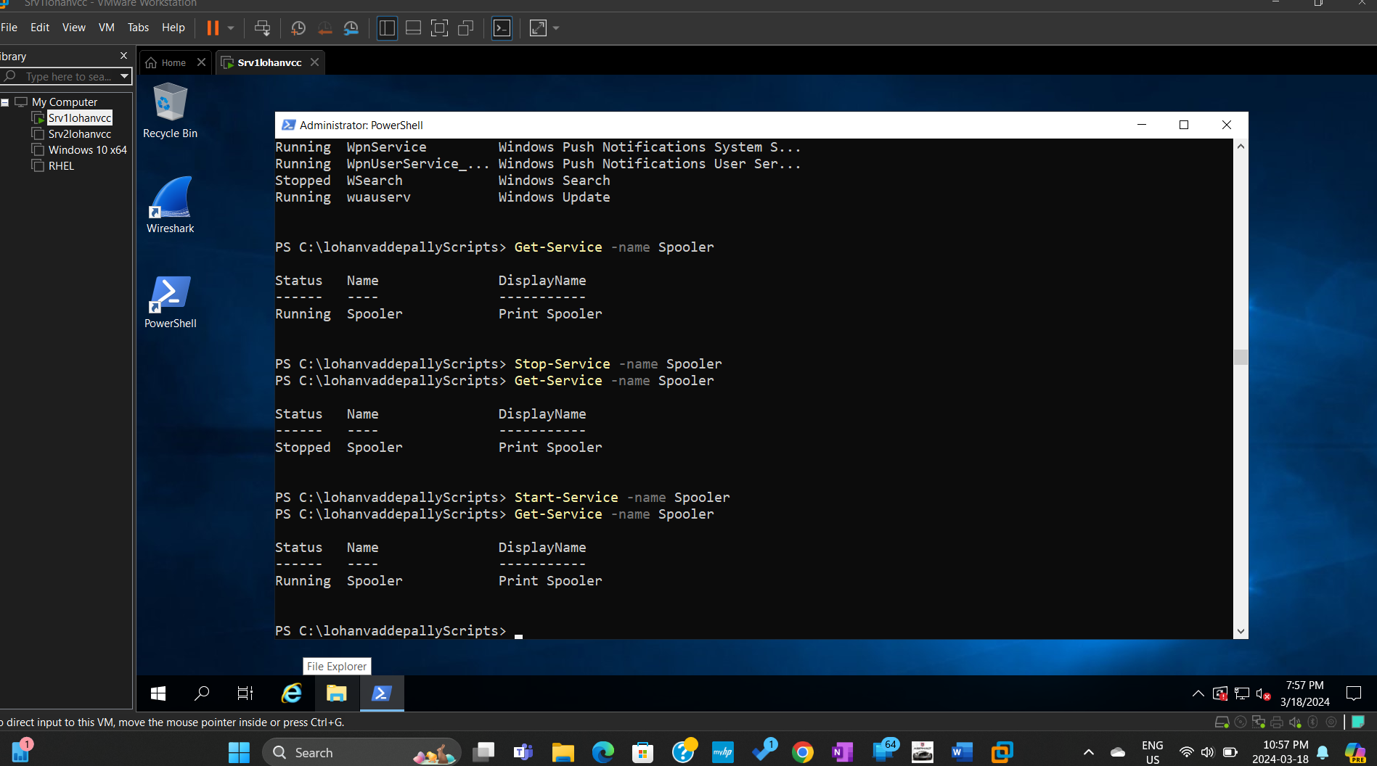
PS-stop&startservice.jpg

Aliases – Get ChildItem.
How many aliases are there for the Get-ChildItem cmdlet? List the aliases.
Alias dir -> Get-ChildItem
Alias gci -> Get-ChildItem
Alias ls -> Get-ChildItem

Get ChildItem and its Aliases

PS C:\lohanvaddepallyScripts> ls C:\lohanvaddepallyScripts
>> Directory: C:\lohanvaddepallyScripts
Mode LastWriteTime Length Name
---- ------------- ------ ----
-a---- 3/18/2024 7:23 PM 0 file1.txt
-a---- 3/18/2024 7:24 PM 0 file2.txt
-a---- 3/18/2024 7:24 PM 0 file3.txt
PS C:\lohanvaddepallyScripts> dir C:\lohanvaddepallyScripts
>> Directory: C:\lohanvaddepallyScripts
Mode LastWriteTime Length Name
---- ------------- ------ ----
-a---- 3/18/2024 7:23 PM 0 file1.txt
-a---- 3/18/2024 7:24 PM 0 file2.txt
-a---- 3/18/2024 7:24 PM 0 file3.txt

PS C:\lohanvaddepallyScripts> gci C:\lohanvaddepallyScripts
>> Directory: C:\lohanvaddepallyScripts
Mode LastWriteTime Length Name
---- ------------- ------ ----
-a---- 3/18/2024 7:23 PM 0 file1.txt
-a---- 3/18/2024 7:24 PM 0 file2.txt
-a---- 3/18/2024 7:24 PM 0 file3.txt

Did you notice any differences in the outputs? Why or why not?
Ans: I did not notice any differences. Because all the three commands were aliases for the get childitem command i.e; they can be used instead of get childitem command to view the content in it.

Displaying the gs Alias
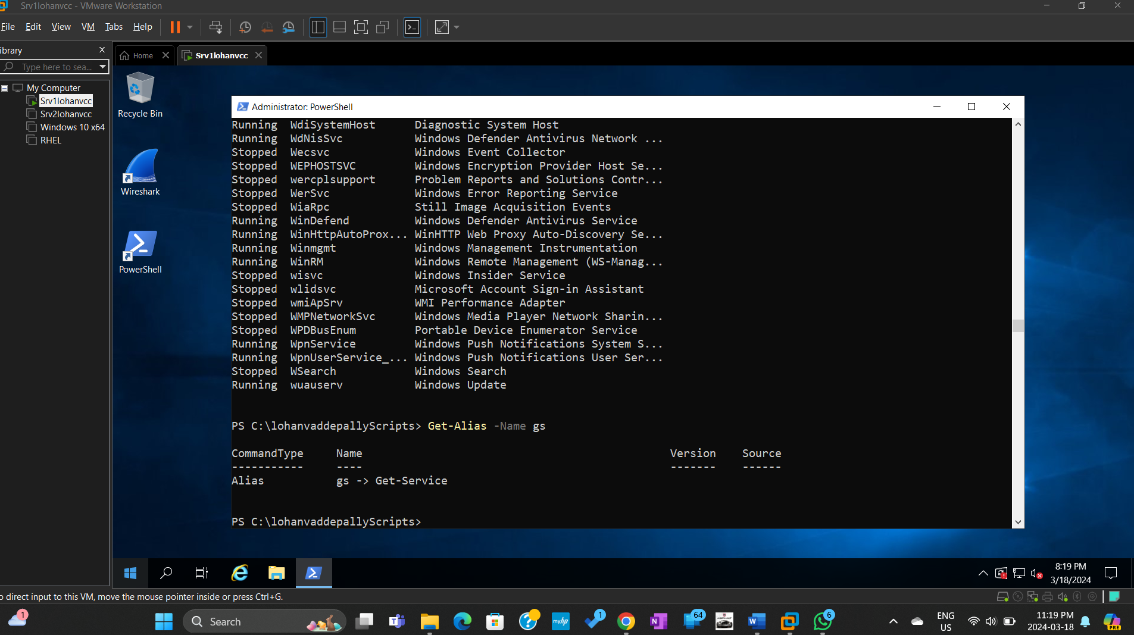
PS-gs-alias.jpg

Creating a Profile
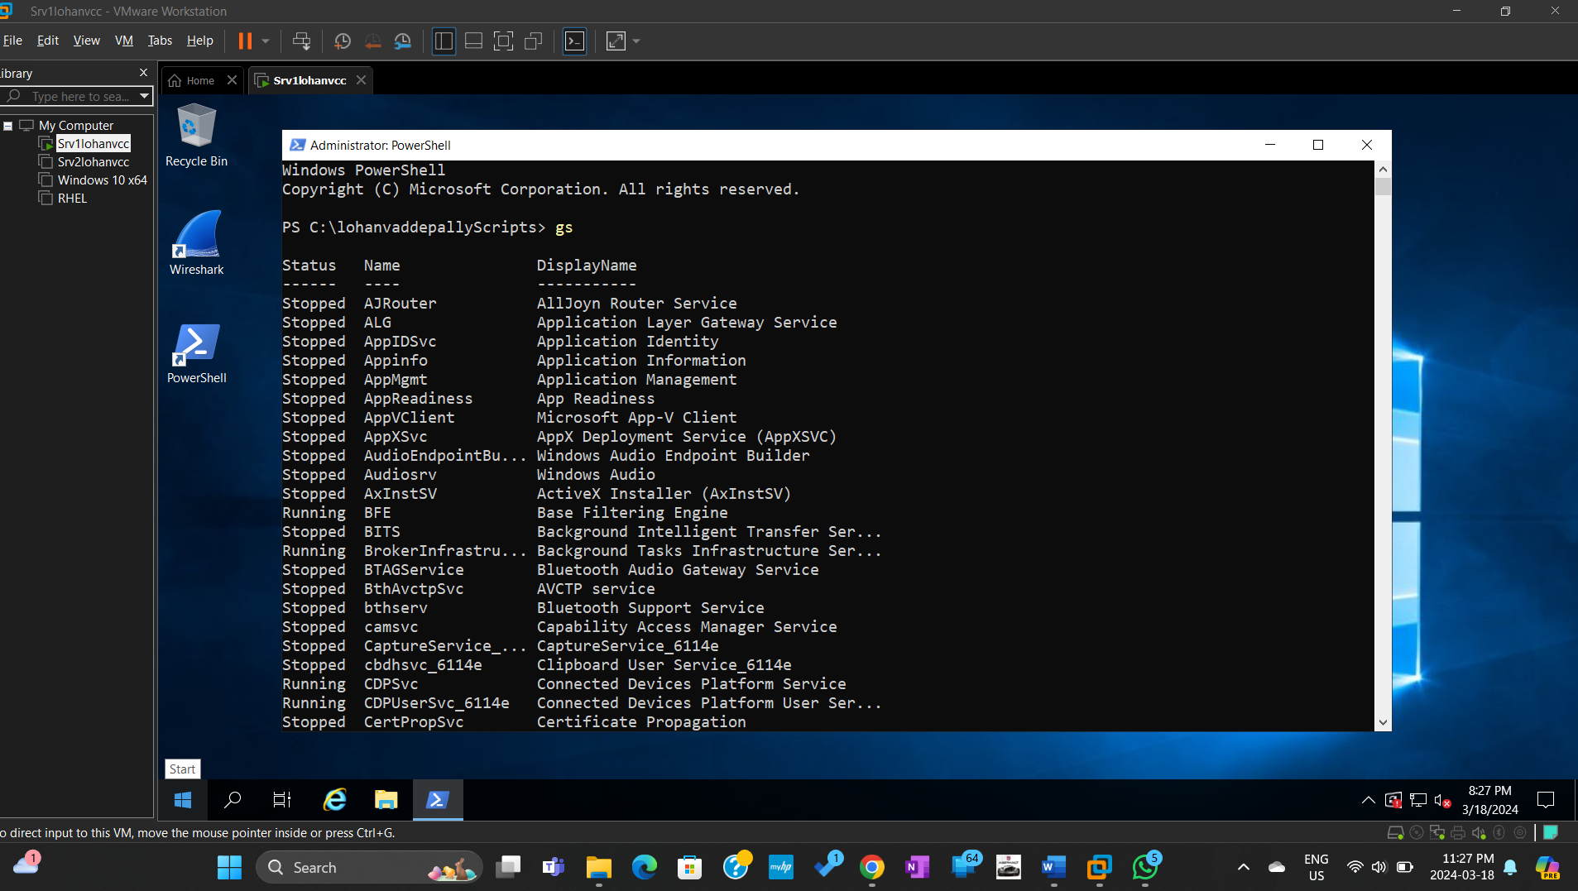
PS-profile.jpg
heading Section 2: Journal Wiki 3 (2.5%)

- What were some issues/problems you had while completing this lab and how did you solve each? Include web links, if necessary
Ans: I faced issues while performing aliases task for getchilditem command. But itook time and went through the docs carefully iwas able to solve the issus.
- Include a reflection of at least 3 things that you learnt from doing the lab – this should not only be a list, you should also state/explain what you have learnt, i.e., your takeaways
Ans: 1. I learnt using powershell.
- How to edit powershell - layout,font,color
- Setting aliases and making them permanent
- Creating personal profilr.

3.What 2 things would you like to know more about?
Ans:
a. more about profiles created in powershell.
b.creating aliases, functons, commands in personel profile.

4.Include some links to good and relevant information for the lab and indicate why?
Ans:
https://en.wikipedia.org/wiki/PowerShell
https://www.techtarget.com/searchitoperations/tip/When-to-use-the-Windows-command-prompt-vs-PowerShell

