
Table of Contents

Section 1: Introduction 3
Executive Summary 3
Organization Background/Introduction 3
Section 2: Network Infrastructure Assessment and Findings 4
Assessment Methodology 4
Findings 4
Section 3: Proposed Solution 6
1. Windows Editions and Virtualization 6
2. Network Topology 8
3. DHCP Server, DNS Server, File Server, Domain Controller 11
4. VM Creation 13
5. Cloud Consideration 25
6. Server Room Conditions 26
Section 4: Costs, Cost/Benefit Analysis, and Justifications 27
Cost Breakdown 27
Cost/Benefit Analysis 28
Justifications 29
Section 5: Recommendations and Conclusion 30
Recommendations 30
Conclusion 30
References 31

Section 1: Introduction

Executive Summary

Through thorough research on our organization’s server infrastructure, we, the IT department have found problems that are quite concerning and will have a negative impact in the future. The problems that we found were critical issues, slow networks, old hardware, old software, outdated security, and heavy reliance on technology that is already so old.
To address these issues, we, the IT department have devised a plan that will help solve these concerning problems, these revolves around: Increased overall server performance, better productivity, stronger security, lesser uptime costs, better server room ventilation, as well as the modernization of hardware that meets industry standards.
With these proposed solutions, we are very confident that we will not only solve the problems at hand but also build an organization that is strong and that can keep up with the world of technology that only evolves faster as the days go by.

Organization Background/Introduction

Amazon Fulfillment Centers are a crucial part of every big machine in the logistics and distribution world being the link in the supply chain. HR, IT, Accounting, Marketing, are just a few of the departments that make our organization grow. There is no doubt that we run on the effort given by a diverse and excellent workforce, driven to offer a great service. Currently, our server system runs on Windows Server 2012 and is in our private premises. Nevertheless, we have come up against several challenges recently, and it now seems like our present network configuration is not as successful as we’d like it to be.

We have been experiencing several network congestion problems, a few security issues, as well as some drag caused by older technology, which has led to extended system unavailability, slow response times and, quite likely, a reduction in our position on the market. Since his arrival, our CEO has been focused on offering standardized packages to our international clients for the bulk of our communication footprint. He has assigned our Information Technology department with the task of doing a thorough analysis to determine the best way to improve the situation. Working as one enterprise, we will mobilize our collective expertise and resources to offer you a custom copy. We aim not only to help your Amazon Fulfillment Centers address current challenges, but we also want to support your sustainability for the long run. We believe that the proposed solution incorporating innovation and strategic thinking will be suitable for your organization and secure your future ahead of your competition.

Section 2: Network Infrastructure Assessment and Findings

Assessment Methodology

To conduct a proper assessment of the organizations network infrastructure, we need to have an approach that is properly planned and executed. This will become the foundation of the project as it will guide us in examining what works and what will not regarding of the situation at hand.

Employee Interviews:
We will be conducting an interview to each department who uses the current network infrastructure, such as the IT Department, HR Department, Accounting Department, and Marketing Department to gather information on the organizations’ current network configurations, problems, and situation.

Network Setup Review:
We will conduct a comprehensive review of the current system infrastructure setup, which will include the review of their current software and hardware specifications.

Performance Testing:
We will conduct a network evaluation using internet speed tests, latency checks, as well as bandwidth tests so that we can identify which areas needs to be improved.

Security Check:
We will check their current systems for vulnerabilities, we will also do tests that will check if the server is penetrable by common hacking techniques, this way, we can know the potential risks and weaknesses of the system so we can avoid it in our solution.

Server Room Checkup:
We will check their server rooms to see if it has proper temperature levels, humidity, and if it follows the best practices regarding on-site servers.

Findings

After doing the network assessment, we have found critical findings regarding the organization’s current network infrastructure.

Current Software and Hardware:
- The organization is utilizing Windows Server 2012, an older, outdated, and vulnerable Windows Server Version.
- The server’s operating system is Windows 8. An older version of the windows operating systems. This version has lost support from Microsoft back on January 12, 2016.
- These are the software that the organization is using:
- Symantec Norton Antivirus
- Skype
- Microsoft Office 2013
- QuickBooks (Accounting Department)
- ADP Workforce (HR Department)
- Cisco Security Suites (IT Department)
- Tableau (Marketing Department)

- As for the hardware, the servers’ specs are:
- Motherboard: ASUS Z9PE-D8 WS
- CPU: Intel Xeon E5-2600 v1 (6 Cores)
- RAM: Kingston Technology DDR3 (304 GB | 16GB * 38)
- Storage: 10TB HDD
- PSU: Seasonic 80 Plus Gold 850 Watts
- Their Routers are Cisco ISR G2
- Their Switches are Cisco Catalyst 3750
- Their Ethernet cable is a Gigabit Ethernet Cable

Network Performance:
- With regular usage, the file transfer speeds would be between 6Mbps to 3 Mbps per employee. To get this value, since we are using a gigabit ethernet cable, we divide 1Gbps to 150 employees, the results would be 6.67 MBps per employee, but this is if the connection is perfect which is rarely the case, so the actual speeds could be as low as 3 Mbps to 6 Mbps per employee and it might be lower especially during peak usage times.
- The organization is using Roger’s 2 Gigabit internet plan which if divided to all the employees would be 13.33 Mbps per employee which is sufficient to get through different types of work. During peak times, it was recorded to be as low as 7 Mbps per employee, so the actual range of their internet connection bandwidth would be 7 Mbps to 13.33 Mbps.

Security Concerns:
- Due to the Windows Server and their Operating System being in an older version, their system now has an older firmware which has limited security protocols, this version also doesn’t receive regular security updates, these issues are big risks of possible data breaches and hackers having unauthorized access.

Server Room Conditions:
- As for the temperature, it was higher than normal at 33°C. (According to Cool-Tec (2023), Normal server room temperature ranges are 19-21°C) This high temperature can cause damages to hardware if left ignored.
- As for the humidity, it was recorded at 10% which is significantly lower than the average humidity of 40-60% (Cool-Tec, 2023).

Summary
Based on our findings, we find it urgent for an upgrade of the current network infrastructure of the organization. An upgrade is needed to address the performance issues (High latency, Congested network), security vulnerabilities (Older firmware, bad security protocols), older software (Usage of an older Windows Server), and older hardware (Degrading routers and switches). If the organization decides to prolong the upgrade, there could be big consequences which includes the shutdown of the entire organization.

Section 3: Proposed Solution

Windows Editions and Virtualization

- Windows Server Edition:

Upgrade to Windows Server 2019 Datacenter Edition:

This choice is made for several reasons:

- Enhanced Features:
Windows Server 2019 Datacenter Edition offers the latest features, including improved security measures, enhanced performance, and better support for modern hardware.

- Robust Virtualization:
With built-in Hyper-V virtualization technology, Windows Server 2019 Datacenter Edition allows for efficient creation, management, and deployment of virtual machines (VMs). This is crucial for optimizing server resources and scaling infrastructure as needed.

- Seamless Integration:
The Datacenter Edition seamlessly integrates with cloud services, facilitating hybrid cloud deployments and enabling organizations to leverage the benefits of both on-premises and cloud-based solutions.

- Compatibility:
Before the upgrade, thorough compatibility checks will be conducted to ensure that existing applications and network infrastructure are compatible with Windows Server 2019. Any compatibility issues will be addressed accordingly.

- Cost Implications:
While the Datacenter Edition may involve higher initial licensing costs compared to other editions, its comprehensive features and scalability justify the investment in the long run. Additionally, potential cost savings can be achieved through server consolidation and improved resource utilization with virtualization.

- Scalability:
The Datacenter Edition offers scalability to accommodate growing organizational needs, allowing for the deployment of additional VMs as required without significant administrative overhead.

- Administrative Efforts:
The centralized management features of Windows Server 2019 Datacenter Edition streamline administrative tasks, reducing the time and effort required for server maintenance and management.

- Security:
Leveraging virtualization technology, such as Hyper-V, enhances security by isolating applications and workloads within individual VMs. This reduces the risk of security breaches and provides a layer of protection against potential threats.

- Application Compatibility:
Compatibility testing will be conducted to ensure that critical applications used by the organization are fully compatible with the chosen server OS. Any compatibility issues will be addressed through updates, patches, or alternative solutions.

- Windows 10 Edition:

- Deploy Windows 10 Pro:
Windows 10 Pro is chosen for client machines due to its compatibility with the organization's network infrastructure and applications. Additionally, Windows 10 Pro offers advanced security features, such as BitLocker encryption and Windows Defender Antivirus, to protect against modern cyber threats.

- Virtualization Strategy:

- Utilize Hyper-V:
Hyper-V, included with Windows Server 2019 Datacenter Edition, will be utilized for hosting virtual machines. This provides benefits such as efficient server management, hardware abstraction, and workload isolation. Moreover, Hyper-V enables organizations to optimize server resources and achieve higher levels of resource utilization.

- Benefits of Selected Server:

- Enhanced Security:
Windows Server 2019 Datacenter Edition offers advanced security features, including built-in threat detection and protection mechanisms, safeguarding organizational data and assets.

- Improved Performance:
With optimizations and enhancements, Windows Server 2019 Datacenter Edition delivers improved performance and reliability, ensuring smooth operation of critical workloads and applications.

- Scalability:
The scalability of Windows Server 2019 Datacenter Edition allows organizations to expand their infrastructure seamlessly, accommodating growing demands without significant disruptions.

- Centralized Management:
Centralized management features simplify server administration tasks, reducing complexity and improving efficiency for IT administrators.

- Cost-Effectiveness:
While there may be initial licensing costs associated with Windows Server 2019 Datacenter Edition, the long-term benefits, including improved resource utilization and reduced administrative overhead, contribute to overall cost-effectiveness.

Network Topology

- Hardware and Network Devices:

- Servers:
Upgrade to Dell PowerEdge R740 servers with Intel Xeon Gold 6254 processors and 256GB of RAM to meet the hardware requirements for Windows Server 2019.

- Storage:
Implement NetApp AFF A-300 all-flash arrays for high-performance storage, enhancing data reliability and availability.

- Network Equipment:
Deploy Cisco Catalyst 9300 switches and Cisco ISR 4321 routers for reliable, high-speed networking supporting increased data throughput and network performance.

- Software Solutions:

- Antivirus Solution:
Implement enterprise-grade antivirus software such as Symantec Endpoint Protection or McAfee Endpoint Security to safeguard networked devices from malware threats and ensure comprehensive security coverage.

- Network Topology Diagram:

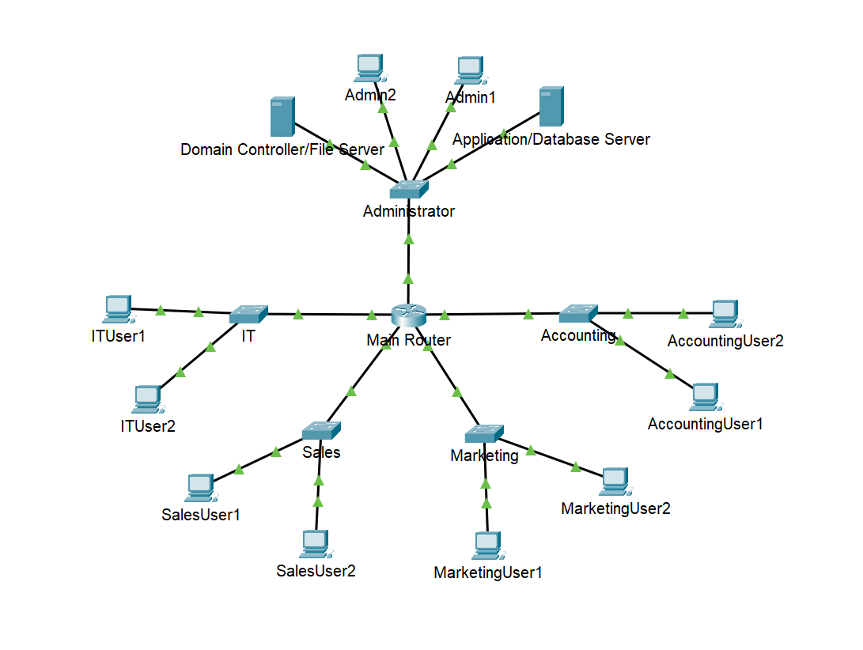
Figure 1:Network Topology
The IP addresses used in the table represent addresses typically used in private networks, specifically from the IPv4 private address ranges defined by RFC 1918. These addresses are reserved for use within private networks and are not routable on the public internet.

The specific range used in this diagram, 192.168.1.0/24, falls within the private address space reserved for use within a single organization's internal network. The addresses within this range can be freely assigned and used within the organization's network without conflicting with public internet addresses.

- IP Addressing Scheme:

- Department IP Addressing Plan:

- Network Topology Diagram Explanation:

Department | Subnet | IP Range | Gateway
Administration | 192.168.1.0/24 | 192.168.1.1 - 192.168.1.50 | 192.168.1.1
Sales | 192.168.2.0/24 | 192.168.2.1 - 192.168.2.50 | 192.168.2.1
Marketing | 192.168.3.0/24 | 192.168.3.1 - 192.168.3.50 | 192.168.3.1
IT | 192.168.4.0/24 | 192.168.4.1 - 192.168.4.50 | 192.168.4.1
Accounting | 192.168.5.0/24 | 192.168.5.1 - 192.168.5.50 | 192.168.5.1

The network topology diagram depicts the arrangement of servers, clients, and network devices within the organization's network infrastructure. The diagram showcases the placement of Dell PowerEdge R740 servers, NetApp AFF A-300 storage arrays, Cisco Catalyst 9300 switches, and Cisco ISR 4321 routers.

Key elements of the network topology diagram include:

- Server Placement:
Dell PowerEdge R740 servers are strategically positioned within the network infrastructure to ensure optimal performance and accessibility.

- Storage Arrays:
NetApp AFF A-300 Series all-flash arrays are integrated into the network to provide high-performance storage capabilities, enhancing data reliability and availability.

- Network Devices:
Cisco Catalyst 9300 switches and Cisco ISR 4321 routers are deployed to facilitate reliable, high-speed networking, supporting increased data throughput and network performance.

- IP Addressing Scheme Explanation:
The IP addressing scheme defines the allocation of IP addresses to different departments within the organization, ensuring efficient utilization of IP address space and defining gateways and subnet masks accordingly.

- Each department is assigned a unique subnet, facilitating network segmentation for enhanced security and efficient management.

- IP ranges are allocated within each subnet to accommodate the required number of devices while allowing for future expansion.

- Gateways are defined to provide connectivity between different subnets and enable communication with external networks.

DHCP Server, DNS Server, File Server, Domain Controller

- DHCP Server
DNS Server Configuration:

DHCP (Dynamic Host Configuration Protocol) allows servers to automatically assign IP addresses to devices connecting to a network. When a device joins the network, it sends a request to the DHCP server, which responds with an available IP address and other configuration details. This automation streamlines network setup, reduces errors, and accommodates network changes seamlessly.

DHCP works by:

Client Request: Devices send a request for network configuration.
DHCP Offer: Servers respond with available IP addresses.
Client Selection: Devices select an IP address and confirm the choice.
IP Assignment: Servers assign the chosen IP address to the device.

- Operating System: Windows Server 2019 Datacenter Edition
- Hardware: Virtual machine running on one of the Dell PowerEdge R740 servers
- Processor: 4 virtual CPUs (vCPUs) from the Intel Xeon Gold 6254 processors
- RAM: 8GB RAM
- Storage: Allocate sufficient storage space for DHCP logs and database storage. Consider using RAID for data redundancy and fault tolerance.
- Networking: Connect the DHCP server to the network using a dedicated VLAN for DHCP traffic, ensuring proper network segmentation.

DHCP Server Configuration:

- Install the DHCP Server role via Server Manager or PowerShell (Install-WindowsFeature -Name DHCP).
- Open the DHCP management console (dhcpmgmt.msc) to configure DHCP settings.
- Configure DHCP scopes, including IP address ranges, subnet masks, default gateways, DNS servers, and lease durations.
- Optionally, configure DHCP options to provide additional settings to DHCP clients (e.g., DNS servers, domain name, NTP servers).
- Authorize the DHCP server in Active Directory (if applicable) to enable DHCP service.
- Activate the DHCP scope(s) to start leasing IP addresses to clients.

- DNS Server:

DNS (Domain Name System) serves as the internet's address book, translating human-readable domain names into IP addresses computers understand. In our server infrastructure, DNS plays a crucial role in facilitating communication between devices by resolving domain names to their corresponding IP addresses.

Structure of DNS:

Domain Hierarchy: DNS operates in a hierarchical structure, organized into domains, subdomains, and individual hosts. Domains are grouped into zones, each managed by authoritative DNS servers.

Resource Records: DNS databases store resource records (RRs) containing information about domain names and associated data types, such as:

A Records: Maps domain names to IPv4 addresses.
AAAA Records: Maps domain names to IPv6 addresses.
CNAME Records: Provides alias names for canonical domain names.
MX Records: Specifies mail exchange servers for the domain.
NS Records: Identifies authoritative name servers for the domain.

Role of DNS in Our Server Infrastructure:

Name Resolution: DNS resolves domain names to IP addresses, enabling devices to locate and connect to servers and services on the network using human-readable names.

Domain Hosting: Our DNS servers host domain zones, providing authoritative responses to DNS queries for domains under our control. This ensures accurate resolution of domain names within our infrastructure.

Reverse DNS Lookup: DNS facilitates reverse DNS lookup, translating IP addresses back to domain names. This capability is essential for network diagnostics, security, and spam filtering.

Load Balancing: DNS-based load balancing distributes incoming network traffic across multiple servers, enhancing performance, scalability, and fault tolerance for our services.

Redundancy and Fault Tolerance: DNS supports redundant and fault-tolerant configurations, allowing us to deploy multiple DNS servers across different locations to ensure continuous service availability and resilience against server failures or network issues.

- Operating System: Windows Server 2019 Datacenter Edition
- Hardware: Virtual machine running on one of the Dell PowerEdge R740 servers
- Processor: 4 virtual CPUs (vCPUs) from the Intel Xeon Gold 6254 processors
- RAM: 8GB RAM
- Storage: Allocate sufficient storage space for DNS logs and zone data. Consider using RAID for data redundancy.
- Networking: Connect the DNS server to the network using a dedicated VLAN for DNS traffic, ensuring proper network segmentation.

- Install the DNS Server role via Server Manager or PowerShell (Install-WindowsFeature -Name DNS).
- Open the DNS management console (dnsmgmt.msc) to configure DNS settings.
- Create forward and reverse lookup zones for the organization's DNS namespace.
- Configure DNS zone properties, including zone transfer settings, dynamic updates, and aging/scavenging options.
- Add DNS records (e.g., A, AAAA, CNAME, MX, SRV) to the DNS zones as required.
- Configure DNS forwarders to enable recursive DNS resolution for external queries.
- Test DNS resolution using nslookup or other diagnostic tools to ensure proper functionality.

- File Server:

File Server Implementation:

The role of the file server in our infrastructure is to provide centralized storage and management of files and folders accessible to network users. Following industry standards, we plan to implement the file server with the aim of facilitating efficient data sharing, collaboration, and backup operations within the organization. The setup will adhere to best practices to ensure security, reliability, and scalability.

Role of File Server:

Centralized Storage: The file server will host shared folders containing user data, ensuring a single, reliable location for storing files.
Access Control: Proper permissions, including NTFS permissions and share permissions, will be configured to control access to files and folders, maintaining data security.
Data Management: Utilizing features such as access-based enumeration (ABE) and quota management, we will manage disk space usage and ensure that users only see files and folders they have permission to access.
Implementation Plan:

Installation: The File Server role will be installed on a virtual machine running Windows Server 2019 Datacenter Edition, deployed on Dell PowerEdge R740 servers.
Storage Configuration: NetApp AFF A-300 Series all-flash arrays will be utilized for high-performance storage, ensuring fast access to files.
Networking: The file server will be connected to the network via dedicated VLANs for file sharing traffic, ensuring proper segmentation and access controls.
Shared Folders: Shared folders will be created for user data, with appropriate permissions configured to restrict access as per organizational policies.
Additional Features: Access-based enumeration (ABE) will be enabled to display only files and folders that users have permission to access, enhancing data security.

- Operating System: Windows Server 2019 Datacenter Edition
- Hardware: Virtual machine running on one of the Dell PowerEdge R740 servers
- Processor: 8 virtual CPUs (vCPUs) from the Intel Xeon Gold 6254 processors
- RAM: 32GB RAM
- Storage: Utilize NetApp AFF A-300 Series all-flash arrays for high-performance storage. Allocate sufficient storage space for user data, considering growth projections and data retention policies. Implement RAID for data redundancy and fault tolerance.
- Networking: Connect the file server to the network using dedicated VLANs for file sharing traffic, ensuring proper network segmentation and access controls.

File Server Configuration:

- Install the File Server role via Server Manager or PowerShell (Install-WindowsFeature -Name FS-Fileserver).
- Configure disk storage for file shares, ensuring sufficient capacity and redundancy (e.g., RAID arrays).
- Create shared folders for user data and set appropriate permissions (e.g., NTFS permissions, share permissions).
- Enable access-based enumeration (ABE) to display only files and folders that users have permission to access.
- Configure quota management to monitor and control disk space usage on shared folders.
- Implement File Server Resource Manager (FSRM) to manage file screening, quotas, and file classification.

- Domain Controller:

Domain Controller Implementation:

The domain controller serves as the core of our network infrastructure, providing centralized authentication and authorization services. Adhering to established standards, we plan to implement the domain controller to ensure secure user authentication, efficient resource management, and seamless network operations.

Role of Domain Controller:

User Authentication: The domain controller will authenticate user credentials, allowing users to securely access network resources.
Active Directory Management: It will host Active Directory Domain Services (AD DS), storing information about users, groups, computers, and organizational units.
Policy Enforcement: Group policies will be applied to enforce security settings and configurations across the network, ensuring compliance with organizational standards.
Implementation Plan:

Installation: Windows Server 2019 Datacenter Edition will be installed on a virtual machine deployed on Dell PowerEdge R740 servers to serve as the domain controller.
Active Directory Configuration: The Active Directory Domain Services (AD DS) role will be installed and configured, establishing the domain controller as the authoritative source for user authentication and directory services.
DNS Integration: The domain controller will host DNS services, allowing it to resolve domain names within the network and facilitating seamless communication.
Security Measures: Proper network segmentation and security controls will be implemented, with the domain controller connected to dedicated VLANs for Active Directory traffic to ensure isolation and protect against unauthorized access.
Replication and Redundancy: Replication settings will be configured to ensure data consistency across domain controllers, providing redundancy and fault tolerance.

- Operating System: Windows Server 2019 Datacenter Edition
- Hardware: Virtual machine running on one of the Dell PowerEdge R740 servers
- Processor: 8 virtual CPUs (vCPUs) from the Intel Xeon Gold 6254 processors
- RAM: 32GB RAM
- Storage: Allocate sufficient storage space for Active Directory database, logs, and SYSVOL replication. Utilize RAID for data redundancy.
- Networking: Connect the domain controller to the network using dedicated VLANs for Active Directory traffic, ensuring proper network segmentation and security.

Domain Controller Configuration:

- Install the Active Directory Domain Services (AD DS) role via Server Manager or PowerShell (Install-WindowsFeature -Name AD-Domain-Services).
- Promote the server to a domain controller by running the Active Directory Domain Services Configuration Wizard (dcpromo) and following the prompts.
- Configure the domain controller with a new forest or join an existing domain as a new domain controller.
- Install DNS Server role on the domain controller and configure it to use itself as the primary DNS server.
- Configure global catalog (GC) settings if the domain controller will serve as a GC server.
- Perform post-deployment tasks such as configuring Active Directory Sites and Services, FSMO role placement, and replication settings.

VM Creation

To test the infrastructure, we used VMWare Workstation 17. The following specifications were used for the Windows Server 2019 Datacenter Edition Virtual Machine:

- Hard Disk: 80 GB
- Memory: 4 GB
- Processor: 2 Processors/4 Cores

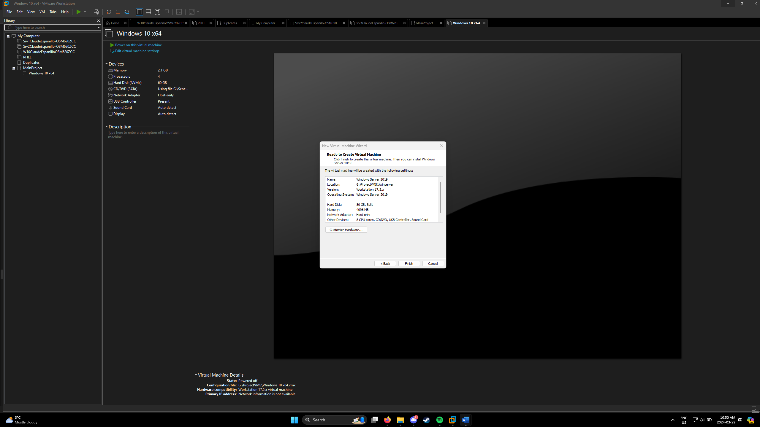
Figure 2:Windows Server 2019 Datacenter Edition

The following specifications were used for the Windows 10 Enterprise Virtual Machine:

- Hard Disk: 60 GB
- Memory: 2 GB
- Processor: 1 Processor/4 Cores

Do know that these specifications are NOT the final specifications that we will use for the final production environment. These VM’s are created to test the features we want to implement as well as demonstrate to you the functionalities as well as the services that the organization needs.

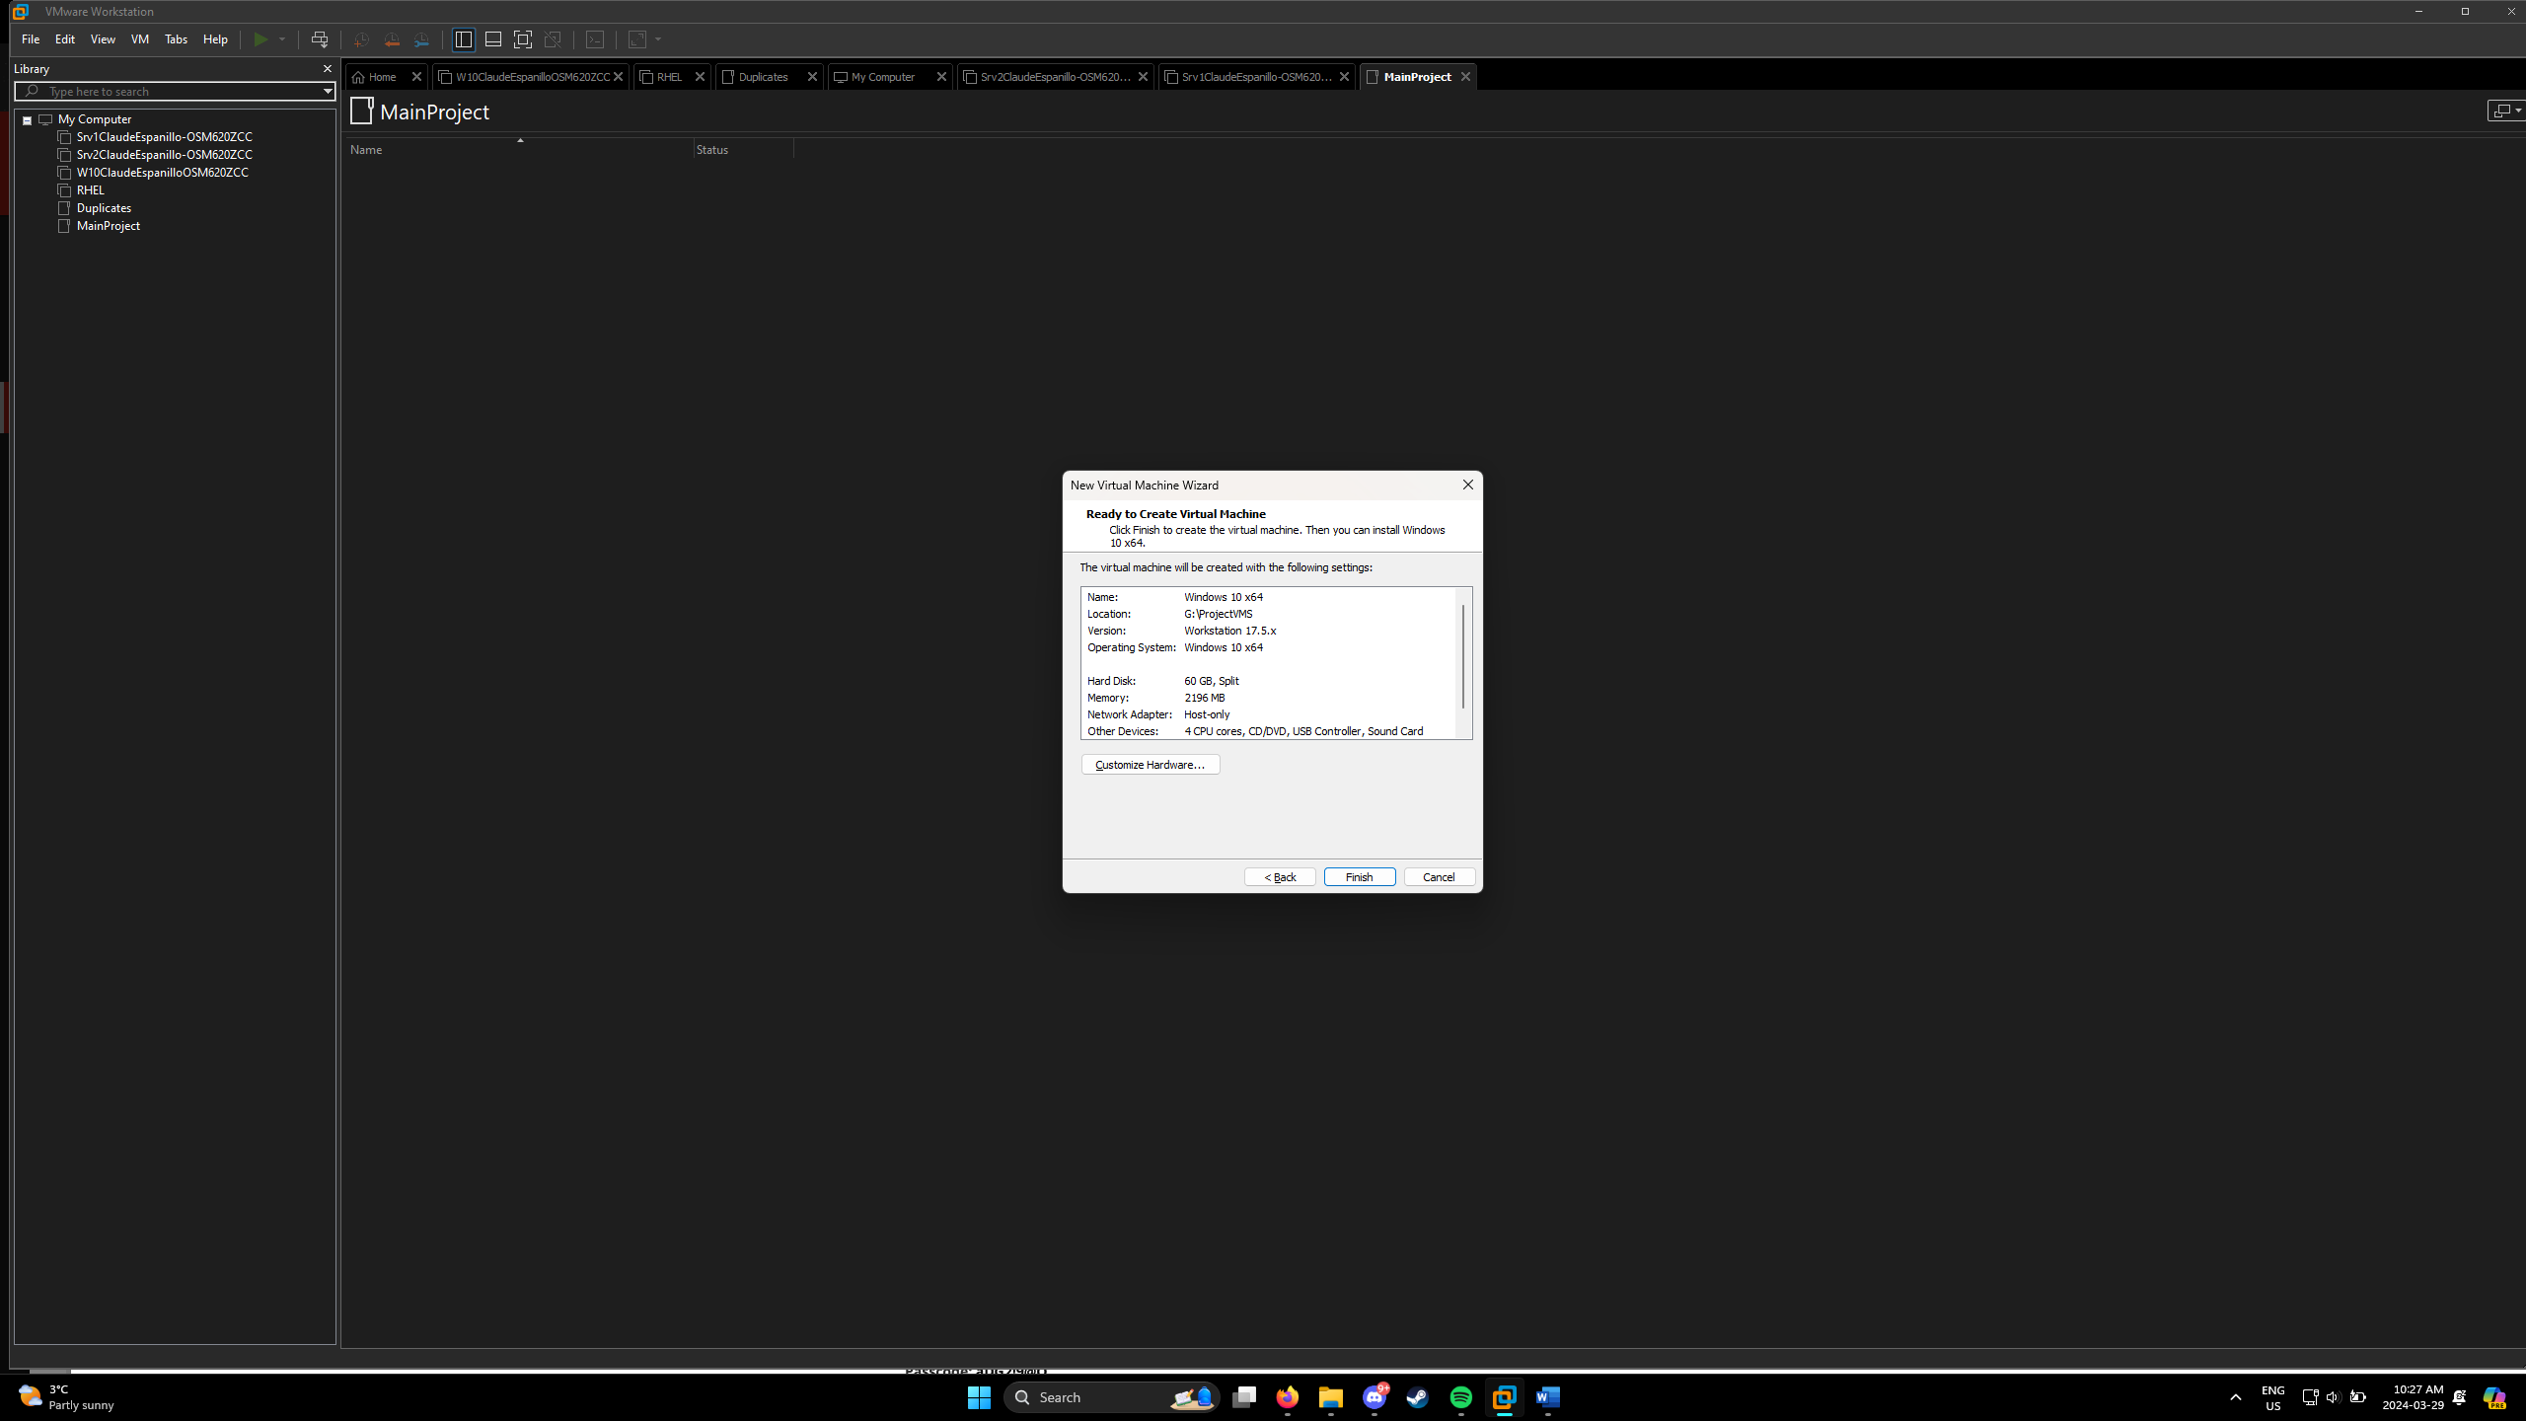
Figure 3:Windows 10 Enterprise

- Domain Controller Configuration:

For us to succeed in promoting our Server 2019 as a domain controller, we first must install the active directory.

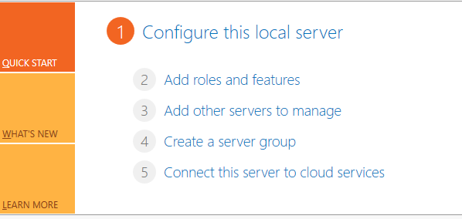
Figure 4:Server Manager Dashboard

In the Server Manager Dashboard. Click on the Add roles and features.

You can choose the default options on the next menus right UNTIL you are at the Server Selection Tab.
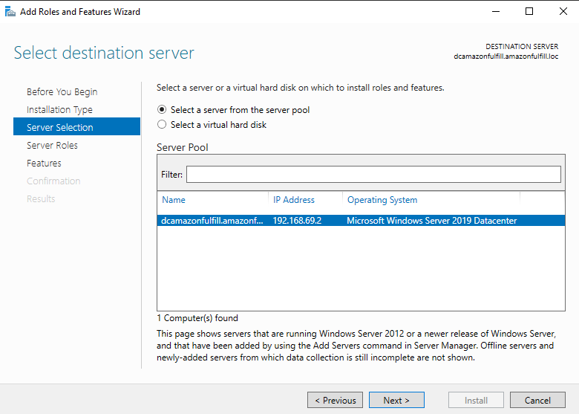
Figure 5:Server selection tab

In the server selection tab, select the server of your choice. In this menu, we will pick dcamazonfulfill since it is our Server 2019 name. Click Next.

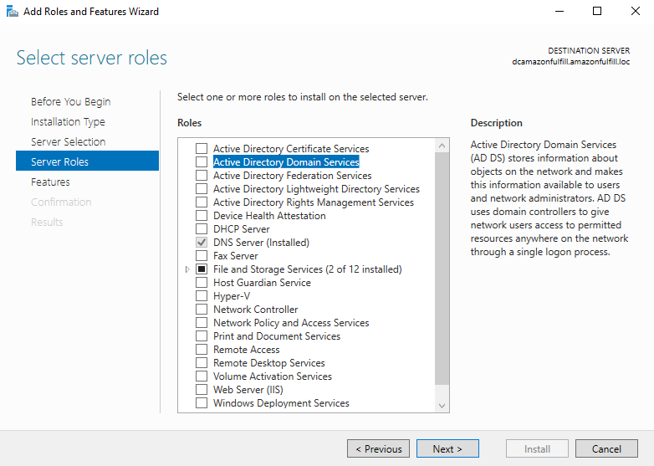
Figure 6:Server Roles

In this part, MAKE SURE that you put a checkmark on the “Active Directory Domain Services”. Doing so will show a menu where you are shown the features that will be added along with it. When that pops up, first make sure a checkmark is at the “Include Management Tools” checkbox, then, click the “Add Features” button.

After that, you just proceed with the defaults in every other tab. When you reached the “Confirmation” tab, you can simply click the “Install” button.

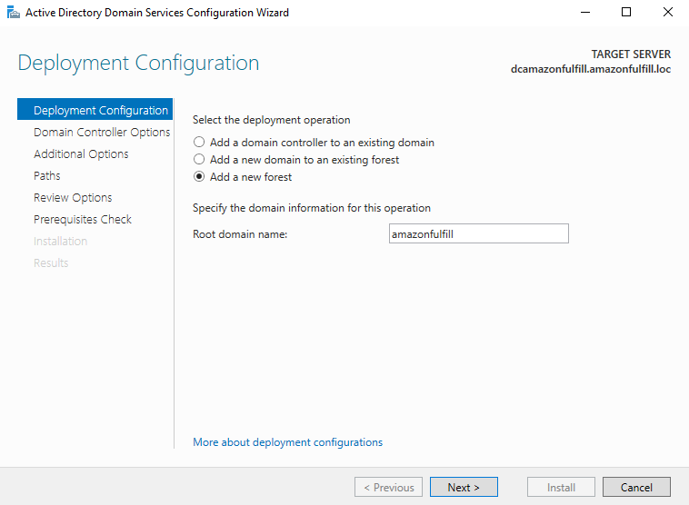

Now, for the Domain Controller Configuration and Installation.
For the first step, in the top-right corner, you can see a flag with a yellow warning sign on it. Click it. You can then see the option to “Promote this server to a domain controller”. Click it too.
Right here, you can click the “Add a new forest” deployment operation. Doing so will let us create a new Active Directory Forest which will be different from other forests’ that are already created. As for the root domain name, this will become the organization’s naming convention. We also must make sure that there is a domain at the end of the name, in this example, we are using “amazonfulfill.com”.

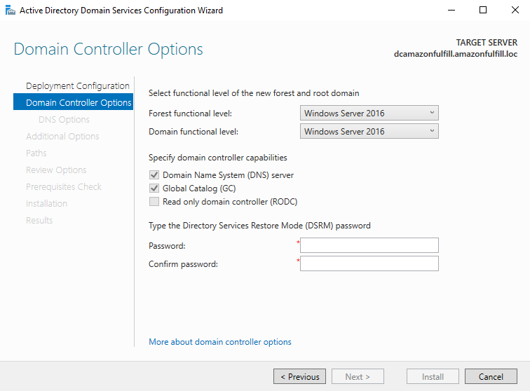
Figure 7:Domain Controller

In this part, we should be picking Windows Server 2019 as the functional level of the new forest we created. This basically refers to which Windows Server features you are going to use for your forest and root domain. You can also leave DNS server checked and Global Catalog. You can also input a password for DSRM. This will be the password that you will use when the domain controller is started in Directory Services Restore Mode.

For the next options, you can choose the default values right until the pre-requisites check tab. There, you will see some warnings, but you can ignore them and then you can click “Install”. After the installation, you will be prompted to restart the server which will finish the installation process.

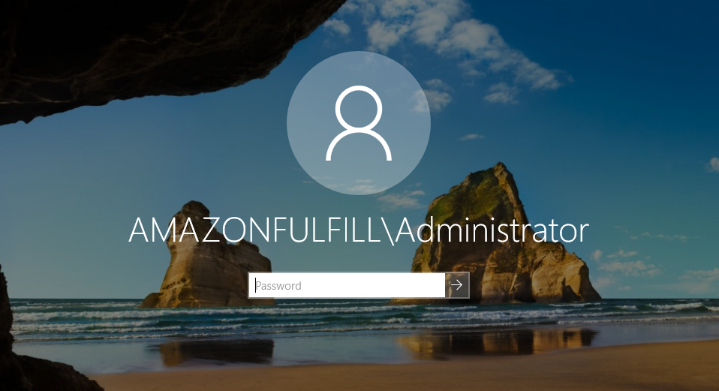
Figure 8:Login screen

After the restart, you will now see that the domain name is added next to the username login information. After you login, you can now notice the differences, DNS and AD DS are now installed along with the new domain name.

- Organizational Units (OUs) Creation:

We chose to do the Organizational Units for each department instead of doing the users and group first, why? So, we don’t have to drag the created user onto these OUs later. These are the created OUs based on the departments on the company:

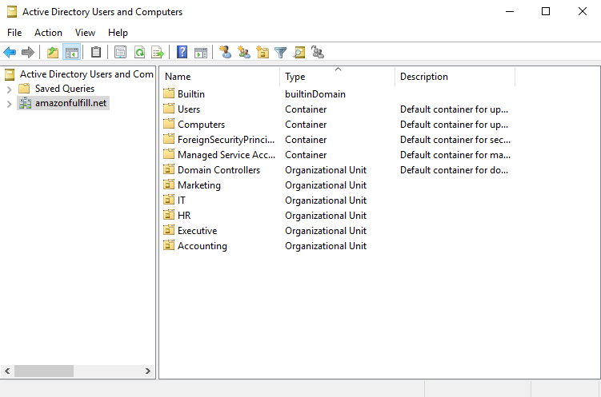
Figure 9:Active Directory Users and Computers
OUs Made: Executive, IT, Marketing, HR, Accounting

- User and Group Creation:

We have different ways to create a user, for demonstration purposes, we will show you two of them. The first one we will demonstrate is by adding them via Active Directory Users and Computer.

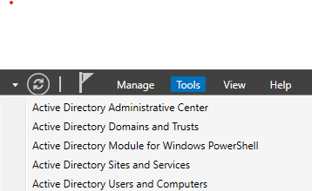
Figure 10:Tools
You can access it via the Tools tab at the upper-right corner menu. You can click on the Active Directory Users and Computers.

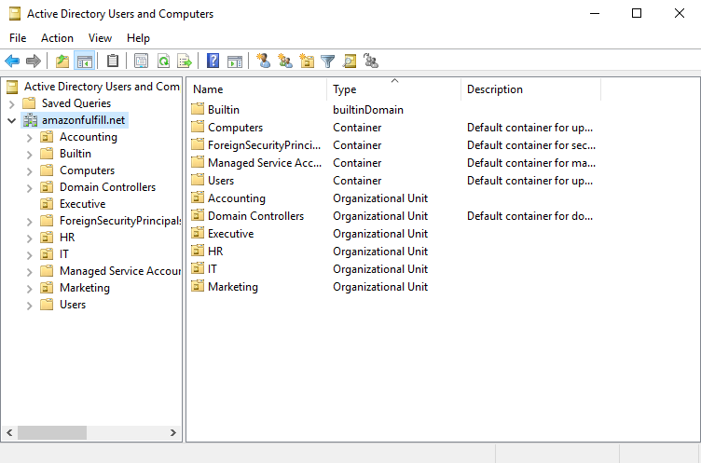
Figure 11:Organizational Unit

To add users to the Organizational Units we created, click on your domain, in our perspective it’s the amazonfulfill.net. You can now see the OUs we created earlier.

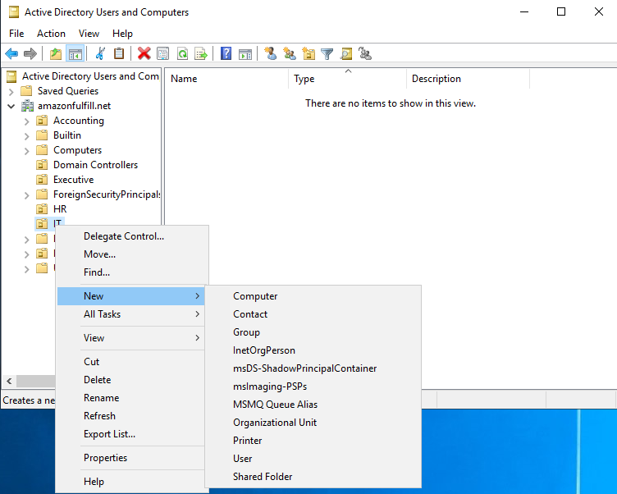
Figure 12:User Creation

Right click on the OU you picked, then click on New > User. You will then be shown a new window where you will input the details you want for the user you just created. After clicking next you are then prompted to enter a password. You can finish and you now see the new user under the OU you created.

There is another way to create a user, and that is by utilizing PowerShell. To successfully add a user to the HR OU, we can do this in PowerShell.

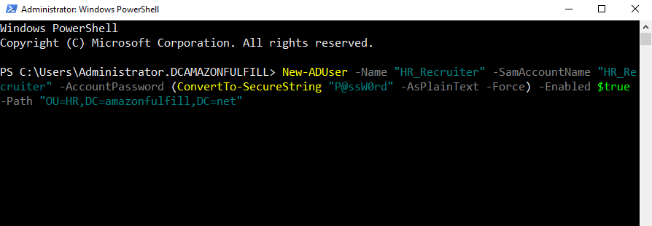
Figure 13:Windows PowerShell

Now let us do a breakdown of the New-ADUser cmdlet:

- New-ADUser -Name “HR_Recruiter”
- We are using the New-ADUser cmdlet to properly create a user. For the first parameter, we are using -Name and then the string which is going to be the display name of the user you will create.

- SamAccountName "HR_Recruiter"
- This parameter Sam which stands for (Security Account Manager), will give the user that we will create a sort of unique identifier in the domain. We are keeping it with the same name to avoid confusion.

- AccountPassword (ConvertTo-SecureString “P@ssW0rd” -AsPlainText -Force)
- As you can tell, this is a way to create a password for the user we created, and for our password to be secure, we will be using another cmdlet which is ConvertTo-SecureString. What this does is it converts the password, which is a plain text to a string that is secure.
- We then used -AsPlainText to tell the cmdlets that the string we input is in plain text format.
- Since we used -AsPlainText, we will be using -Force to force the conversion.

- Enabled $true
- What this does is basically enabling our account when it was created so that the user can access it.

- Path “OU=HR,DC=amazonfulfill,DC=net”
- Lastly, we must identify the path of where this is user is going to be created. We then use the -Path parameter to specify which domain we are going to use, as well as which OU we are going to put the user in.

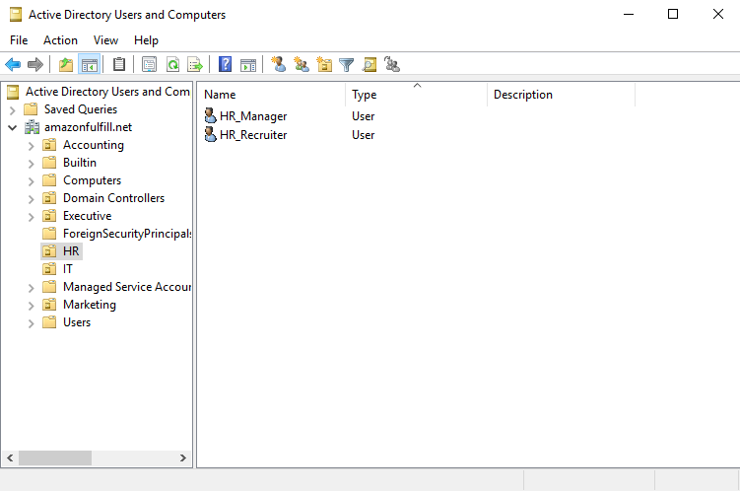
Figure 14:User.

After repeating the command but changing the name and samaccountname to HR_Manager, we can now see the two users created in the HR OU under the amazonfulfill.net domain.

You can use the first approach or this approach to successfully create users under each department. It is now time to create groups to properly organize the employees.
Here are the departments and what group each department has:

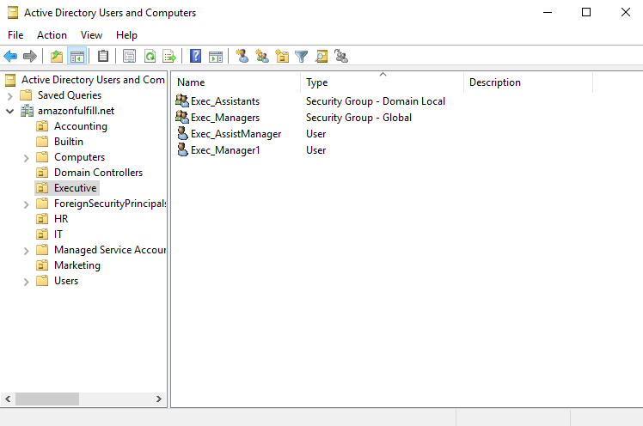
Figure 15:Executive OU
For our Executive OU, we have the Executive Assistants as well as the Executive Managers groups, we also have the two sample users Executive Assistant Manager and Executive Manager.

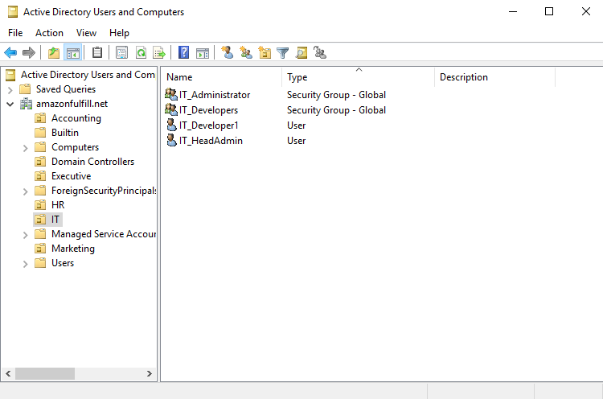
Figure 16:IT OU
For our IT OU, we have the IT Administrators and the IT Developers groups. We also have the IT Developer and IT Head Admin Users.

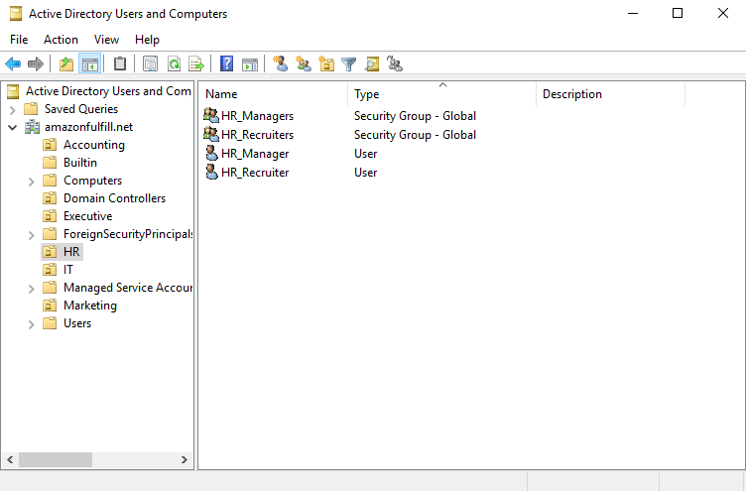
Figure 17:HR OU
For our HR OU, we have the HR Managers and the HR Recruiters groups. We also have the HR Manager and HR Recruiter sample users.

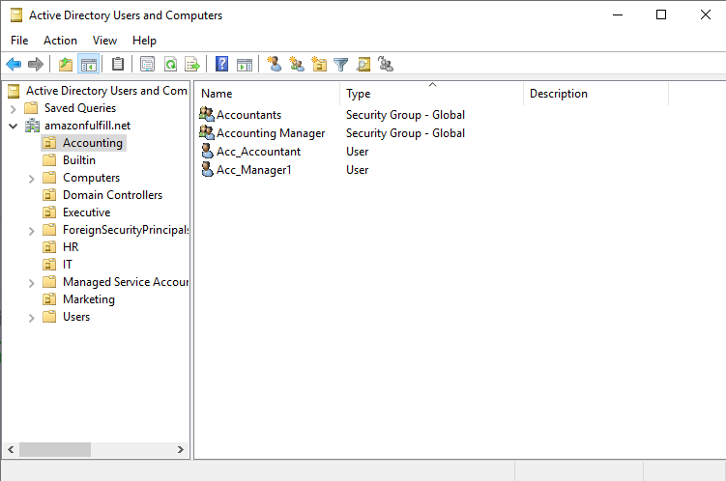
Figure 18:Accounting OU
For our Accounting OU, we have the Accountants and the Accounting Managers group, we also have the sample users Accountant and Accounting Manager.

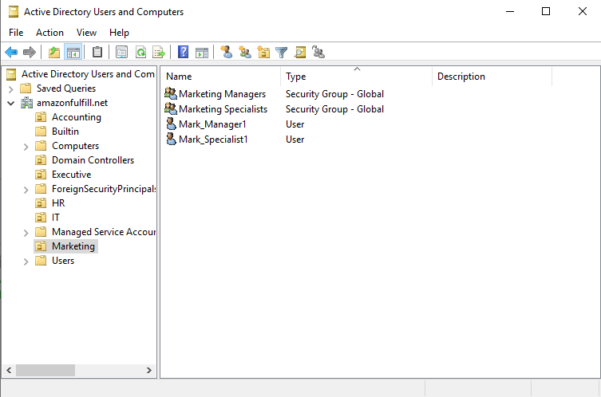
Figure 19:Marketing OU
And finally, we have the Marketing OU with the Marketing Managers and Marketing Specialists groups, and Marketing Specialist and Marketing Manager sample users.

- Windows 10 Configuration:

To connect the Windows 10 Virtual Machine to the Domain Controller. We first must configure the Windows 10 to use the domain instead of its default, WORKGROUP. After all the necessary changes, this is now our system properties:

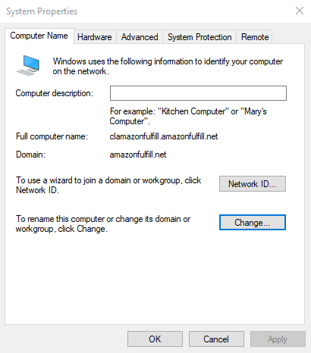
Figure 20:System Properties

You can notice that the domain of our windows 10 is now using the amazonfulfill.net. When we sign out of this administrator account you will be met with the following…

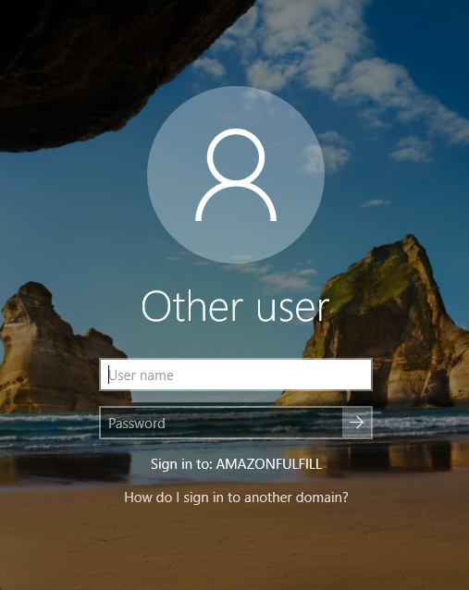
Figure 21:Login User

When we use the Other User account, you can now see that we must Sign in to: AMAZONFULFILL, which is our domain. For example, we can login to our IT Developer account: IT_Developer1.

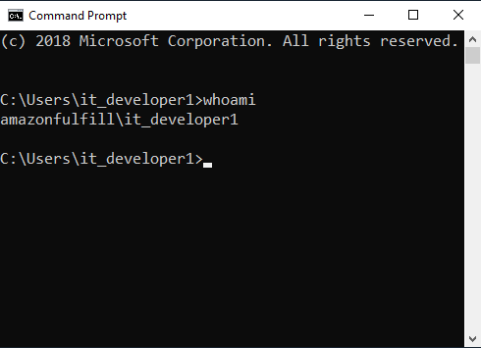
Figure 22:Whoami.
As you can see, by typing the command “whoami” in the command prompt, you can see that we are logged in with the it_

Cloud Consideration
Public Cloud provider AWS (pay as you go - service)

- Considering the organization's needs for improved network infrastructure, scalability, security, and alignment with existing Amazon operations, transitioning certain workloads or services to AWS would be highly beneficial. A phased approach to cloud adoption can be implemented, starting with non-critical workloads or test environments to assess performance and suitability before migrating mission-critical applications.

- By leveraging AWS's robust cloud platform, the Amazon Fulfillment Center can overcome network challenges, enhance operational efficiency, and maintain a competitive edge in the logistics and distribution industry. Additionally, AWS offers a range of resources and support for organizations undergoing cloud migration, ensuring a smooth and successful transition.

- This recommendation aligns with the organization's goal of offering standardized packages to international clients while also addressing current network challenges and supporting long-term sustainability.

Server Room Conditions
To mitigate the risks associated with high temperatures, consider implementing the following measures:

- Improved Cooling System:
Upgrade the server room's cooling system to ensure that it can effectively regulate temperature levels within the recommended range. This may involve installing additional air conditioning units, optimizing airflow, and implementing temperature monitoring systems.
- Server Rack Cooling Solutions:
Install cooling solutions specifically designed for server racks, such as fans, air ducts, or liquid cooling systems, to dissipate heat generated by servers more efficiently.
- Hot Aisle/Cold Aisle Containment:
Implement hot aisle/cold aisle containment to isolate hot and cold airflows, preventing hot air recirculation and improving cooling efficiency within the server room.
- Regular Maintenance:
Schedule regular maintenance checks for cooling equipment to ensure optimal performance and identify any potential issues early on.

Low Humidity:

To address low humidity levels, consider implementing the following solutions:

- Humidification Systems:
Install humidification systems in the server room to maintain humidity levels within the recommended range of 40-60%. These systems can include humidifiers or evaporative cooling units that add moisture to the air as needed.
- Antistatic Measures:
Implement antistatic measures, such as antistatic flooring, grounding straps, and antistatic packaging, to prevent electrostatic discharge and protect sensitive equipment from damage.
- Regular Monitoring:
Use humidity sensors and monitoring tools to regularly monitor humidity levels in the server room and receive alerts if levels fall outside the acceptable range.

This proposed solution aligns with the organization's objectives, leveraging Windows Server 2019 and Windows 10 for enhanced security, scalability, and compatibility. It encompasses hardware, software, and network infrastructure upgrades while adhering to best practices in network design and management.

Section 4: Costs, Cost/Benefit Analysis, and Justifications

Cost Breakdown

- Hardware Costs:

- Server Specifications:

- Dell PowerEdge R740 Server with Intel Xeon Gold 6254 Processor: $9,425

- 128 x 2 2933 MT/s DDR4 ECC Memory: $850 Each/Total of $1,700

- cPowerVault ME412 Storage Expansion Enclosure – 12TB X 8: $15,273

- Routers and Switches:
- Cisco Catalyst 9300L: $6,039 each
1 switch per department: 5 x 1 = 6,039 x 5 = $30,195 Total

- Cisco ISR1100-6G: $1,692 each
1 Router for IT and Administration, 1 Router for other departments:
2 x 1 = 1,692 x 2 = $3,384 Total

- Physical Hardware:
- Open Frame Server Racks 20” 5U: $372 Each
- Cat7 Ethernet Cables: Price will vary based on length.

- Server Room Appliances:
- Ductless Mini-Split Heat Pump System (Including the installation labor, permits, and other materials): $2,250 - $5,700.
- Humidity Sensor: $20
- NOMA 42 Pint 2-Speed LED Dehumidifier: $190
- Yearly Electricity Cost: $12,000 to $15,000

- Software Costs:

- Windows Server and Windows:

- Windows Server 2019 Datacenter License: $8334 Windows 10 Enterprise: $150 per
User

- Antivirus Protection:

- Symantec Endpoint Protection: 77$ per User

OVERALL COST:
The Overall Investment to accomplish this solution is: $150,000 to $170,000.
Yearly Maintenance (Includes everything): $8,231.55 to $10,270.20

Cost/Benefit Analysis

- Cost Savings and Benefits

- Better Overall Performance:
Upgrading the infrastructure will lead to a much more efficient workspace as well as give the potential of saving the organization a large amount of money based on problems that are associated with downtime and slow computers.

- Better Security:
With the safety features of Windows Server 2019 as well as the Symantec Endpoint Protection antivirus, we are greatly avoiding the cost of potential security breaches and attacks.

- Scalability:
By upgrading our servers, we can avoid sudden potential future costs regarding upgrades.

- Better Productivity:
Along with better overall performance comes better productivity. Faster computers can and will increase productivity by faster boot times of both the system and the applications installed. Not only that, but apparently, faster computers affect employees physically and mentally. Based on a survey that Crucial.com commissioned, 37% of people feel more drained after waiting on a slow computer than they would after a hard workout. Another research from Endpoint Central in 2022 also stated that 32% of users who use workplace computers are damaging their ability to perform well.

- Cost Reductions

- Reduced Downtime Risks:
By upgrading the server, not only are we getting better performance, but we are also greatly reducing the risk of downtime. Downtimes in this organization will be devasting if it happens, based on the research of the Pingdom Team in 2023, the average cost of downtime in businesses are $2,300 to $9,000 per minute. Just by having a 2-hour downtime, you can lose as much as $276,000 up to $1,080,000.

- Lower Maintenance Costs:
Using newer hardware can help us avoid the hassle of looking for older parts as well as costlier maintenance costs for older devices.

- Energy Conservation:
By using hardware and appliances that are optimized to have low energy consumption, we can have long-term savings on the electricity bill.

Justifications

- Security and Data Protection:
By investing in the antivirus program as well, helps us greatly reduce the risks of data breaches and cyber-attacks. Since we are handling sensitive information of customers, we should meet data protection regulations by the government, and with the implementation of Windows Server 2019 as well as Symantec Endpoint Protection we are meeting their requirements which helps us avoid legal liabilities.

- Business Advantage and Reliability:
By upgrading the servers as well as the overall infrastructure, we are gaining an edge that can help us get more packages than other Amazon Fulfillment Centers. Having a broader and scalable server and database makes us able to adapt to different types of business needs which can increase our reputation and reliability.

- Optimized Efficiency and Productivity:
With better server performance, employees can do their work faster and better such as taking and processing transactions, managing the inventory, and fulfilling customers’ orders.

- Conclusion:
While the upfront cost can scare you, think of what the potential losses that you can have for having an older system. Upgrading the system not only improves the performance of both the computers and the employees, but also reduces the risks of problems that come with having older systems such as downtimes, sudden maintenance, security breaches, as well as poor productivity. The benefits that you can gain from upgrading greatly justify the amount for this investment.

Section 5: Recommendations and Conclusion

Recommendations

- Immediate action:
Implementing the proposed solution for network infrastructure upgrade right now, without wasting any time to address these findings that are critical and mitigate the potential risks associated with the current infrastructure.

- Security Takes Priority:
Elaborate on security by embracing Windows Server 2019 Datacenter Edition plus enterprise-class antivirus software to protect against hacking as well as privacy violations.

- Scalability Planning:
By investing in hardware and software solutions that can take expanding organization’s needs into account, you should also plan for future growth and scalability requirements.

- Monitoring of server room conditions:
Regulate temperature and humidity levels regularly within a server room as required to ensure optimal performance and stability of hardware.

- Cloud Integration Strategy:
Possibly move some workloads or services to a public cloud provider like AWS, for example, to enhance scalability, resilience, and cost-efficiency.

Conclusion

In summary, this proposal is an all-inclusive way of effectively addressing network infrastructure issues experienced by the organization. The company can improve performance, safety and adaptiveness while mitigating risks that have been linked with our operating systems through upgrading to Windows Server 2019 Datacenter Edition; buying new hardware and software components; or even considering cloud computing options like Amazon Web Services (AWS).

References

https://www.pingdom.com/outages/average-cost-of-downtime-per-industry/
https://blogs.manageengine.com/desktop-mobile/desktopcentral/2022/06/02/in-2022-should-we-still-be-wrestling-with-slow-computers.html
https://thefastcomputer.com/slow-computer-affects-health/
https://www.dataguidance.com/notes/canada-data-protection-overview

