**Objective:**

Covid19 is a website to track covid cases.

**Users of the system:**

1. Admin
2. Public

**Functional Requirements:**

1. Build an application where public people can track the number of people affected by Covid-19 daily.
2. Navigation icons must be placed on each side and must have their own contents.
3. The number of people vaccinated and non-vaccinated must also be mentioned with percentage.
4. The affected people of Covid-19 are differentiated by Confirmed, Active, Deceased, Recovered.
5. The total number of people vaccinated doses are also administered.
6. A tabular column must be created that refers to the number of people affected by Covid-19 are differentiated by State wise and differentiated by Confirmed, Active, Deceased, Recovered.
7. A pictorial representation of India map must indicate the states with colored effects that mentions the Covid-19 affected and delivers contents of states.

**Non-Functional Requirements:**

**Security**

• Secure connection for transmission of any data.

•Data must be secured so that no false data is delivered.

**Performance**

When there is more traffic.

• Home page < 3 sec

**Availability**

• 99.99% Availability

**Standard Features**

• The website must be responsive.

• Maintainability.

•Availability.

•Usability.

•Failover.

**Browser Compatible**

•The website must be compatible with all latest Browsers.

**Technology Stack**

• **Front End:** HTML, CSS, Bootstrap.

• **Backend:** JavaScript, NodeJS, EJS.

• **Server Side:** Express.

• **Database**: MongoDB.

**Key points to remember:**

1. The id (for frontend) and attributes(backend) mentioned in the SRS should not be

modified at any cost. Failing to do may fail test cases.

2. Strictly adhere to the proper project scaffolding (Folder structure), coding

conventions, method definitions and return types.

Adhere strictly to the endpoints given below.

**Application Assumptions:**

• The page must have a tabular column which represents the number of Covid-19 cases daily.

• The page must have an Indian map which displays the Indian map and must display the number of Covid-19 cases in each state.

• The page must display the number of people vaccinated and non-vaccinated.

**Project Tasks:**

**API Endpoints:**

**USER**

**Action URL Method of Response:**

GET Covid-19 cases data.

**ADMIN**

**Action URL Method of Response:**

POST Covid-19 cased data.

**Frontend:**

**Customer:**

1. Design a page so that user can see Covid-19 cases data, the number of people Affected, Recovered, Deceased and Vaccinated.

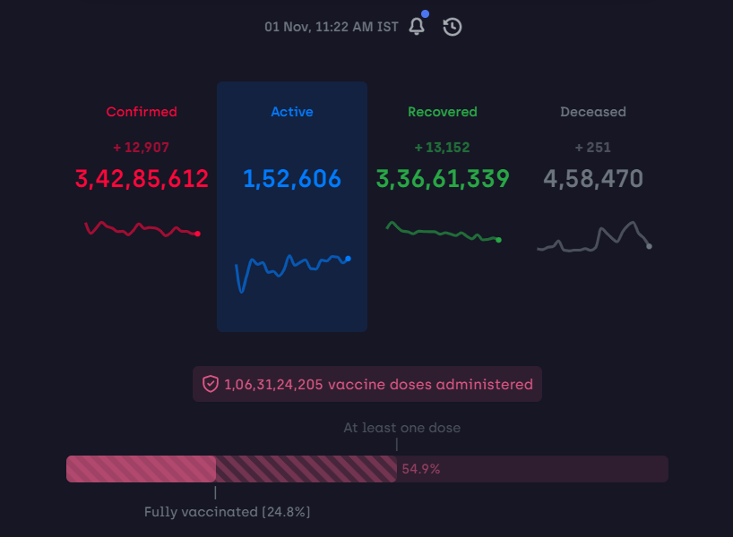

2. A search box is provided to search for a particular state.

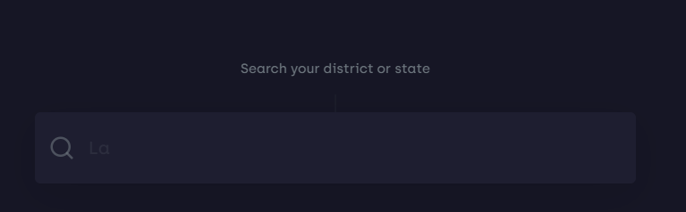

3. Data is requested from a database and displayed in the form of a tabular column.

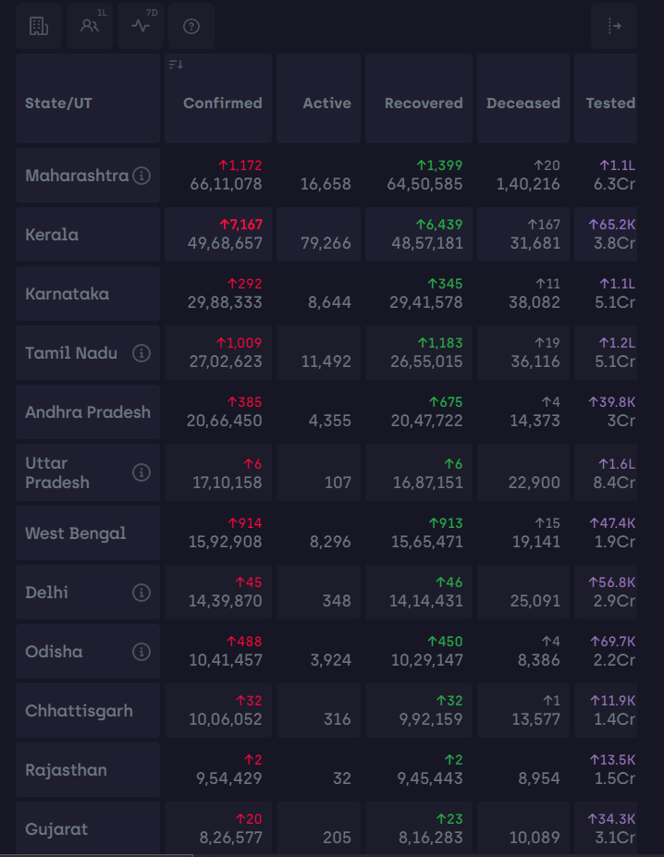

4. An image of the Indian map is also displayed and the covid cases in particular state can also be seen.

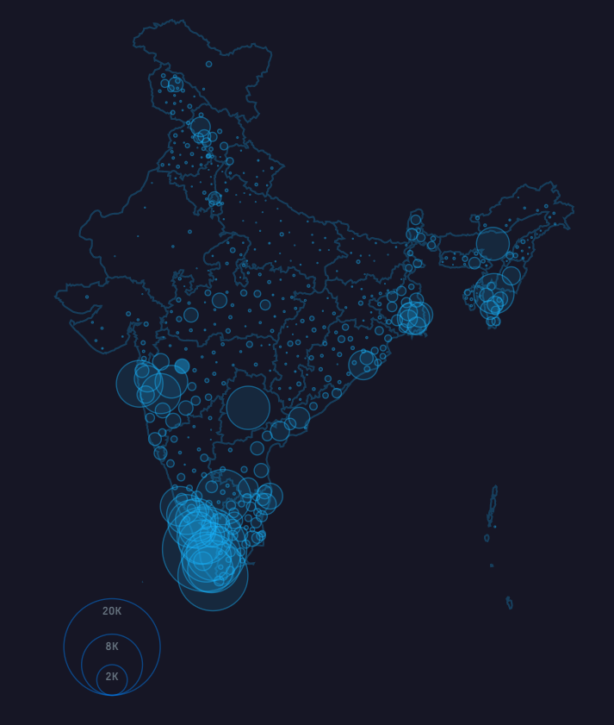

5. Customers can also provide their feedback on the website.

**Admin:**

1. The admin can update the data in the database.

2. The admin can read the feedback given by the customers.

**Backend:**

• When the webpage is opened the data from the MongoDB database is displayed in the webpage.

• A search box is placed at the top where users can search any state for covid cases. The input from the user is taken and the relevant state is displayed.