Airline Loyalty Analytics
Behavioral Intelligence for Customer Retention

1. Problem Statement
Airline loyalty programs are central to customer retention and long-term profitability. However, a key challenge for airlines is identifying which customers are likely to churn and which ones are worth saving.
This project addresses the following business question:
How can we identify at-risk customers early and prioritize high-value customers for targeted retention strategies?
The goal was not just to build a prediction model, but to create a decision-support system that helps business stakeholders act on insights.

2. Data Understanding & Preparation
The dataset included three key components:
- Customer demographics and loyalty information
- Monthly flight activity and engagement metrics
- Calendar-based time reference data
Key Data Decisions
- Handling Missing Values
  - Salary had missing values (~25%) → retained without imputation to avoid distortion.
  - Cancellation fields missing → interpreted as active customers.
- Data Integration
  - Merged customer data with monthly behavioral data using Loyalty Number.
  - Final dataset structured at customer-month level.
- Time Structuring
  - Combined Year and Month into a unified date column.
  - Enabled chronological tracking of customer behavior.
- Behavior Interpretation
  - Months with zero flights were treated as inactive periods, forming the basis for churn detection.

3. Feature Engineering
To capture meaningful behavioral patterns, features were engineered at the customer level.
Key Feature Groups
1. Usage Metrics
- Average flights per month
- Total flights
- Maximum flights
- Distance traveled
2. Engagement Indicators
- Points accumulated and redeemed
- Decline in flight activity
- Inactivity patterns
3. Customer Value
- Customer Lifetime Value (CLV)
- Loyalty card tier

4. Churn Definition
Churn was defined as:
A customer having no flight activity for 6 consecutive months
This reflects real-world disengagement in airline behavior.

5. Modeling Approach
A Random Forest Classifier was used due to its ability to:
- Capture nonlinear behavioral patterns
- Handle mixed feature types
- Provide feature importance insights
Model Refinement (Critical Step)
Initial models showed unrealistically perfect accuracy, indicating data leakage. This was corrected by:
- Removing leakage features such as inactivity streak indicators directly tied to churn
- Restricting model complexity (controlled tree depth and leaf size)
- Ensuring proper feature alignment during prediction
Final Model Performance
- Accuracy: ~91%
- Balanced precision and recall
- Improved generalization
- Probability outputs stabilized to avoid extreme overconfidence
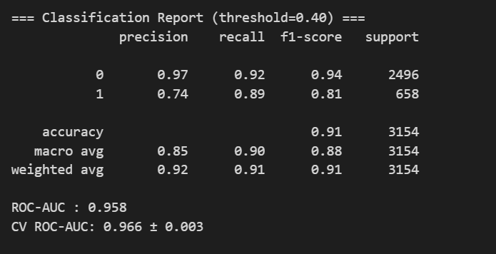

6. Key Insights
🔹 1. Flight Activity is the Strongest Retention Driver
Customers with higher flight frequency are significantly less likely to churn.
🔹 2. Declining Engagement Signals Early Risk
A drop in monthly flight activity is one of the earliest indicators of churn.
🔹 3. High-Value Customers Can Still Churn
A portion of high CLV customers show declining engagement, making them high-risk and high-impact.
🔹 4. Majority of Customers are Low-Value
Most customers fall into low-value segments, requiring cost-efficient engagement strategies.

7. Customer Segmentation
Customers were segmented using:
- Customer Value (CLV)
- Churn Risk (Model Prediction)
Final Segments
- High Value – Loyal
- High Value – At Risk
- Low Value – Stable
- Low Value – At Risk
This segmentation enables targeted decision-making instead of generic strategies.

8. Dashboard & Decision System
A Streamlit-based interactive dashboard was developed to operationalize insights.
Key Features
- Customer selection via dropdown and search
- Real-time churn probability prediction
- Customer segmentation display
- Business recommendations based on segment
- Visual insights (flights, distance, points)
- Segment distribution charts

🚨 Priority Feature: Risk Panel
A dedicated panel identifies:
Top High-Value Customers at Risk
This allows decision-makers to:
- Focus on the most critical customers
- Prioritize retention efforts
- Optimize resource allocation

9. Business Recommendations
🔹 1. Prioritize High-Value At-Risk Customers
(CFO + CMO)
- Focus retention campaigns on high CLV customers with high churn probability
- Offer personalized incentives (bonus miles, upgrades, exclusive deals)
Impact:
- Prevents revenue loss
- Maximizes ROI on marketing spend

🔹 2. Implement Early Warning System
(CMO Focus)
- Track decline in flight frequency
- Trigger automated engagement campaigns when activity drops

Impact:
- Reduces churn proactively
- Improves customer lifetime engagement

🔹 3. Optimize Loyalty Program Investment
(CFO Focus)
- Reduce excessive spending on low-value stable customers
- Redirect budget toward high-impact segments

Impact:
- Better capital allocation
- Increased profitability

10. Conclusion
This project demonstrates how behavioral data and machine learning can be transformed into actionable business intelligence.
The key contribution is not just predicting churn, but:
Identifying which customers matter most and enabling targeted action.
By integrating analytics with a user-friendly dashboard, this solution bridges the gap between data science and business decision-making.

