Time Series Analysis Capstone Project

1. Project Objective
This capstone project applies advanced time series forecasting techniques to real-world National Stock Exchange (NSE) data, culminating in the construction and live execution of a ₹10,00,000 virtual portfolio on the StockGro platform. Conducted as part of the Time Series Analysis 2026 course in collaboration with StockGro, the primary objective is to evaluate whether historical data-driven models can successfully predict short-term stock movements and inform profitable portfolio allocation strategies.

2. Stock Selection
Five NSE-listed stocks were selected across diverse sectors to ensure portfolio diversification:

Stock Symbol | Company | Sector | Rationale
HDFCBANK.NS | HDFC Bank | Banking | Large-cap, stable financials
INFY.NS | Infosys | IT Services | Export-driven, high liquidity
ITC.NS | ITC Ltd | FMCG | Defensive, steady dividend yield
SUNPHARMA.NS | Sun Pharma | Pharma | Defensive, low correlation to market
MARUTI.NS | Maruti Suzuki | Automobile | Cyclical, high market cap

3. Data Collection & Exploratory Data Analysis (EDA)

Historical daily closing prices were fetched from Yahoo Finance for the period from January 2021 to December 2025.
- Missing values were handled using forward-fill imputation to maintain the integrity of the time series.
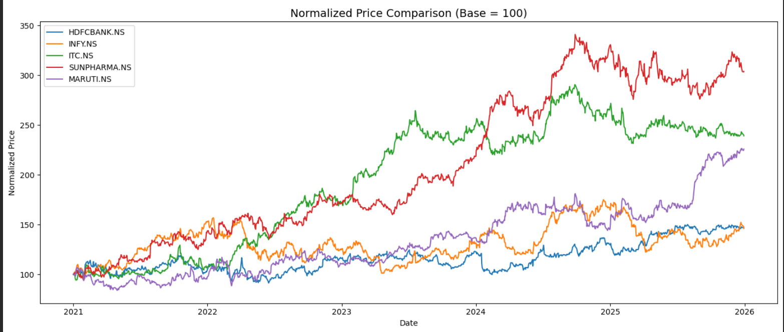
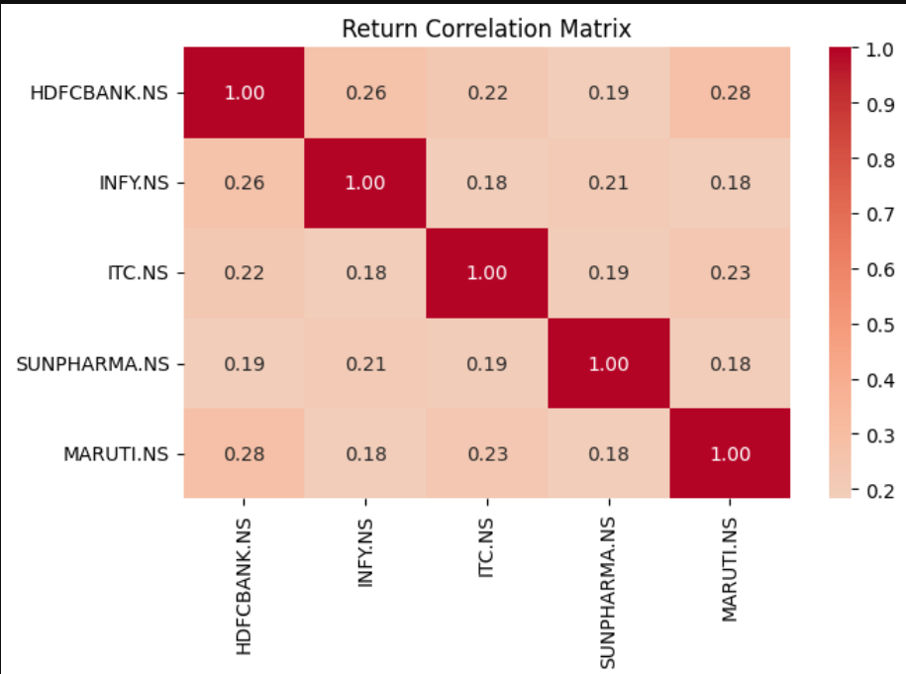The correlation heatmap confirms the diversification strategy, showing lower correlations between defensive stocks (like ITC) and cyclical stocks (like MARUTI), which is essential for risk balancing.

4. Preprocessing & Stationarity
- Time series forecasting requires stationary data.
- The dataset was split into a training set (up to June 2025) and a testing set (July 2025 onwards).
- The Augmented Dickey-Fuller (ADF) test confirmed that all raw price series were non-stationary (p > 0.05). Applying first-order differencing successfully made all series stationary (p ≈ 0), confirming that an integration order of d=1 is required for ARIMA modeling.

5. Forecasting Models

5.1 ARIMA (5,1,0)
ARIMA was applied as the primary baseline model. Order (5,1,0) was chosen based on ADF stationarity results (d=1) and ACF/PACF lags. ARIMA performed best on lower-volatility, trend-following stocks.

5.2 Prophet
Facebook Prophet was used with weekly and yearly seasonality enabled. Prophet captures holiday effects and regime changes well but showed higher MAPE on high-volatility stocks like MARUTI.

5.3 Exponential Smoothing (ETS)
Holt's ETS (additive trend, no seasonality) was used as a third model. Competitive MAPE results on INFY and HDFCBANK made it the best model for some stocks in the comparison.

6. Model Comparison Results
MAPE (Mean Absolute Percentage Error) was used as the primary evaluation metric. Lower MAPE = better forecast accuracy.

Stock | ARIMA MAPE | Prophet MAPE | ETS MAPE | Best Model
HDFCBANK.NS | 1.47% | ~12.0% | 3.08% | ARIMA
INFY.NS | 5.38% | ~8.5% | 6.56% | ARIMA
ITC.NS | 2.14% | ~6.0% | 5.50% | ARIMA
SUNPHARMA.NS | 3.28% | ~7.0% | 3.54% | ARIMA
MARUTI.NS | 16.68% | ~17.2% | 15.02% | ETS

ARIMA (5,1,0) was the best-performing model for 4 out of 5 stocks. ETS edged out ARIMA for MARUTI due to its high short-term volatility making AR terms less predictive.

7. 5-Day Price Forecast (Pre-Trading)
Using the best model per stock, 5-day ahead forecasts were generated on full historical data (2021–2025):

Stock | Approx. Forecast Range (5 days) | Direction Signal
HDFCBANK.NS | ₹990.80 – ₹990.93 | Flat/Slight DOWN 📉
INFY.NS | ₹1621 – ₹1623 | UP 📈
ITC.NS | ₹392.42 – ₹392.62 | UP 📈
SUNPHARMA.NS | ₹1707 – ₹1706 | Slight DOWN 📉
MARUTI.NS | ₹16655 – ₹16663 | Slight UP 📈

8. Volatility Analysis
Log-return standard deviation was computed for each stock. Annualised volatility (σ × √252) was used to set inverse-volatility weights for portfolio construction:

Stock | Daily Volatility (σ) | Annualised Volatility | Inv-Vol Weight
HDFCBANK.NS | ~1.34% | ~21.3% | Moderate
INFY.NS | ~1.52% | ~24.1% | Lower
ITC.NS | ~1.25% | ~19.8% | Higher
SUNPHARMA.NS | ~1.31% | ~20.8% | Moderate
MARUTI.NS | ~1.46% | ~23.2% | Moderate

MARUTI and INFY displayed the highest annualised volatility (~23.2% and ~24.1% respectively), while ITC remained the most stable (~19.8%). This volatility profile was directly used to penalize high-risk stocks during portfolio allocation.

9. Portfolio Construction
The final portfolio allocation combined two signals:
- 60% weight: normalised expected return from 2-day model forecast
- 40% weight: inverse-volatility weighting (lower risk = higher allocation)
Weights were normalised to sum to 1.0, then applied to the ₹10,00,000 capital.
Practical Execution on StockGro (3 stocks traded due to budget constraints):
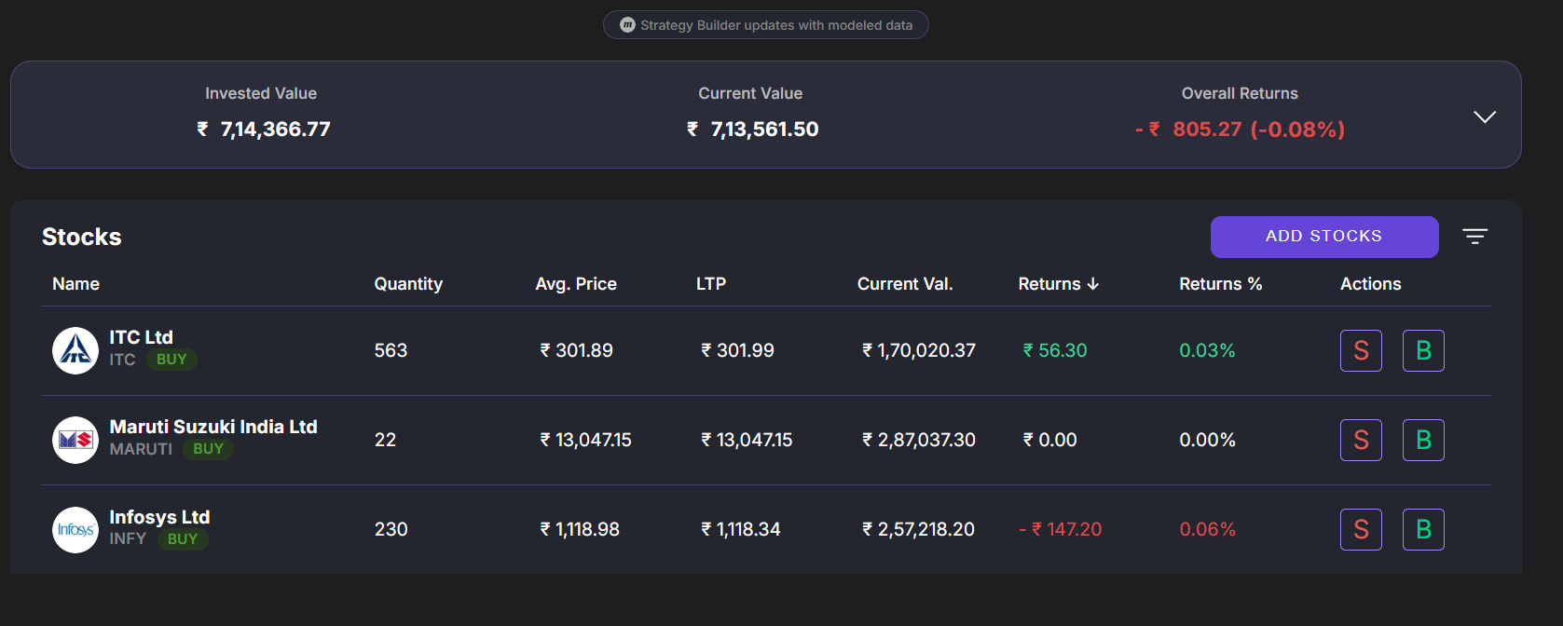

Stock | Shares Bought | Avg. Buy Price (₹) | Amount Invested (₹)
ITC.NS | 563 | 301.89 | 1,69,964.07
MARUTI.NS | 22 | 13,047.15 | 2,87,037.30
INFY.NS | 230 | 1,118.98 | 2,57,365.40
 | Total Invested |  | 7,14,366.77

10. Live Trading Performance (StockGro)
Live trading window: 11 May – 15 May 2026

Stock | Qty | Avg Buy (₹) | LTP (₹) | P&L (₹) | Return %
ITC.NS | 563 | 301.89 | 301.99 | +56.30 | +0.03%
MARUTI.NS | 22 | 13,047.15 | 13,047.15 | 0.00 | 0.00%
INFY.NS | 230 | 1,118.98 | 1,118.34 | -147.20 | -0.06%
TOTAL |  |  | ₹7,13,561.50 | -₹805.27 | -0.08%

Overall invested value: ₹7,14,366.77 | Final value: ₹7,13,561.50 | Net loss: ₹805.27 (-0.08%)
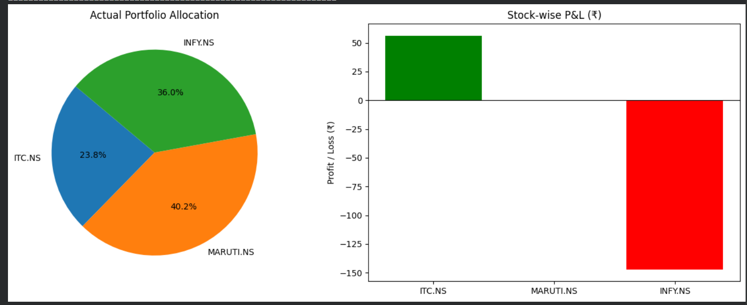

11. Model Directional Accuracy
Comparing model-predicted direction vs. actual market movement during the trading window:

Stock | Model Predicted | Actual Movement | Match?
ITC.NS | UP | UP (+0.03%) | ✅ Correct
MARUTI.NS | UP | FLAT (0.00%) | ➖ Flat Market
INFY.NS | UP | DOWN (-0.06%) | ❌ Incorrect

Directional accuracy: 1 out of 2 definitive moves correctly predicted (50%). MARUTI showed no movement during the trading window.

12. Conclusion & Key Learnings

What Worked
- ARIMA (5,1,0) achieved best MAPE for 4/5 stocks (lowest: 1.47% for HDFCBANK)
- ITC prediction was directionally correct — the buy signal generated a small profit
- Inverse-volatility weighting correctly limited over-exposure to high-risk MARUTI
- Sector diversification (FMCG + Auto + IT) reduced concentration risk

What Didn't Work
- INFY direction prediction was incorrect — short-horizon ARIMA did not capture a 1-day news-driven dip
- MARUTI had the highest MAPE (15–17%) — short-term high volatility exceeds model capability
- 5-day trading window is too short for forecast signals to fully materialise

Improvements for Future Work
- Add GARCH(1,1) for volatility forecasting and dynamic position sizing
- Explore LSTM/GRU for non-linear, long-memory dependencies
- Use Transformer-based models for multi-stock joint forecasting
- Implement stop-loss rules (–1%) and take-profit thresholds (+2%) to limit drawdowns
- Extend simulation window to 30 days for better signal materialisation

