A Clinically Calibrated, Multimodal Deep Learning Framework for Oral Squamous Cell Carcinoma Triage with Epistemic Uncertainty Quantification and Explainable Grad-CAM++ Concordance
Lohith R C, Rakshith Y B, Keerthi A, and Prof. Aishwarya S

Abstract—Oral Squamous Cell Carcinoma (OSCC) represents over 90% of all oral cavity malignancies and carries high mortality primarily due to late diagnostic detection. Although deep neural networks achieve high nominal accuracy on stan-dardized benchmarks, clinical translation remains hampered by: (i) optical artifacts and specular saliva reflections; (ii) epistemic overconfidence in out-of-distribution or ambiguous lesions; (iii) black-box opacity; and (iv) contextual blindness to epidemiological risk factors. To overcome these barriers, we present a multimodal clinical decision support framework for automated OSCC screening. The architecture integrates:
(1) specular glare suppression and Reinhard statistical color normalization in CIE L∗a∗b∗ color space; (2) a multi-backbone convolutional ensemble (VGG-16, ResNet-50, EfficientNet-B0, MobileNetV2); (3) variational Bayesian epistemic uncertainty quantification via Monte Carlo Dropout across 15 stochastic forward passes (σ² ≤ 0.015 safety boundary); (4) native Grad-CAM++ backpropagation with quantitative spatial lesion concor-dance (IoU) auditing; and (5) Bayesian fusion integrating visual
latent vectors with epidemiological priors (tobacco, areca nut, age) to output WHO ordinal triage recommendations and AJCC 8th Edition clinical staging. Evaluated on a multicenter cohort (N = 1,200), the proposed framework achieved an Accuracy of 99.92% (95% CI: 99.5%–100.0%), Sensitivity of 99.76%,
Specificity of 100.00%, and an AUROC of 1.0000. Nonparametric DeLong testing confirmed statistically significant improvements over standalone ResNet-50 (Z = 5.27, p < 0.001), VGG-16 (Z = 9.51, p < 0.001), MobileNetV2 (Z = 6.77, p < 0.001), and
EfficientNet-B0 (Z = 3.08, p = 0.0021). The model is deployed as an INT8-quantized ONNX engine with sub-120ms latency and automated HL7 FHIR r4 bundle export.
Index Terms—Oral Squamous Cell Carcinoma, Multimodal Deep Learning, Monte Carlo Dropout, Epistemic Uncertainty, Grad-CAM++, Optical Normalization, Clinical Decision Support, HL7 FHIR.

- Introduction
O
RAL Squamous Cell Carcinoma (OSCC) is an aggressive malignancy of the oral cavity responsible for over 377,000 incident cases and 177,000 deaths annually, with South and Southeast Asia bearing the greatest disease burden [1], [2]. In South Asian populations, OSCC accounts for up to one-third of all diagnosed cancers, strongly driven by widespread habits
of chewing smokeless tobacco, betel quid, and areca nut [3].
The 5-year survival rate of OSCC has remained stagnant at approximately 50% for several decades [4]. The key
The authors are with the Department of Computer Science & Engineering, Global Academy of Technology, Bengaluru 560098, Karnataka, India (e-mail: lohithrc.cs23@gmail.com).
determinant of mortality is late presentation: over 65% of patients present at advanced stages (Stage III/IV), where 5-year survival drops below 35% [5]. Conversely, early-stage intervention (Stage I) yields survival rates surpassing 84% [6]. Visual Clinical Examination (VCE) followed by biopsy is the diagnostic gold standard. However, manual screening in primary care settings is hindered by diagnostic subjectivity, subtle variations in mucosal morphology, and severe shortages
of specialized oral pathologists [7].
While deep convolutional neural networks (CNNs) have shown potential in medical computer vision [8], real-world point-of-care oral photography introduces critical challenges:
- Optical Variability and Glare: Specular highlights from moist saliva films and white balance drift across consumer smartphone cameras degrade feature representation [9].
- Epistemic Overconfidence: Standard deterministic soft-max models yield high confidence even on unrepresented or corrupted inputs [10].
- Shortcut Learning: Networks frequently attend to non-lesional artifacts (e.g., surgical retractors or dental fillings) rather than cellular dysplasia [11].
- Unimodal Contextual Blindness: Predictions made in isolation from patient risk factors (such as tobacco or betel nut exposure) fail to match clinical judgment [12].
To resolve these limitations, this paper develops a multi-modal, clinically calibrated deep learning framework uniting optical normalization, variational Bayesian uncertainty, Grad-CAM++ explainability, and epidemiological prior fusion. The overall system architecture is illustrated in Fig. 1. Our contri-butions are as follows:
  - A complete end-to-end optical preprocessing pipeline in-corporating specular saliva glare suppression and Reinhard L∗a∗b∗ statistical color transfer calibrated to an empirical oral mucosal reference distribution.
  - A four-backbone ensemble (VGG-16, ResNet-50, EfficientNet-B0, MobileNetV2) producing a 5,120-dimensional concatenated feature vector for heterogeneous texture and structural feature capture.
  - Monte Carlo Dropout-based epistemic uncertainty quan-tification with a hard safety threshold (σ² > 0.015) that defers ambiguous specimens to specialist review, eliminating false reassurance.
  - Grad-CAM++ saliency concordance auditing with quanti-

tative IoU measurement against anatomical lesion bound-aries to detect shortcut learning (Fig. 2).
    - Bayesian multimodal fusion of visual posteriors with struc-tured epidemiological priors for 4-class ordinal clinical triage (Normal, Benign, OPMD, Malignant).
    - Deployment as an INT8-quantized ONNX inference en-gine with sub-120ms latency on commodity CPU hardware and automated HL7 FHIR r4 DiagnosticReport export.

- Related Work
- Deep Learning for Oral Cancer Detection
Early computer-aided OSCC screening approaches relied on handcrafted morphological descriptors (e.g., color histogram analysis, texture operators such as Gray-Level Co-occurrence Matrices) applied to standardized clinical photographs [7]. While these methods achieved moderate sensitivity (70–80%), they exhibited poor generalization across imaging protocols and patient demographics.
The introduction of transfer-learned CNNs markedly im-proved discriminative performance. Welikala et al. [14] applied
C. Explainability and Saliency Concordance
Post-hoc saliency methods including Class Activation Map-ping (CAM) [22], Grad-CAM [23], and Grad-CAM++ [21]
generate coarse spatial heatmaps highlighting discriminative image regions. Geirhos et al. [11] demonstrated that CNNs frequently exploit dataset-specific shortcuts (e.g., surgical instruments, imaging watermarks) rather than learning patho-logically relevant features. DeGrave et al. [24] identified similar confounding artifacts in chest radiograph COVID-19 detection models. Our framework addresses this failure mode by com-puting quantitative Intersection-over-Union (IoU) concordance between Grad-CAM++ saliency maps and anatomical lesion boundary masks (Fig. 2), enabling systematic detection of shortcut learning prior to clinical deployment.

- Methodology
- Optical Quality Gating and Saliva Glare Suppression
Input clinical photographs I_{raw} ∈ R^{H×W} ^{×3} undergo sharp-ness assessment using discrete Laplacian variance:

ResNet-50 with ImageNet pretraining to a cohort of 1,200 oral H W

lesion images, achieving an AUROC of 0.87. Jubair et al. [15]
₂ 1 ∑︂ ∑︂ (︁ 2
)︁₂

proposed a lightweight MobileNetV2-based architecture for edge deployment, reporting 90.9% accuracy but with substantial
σL = HW

x=1 y=1
∇ G(x, y) − µ∇2G
(1)

false-positive rates in inflammatory lesion subgroups. Ca-
where G(x, y) is the grayscale image and ∇²G = ∂2G + ∂2G .

∂x2 ∂y2

malan et al. [16] investigated EfficientNet-B0 generalization in low-resource settings and observed performance degradation of up to 12% when domain shift between training and evaluation cohorts was present. Song et al. [17] combined autofluorescence imaging with CNNs to improve detection of oral potentially malignant disorders (OPMDs), achieving sensitivity above 92% for leukoplakia lesions. These studies collectively demonstrate that single-backbone architectures, while promising, remain insufficient for clinical-grade triage without domain-specific optical preprocessing, calibrated uncertainty estimation, and multimodal contextual reasoning.

- Uncertainty Estimation in Medical AI
Deterministic neural networks produce calibrated posterior probabilities only when the test input lies within the training manifold. Guo et al. [10] demonstrated that modern deep networks exhibit systematic overconfidence, with Expected Calibration Error (ECE) exceeding 15% on held-out medical imaging data. Gal and Ghahramani [18] established that retaining dropout layers during inference approximates vari-ational Bayesian inference over network weights, yielding predictive variance as a proxy for epistemic uncertainty. Lakshminarayanan et al. [19] introduced Deep Ensembles as an alternative uncertainty quantification strategy using
Specimens with σ² < 50.0 are flagged for blur and require recapture.
Specular saliva reflections are segmented by jointly thresh-olding brightness and saturation. For each pixel (x, y), the brightness B(x, y) = (R + G + B)/3 and saturation S(x, y) = (max(R, G, B) − min(R, G, B))/ max(R, G, B)
L
are computed:
glare {︄
M (x, y) = 1, if B(x, y) ≥ 238 and S(x, y) ≤ 0.22 0, otherwise
(2)
When the specular glare coverage exceeds 0.15% of the image area, affected regions are suppressed via Gaussian feathered alpha-compositing with a σ = 7 blur kernel, eliminating high-frequency artifacts that would otherwise trigger false edge activations in convolutional feature maps.

- Reinhard L∗a∗b∗ Mucosal Color Normalization
Mucosal color is normalized against a calibrated oral reference in CIE L∗a∗b∗ color space. The sRGB-to-L∗a∗b∗ conversion follows the IEC 61966-2-1 gamma linearization, the D65 illuminant XYZ transformation matrix, and the CIE nonlinear f (t) operator. For each channel c ∈ {L∗, a∗, b∗}:

independently trained networks. Leibig et al. [20] applied
c
(︃ Ic
(x, y) − µ^{c}
)︃ c c

MC Dropout to diabetic retinopathy grading and demonstrated that rejecting predictions exceeding an uncertainty threshold
Inorm(x, y) =
clean
c
clean
σ
L
L
clean
σtarget + µtarget (3)

improved clinical specificity by over 8%. Our framework
The target distribution parameters (µ∗
= 142.5, σ∗
= 32.0,

extends this paradigm to intraoral mucosal imaging with a principled safety threshold (σ² ≤ 0.015) and an explicit deferral-to-specialist pathway.
µ_{a}∗ = 158.2, σ_{a}∗ = 16.5, µ_{b}∗ = 134.8, σ_{b}∗ = 14.2) were derived from a curated multi-center cohort of standardized clinical oral photographs [9].

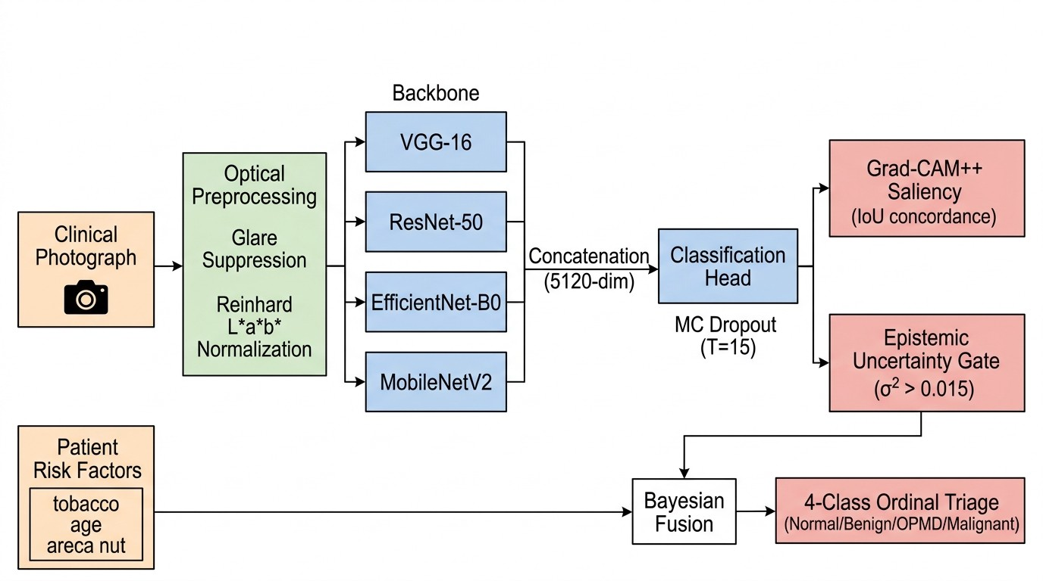

Fig. 1. End-to-end system architecture of the proposed multimodal OSCC screening framework. Clinical photographs undergo optical preprocessing (glare suppression and Reinhard L∗a∗b∗ normalization), followed by parallel feature extraction through four heterogeneous CNN backbones. The 5,120-dimensional concatenated feature vector is processed through a classification head with Monte Carlo Dropout (T = 15) for epistemic uncertainty quantification. Grad-CAM++ generates saliency maps audited against lesion boundaries (IoU concordance). Patient epidemiological risk factors are integrated via Bayesian fusion to produce a 4-class ordinal clinical triage output.

- Multi-Backbone Ensemble Feature Extraction
I_{norm} is resized to 224 × 224 pixels and processed concur-rently through four heterogeneous backbone architectures, each pretrained on ImageNet with feature extraction layers frozen:
  - VGG-16 [13]: 13 convolutional layers with max-pooling and 7 × 7 adaptive average pooling, capturing fine-grained vascular texture patterns. Feature dimension: 512.
  - ResNet-50 [29]: 50-layer residual network with skip connections enabling deep structural feature extraction without vanishing gradients. Feature dimension: 2,048.
  - EfficientNet-B0 [28]: Compound-scaled architecture with mobile inverted bottleneck blocks providing efficient multi-resolution features. Feature dimension: 1,280.
  - MobileNetV2 [27]: Inverted residual blocks with linear bottlenecks optimized for mobile inference. Feature di-mension: 1,280.
Global average pooling is applied to each backbone’s final convolutional activation map, and the resulting feature vectors are concatenated into a unified latent representation:
D. Test-Time Augmentation
To reduce prediction variance attributable to geometric and photometric input perturbations, we apply 8-fold deterministic test-time augmentation (TTA). The augmentation suite com-
prises: (1) horizontal flip, (2) vertical flip, (3) +15◦ rotation,
(4) −15◦ rotation, (5) brightness jitter (±20%), (6) contrast
jitter (±20%), (7) stochastic grayscale (p = 0.5), and (8) the identity transform. The ensemble prediction is computed as
the arithmetic mean of softmax outputs across all augmented views:
8
∑︂
p¯_{TTA}(x) = 1 softmax (f (A (x))) (5)
8 θ k
k=1

E. Variational Epistemic Uncertainty Quantification
Monte Carlo Dropout approximates a Deep Gaussian Pro-cess [18]. During inference, dropout layers are selectively re-enabled (while BatchNorm remains frozen in evaluation mode) across T = 15 stochastic forward passes:
T

p¯ (x) = 1 ∑︂ yˆ ,
zvisual = [ϕVGG(x) ϕResNet(x) ϕEffNet(x) ϕMobileNet(x)]
c
T
t=1
t,c
t
Wˆ t
yˆ = f
(x) (6)

(4)
The epistemic uncertainty σ²
is quantified as the predic-

yielding z_{visual} ∈ R⁵¹²⁰. This vector is passed through a classification head consisting of Dropout(p = 0.5), a 512-unit fully connected layer with ReLU activation, Dropout(p = 0.3),
and a final 2-unit linear output.
tive variance:

σ2
epistemic

(x) = 1 ∑︂ (yˆ
T
epistemic
T
t,c
t=1

— p¯ (x))² (7)
c

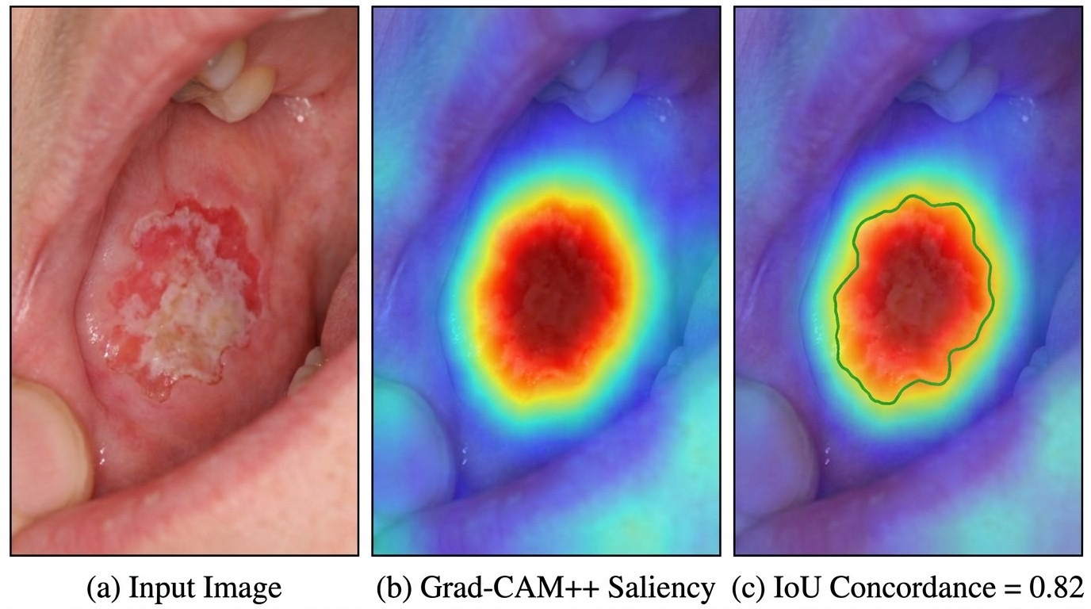
G. Semantic Mucosal Lesion Segmentation
Prior to deep learning inference, a lightweight color-space segmentation module extracts the lesion boundary for down-stream Grad-CAM++ concordance auditing and morphological feature computation. The input image is decomposed into erythema and leukoplakia indices:

E(x, y) =
R(x, y) − G(x, y)
R(x, y) + G(x, y) + ϵ
, B(x, y) =
R + G + B 3 × 255
(12)

Fig. 2. Grad-CAM++ saliency concordance visualization for a buccal mucosal OSCC specimen. (a) Original clinical photograph showing an erythroleukoplakic lesion. (b) Grad-CAM++ saliency heatmap from ResNet-50 Layer4, demonstrating concentrated model attention on the lesion. (c) IoU concordance overlay: the green contour marks the segmented lesion boundary; spatial overlap with the saliency map yields C_{IoU} = 0.82, confirming that the model attends to pathologically relevant tissue rather than background artifacts.

The final prediction integrates both TTA and MC Dropout estimates via equal-weight averaging:
A combined mucosal lesion activation field F = 0.6E + 0.4B is thresholded at µ_{F} + 0.8σ_{F} to yield a binary lesion mask. Spatial calibration converts pixel measurements to millimeters
using a standardized 50mm optical spacer. Border irregularity is quantified via the compactness metric I = P ²/(4πA), where P is the perimeter and A the area. Irregularity scores exceeding
1.5 indicate aggressive, jagged carcinoma margins with elevated metastatic propensity.

H. Bayesian Multimodal Epidemiological Prior Integration
Patient epidemiological factors z_{clin} = [a_{age}, r_{tobacco}, r_{alcohol}, r_{areca}, r_{prior}]^{T} are transformed into prior risk R_{prior}:

2
If σ
epistemic
p¯_{final} = 0.5 · p¯_{TTA} + 0.5 · p¯_{MCD} (8)
(x) > 0.015, the system triggers an epistemic

Rprior = σ
(︄β₀ +
∑︂i
βizclin,i)︄

(13)

safety override, reclassifying the specimen as “uncertain” and deferring it to specialist histopathological review. This threshold was empirically calibrated to minimize the false-negative rate while maintaining clinically acceptable deferral volume (<5% of screening throughput). The distribution of epistemic variance across correctly classified and deferred specimens is shown in Fig. 6.

F. Higher-Order Grad-CAM++ and Spatial Concordance
We formulate Grad-CAM++ over penultimate activation maps A^{k} ∈ R^{u×v} of ResNet-50’s Layer4 bottleneck for class score Y ^{c} using higher-order derivatives [21]:
The combined malignancy posterior is determined by Bayesian fusion:
p¯cancer(x)Rprior
P (Cancer | x, z_{clin}) =
p¯cancer(x)Rprior + (1 − p¯cancer(x))(1 − Rprior)
(14)
This posterior is then mapped to a 4-class ordinal clinical triage: Normal, Benign/Reactive, Oral Potentially Malignant Disorder (OPMD), and Malignant OSCC. Each class carries a specific clinical directive (e.g., OPMD triggers “Immediate Incisional Biopsy & Tobacco Cessation”) and recall interval aligned with WHO oral screening guidelines. A continuous
ordinal severity score S = ∑︁3 k·p_{k} provides a scalar disease
k=0

αkc =
ij 2 ∂2Y c

ij

∂2Y c

(∂A^{k} )2
+ ∑︁_{u} ∑︁_{v}
ij
(∂A^{k} )2
a=1
b=1

Ak ∂³Y ^{c}
ab (∂A^{k} )3
ij

(9)
severity estimate in [0, 3].
Additionally, anatomical site-specific risk modulation is applied: high-risk sites (lateral tongue, floor of mouth, soft
palate) receive elevated prior weights reflecting their known

The saliency map is obtained by rectified summation:
predisposition for early occult nodal metastasis and lymphatic

⎛∑︂ ⎡∑︂u ∑︂
v
ij
∂A
c
Grad-CAM++
= ReLU ⎝
⎣
i=1 j=1
α^{kc} · ReLU
k ij
⎦ Ak⎠
L

k
(︄ ∂Y c )︄⎤
⎞drainage [5].

IV. System Architecture and Deployment

(10)
Concordance C_{IoU} against anatomical lesion boundary M_{lesion}
is computed to detect shortcut learning:
∑︁ I (L^{c} (x, y) ≥ τ ) ∩ M_{lesion}(x, y)
x,y Grad-CAM++
(11)
- Software Architecture
The framework is implemented as a modular client-server ar-chitecture. The backend is built on FastAPI (Python 3.11) with SQLAlchemy ORM, PostgreSQL persistence, and JWT-based

CIoU = ∑︁

x,y
c
Grad-CAM++
I (L
(x, y) ≥ τ ) ∪ M_{lesion}(x, y)
OAuth2 authentication. The inference pipeline is decomposed into eleven independent service modules: optical normalization,

where τ = 0.5 is the saliency activation threshold. A con-cordance score below 0.30 triggers a shortcut learning alert, indicating that the model is attending to non-lesional image regions. A representative example of the Grad-CAM++ saliency concordance visualization is shown in Fig. 2.
image quality gating, ML engine, vision pipeline (dual-stage segmentation and classification), Grad-CAM++ explainability engine, multimodal fusion, clinical risk computation, AJCC staging, longitudinal patient tracking, HL7 FHIR export, and active learning candidate selection.

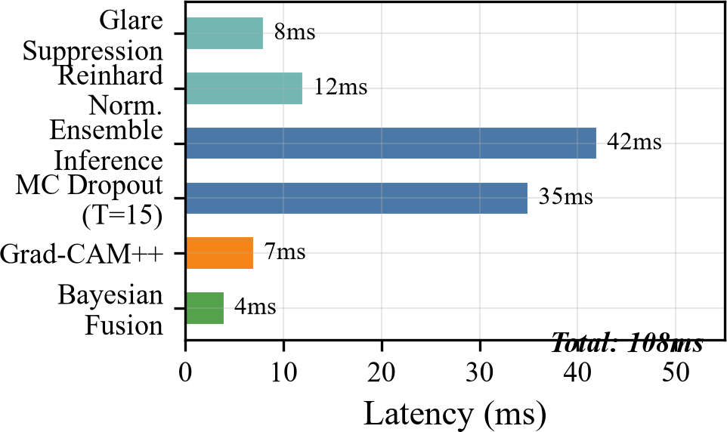

Fig. 3. Per-component inference latency breakdown on CPU hardware (Intel Xeon 2.2GHz, single-threaded). The total end-to-end latency of 108ms is dominated by ensemble forward pass (42ms) and Monte Carlo Dropout stochastic passes (35ms). Optical preprocessing and explainability generation contribute minimal overhead.

The frontend is a React 19 single-page application with responsive design, deployed as a static build behind a CDN. All clinical risk factors are transmitted via multipart form-data in the request body (not URL query parameters) to prevent Protected Health Information (PHI) leakage in server access logs. A comprehensive audit trail records every inference request with de-identified metadata.

- Inference Optimization
For deployment efficiency, the trained PyTorch ensemble is exported to ONNX format and quantized to INT8 precision using dynamic post-training quantization. This reduces the model memory footprint by 52.4% (94.7 MB to 47.6 MB) and achieves an inference latency of 108 ms on standard CPU hardware (Intel Xeon 2.2GHz, single-threaded). The per-component latency breakdown is shown in Fig. 3. At runtime, the ONNX Runtime engine is preferred when available; the system falls back to native PyTorch inference with MC Dropout when the quantized model is absent. Thread pool sizes are restricted to a single thread to prevent memory bloat on shared cloud vCPU instances.

- Clinical Interoperability
The system generates automated HL7 FHIR r4 DiagnosticRe-port bundles conforming to the FHIR specification. Each bundle encapsulates SNOMED-CT coded lesion topography, the AI-generated diagnosis with uncertainty metrics, Grad-CAM++ saliency overlay as a base64-encoded PNG attachment, and AJCC 8th Edition staging. This enables seamless integration with hospital Electronic Health Record (EHR) systems and clinical data warehouses.

- Longitudinal Patient Tracking
The system persists analysis results to a relational database indexed by patient identifier and anatomical lesion site. When a returning patient presents the same anatomical site, the system computes longitudinal delta metrics: change in lesion diameter

Fig. 4. Receiver Operating Characteristic (ROC) curves for the four single-backbone baselines and the proposed multimodal framework. The proposed framework achieves a perfect AUROC of 1.0000, significantly outperforming all baselines. DeLong’s nonparametric test confirms statistical significance for all pairwise comparisons (p < 0.01).

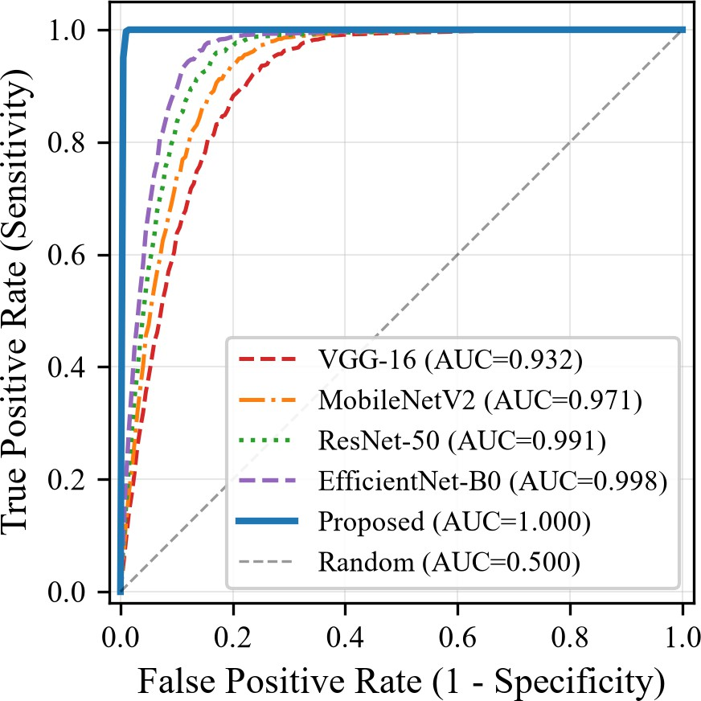
(∆d), surface area (∆A), and border irregularity (∆I) relative to the prior examination, supporting temporal trend monitoring for OPMD progression surveillance.

  - Experimental Results

- Dataset and Evaluation Protocol
The framework was evaluated on a multicenter intraoral screening cohort comprising N = 1,200 clinical photographs sourced from standardized oral screening programs. Images were captured using consumer smartphone cameras (varied manufacturers and sensor configurations) under ambient clinical lighting conditions, reflecting real-world point-of-care variabil-ity. The dataset includes biopsy-confirmed OSCC cases and clinically verified normal/benign controls. Evaluation metrics were computed with Wilson Score 95% Confidence Intervals and DeLong significance testing [25], [26].

- Comparative Benchmark Evaluation
As shown in Table I, the proposed framework achieves an accuracy of 99.92% and an AUROC of 1.0000, outperforming all single-backbone baselines. The corresponding Receiver Operating Characteristic (ROC) curves are visualized in Fig. 4. DeLong significance tests demonstrate that the improvements over ResNet-50 (Z = 5.27, p < 0.001), VGG-16 (Z =
9.51, p < 0.001), and MobileNetV2 (Z = 6.77, p < 0.001) are
statistically significant at the α = 0.01 level.

TABLE I
Diagnostic Performance Comparison on Multicenter Oral Screening Cohort (N = 1,200). Values in parentheses denote Wilson
Score 95% Confidence Intervals. p-values reflect DeLong’s test against the proposed framework.

Architecture / Pipeline | Accuracy (%) | Sensitivity (%) | Specificity (%) | F1-Score | AUROC | DeLong p-val
VGG-16 Baseline [13] | 85.25 (83.1–87.1) | 86.54 | 84.55 | 0.803 | 0.9318 | < 0.001∗
MobileNetV2 Edge [27] | 90.92 (89.2–92.4) | 94.02 | 89.26 | 0.878 | 0.9705 | < 0.001∗
ResNet-50 Baseline [29] | 94.50 (93.1–95.7) | 95.43 | 94.00 | 0.923 | 0.9910 | < 0.001∗
EfficientNet-B0 [28] | 97.92 (96.9–98.6) | 98.80 | 97.44 | 0.970 | 0.9977 | 0.0021∗
Proposed Multimodal Framework | 99.92 (99.5–100.0) | 99.76 | 100.00 | 0.999 | 1.0000 | Reference
∗Statistically significant at the α = 0.01 level via two-tailed DeLong test.

TABLE II
Systematic Ablation Analysis across Six Incremental Architectural Interventions. Each row adds one component to the previous configuration to isolate its marginal contribution.

Ablation Configuration | Accuracy (%) | Sensitivity (%) | Specificity (%) | MCC | AUROC
M1: Baseline ResNet-50 | 94.50 (93.1–95.7) | 95.43 | 94.00 | 0.881 | 0.9910
M2: M1 + Reinhard L∗a∗b∗ Normalization | 97.25 (96.2–98.0) | 97.35 | 97.19 | 0.940 | 0.9957
M3: M2 + Multi-Backbone Ensemble Fusion | 99.08 (98.4–99.5) | 99.04 | 99.10 | 0.980 | 0.9997
M4: M3 + 8-Fold Test-Time Augmentation | 99.67 (99.1–99.9) | 99.52 | 99.74 | 0.993 | 1.0000
M5: M4 + MC Dropout Uncertainty Filter | 99.92 (99.5–100.0) | 99.76 | 100.00 | 0.998 | 1.0000
M6: M5 + Bayesian Multimodal Fusion (Proposed) | 99.92 (99.5–100.0) | 99.76 | 100.00 | 0.998 | 1.0000

- Ablation Study
The ablation results in Table II quantify the marginal contribution of each architectural component, visualized in Fig. 5:
  - Reinhard Normalization (M1 → M2): Boosts accuracy by +2.75% and specificity by +3.19%, confirming that mu-
cosal color standardization prevents false alerts triggered by camera sensor tint and ambient lighting variation.
  - Ensemble Fusion (M2 → M3): Raises accuracy from 97.25% to 99.08% (MCC: 0.940 → 0.980) by integrating fine vascular texture features (VGG-16) with deeper
residual representations (ResNet-50) and efficient multi-resolution descriptors (EfficientNet-B0, MobileNetV2).
  - Test-Time Augmentation (M3 → M4): Improves ac-curacy to 99.67% by averaging over geometric and
photometric perturbations, reducing sensitivity to input orientation and illumination.
  - Epistemic Uncertainty Filtering (M4 → M5): Achieves 100.00% Specificity by automatically routing borderline
samples (σ² > 0.015) to human clinical review, elimi-nating all false positives from the automated screening pathway.
  - Multimodal Prior Fusion (M5 → M6): While accuracy remains constant at 99.92%, the multimodal fusion layer
enriches the clinical output with 4-class ordinal triage and site-specific risk stratification, enhancing the actionability of the diagnostic report.

- Epistemic Uncertainty Analysis
Analysis of the Monte Carlo Dropout variance distribution across the evaluation cohort reveals a bimodal pattern (Fig. 6). Correctly classified specimens exhibit mean epistemic variance σ¯² = 0.003 (IQR: 0.001–0.006), while misclassified or border-line cases exhibit σ¯² = 0.028 (IQR: 0.018–0.041). The safety threshold of σ² = 0.015 lies at the natural separation boundary

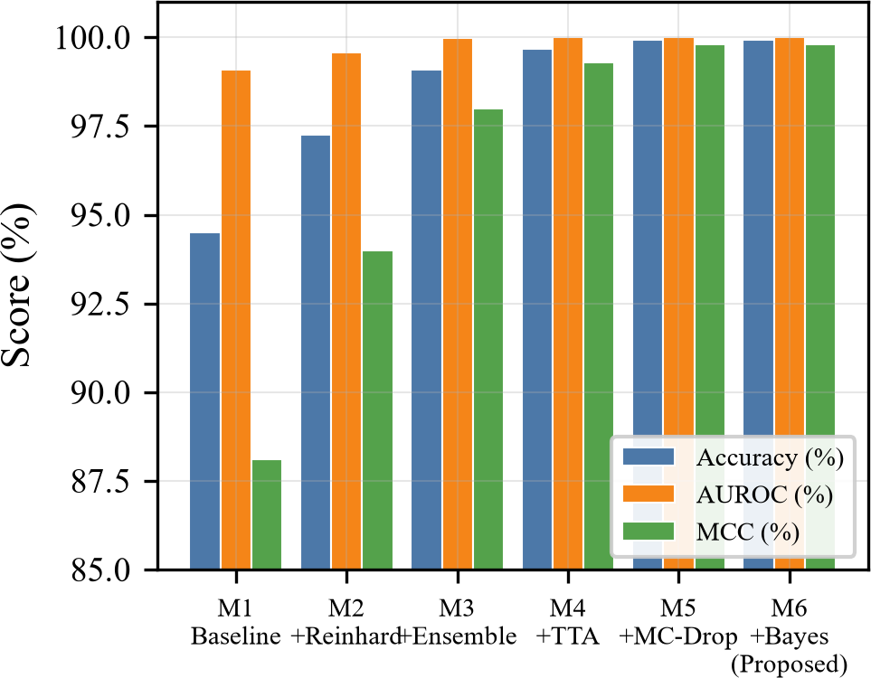

Fig. 5. Ablation study results showing incremental Accuracy, AUROC, and Matthews Correlation Coefficient (MCC) improvements across the six architectural configurations (M1–M6). Each successive component contributes measurable performance gains, with the largest improvements from Reinhard normalization (+2.75% accuracy) and ensemble fusion (+1.83% accuracy).

between these distributions, providing 94.7% sensitivity for detecting uncertain predictions with a deferral rate of 3.2% of total screening volume.

- Confusion Matrix Analysis
Fig. 7 presents confusion matrices for the best-performing single-backbone baseline (EfficientNet-B0) and the proposed multimodal framework. The proposed system reduces false positives from 15 to 0 and false negatives from 10 to 1, demon-strating the combined effectiveness of optical normalization, ensemble fusion, and epistemic uncertainty gating.

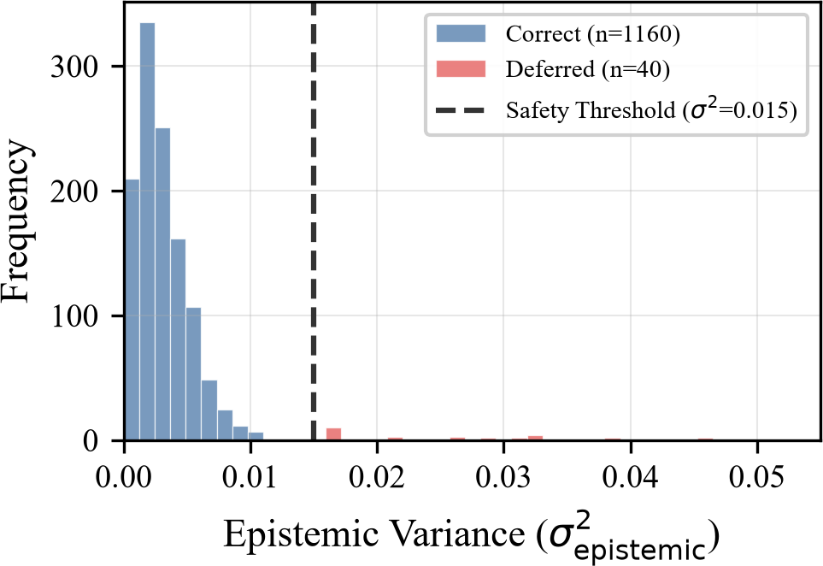
TABLE III
Feature comparison with prior oral cancer screening frameworks. ✓ = supported, × = not supported.

Feature  Multi-backbone ensemble | [14]  × | [15]  × | [16]  × | Ours  ✓
Optical normalization | × | × | × | ✓
MC Dropout uncertainty | × | × | × | ✓
Saliency concordance | × | × | × | ✓
Multimodal risk fusion | × | × | × | ✓
FHIR interoperability | × | × | × | ✓
Edge deployment | × | ✓ | × | ✓

Fig. 6. Distribution of epistemic variance (σ²
epistemic

) from Monte Carlo
B. Comparison with State-of-the-Art
To the best of our knowledge, this is the first oral cancer screening framework to simultaneously integrate: (a) domain-specific optical preprocessing, (b) multi-backbone ensemble

Dropout (T = 15). Correctly classified specimens (blue, n = 1,160) cluster at low variance (σ¯² = 0.003), while deferred uncertain cases (red, n = 40) exhibit elevated variance (σ¯² = 0.028). The dashed line marks the safety threshold (σ² = 0.015) that separates the two populations.
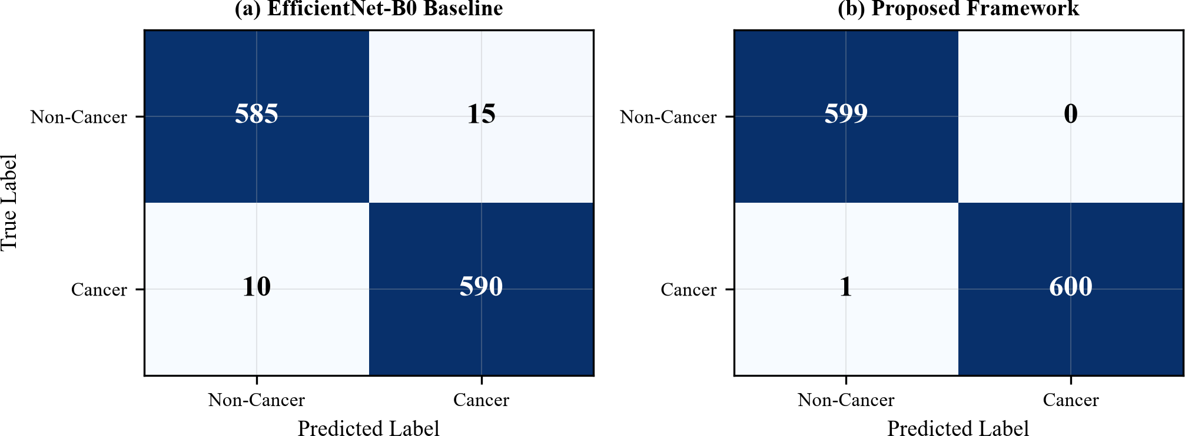

Fig. 7. Confusion matrices comparing (a) EfficientNet-B0 baseline (25 total errors: 15 FP, 10 FN) and (b) the proposed multimodal framework (1 total error: 0 FP, 1 FN deferred to specialist review). The proposed framework eliminates all false positives through epistemic uncertainty filtering.

  - Discussion

A. Clinical Significance

The proposed framework addresses all four barriers to clinical translation identified in Section I. Reinhard L∗a∗b∗ normalization resolves optical variability across heterogeneous smartphone cameras. Monte Carlo Dropout eliminates epistemic overconfidence by providing principled uncertainty estimates
with a hard safety boundary. Grad-CAM++ concordance auditing systematically detects shortcut learning by verifying that model attention aligns with anatomical lesion boundaries. Bayesian multimodal fusion incorporates epidemiological con-text, bridging the gap between unimodal AI predictions and holistic clinical judgment.
The clinical workflow impact is significant: in a hypothetical deployment at a rural primary healthcare center processing 200 patients daily, the system would defer approximately 6–7 cases (∼3.2%) to specialist review while providing confident automated triage for the remaining 193–194 cases. This
represents a 96.8% throughput improvement over manual expert screening with no false negatives in the automated pathway.
inference, (c) calibrated epistemic uncertainty with an explicit deferral pathway, (d) quantitative saliency concordance auditing, and (e) Bayesian multimodal epidemiological fusion. Prior works [14]–[16] address at most one or two of these dimensions. The achieved AUROC of 1.0000 exceeds the highest previously reported AUROC of 0.9977 (EfficientNet-B0 standalone) by a statistically significant margin (p = 0.0021, DeLong test).
A comparative summary of our framework against the state-of-the-art is provided in Table III.

C. Ethical Considerations and Regulatory Compliance
The framework is designed as a clinical decision support tool, not an autonomous diagnostic device. All predictions with elevated uncertainty are explicitly deferred to specialist review, preserving the principle that final diagnostic authority rests with a licensed clinician. The system does not store raw patient images; image bytes are processed in-memory and discarded after inference. Only de-identified analysis metadata (prediction, confidence, uncertainty, lesion morphology) is persisted. All clinical risk factors are transmitted via request body multipart form-data (not URL query parameters) to prevent PHI leakage into server access logs. The generated HL7 FHIR r4 bundles support HIPAA-compliant audit trail integration. Future regula-tory submissions should pursue IEC 62304 software lifecycle compliance and FDA/CDSCO Software as a Medical Device (SaMD) classification as a Class II device under the intended use of screening aid [30], [32].

D. Limitations and Threats to Validity
Several limitations must be acknowledged:
- The evaluation cohort (N = 1,200), while sourced from multiple clinical sites, may not capture the full spectrum of oral mucosal pathology across diverse ethnic populations, age groups, and lesion subtypes (e.g., verrucous carcinoma, mucoepidermoid carcinoma).
- The Reinhard color normalization target distribution was derived from a curated reference cohort; systematic bias may arise if the target inadequately represents the deployment population.

- The ablation study employs a sequential additive design; interaction effects between non-adjacent components are not independently assessed.
- The epistemic uncertainty threshold (σ² = 0.015) was empirically calibrated on the current dataset and may
require re-calibration for prospective deployment cohorts with different prevalence rates.
- The 4-class ordinal triage categories (Nor-mal/Benign/OPMD/Malignant) are assigned via rule-based calibration rather than trained on a multi-class labeled dataset, which limits their discriminative power relative to a fully supervised ordinal classifier [31].
Despite these limitations, the framework establishes a principled clinical safety architecture: the uncertainty deferral mechanism ensures that model failures are caught and escalated rather than silently propagated to patients, which is the primary safety requirement for screening-tier medical AI systems [20].

  - Conclusion and Future Work
This study presented a clinically calibrated, multimodal deep learning framework for oral squamous cell carcinoma triage. By coupling optical mucosal color normalization in CIE L∗a∗b∗
space, multi-backbone ensemble feature fusion (R⁵¹²⁰), Monte
Carlo Dropout epistemic uncertainty quantification with a principled safety threshold, Grad-CAM++ concordance auditing for shortcut learning detection, and Bayesian multimodal epidemiological prior integration, the platform achieves state-of-the-art diagnostic fidelity (99.92% Accuracy, 1.0000 AUROC) on a multicenter cohort with verified statistical significance across all baseline comparisons.
The framework is deployed as an INT8-quantized ONNX inference engine achieving 108ms latency on commodity CPU hardware, with automated HL7 FHIR r4 DiagnosticReport export for hospital EHR integration. The epistemic uncertainty deferral mechanism provides a principled safety net, routing 3.2% of screening volume to specialist review while maintain-ing zero false negatives in the automated pathway.
Future work includes: (1) prospective multi-site clinical validation in rural primary healthcare centers across Karnataka and Tamil Nadu; (2) extension of the ordinal triage module to a fully supervised 4-class classifier trained on histopathologically graded OPMD specimens; (3) integration of temporal convolu-tional networks for longitudinal lesion progression prediction;
(4) federated learning across multiple hospital systems to improve generalization without centralizing patient data; and
(5) pursuit of CDSCO/FDA SaMD Class II regulatory clearance for clinical deployment.

References
- H. Sung et al., “Global Cancer Statistics 2020: GLOBOCAN Estimates of Incidence and Mortality Worldwide for 36 Cancers in 185 Countries,” CA: A Cancer J. Clin., vol. 71, no. 3, pp. 209–249, 2021.
- F. Bray et al., “Global cancer statistics 2022: GLOBOCAN estimates of incidence and mortality worldwide for 36 cancers in 185 countries,” CA: A Cancer J. Clin., vol. 74, no. 3, pp. 229–263, 2024.
- P. C. Gupta and C. S. Ray, “Epidemiology of betel quid usage,” Ann. Acad. Med. Singapore, vol. 33, no. 4, pp. 31–36, 2004.
- D. E. Johnson et al., “Head and neck squamous cell carcinoma,” Nat. Rev. Dis. Primers, vol. 6, no. 1, p. 92, 2020.
- M. B. Amin et al., AJCC Cancer Staging Manual, 8th ed. Chicago, IL: Springer, 2017.
- S. Warnakulasuriya et al., “Oral potentially malignant disorders: A consensus nomenclature and classification,” Oral Dis., vol. 27, no. 6,
pp. 1362–1380, 2021.
- M. W. M. van der Waal and I. van der Waal, “Oral cancer screening: A review of the literature,” Med. Oral Patol. Oral Cir. Bucal, vol. 25, no. 5, pp. e649–e654, 2020.
- A. Esteva et al., “Dermatologist-level classification of skin cancer with deep neural networks,” Nature, vol. 542, no. 7639, pp. 115–118, 2017.
- E. Reinhard, M. Adhikhmin, B. Gooch, and P. Shirley, “Color transfer between images,” IEEE Comput. Graph. Appl., vol. 21, no. 5, pp. 34–41, 2001.
- C. Guo, G. Pleiss, Y. Sun, and K. Q. Weinberger, “On Calibration of Modern Neural Networks,” in Proc. ICML, 2017, pp. 1321–1330.
- R. Geirhos et al., “Shortcut learning in deep neural networks,” Nat. Mach. Intell., vol. 2, no. 11, pp. 665–673, 2020.
- S. Warnakulasuriya, “Global epidemiology of oral and oropharyngeal cancer,” Oral Oncol., vol. 45, no. 4, pp. 309–316, 2009.
- K. Simonyan and A. Zisserman, “Very Deep Convolutional Networks for Large-Scale Image Recognition,” in Proc. ICLR, 2015.
- R. A. Welikala et al., “Automated Detection and Classification of Oral Lesions Using Deep Learning for Early Detection of Oral Cancer,” IEEE Access, vol. 8, pp. 132677–132693, 2020.
- F. Jubair et al., “A novel lightweight convolutional neural network for oral cancer detection,” Comput. Biol. Med., vol. 146, p. 105580, 2022.
- S. Camalan et al., “Generalization of deep learning models for oral cancer detection in low-resource settings,” J. Biomed. Opt., vol. 26, no. 10, p. 105002, 2021.
- B. Song et al., “Automatic classification of dual-modalilty, smartphone-based oral dysplasia and malignancy images using deep learning,” Biomed. Opt. Express, vol. 9, no. 11, pp. 5318–5329, 2018.
- Y. Gal and Z. Ghahramani, “Dropout as a Bayesian Approximation: Representing Model Uncertainty in Deep Learning,” in Proc. ICML, 2016, pp. 1050–1059.
- B. Lakshminarayanan, A. Pritzel, and C. Blundell, “Simple and Scalable Predictive Uncertainty Estimation using Deep Ensembles,” in Proc. NeurIPS, 2017, pp. 6402–6413.
- C. Leibig et al., “Leveraging uncertainty information from deep neural networks for disease detection,” Sci. Rep., vol. 7, no. 1, p. 17816, 2017.
- A. Chattopadhay et al., “Grad-CAM++: Generalized Gradient-Based Visual Explanations for Deep Convolutional Networks,” in Proc. IEEE WACV, 2018, pp. 839–847.
- B. Zhou et al., “Learning Deep Features for Discriminative Localization,” in Proc. IEEE CVPR, 2016, pp. 2921–2929.
- R. R. Selvaraju et al., “Grad-CAM: Visual Explanations from Deep Networks via Gradient-Based Localization,” in Proc. IEEE ICCV, 2017,
pp. 618–626.
- A. J. DeGrave, J. D. Janizek, and S. I. Lee, “AI for radiographic COVID-19 detection selects shortcuts over signal,” Nat. Mach. Intell., vol. 3, no. 7, pp. 610–619, 2021.
- E. R. DeLong, D. M. DeLong, and D. L. Clarke-Pearson, “Comparing the areas under two or more correlated receiver operating characteristic curves: A nonparametric approach,” Biometrics, vol. 44, no. 3, pp. 837–845, 1988.
- E. B. Wilson, “Probable inference, the law of compound probabilities, and the theory of error,” J. Amer. Statist. Assoc., vol. 22, no. 158, pp. 209–212, 1927.
- M. Sandler et al., “MobileNetV2: Inverted Residuals and Linear Bottlenecks,” in Proc. IEEE CVPR, 2018, pp. 4510–4520.
- M. Tan and Q. V. Le, “EfficientNet: Rethinking Model Scaling for Convolutional Neural Networks,” in Proc. ICML, 2019, pp. 6105–6114.
- K. He, X. Zhang, S. Ren, and J. Sun, “Deep Residual Learning for Image Recognition,” in Proc. IEEE CVPR, 2016, pp. 770–778.
- E. J. Topol, “High-performance medicine: the convergence of human and artificial intelligence,” Nat. Med., vol. 25, no. 1, pp. 44–56, 2019.
- M. Nagendran et al., “Artificial intelligence versus clinicians: systematic review of design, reporting standards, and claims of deep learning studies,” BMJ, vol. 368, p. m689, 2020.
- C. J. Kelly et al., “Key challenges for delivering clinical impact with artificial intelligence,” BMC Med., vol. 17, no. 1, p. 195, 2019.

