**23CSE111**

**LAB MANUAL**

**Department of CSE**

**Amrita School of Engineering**

**Amrita Vishwa Vidyapeetham, Amaravati Campus**

**Verified By :- Name: CH LOHITH**

**Roll No: 24039**

|  |  |  |  |  |
| --- | --- | --- | --- | --- |
| S.NO | Programs | Date | Pg:No | Signature |
| 1 | 1. Download and Install Java Software. 2. Write a java program to print message “Welcome to java programming”. 3. Write a java program that prints name , roll number, section of a student. |  |  |  |
| 2 | i. To calculate the area of the rectangle  ii. Program to convert the temperature in celsius to Fahrenheit.  iii. Program to calculate the simple interest.  iv. Program to find the largest of three numbers using the ternary operators.  v. Program to find the factorial of the number. |  |  |  |
| 3 | i. Create the java program for the cars with constructor and methods.  ii. Create the java program to withdraw and deposit money in the bank account. |  |  |  |
| 4 | i. Create the java program for the books by using the constructor and display its details using methods.  ii. Program to explain the final and the static variables. |  |  |  |
|  |  |  |  |  |
|  |  |  |  |  |
|  |  |  |  |  |
|  |  |  |  |  |

Week 1:-

Program-1:-

Aim:-Download and Install the Java Software

Procedure

Step-1:- Type Java download in search

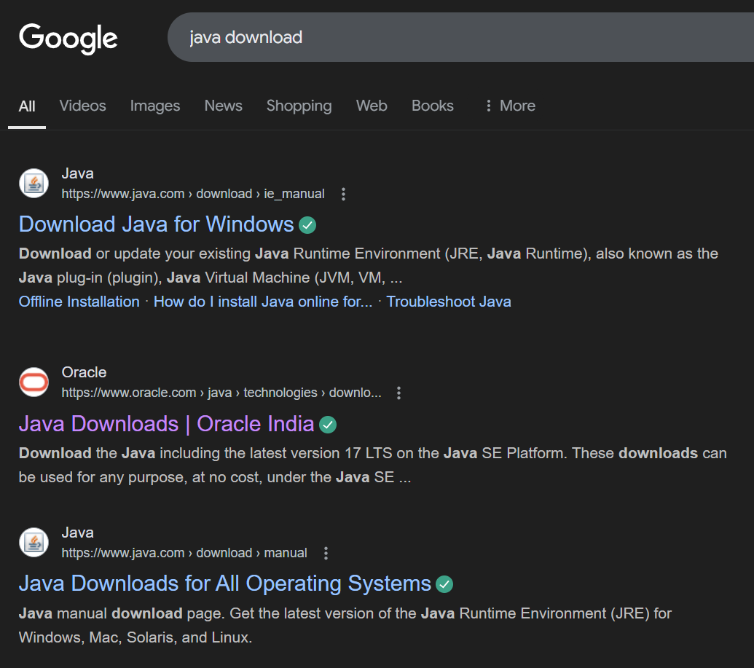

Step-2:-click on oracle java download and enter into oracle website 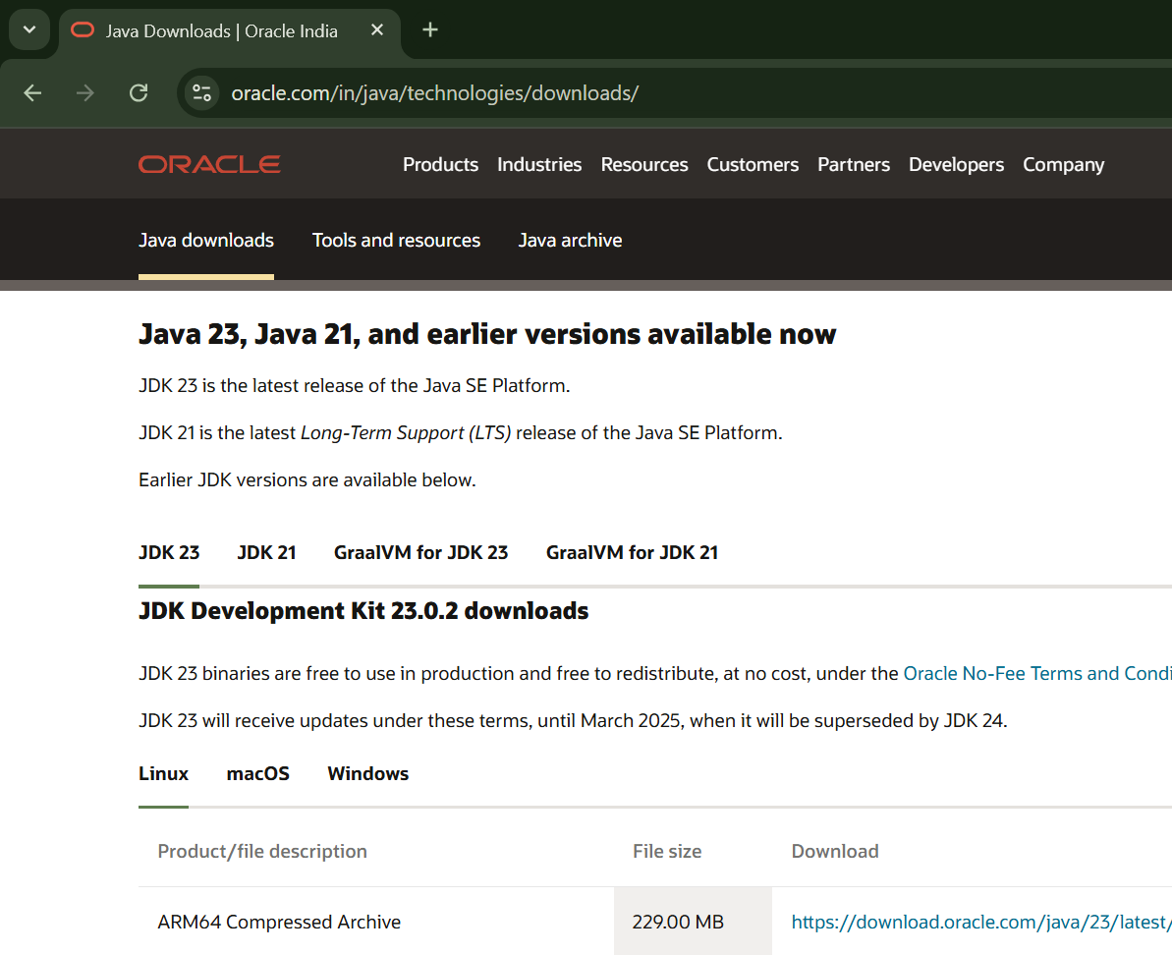

Step-3:-click on JDK21 and click on windows and later click on x64 instalier link to download

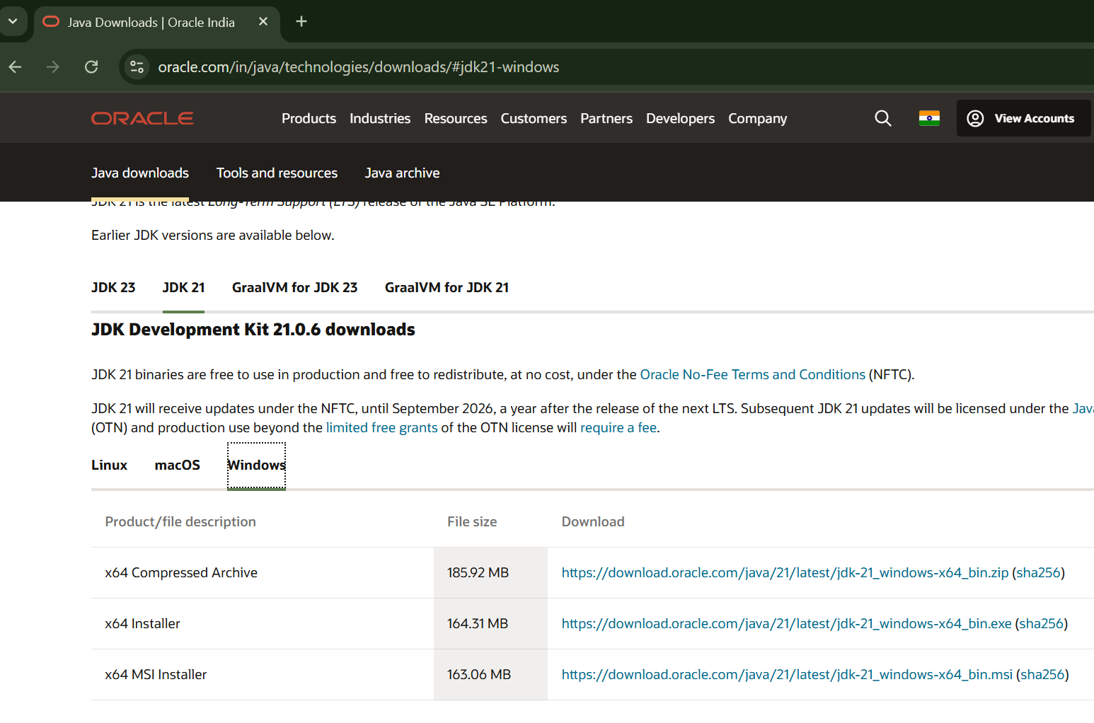

Step-4:-After completing download click on it’s file and then give permission to install

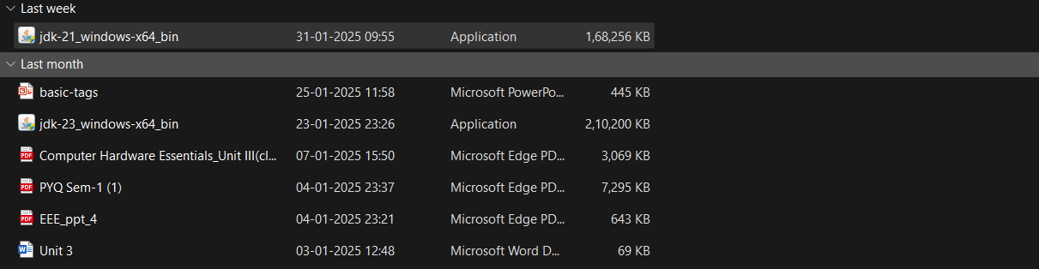

Step-5:-Then go to (This pc) in that click (windows{c}) in that click (Program files) in that click (Java) in that click (jdk-21) in that click (bin)

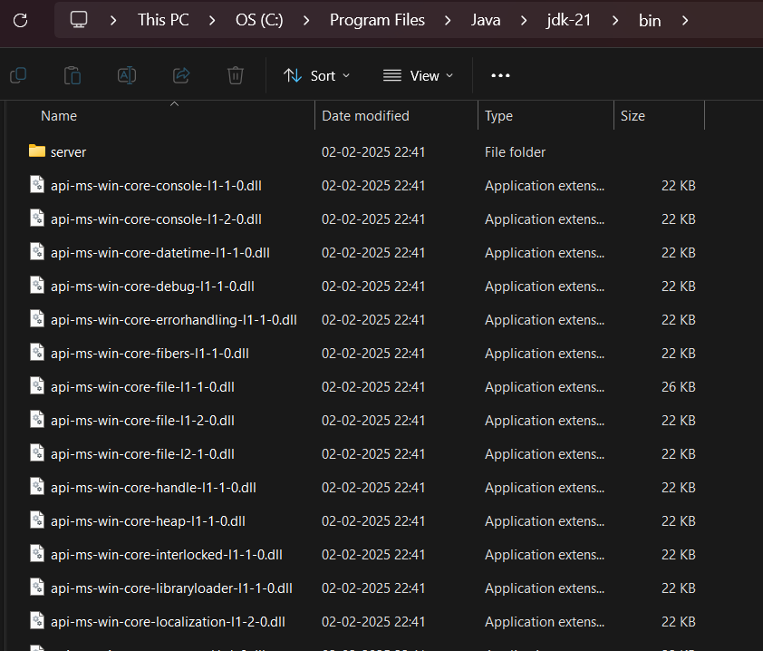

Step-6:-Select and copy path of opening the file and then press windows and search System Environmental

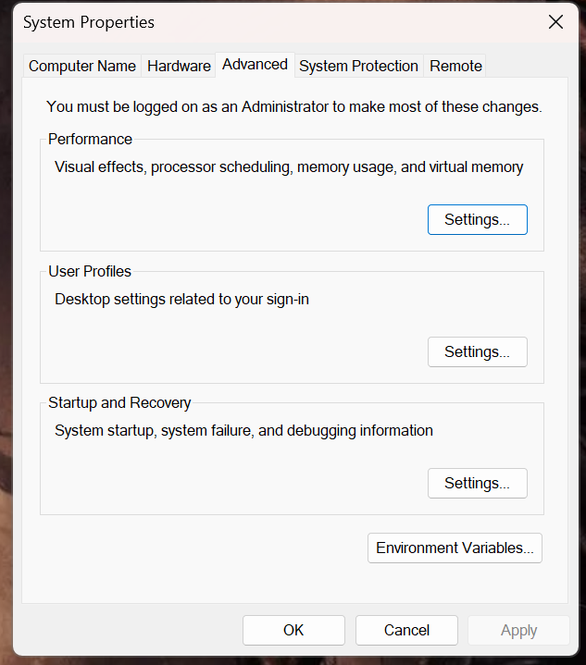

Step-7:-After opening Environment variables then past path of opening file in user variable and click on ok

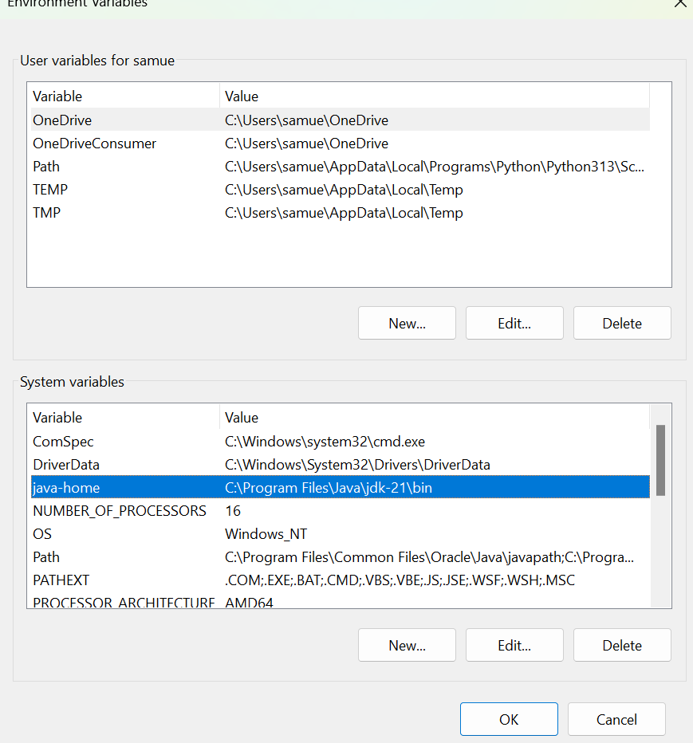

Step-8:-To verify version open CMD and type java --version

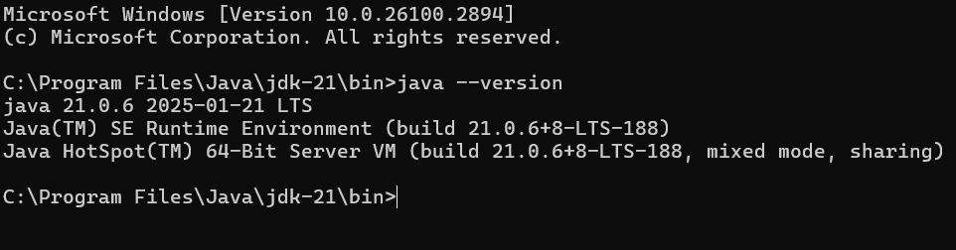

Program : 2

Aim:-write a java program to print[welcome to java programming]

Input:-

class ex_1{

public static void main(String[] args){

System.out.println("welcome to java programming");

}

}

Output:- 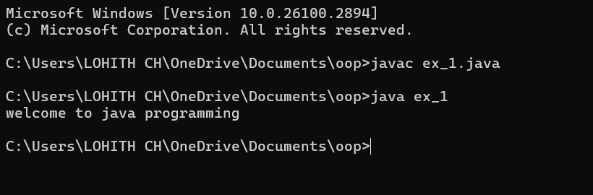

Program : 3

Aim:-write a java program that prints name, roll no, section of the student

Input:-

class ex_2 {

public static void main(String args[]) {

System.out.println("Name: lohith");

System.out.println("Class: CSE A");

System.out.println("Roll No: 24039");

}

}

Output:- 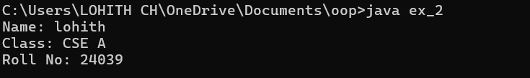

***WEEK-2***

Program-1:

Aim: to write a java program to find area of rectangle

Input:

import java.util.Scanner;

public class RectangleArea {

public static void main(String[] args) {

Scanner scanner = new Scanner(System.in);

System.out.print("Enter the length of the rectangle: ");

double length = scanner.nextDouble();

System.out.print("Enter the width of the rectangle: ");

double width = scanner.nextDouble();

double area = length * width;

System.out.println("The area of the rectangle is: " + area);

scanner.close();

}

}

Output:

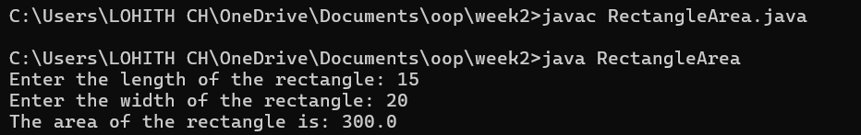

Error table:

|  |  |  |
| --- | --- | --- |
| Error | Error cause | Error rectification |
| error: ';' expected | ‘;’ is missed in the end of print statement | Placed ‘; ’ at the end of the statement |
| error:cannot find symbolScannerinput=new scanner(System.in); | Placed small s in place of capital S | Replaced capital s in place of small s to rectifiy the error |

**Program-2**

Aim: write a java program to convert temp from celsius to farenheit

Input:

import java.util.Scanner;

public class TemperatureConverter {

public static void main(String[] args) {

Scanner scanner = new Scanner(System.in);

System.out.print("Enter temperature in Celsius: ");

double celsius = scanner.nextDouble();

double fahrenheit = (celsius * 9/5) + 32;

System.out.println("Temperature in Fahrenheit: " + fahrenheit);

scanner.close();

}

}

Output:

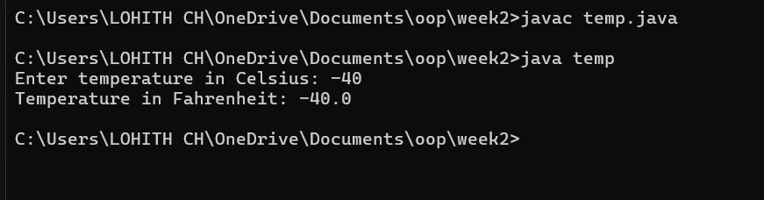

Error table:

|  |  |  |
| --- | --- | --- |
| Error | Error cause | Error rectification |
| error: ';' expected  scanner.close() | Forgot ‘;’ at the end the statement | Rectified by placing ’;’  it |
| error: incompatible types: possible lossy conversion from double to int  int celsius = scanner.nextDouble(); | Placed int in place of double | Rectified by replacing double |

Program-3:

Aim: write a java program to calculate simple interest

Input:

import java.util.Scanner;

public class SI{

public static void main(String[] args) {

Scanner scanner = new Scanner(System.in);

System.out.print("Enter the principal amount: ");

double principal = scanner.nextDouble();

System.out.print("Enter the rate of interest: ");

double rate = scanner.nextDouble();

System.out.print("Enter the time period in years: ");

double time = scanner.nextDouble();

double interest = (principal * rate * time) / 100;

System.out.println("The simple interest is: " + interest);

scanner.close();

}

}

Output:

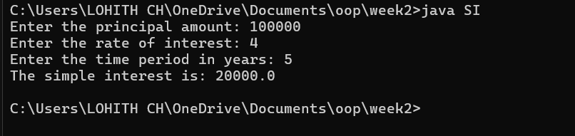

Error table:

|  |  |  |
| --- | --- | --- |
| Error | Error cause | Error rectification |
| error: class Sinterest is public, should be declared in a file named Sinterest.java  public class Sinterest {  ^ | Placed capital s I place of small ‘s’ | Replaced by placing small ‘s’ |

Program-4

Aim: write a java program to find the largest of 3 numbers using terenary operator

Input:

import java.util.Scanner;

public class largestnumber {

public static void main(String[] args) {

Scanner scanner = new Scanner(System.in);

System.out.print("Enter first number: ");

int num1 = scanner.nextInt();

System.out.print("Enter second number: ");

int num2 = scanner.nextInt();

System.out.print("Enter third number: ");

int num3 = scanner.nextInt();

int largest = (num1 > num2) ? (num1 > num3 ? num1 : num3) : (num2 > num3 ? num2 : num3);

System.out.println("The largest number is: " + largest);

scanner.close();

}

}

Output:

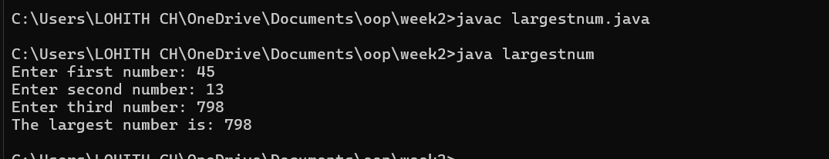

Error table:

|  |  |  |
| --- | --- | --- |
| Error | Error cause | Error rectification |
| error: reached end of file while parsing  ((num1 > num3) ? num1 : num3) | Missed ‘} ’ in the end of the program | Rectified by replacing it |
| error: illegal start of expression  }  ^ | Missed’}’in the starting | Rectified by replacing it |

Program-5

Aim: write a java program to find the factorial of a number

Input:

import java.util.Scanner;

public class FactorialCalculator {

public static void main(String[] args) {

Scanner scanner = new Scanner(System.in);

System.out.print("Enter a number: ");

int number = scanner.nextInt();

long factorial = 1;

for (int i = 1; i <= number; i++) {

factorial *= i;

}

System.out.println("The factorial of " + number + " is: " + factorial);

scanner.close();

}

}

Output:

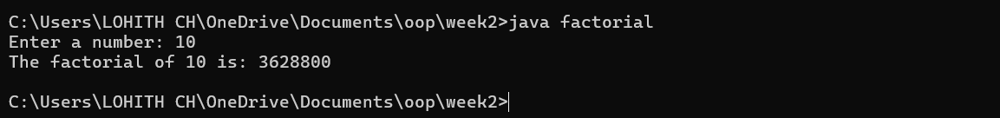

Error table:

|  |  |  |
| --- | --- | --- |
| Error | Error cause | Error rectification |
| error: unclosed string literal  System.out.print("Enter a number: );  ^ | Missed “ in the end | Rectified by replacing “ |

**Week-3:**

**Aim: (i)** Create the java program for the cars with constructor and methods.

**Class Diagram:**

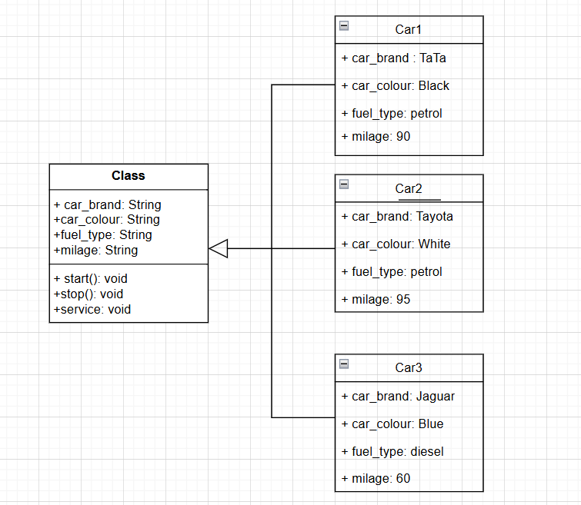

**Program:**

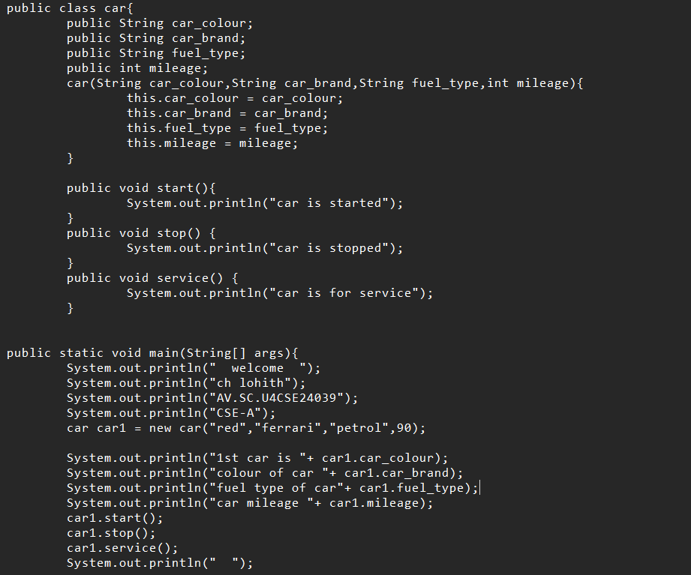

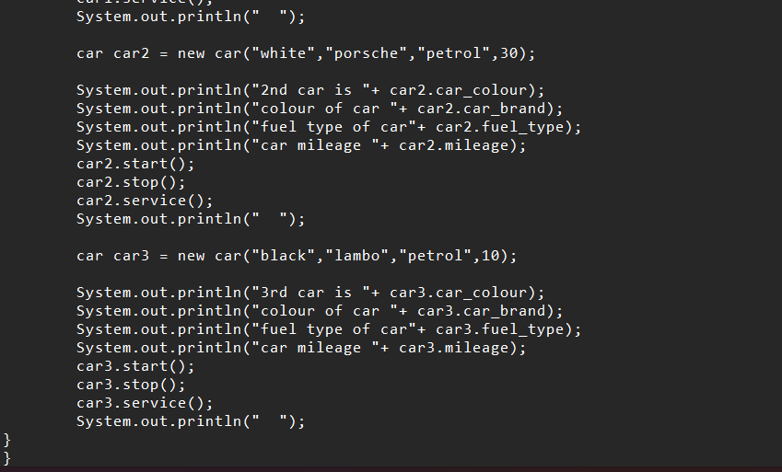

**Output:**

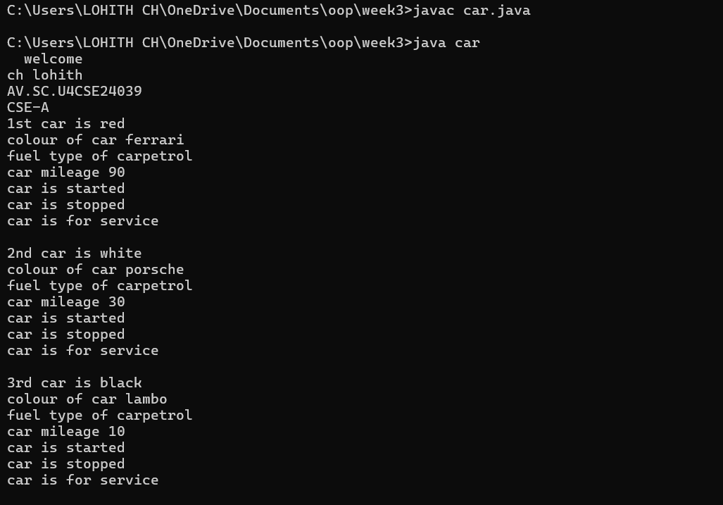

**Error:**

|  |  |  |
| --- | --- | --- |
| **Error Type** | **Incorrect Code** | **Corrected Code** |
| **Class Naming Issue** | class main{ | class Main{ |
| **Incorrect Object Description** | "1st car is "+car2.car_brand; | "2nd car is "+car2.car_brand; |

**Aim: (ii)** Create the java program to withdraw and deposit money in the bank account.

**Class Diagram:**

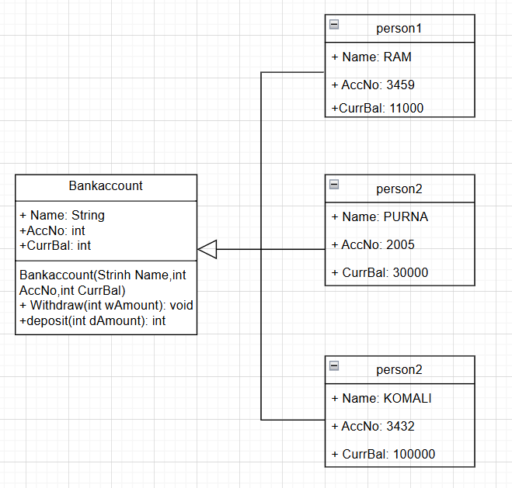

**Procedure:**

Code:

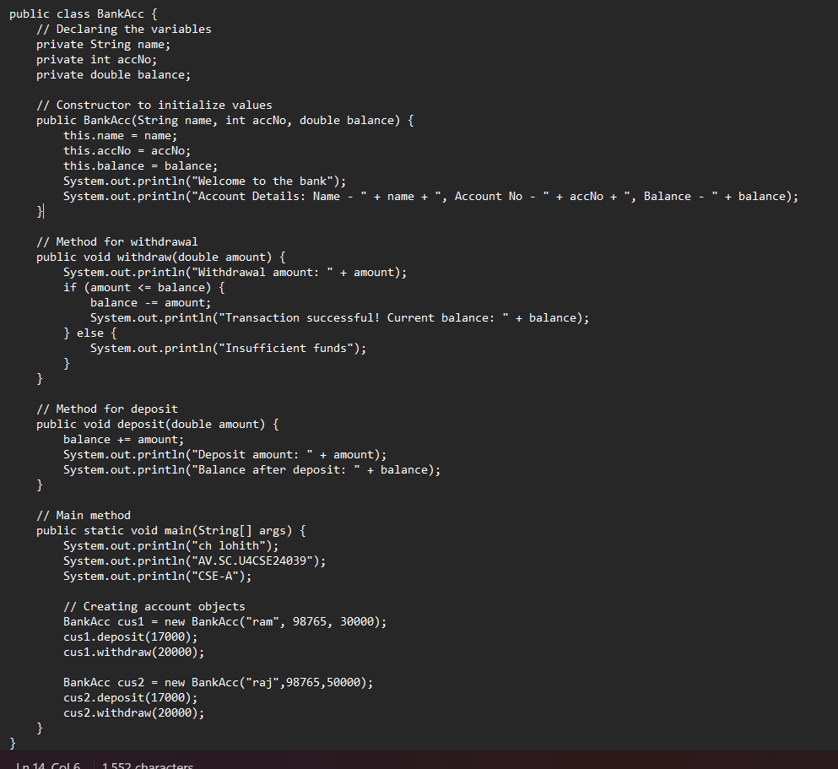

**Output:**

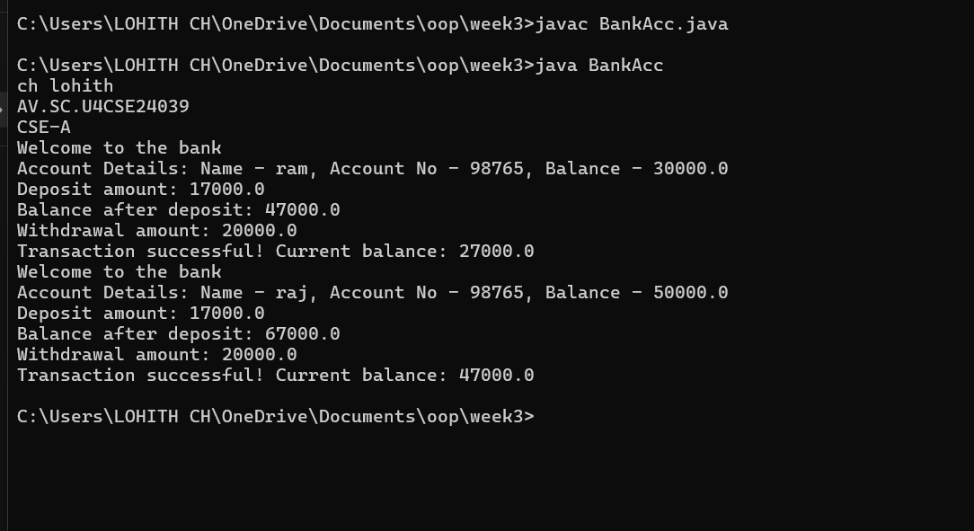

**Error:**

|  |  |  |
| --- | --- | --- |
| **Error Type** | **Incorrect Code** | **Corrected code** |
| **Class Name Capitalization** | class Bankaccount | class BankAccount (Java follows PascalCase for class names) |
| **Object Naming Issue** | BankAccount person-1 (hyphen is not allowed) | BankAccount person1 |
| **Missing Semicolon** | System.out.println ("Balance is "+ person-1.deposit (50,000)) | System.out.println ("Balance is "+ person1.deposit (50000)); (semicolon added) |

|  |  |  |
| --- | --- | --- |
|  |  |  |
|  |  |  |
|  |  |  |
|  |  |  |

**Week-4:**

**Aim: (i)** Create the java program for the books by using the constructor and display its details using methods.

**Class Diagram:**

|  |
| --- |
| **Book** |
| **- title: String**  **- author: String**  **- yearOfPublication: int** |
| **+ Book(title: String, author: String,**  **yearOfPublication: int)**  **+ displayDetails(): void** |

**Proceure:**

Code: 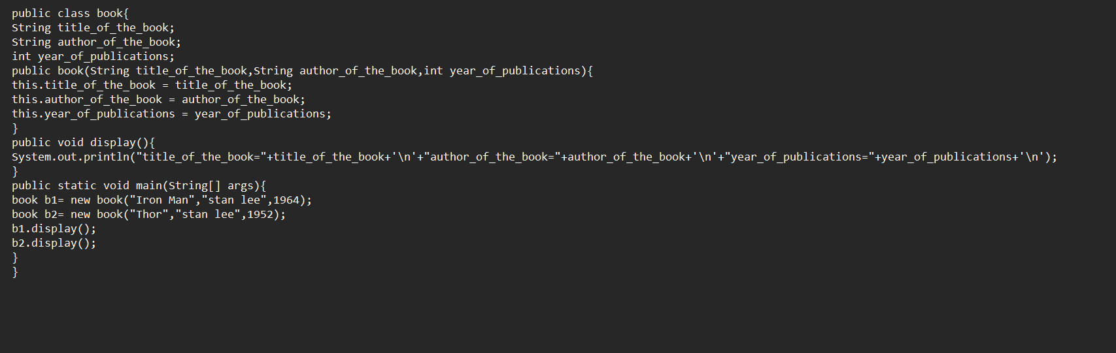

**Output:**

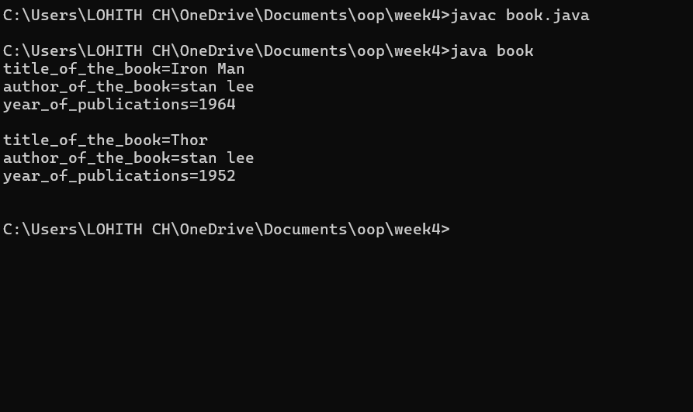

**Errors:**

|  |  |  |  |  |
| --- | --- | --- | --- | --- |
| **Error Type** | |  | | --- | | **Incorrect Code** |  |  | | --- | |  | | **Corrected Code** |
| **Class Name Capitalization** | public class book | public class Book (Java follows PascalCase for class names) |
| **Constructor Name Mismatch** | new book(...) | new Book(...) (Constructor name must match class name) |

**Aim: (ii)** Program to explain the final and the static variables.

**Class Diagram:**

|  |
| --- |
| **MyClass** |
| **- Count: int**  **+ pi: double** |
| **+ MyClass()**  **+ getCount(): int** |

|  |  |  |
| --- | --- | --- |
|  |  |  |
|  |  |  |
|  |  |  |

**Procedure:**

Code:

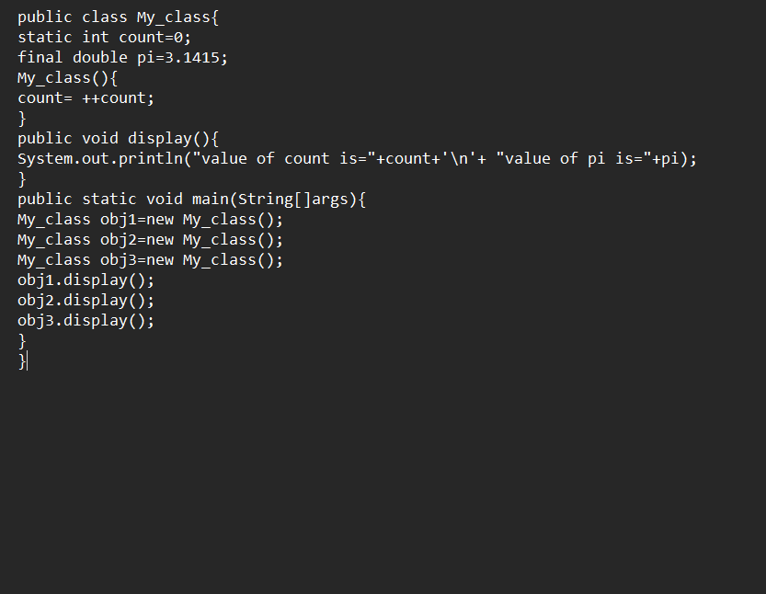

**Output:** 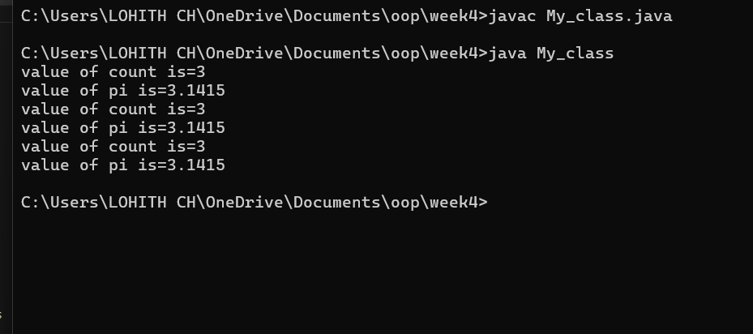

**Error:**

|  |  |  |
| --- | --- | --- |
| **Error Type** | **Incorrect Code** | **Corrected Code** |
| **Attempt to Modify final Variable** | pi = 3.14; (if added inside the constructor or method) | Remove this line (final variables cannot be reassigned) |
| **Incorrect Class Name** | public class Myclass | public class MyClass (Java follows PascalCase for class names) |

**WEEK-5**

1. **Create a calc using the operations including add, sub, mul, div using multilevel inheritance and display the desired output.**

**Class Diagram:**

|  |
| --- |
| **Basic Operations** |
| **+ add (a,b)**  **+subtract (a,b)** |

|  |
| --- |
| **Multiplication** |
| **+Multiply (a,b)** |

|  |
| --- |
| **Division** |
| **+ Divide (a,b)** |

|  |  |
| --- | --- |
| **Subtraction** | |
| **+ subtraction(a,b)** | |
|  | |  | |

|  |
| --- |
| **Calculator** |
| **+calculate (op,a,b)** |

**Program:**

**public class cacluator {**

**public int add( int a,int b){**

**int addition = a+b;**

**return addition;**

**}**

**}**

**class advanced_cacluator extends cacluator{**

**public int sub(int a ,int b){**

**int subraction=a-b;**

**return subraction;**

**}**

**}**

**class scientific_cacluator extends advanced_cacluator{**

**public int multi(int a , int b){**

**int multiplication=a*b;**

**return multiplication;**

**}**

**}**

**class super_cacluator extends scientific_cacluator{**

**public int div(int a,int b){**

**if(b !=0){**

**return a/b;**

**}else{**

**System.out.println("the ans is undefine");**

**return a/b;**

**}**

**}**

**}**

**class main{**

**public static void main(String []args){**

**super_cacluator obj = new super_cacluator();**

**System.out.println("additon is:"+obj.add(4,3));**

**System.out.println("substraction is:"+obj.sub(4,3));**

**System.out.println("multiplication is:"+obj.multi(4,3));**

**System.out.println("division is:"+obj.div(4,3));**

**System.out.println("division is:"+obj.div(4,0));**

**}**

**}**

**Output:**

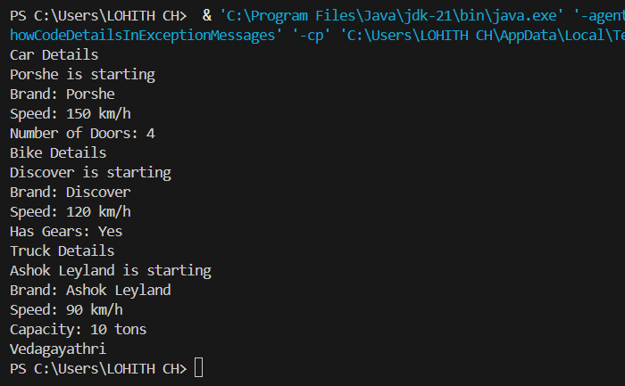

**Error table:**

|  |  |  |
| --- | --- | --- |
| **S.NO** | **Errors** | **Rectification** |
| **1** | **.variable** | **We must mention variable name to call the variable.** |
| **2** | **static** | **Static variables contain only one value.** |

**B.Program : 2**

**Q) A Vehicle rental company wants to develop a system ,that maintains information about**

**different types of vehicles available for rent.The company rents out cars and bikes and**

**they a need a program to store details about each vehicle such as brand and speed .**

* **Cars should have an additional properties .**
* **“Number of doors “ seating capacity.**
* **Bikes should have a property indicating whether they have gears are not ?**
* **The system should also include a fuction to display details about each vehicle and indicate when a vechicle is starting .**
* **If the company describes to add a new type of vechile ‘truck’ how would you modify above program.**
* **Truck should include an addition property capacity ‘in tons’.**
* **Create a show truck details method to display the trucks capacity.**
* **Write a constructor for truck that initializes all properties.**
* **Implement the truck class and update the main method to create a truck object and also create an object and also create an object car and bike subclass find display it details.**

**Class Diagram:**

|  |
| --- |
| **Vechile** |
| * **Brand: String** * **speed: int** |
| **+ Vechile(String,b int)**  **+ Start()**  **+ DisplayDetails()** |

|  |  |  |  |  |  |  |  |
| --- | --- | --- | --- | --- | --- | --- | --- |
| |  | | --- | | **Car** | | * **numberofdoors: int** * **seatingCapacity: int** | | **+ car(String,int,int,int)**  **+ displaydetails()** | | |  | | --- | | **Bike** | | **-hasGears: boolean** | | **+ Bike(String,int,Boolean)**  **+displayetails()** | |

|  |
| --- |
| **Truck** |
| **-capacity: double** |
| **+ truck(String,int,double)**  **+showtruckdetails()**  **+displaydetails()** |

**// Base class for Vehicle**

**public class vehicle {**

**public String brand;**

**public int speed;**

**public vehicle(String brand, int speed) {**

**this.brand = brand;**

**this.speed = speed;**

**}**

**public void start() {**

**System.out.println(brand + " is starting");**

**}**

**public void showDetails() {**

**System.out.println("Brand: " + brand);**

**System.out.println("Speed: " + speed + " km/h");**

**}**

**}**

**class Car extends vehicle {**

**private int noOfDoors;**

**public Car(String brand, int speed, int noOfDoors) {**

**super(brand, speed);**

**this.noOfDoors = noOfDoors;**

**}**

**public void showDetails() {**

**super.showDetails();**

**System.out.println("Number of Doors: " + noOfDoors);**

**}**

**}**

**class Bike extends vehicle {**

**private boolean hasGears;**

**public Bike(String brand, int speed, boolean hasGears) {**

**super(brand, speed);**

**this.hasGears = hasGears;**

**}**

**public void showDetails() {**

**super.showDetails();**

**System.out.println("Has Gears: " + (hasGears ? "Yes" : "No"));**

**}**

**}**

**class Truck extends vehicle {**

**private int capacity;**

**public Truck(String brand, int speed, int capacity) {**

**super(brand, speed);**

**this.capacity = capacity;**

**}**

**public void showTruck() {**

**super.showDetails();**

**System.out.println("Capacity: " + capacity + " tons");**

**}**

**}**

**class main {**

**public static void main(String[] args) {**

**Car car = new Car("Porshe", 150, 4);**

**Bike bike = new Bike("Discover", 120, true);**

**Truck truck = new Truck("Ashok Leyland", 90, 10);**

**System.out.println("Car Details");**

**car.start();**

**car.showDetails();**

**System.out.println("Bike Details");**

**bike.start();**

**bike.showDetails();**

**System.out.println("Truck Details");**

**truck.start();**

**truck.showTruck();**

**System.out.println("Vedagayathri");**

**}**

**}**

**Output:**

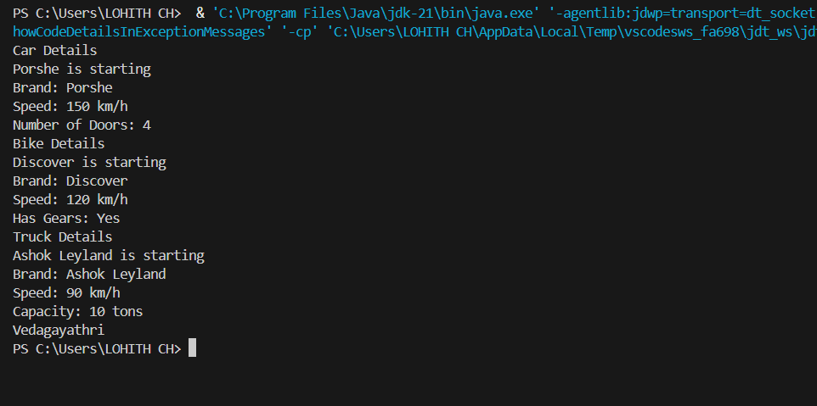

|  |  |  |
| --- | --- | --- |
| **S.NO** | **Errors** | **Rectification** |
| **1** | **.variable** | **We must mention variable name to call the variable.** |
| **2** | **static** | **Static variables contain only one value.** |

**WEEK-6**

1. **Write a java program to create a vechiles class with a method displayinfo() override this method in the car subclass to provide specific information about a car**

* **Company**
* **Model**
* **Price**
* **Seating capacity**
* **Petrol or not**

**Class Diagram:**

|  |
| --- |
| **Vehicle** |
| **+displayInfo(): void** |

|  |
| --- |
| **car** |
| **+displayInfo(): void** |

**Program:**

**class vehicle**

**{**

**public void displayinfo()**

**{**

**System.out.println("This is the vehicle information");**

**}**

**}**

**class car extends vehicle**

**{**

**public void displayinfo(String car_company , String car_model, int car_price,int car_seating_capacity,boolean petrol)**

**{**

**System.out.println("the car company is " + car_company+'\n'+"the car model is "+car_model +'\n'+"the car price is "+car_price+'\n'+"the car seating capacity"+ car_seating_capacity+'\n'+"car fuel tank type is "+petrol);**

**}**

**}**

**class main**

**{**

**public static void main(String[] args)**

**{**

**car c = new car();**

**c.displayinfo();**

**c.displayinfo("BMW","Mrcedies",19934,6,true);**

**}**

**}**

**Output:**

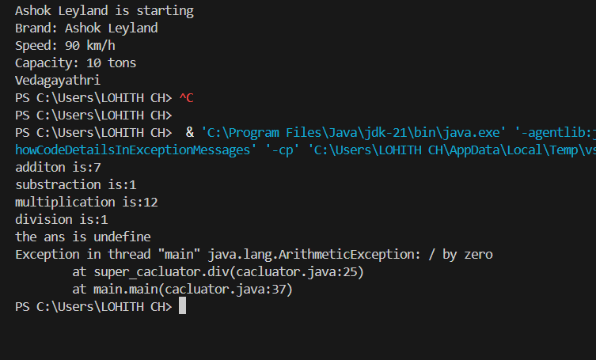

**Error table:**

|  |  |  |
| --- | --- | --- |
| **S.No** | **Expected Error** | **Reason** |
| **1** | **Setting the parameters inside the constructor** | **We cannot pass the values inside constructor without setting them first** |
| **2** | **}** | **Ending the class and main method is required** |

**2Q) A college is developing automated admission system that verifies students eligibility for UG and PG programs .Each program has different eligibility criteria based on the students percentage in their previous qualification.**

* **UG admission require minimum 60%**
* **PG admission require minimum 70%**

**Program:**

**class Admi**

**{**

**double UG=0;**

**double PG=0;**

**public void samp()**

**{**

**this.UG=0;**

**this.PG=0;**

**}**

**public void samp(double UG, double PG)**

**{**

**this.UG=UG;**

**this.PG=PG;**

**}**

**}**

**class Ssion extends Admi**

**{**

**public void UG()**

**{**

**if ( UG<=60 )**

**{**

**System.out.println("In valid for UG because of low score");**

**}**

**else**

**{**

**System.out.println("Student is eligible for UG");**

**}**

**}**

**public void PG()**

**{**

**if ( PG<=70 )**

**{**

**System.out.println("In valid for PG because of low score");**

**}**

**else**

**{**

**System.out.println("Student is eligible for PG");**

**}**

**}**

**}**

**class Admission**

**{**

**public static void main(String args[])**

**{**

**Ssion A = new Ssion();**

**A.samp(69,79);**

**A.UG();**

**A.PG();**

**}**

**}**

**Class Diagram:**

|  |
| --- |
| **adm** |
| **elg():void** |

|  |  |
| --- | --- |
| **ug** | **pg** |
| **+elg():void** | **+elg():void** |

**Output:**

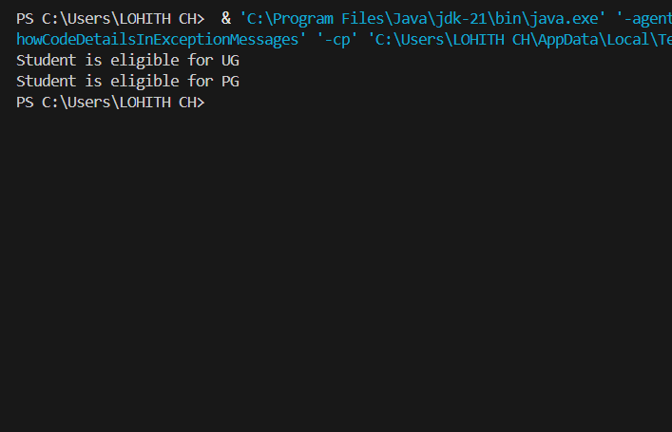

**Error table:**

|  |  |  |
| --- | --- | --- |
| **S.No** | **Expected Error** | **Reason** |
| **1** | **Setting the parameters inside the constructor** | **We cannot pass the values inside constructor without setting them first** |
| **2** | **}** | **Ending the class and main method is required** |

**3Q)Create a calculator class with overloading methods to perform addition**

* **Add two doubles**
* **Add two integer**
* **Add three integer**

**Program:**

**class cacluato{**

**public int add(int a, int b){**

**return a+b;**

**}**

**public Double add(Double a , Double b){**

**return a+b;**

**}**

**public int add(int a, int b, int c){**

**return a+b+c;**

**}**

**}**

**class main{**

**public static void main(String[] args) {**

**cacluato d = new cacluato();**

**System.out.println( "sum of 5 and 6 is:"+ d.add(5, 6));**

**System.out.println("sum of 5.5 and 6.6 is:"+ d.add(5.5,6.6));**

**System.out.println("sum of 5,6 and 7 is:"+ d.add(5,6,7));**

**}**

**}**

**Class Diagram:**

|  |
| --- |
| **cal** |
| **+add(int a,int b):int**  **+add(double a,double b):double**  **+add(int a,int b,int c):int** |

**Output:**

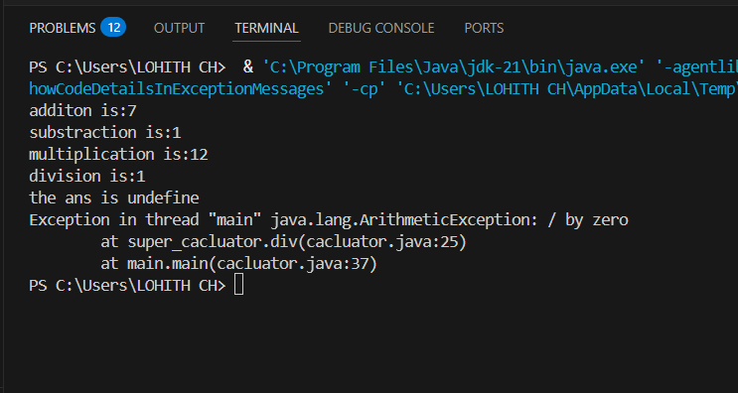

**Error table:**

|  |  |  |
| --- | --- | --- |
| **S.No** | **Expected Error** | **Reason** |
| **1** | **Setting the parameters inside the constructor** | **We cannot pass the values inside constructor without setting them first** |
| **2** | **}** | **Ending the class and main method is required** |

**4Q)Create a shape class with a method calculate area that is overloaded for different shapes Square,Rectangle then create a sub class circle that overerides the calculate area methods for a circle.**

**Program:**

**class shape{**

**public Double area( Double a ){**

**return a*a;**

**}**

**public  Double area(Double length , Double breadth ){**

**return length*breadth;**

**}**

**}**

**class circle extends shape{**

**public Double area(Double radius){**

**return 3.14*radius*radius;**

**}**

**}**

**class main{**

**public static void main(String[]args){**

**shape s = new shape();**

**circle c = new circle();**

**System.out.println("area of square is "+s.area(5.0));**

**System.out.println("area of rectangle is"+s.area(5.0,6.0));**

**System.out.println("area of circle is "+c.area(3.0));**

**}**

**}**

**Class Diagram:**

|  |
| --- |
| **shape** |
| **+calarea(float side):float**  **+calarea(float l,float b):float**  **+calarea(float c):float** |

|  |
| --- |
| **Circle** |
| **+calarea(double r):double** |

**Output:**

**Error table:**

|  |  |  |
| --- | --- | --- |
| **S.No** | **Expected Error** | **Reason** |
| **1** | **Setting the parameters inside the constructor** | **We cannot pass the values inside constructor without setting them first** |
| **2** | **}** | **Ending the class and main method is required** |