Ideation Phase
Brainstorm & Idea Prioritization Template

Date | 31 January 2025
Team ID | SWTID-2026-1588
Project Name | Implement Client Script & UI Policy (Incident)
Maximum Marks | 4 Marks

Brainstorm & Idea Prioritization Template:
Brainstorming provides a free and open environment that encourages everyone within a team to participate in the creative thinking process that leads to problem solving. Prioritizing volume over value, out-of-the-box ideas are welcome and built upon, and all participants are encouraged to collaborate, helping each other develop a rich amount of creative solutions.
Use this template in your own brainstorming sessions so your team can unleash their imagination and start shaping concepts even if you're not sitting in the same room.
Reference: https://www.mural.co/templates/brainstorm-and-idea-prioritization
Step-1: Team Gathering, Collaboration and Select the Problem Statement
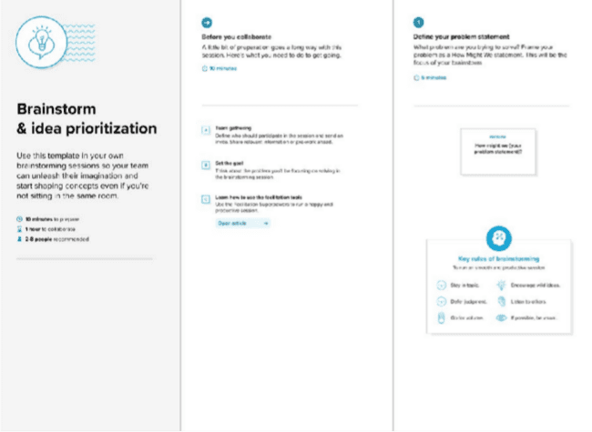

Step-2: Brainstorm, Idea Listing and Grouping
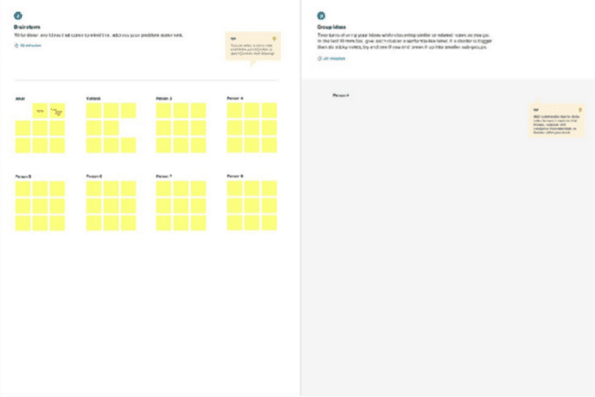

Step-3: Idea Prioritization
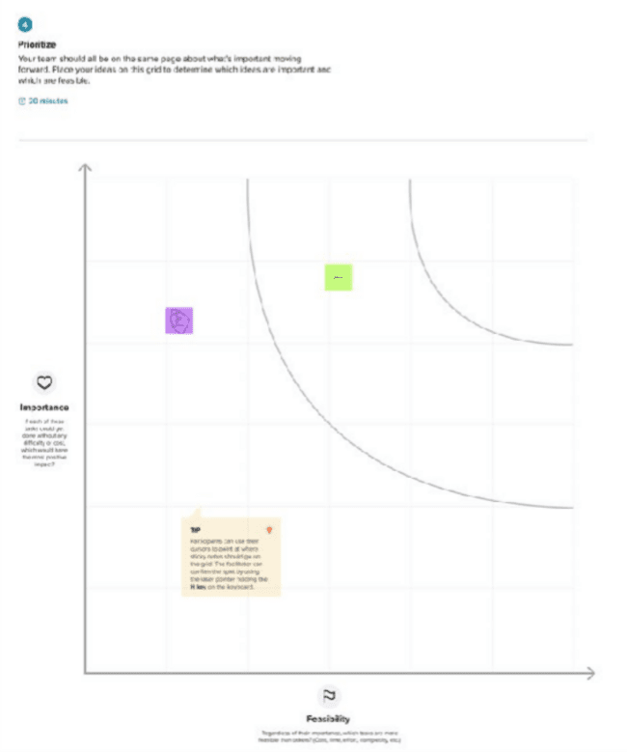

Ideation Phase
Define the Problem Statements

Date | 31 January 2025
Team ID | SWTID-2026-1588
Project Name | Implement Client Script & UI Policy (Incident)
Maximum Marks | 2 Marks

Customer Problem Statement Template:
Create a problem statement to understand your customer's point of view. The Customer Problem Statement template helps you focus on what matters to create experiences people will love.
A well-articulated customer problem statement allows you and your team to find the ideal solution for the challenges your customers face. Throughout the process, you’ll also be able to empathize with your customers, which helps you better understand how they perceive your product or service.
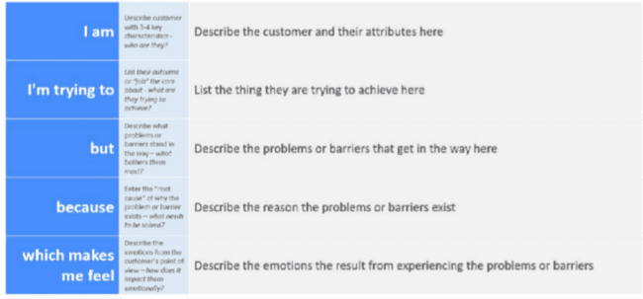
Reference: https://miro.com/templates/customer-problem-statement/
Example:
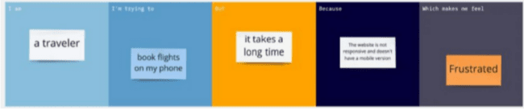

Problem Statement (PS) | I am (Customer) | I’m trying to | But | Because | Which makes me feel
PS-1
PS-2

Ideation Phase Empathize & Discover

Date | 31 January 2025
Team ID | SWTID-2026-1588
Project Name | Implement Client Script & UI Policy (Incident)
Maximum Marks | 4 Marks

Empathy Map Canvas:
An empathy map is a simple, easy-to-digest visual that captures knowledge about a user’s behaviours and attitudes.

It is a useful tool to helps teams better understand their users.
Creating an effective solution requires understanding the true problem and the person who is experiencing it. The exercise of creating the map helps participants consider things from the user’s perspective along with his or her goals and challenges.
Example:
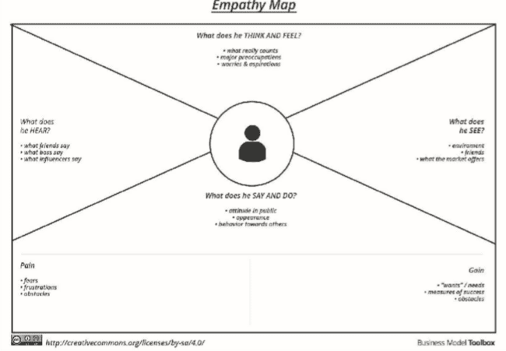

Reference: https://www.mural.co/templates/empathy-map-canvas

Example: Food Ordering & Delivery Application
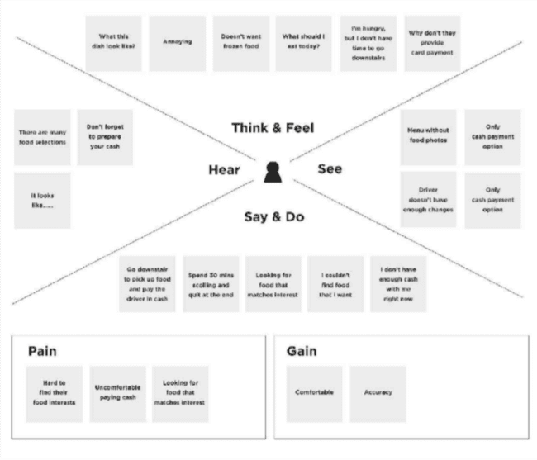

Project Design Phase-II
Data Flow Diagram & User Stories

Date | 31 January 2025
Team ID | SWTID-2026-1588
Project Name | Implement Client Script & UI Policy (Incident)
Maximum Marks | 4 Marks

Data Flow Diagrams:
A Data Flow Diagram (DFD) is a traditional visual representation of the information flows within a system. A neat and clear DFD can depict the right amount of the system requirement graphically. It shows how data enters and leaves the system, what changes the information, and where data is stored.

Example: (Simplified)
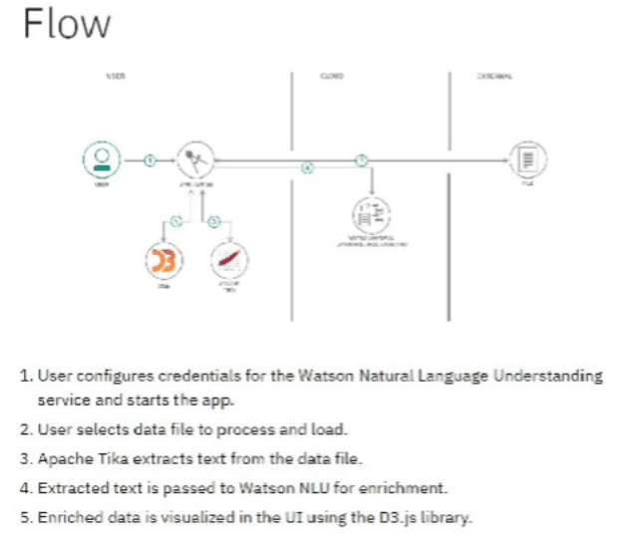

User Stories
Use the below template to list all the user stories for the product.

User Type | Functional Requirement (Epic) | User Story Number | User Story / Task | Acceptance criteria | Priority | Release
Customer (Mobile user) | Registration | USN-1 | As a user, I can register for the application by entering my email, password, and confirming my password. | I can access my account / dashboard | High | Sprint-1
 |  | USN-2 | As a user, I will receive confirmation email once I have registered for the application | I can receive confirmation email & click confirm | High | Sprint-1
 |  | USN-3 | As a user, I can register for the application through Facebook | I can register & access the dashboard with Facebook Login | Low | Sprint-2
 |  | USN-4 | As a user, I can register for the application through Gmail |  | Medium | Sprint-1
 | Login | USN-5 | As a user, I can log into the application by entering email & password |  | High | Sprint-1
 | Dashboard
Customer (Web user)
Customer Care Executive
Administrator

Project Design Phase-II
Solution Requirements (Functional & Non-functional)

Date | 31 January 2025
Team ID | SWTID-2026-1588
Project Name | Implement Client Script & UI Policy (Incident)
Maximum Marks | 4 Marks

Functional Requirements:
Following are the functional requirements of the proposed solution.

FR No. | Functional Requirement (Epic) | Sub Requirement (Story / Sub-Task)
FR-1 | User Registration | Registration through Form Registration through Gmail Registration through LinkedIN
FR-2 | User Confirmation | Confirmation via Email Confirmation via OTP
FR-3
FR-4

Non-functional Requirements:
Following are the non-functional requirements of the proposed solution.

FR No. | Non-Functional Requirement | Description
NFR-1 | Usability
NFR-2 | Security
NFR-3 | Reliability
NFR-4 | Performance
NFR-5 | Availability
NFR-6 | Scalability

Project Design Phase-II Technology Stack (Architecture & Stack)

Date | 31 January 3035
Team ID | SWTID-2026-1588
Project Name | Implement Client Script & UI Policy (Incident)
Maximum Marks | 4 Marks

Technical Architecture:
The Deliverable shall include the architectural diagram as below and the information as per the table1 & table 2
Example: Order processing during pandemics for offline mode
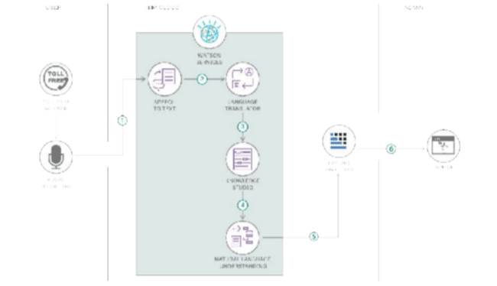
Reference: https://developer.ibm.com/patterns/ai-powered-backend-system-for-order-processing-during-pandemics/
Guidelines:
Include all the processes (As an application logic / Technology Block)
Provide infrastructural demarcation (Local / Cloud) Indicate external interfaces (third party API’s etc.) Indicate Data Storage components / services Indicate interface to machine learning models (if
applicable)

Table-1 : Components & Technologies:

S.No | Component | Description | Technology
1. | User Interface | How user interacts with application e.g. Web UI, Mobile App, Chatbot etc. | HTML, CSS, JavaScript / Angular Js / React Js etc.
2. | Application Logic-1 | Logic for a process in the application | Java / Python
3. | Application Logic-2 | Logic for a process in the application | IBM Watson STT service
4. | Application Logic-3 | Logic for a process in the application | IBM Watson Assistant
5. | Database | Data Type, Configurations etc. | MySQL, NoSQL, etc.
6. | Cloud Database | Database Service on Cloud | IBM DB2, IBM Cloudant etc.
7. | File Storage | File storage requirements | IBM Block Storage or Other Storage Service or Local Filesystem
8. | External API-1 | Purpose of External API used in the application | IBM Weather API, etc.
9. | External API-2 | Purpose of External API used in the application | Aadhar API, etc.
10. | Machine Learning Model | Purpose of Machine Learning Model | Object Recognition Model, etc.
11. | Infrastructure (Server / Cloud) | Application Deployment on Local System / Cloud Local Server Configuration:  Cloud Server Configuration : | Local, Cloud Foundry, Kubernetes, etc.

Table-2: Application Characteristics:

S.No | Characteristics | Description | Technology
1. | Open-Source Frameworks | List the open-source frameworks used | Technology of Opensource framework
2. | Security Implementations | List all the security / access controls implemented, use of firewalls etc. | e.g. SHA-256, Encryptions, IAM Controls, OWASP etc.

S.No | Characteristics | Description | Technology
3. | Scalable Architecture | Justify the scalability of architecture (3 – tier, Micro-services) | Technology used
4. | Availability | Justify the availability of application (e.g. use of load balancers, distributed servers etc.) | Technology used
5. | Performance | Design consideration for the performance of the application (number of requests per sec, use of Cache, use of CDN’s) etc. | Technology used

References:
https://c4model.com/
https://developer.ibm.com/patterns/online-order-processing-system-during-pandemic/ https://www.ibm.com/cloud/architecture
https://aws.amazon.com/architecture
https://medium.com/the-internal-startup/how-to-draw-useful-technical-architecture-diagrams-2d20c9fda90d

Project Design Phase Problem – Solution Fit Template

Date | 15 February 2025
Team ID | SWTID-2026-1588
Project Name | Implement Client Script & UI Policy (Incident)
Maximum Marks | 2 Marks

Problem – Solution Fit Template:
The Problem-Solution Fit simply means that you have found a problem with your customer and that the solution you have realized for it actually solves the customer’s problem. It helps entrepreneurs, marketers and corporate innovators identify behavioral patterns and recognize what would work and why
Purpose:
- Solve complex problems in a way that fits the state of your customers.
- Succeed faster and increase your solution adoption by tapping into existing mediums and channels of behavior.
- Sharpen your communication and marketing strategy with the right triggers and messaging.
- Increase touch-points with your company by finding the right problem-behavior fit and building trust by solving frequent annoyances, or urgent or costly problems.
- Understand the existing situation in order to improve it for your target group.

Template:
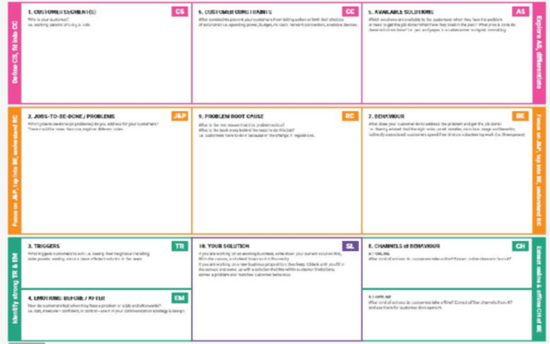
References:
- https://www.ideahackers.network/problem-solution-fit-canvas/
- https://medium.com/@epicantus/problem-solution-fit-canvas-aa3dd59cb4fe

Project Design Phase Proposed Solution Template

Date | 15 February 2025
Team ID | SWTID-2026-1588
Project Name | Implement Client Script & UI Policy (Incident)
Maximum Marks | 2 Marks

Proposed Solution Template:
Project team shall fill the following information in the proposed solution template.

S.No. | Parameter | Description
1. | Problem Statement (Problem to be solved)
2. | Idea / Solution description
3. | Novelty / Uniqueness
4. | Social Impact / Customer Satisfaction
5. | Business Model (Revenue Model)
6. | Scalability of the Solution

Project Design Phase Solution Architecture

Date | 15 February 2025
Team ID | SWTID-2026-1588
Project Name | Implement Client Script & UI Policy (Incident)
Maximum Marks | 4 Marks

Solution Architecture:
Solution architecture is a complex process – with many sub-processes – that bridges the gap between business problems and technology solutions. Its goals are to:

  - Find the best tech solution to solve existing business problems.
  - Describe the structure, characteristics, behavior, and other aspects of the software to project stakeholders.
  - Define features, development phases, and solution requirements.
  - Provide specifications according to which the solution is defined, managed, and delivered.

Example - Solution Architecture Diagram:

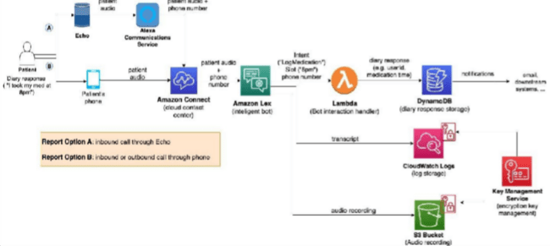
Figure 1: Architecture and data flow of the voice patient diary sample application
Reference: https://aws.amazon.com/blogs/industries/voice-applications-in-clinical-research-powered-by-ai-on-aws-part-1-architecture-and-design-considerations/

A Sprint fixed period or duration in which a team works to complete a set of tasks
An Epic is a big task or project that is too large to complete in one sprint. It is broken down into smaller tasks (stories) that can be completed over multiple sprints.
A Story is a small task . It is part of an Epic.
A Story Point is a number that represents how much effort a story takes to complete. (usually in form of Fibonacci series)
- Very Easy task
- Normal task
- Moderate task
5- Difficult task

Storypoint -5 (1,2,3,5)

Sprint 1
Data Collection (Epic 1)
Gathering Data (USN1) 2 Loading Data(USN2) 1
Data Preparation (Epic 2)
Handling Missing Values(USN3) 3 Creating Fields(USN4)3
Handling Inconsistency in Data(USN5)3 Total Story Point in Sprint 1= 2+1+3+3+3=12

Sprint 2
Data Visualization (Epic 3) Bar Chart(USN6) 2
Pie Chart(USN7) 2
Line Chart(USN8) 2
Map(USN9) 4

Dashboard (Epic 4)
Developing Dashboard(USN10) 5
Story (Epic 5)
Developing Story(USN11) 5

Total story Point in Sprint 2= 2+2+2+4+5+5=20

Total Story Points
Sprint 1 = 12
Sprint 2 = 20

Velocity= Total Story Points Completed/ Number of Sprints Total story Points= 12+20=32
No of Sprints= 2
Velocity =32/2
16(Story Points per Sprint)
Your team’s velocity is 16 Story Points per Sprint.

Project Planning Phase
Project Planning Template (Product Backlog, Sprint Planning, Stories, Story points)

Date | 15 February 2025
Team ID | SWTID-2026-1588
Project Name | Implement Client Script & UI Policy (Incident)
Maximum Marks | 5 Marks

Product Backlog, Sprint Schedule, and Estimation (4 Marks)
Use the below template to create product backlog and sprint schedule

Sprint | Functional Requirement (Epic) | User Story Number | User Story / Task | Story Points | Priority | Team Members
Sprint-1 | Registration | USN-1 | As a user, I can register for the application by entering my email, password, and confirming my password. | 2 | High
Sprint-1 |  | USN-2 | As a user, I will receive confirmation email once I have registered for the application | 1 | High
Sprint-2 |  | USN-3 | As a user, I can register for the application through Facebook | 2 | Low
Sprint-1 |  | USN-4 | As a user, I can register for the application through Gmail | 2 | Medium
Sprint-1 | Login | USN-5 | As a user, I can log into the application by entering email & password | 1 | High
 | Dashboard

Project Tracker, Velocity & Burndown Chart: (4 Marks)

Sprint | Total Story Points | Duration | Sprint Start Date | Sprint End Date (Planned) | Story Points Completed (as on Planned End Date) | Sprint Release Date (Actual)
Sprint-1 | 20 | 6 Days | 24 Oct 2022 | 29 Oct 2022 | 20 | 29 Oct 2022
Sprint-2 | 20 | 6 Days | 31 Oct 2022 | 05 Nov 2022
Sprint-3 | 20 | 6 Days | 07 Nov 2022 | 12 Nov 2022
Sprint-4 | 20 | 6 Days | 14 Nov 2022 | 19 Nov 2022

Velocity:
Imagine we have a 10-day sprint duration, and the velocity of the team is 20 (points per sprint). Let’s calculate the team’s average velocity (AV) per iteration unit (story points per day)
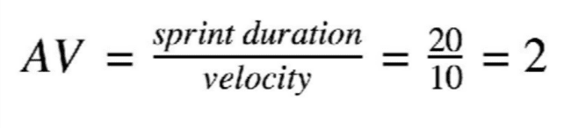

Burndown Chart:

A burn down chart is a graphical representation of work left to do versus time. It is often used in agile software development methodologies such as Scrum. However, burn down charts can be applied to any project containing measurable progress over time.

https://www.visual-paradigm.com/scrum/scrum-burndown-chart/ https://www.atlassian.com/agile/tutorials/burndown-charts

Reference:
https://www.atlassian.com/agile/project-management https://www.atlassian.com/agile/tutorials/how-to-do-scrum-with-jira-software https://www.atlassian.com/agile/tutorials/epics https://www.atlassian.com/agile/tutorials/sprints https://www.atlassian.com/agile/project-management/estimation https://www.atlassian.com/agile/tutorials/burndown-charts

Project Development Phase Model Performance Test

Date | 10 February 2025
Team ID | SWTID-2026-1588
Project Name | Implement Client Script & UI Policy (Incident)
Maximum Marks

Model Performance Testing:
Project team shall fill the following information in model performance testing template.

S.No. | Parameter | Values | Screenshot
1. | Model Summary | -
2. | Accuracy | Training Accuracy -  Validation Accuracy -
3. | Fine Tunning Result( if Done) | Validation Accuracy -

Functional & Performance Testing Template
Model Performance Test

Date | 21 February 2025
Team ID | SWTID-2026-1588
Project Name | Implement Client Script & UI Policy (Incident)
Maximum Marks

Test Scenarios & Results

Test Case ID | Scenario (What to test) | Test Steps (How to test) | Expected Result | Actual Result | Pass/Fail
FT-01 | Text Input Validation (e.g., topic, job title) | Enter valid and invalid text in input fields | Valid inputs accepted, errors for invalid inputs
FT-02 | Number Input Validation (e.g., word count, size, rooms) | Enter numbers within and outside the valid range | Accepts valid values, shows error for out-of-range
FT-03 | Content Generation (e.g., blog, resume, design idea) | Provide complete inputs and click "Generate" | Correct content is generated based on input
FT-04 | API Connection Check | Check if API key is correct and model responds | API responds successfully
PT-01 | Response Time Test | Use a timer to check content generation time | Should be under 3 seconds
PT-02 | API Speed Test | Send multiple API calls at the same time | API should not slow down
PT-03 | File Upload Load Test (e.g., PDFs) | Upload multiple PDFs and check processing | Should work smoothly without crashing

Project Development Phase Model Performance Test

Date | 10 February 2025
Team ID | SWTID-2026-1588
Project Name | Implement Client Script & UI Policy (Incident)
Maximum Marks | 10 Marks

Model Performance Testing:
Project team shall fill the following information in model performance testing template.

S.No. | Parameter | Values | Screenshot
1. | Metrics | Regression Model:  MAE - , MSE - , RMSE - , R2 score -  Classification Model:  Confusion Matrix - , Accuray Score-& Classification Report -
2. | Tune the Model | Hyperparameter Tuning - Validation Method -

Project Development Phase Model Performance Test

Date | 10 February 2025
Team ID | SWTID-2026-1588
Project Name | Implement Client Script & UI Policy (Incident)
Maximum Marks

Model Performance Testing:
Project team shall fill the following information in model performance testing template.

S.No. | Parameter | Screenshot / Values
1. | Data Rendered
2. | Data Preprocessing
3. | Utilization of Data Filters
4. | DAX Queries Used
5. | Dashboard design | No of Visualizations / Graphs -
6 | Report Design | No of Visualizations / Graphs -

Project Development Phase Model Performance Test

Date | 21 February 2025
Team ID | SWTID-2026-1588
Project Name | Implement Client Script & UI Policy (Incident)
Maximum Marks

Model Performance Testing:
Project team shall fill the following information in model performance testing template.

S.No. | Parameter | Values | 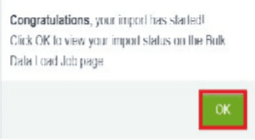  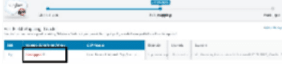  Screenshot
1. | Model Summary | Salesforce automation setup for Data management using Object, Fields and Reports.  Note : Import Records if data Match Correctly then Records will Created or Else it will Show Error | 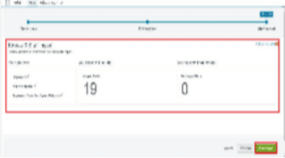
2. | Accuracy | Training Accuracy - 98% Validation Accuracy - 98%
3. | Confidence Score (Only Yolo Projects) | Class Detected - If detecting Object and fields name if wrong and other activity  Confidence Score - If the model is 92% sure the object is correctly detected | 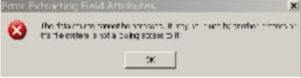

Project Development Phase Performance Test

Date | 10 February 2025
Team ID | SWTID-2026-1588
Project Name | Implement Client Script & UI Policy (Incident)
Maximum Marks

Model Performance Testing:
Project team shall fill the following information in model performance testing template.

S.No. | Parameter | Screenshot / Values
1. | Data Rendered
2. | Data Preprocessing
3. | Utilization of Filters
4. | Calculation fields Used
5. | Dashboard design | No of Visualizations / Graphs -
6 | Story Design | No of Visualizations / Graphs -

User Acceptance Testing (UAT) Template
Screenshot placement note: The generic screenshot columns in the model-performance/BI sections are not populated because the uploaded evidence is for a ServiceNow Client Script & UI Policy project, not a model, dashboard, or BI report.

Date
Team ID | SWTID-2026-1588
Project Name | Implement Client Script & UI Policy (Incident)
Maximum Marks

Project Overview:
Project Name: [Enter Project Name]
Project Description: [Brief Description of the Project] Project Version: [Version Number]
Testing Period: [Start Date] to [End Date]
Testing Scope:
[List of Features and Functionalities to be Tested] [List of User Stories or Requirements to be Tested] Testing Environment:
URL/Location: [Web URL or Application Location] Credentials (if required): [Username/Password]

Test Case ID | Test Scenario | Test Steps | Expected Result | Actual Result | Pass/Fail
TC-001 | [Describe the scenario to be tested] | [Step 1]  [Step 2]  [Step 3] | [Describe the expected outcome] | [Record the actual outcome] | [Pass/Fail]
... | ... | ... | ... | ... | ...
Test Cases:

Bug Tracking:

Bug ID | Bug Description | Steps to reproduce | Severity | Status | Additional feedback
BG-001 | [Describe the issue or bug encountered  ] | [Step 1]  [Step 2]  [Step 3] | [Low/Medi um/High] | [Open/In Progress/ Closed] | [Any additional comments or feedback]
... | ... | ... | ... | ... | ...

Sign-off:
Tester Name: [Name of Tester] Date: [Date of Test Completion] Signature: [Tester's Signature] Notes:
- Ensure that all test cases cover both positive and negative scenarios.
- Encourage testers to provide detailed feedback, including any suggestions for improvement.
- Bug tracking should include details such as severity, status, and steps to reproduce.
- Obtain sign-off from both the project manager and product owner before proceeding with deployment.

Full Stack Development with MERN Project Documentation format

Introduction
  - Project Title: Implement Client Script & UI Policy (Incident)
  - Team Members: Leader-Lohith Kumar. B
Mahesh kumar G Lingesh Kumar S Gautham Krishna A M Abilash L

Project Overview
  - Purpose: Briefly describe the purpose and goals of the project. •
Features: Highlight key features and functionalities.

Architecture
  - Frontend: Describe the frontend architecture using React.
  - Backend: Outline the backend architecture using Node.js and Express.js. •
Database: Detail the database schema and interactions with MongoDB.

Setup Instructions
  - Prerequisites: List software dependencies (e.g., Node.js, MongoDB). •
Installation: Step-by-step guide to clone, install dependencies, and set up the environment variables.

Folder Structure
  - Client: Describe the structure of the React frontend.
  - Server: Explain the organization of the Node.js backend.

Running the Application
  - Provide commands to start the frontend and backend servers locally. o
Frontend: npm start in the client directory.
o Backend: npm start in the server directory.

API Documentation
  - Document all endpoints exposed by the backend.
  - Include request methods, parameters, and example responses.

Authentication

  - Explain how authentication and authorization are handled in the project. •
Include details about tokens, sessions, or any other methods used.

User Interface
  - Provide screenshots or GIFs showcasing different UI features.
Project UI / Configuration Screenshots
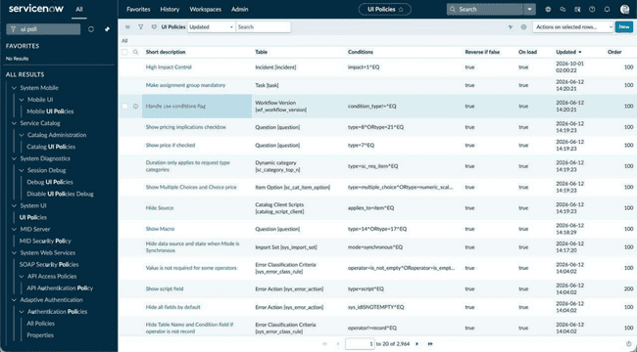
Figure: UI Policy list showing the Incident-related UI policy configuration.
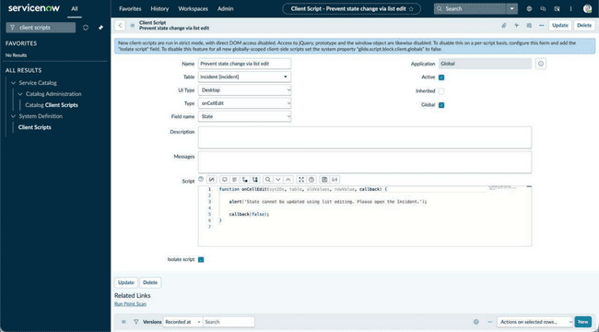
Figure: Client Script preventing State changes through list editing.
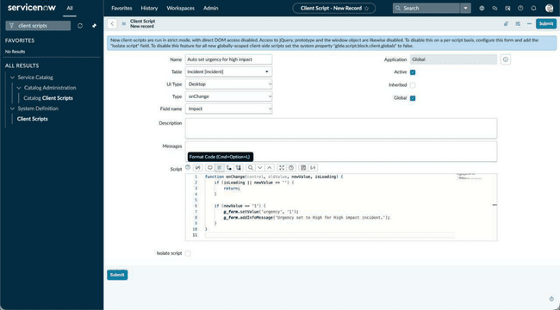
Figure: Client Script that sets urgency based on High Impact.
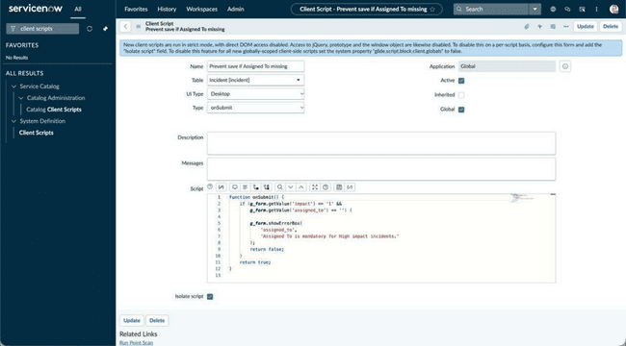
Figure: Client Script validating Assigned To before saving a High Impact incident.
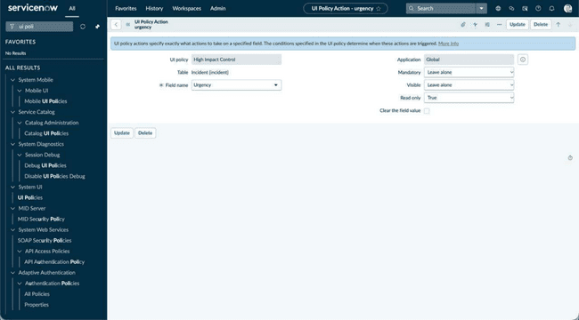
Figure: UI Policy Action configuring the Urgency field.
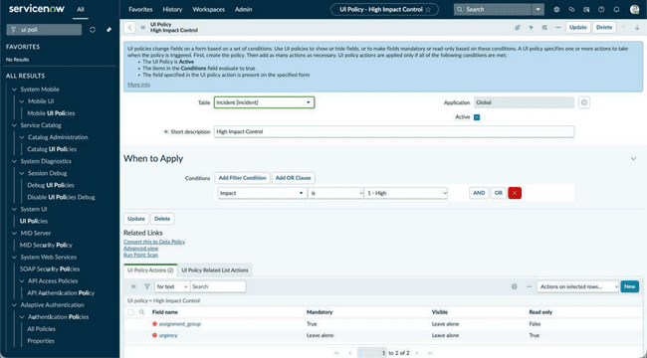
Figure: High Impact Control UI Policy and its conditions/actions.
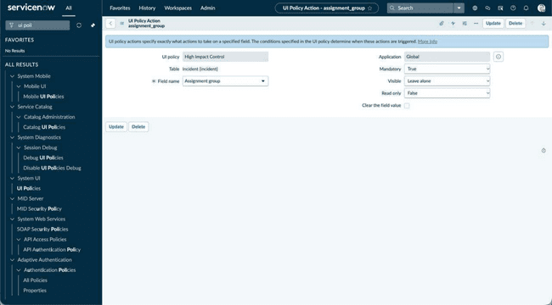
Figure: UI Policy Action making Assignment group mandatory.

Testing
  - Describe the testing strategy and tools used.
Observed Testing / Validation Screenshots
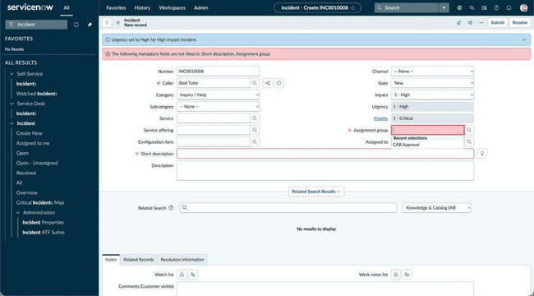
Test result: High Impact sets Urgency to High and displays mandatory-field validation.
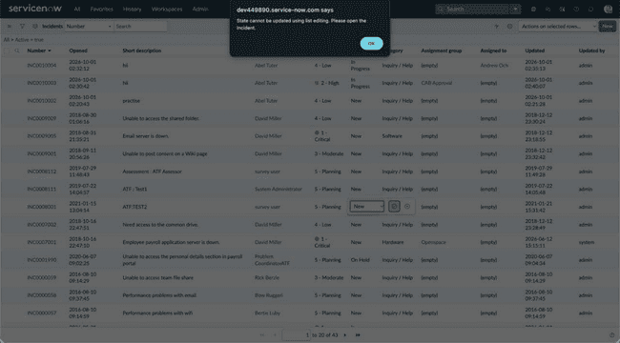
Test result: list editing of State is blocked with an alert.
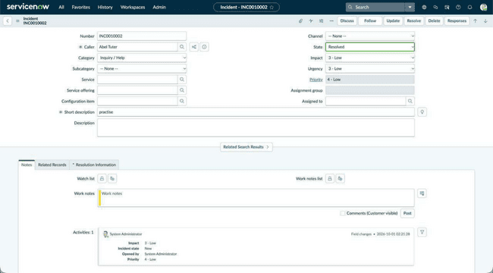
Test result: Incident record displaying the configured fields and values.
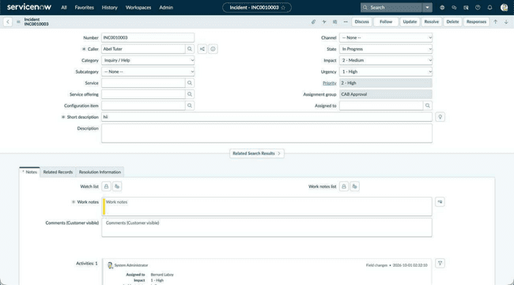
Test result: existing Incident record after applying the configuration.

Screenshots or Demo
  - Provide screenshots or a link to a demo to showcase the application.
Representative Demo Screenshots
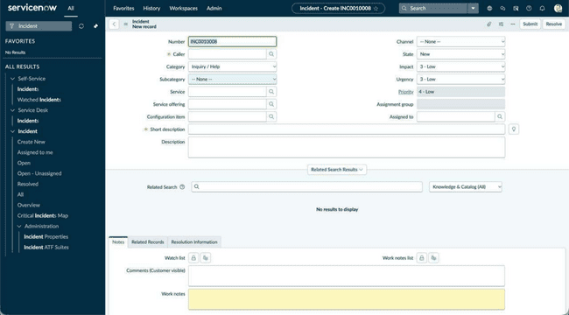
Demo: Incident creation form before applying the rules.
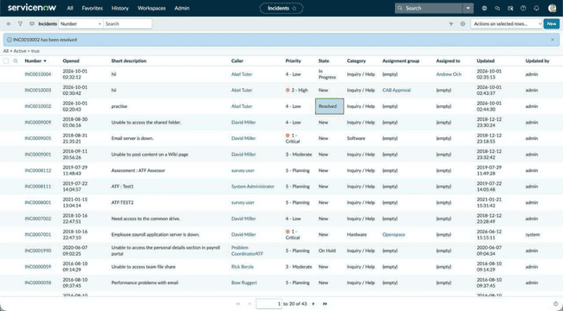
Demo: Incident list showing the project records.

Known Issues

  - Document any known bugs or issues that users or developers should be aware of.

Future Enhancements

  - Outline potential future features or improvements that could be made to the project.

