EX NO:2 | Chebyshev IIR Filter
DATE: | 2.1. Design and Performance Evaluation of a Chebyshev Type-I IIR Low-Pass Filter using MATLAB

Objectives:
  - To design and analyze the magnitude response, phase response, impulse response, and group delay characteristics of the Chebyshev Type-I IIR low-pass filter for the given passband and stopband specifications.
  - To analyze the impulse response, and group delay characteristics of the Chebyshev Type-I IIR low-pass filter for the given passband and stopband specifications.
  - To examine the pole-zero plot and verify the stability and performance of the designed low-pass filter.
  - To determine the minimum filter order and cutoff frequency required to satisfy the design constraints.

Procedure
- Open MATLAB and create a new script file.
- Define the filter specifications such as passband ripple (Rp), stopband attenuation (Rs), passband frequency (Fp), stopband frequency (Fsb), and sampling frequency (Fs) for the Chebyshev Type-I filter design.
- Normalize the passband and stopband frequencies with respect to the Nyquist frequency (Fs/2).
- Use the cheb1ord() function to determine the minimum order and cutoff frequency of the Chebyshev Type-I low-pass and high-pass filters.
- Design the Chebyshev Type-I low-pass and high-pass filters using the cheby1() function and obtain the filter coefficients.
- Display the filter order and cutoff frequency, and compute the frequency response of the designed filters using the freqz() function.
- Plot the magnitude response, phase response, impulse response, group delay response, and pole-zero plot using the appropriate MATLAB functions to analyze the filter characteristics and stability.
- Execute the program, analyze the obtained responses and filter characteristics, record the results, and verify that the designed Chebyshev Type-I filters satisfy the given specifications

Program (MATLAB Code)
clc; clear;

Wp=0.4; Ws=0.55; Rp=1; As=40;

[N,Wn]=cheb1ord(Wp,Ws,Rp,As);
[b,a]=cheby1(N,Rp,Wn);

fprintf('Filter Order = %d\n',N);
fprintf('Cutoff Frequency = %.2f * pi rad/sample\n',Wn);

if all(abs(roots(a))<1) disp('System is STABLE');
else
disp('System is UNSTABLE'); end

% -------- GRAPHS --------
figure; freqz(b,a); % Magnitude + Phase figure; impz(b,a); % Impulse Response figure; grpdelay(b,a); % Group Delay figure; zplane(b,a); % Pole-Zero

Output:

Objective 1:

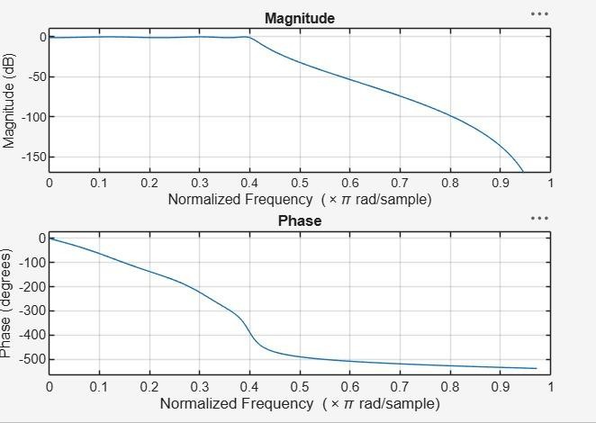

Objective 2:

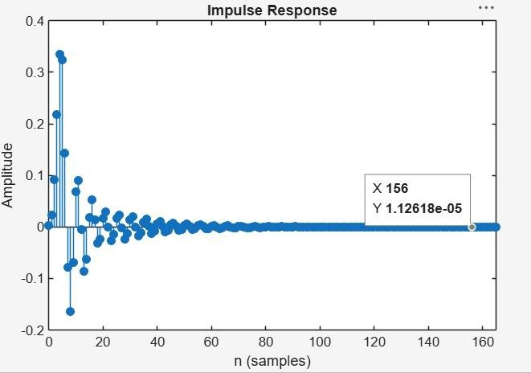

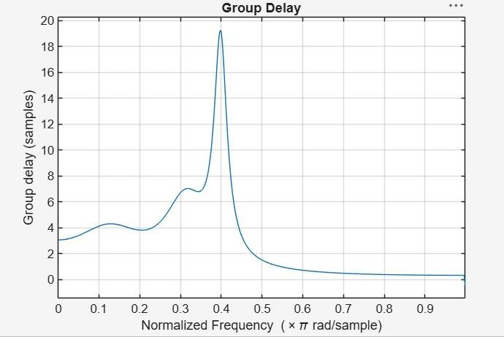

Objective 3:

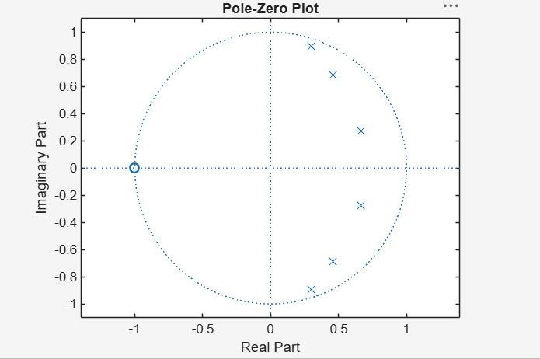
Objective 4:
Filter Order = 6
Cutoff Frequency = 0.40 * pi rad/sample System is STABLE
Result:

- The Chebyshev Type-I IIR low-pass filter was successfully designed, and its magnitude response, phase response, impulse response, and group delay were analyzed.
- The impulse response and group delay characteristics were obtained and found to satisfy the given specifications.
- The pole-zero plot confirmed that all poles lie inside the unit circle, verifying the stability and proper performance of the filter.
- The minimum filter order and cutoff frequency were successfully determined and found to satisfy the given design specifications.

EX NO:2 | Chebyshev IIR Filter
DATE: | 2.2. Design and Performance Evaluation of a Chebyshev Type-I IIR High-Pass Filter

Objectives:

  - To design and analyze the magnitude response, phase response, impulse response, and group delay characteristics of the Chebyshev Type-I IIR High-pass filter for the given passband and stopband specifications.
  - To analyze the impulse response, and group delay characteristics of the Chebyshev Type-I IIR high-pass filter for the given passband and stopband specifications.
  - To examine the pole-zero plot and verify the stability and performance of the designed high-pass filter.
  - To determine the minimum filter order and cutoff frequency required to satisfy the design constraints.

Procedure

- Open MATLAB and specify the passband frequency, stopband frequency, passband ripple, stopband attenuation, and sampling frequency.
- Normalize the frequencies with respect to the Nyquist frequency.
- Determine the minimum filter order and cutoff frequency using cheb1ord.
- Design the Chebyshev Type-I IIR High-Pass Filter using cheby1.
- Obtain the filter coefficients and frequency response using freqz.
- Plot and analyze the magnitude and phase responses.
- Obtain and analyze the impulse response using impz.
- Determine the group delay response using grpdelay.
- Plot the pole-zero diagram using zplane.
- Verify stability by ensuring that all poles lie inside the unit circle and record the observations.

Program (MATLAB Code)
clc; clear; close all;

% Specifications
Rp = 1; % Passband Ripple (dB)
Rs = 40; % Stopband Attenuation (dB) Wp = 0.5; % Passband Edge

Ws = 0.35; % Stopband Edge

% Find Filter Order
[n,Wn] = cheb1ord(Wp,Ws,Rp,Rs);

% Design High-Pass Filter [b,a] = cheby1(n,Rp,Wn,'high');

% Frequency Response figure;
freqz(b,a);
title('Frequency Response');

% Impulse Response figure;
impz(b,a);
title('Impulse Response');

% Group Delay figure; grpdelay(b,a); title('Group Delay');

% Pole-Zero Plot figure; zplane(b,a);
title('Pole-Zero Plot');

fprintf('Filter Order = %d\n',n);

fprintf('Cutoff Frequency = %.4f\n',Wn);

Output:; Objective-1:
Filter Order = 6
Cutoff Frequency = 0.5000

Objective 2:
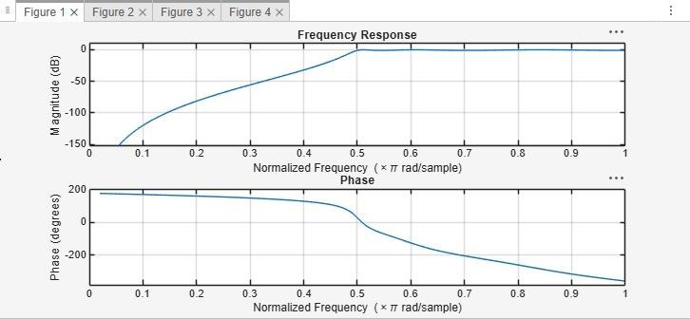

Objective 3:
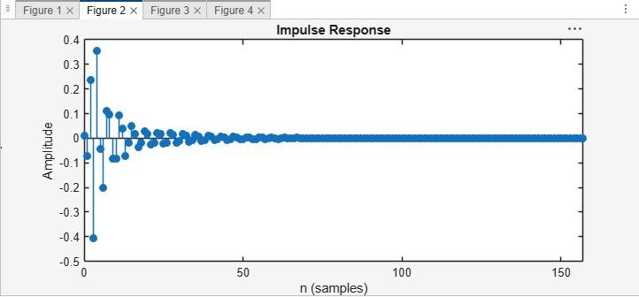

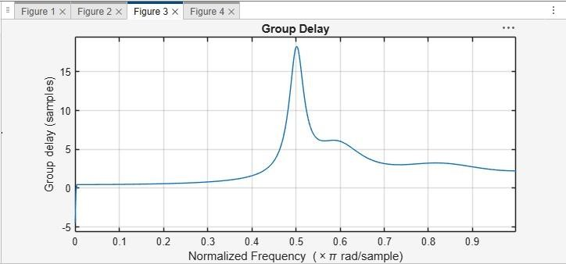
Objective 4:
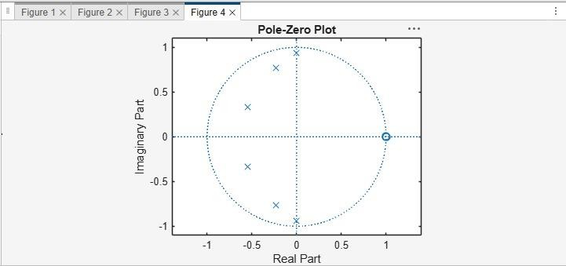

Result:

- The Chebyshev Type-I IIR High-pass filter was successfully designed, and its magnitude response, phase response, impulse response, and group delay were analyzed.
- The impulse response and group delay characteristics were obtained and found to satisfy the given specifications.
- The pole-zero plot confirmed that all poles lie inside the unit circle, verifying the stability and proper performance of the filter.
- The minimum filter order and cutoff frequency were successfully determined and found to satisfy the given design specifications.

