Expt 8 | Multirate Signal Processing
Date: | 8.1 Implementation and Analysis of Decimation and Interpolation in Multirate Signal Processing Using MATLAB

Objectives

- To generate a discrete-time sinusoidal sequence for multirate signal processing.
- To perform decimation of a discrete-time sequence by a factor of 2.
- To perform Interpolation of a discrete-time sequence by a factor of 2.
- To analyze and compare the original, decimated, and interpolated sequences.

Procedure

- Open MATLAB and initialize the workspace using clc, clear, and close all.
- Generate a discrete-time sinusoidal sequence with the desired frequency and sampling rate.
- Perform decimation by selecting every 𝑀^{𝑡ℎ}sample using the downsample() function.
- Perform interpolation by inserting zeros and filtering using the upsample() function.
- Display the original signal samples.
- Display the decimated signal samples.
- Display the interpolated signal samples.
- Plot and compare the original, decimated, and interpolated signals.

Program (Matlab Code)

clc; clear;close all;

% Original Sequence n= 0:40;
x = sin(0.3*pi*n);

% Decimation by 2 y= x(1:2:end);

nd = 0:length(y)-1;

% Interpolation by 2

v = zeros(1,2*length(x)); v(1:2:end)= x;
ni = 0:length(v)-1;

% Figure 1: Original Sequence figure;
stem(n,x,'filled'); grid on;
title('Original Sequence x[n]'); xlabel('n'); ylabel('Amplitude');

% Figure 2: Decimated Sequence figure;
stem(nd,y,'filled'); grid on;
title('Decimated Sequence by 2'); xlabel('n');
ylabel('Amplitude');

% Figure 3: Interpolated Sequence

figure; stem(ni,v,'filled');grid on;
title('Interpolated Sequence by 2'); xlabel('n');
ylabel('Amplitude');

% Figure 4: Comparison figure;
stem(n,x,'b'); hold on; stem(0:2:length(v)-2,v(1:2:end),'r');
legend('Original x[n]','Interpolated Samples'); grid on;
title('Comparison of Sequences'); xlabel('n');
ylabel('Amplitude'); Output: Objective 1:

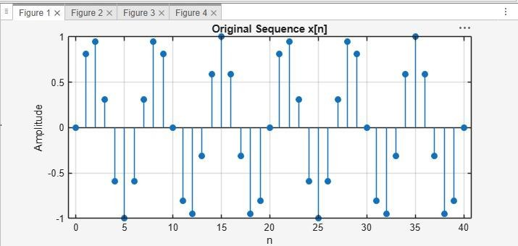

Objective 2:
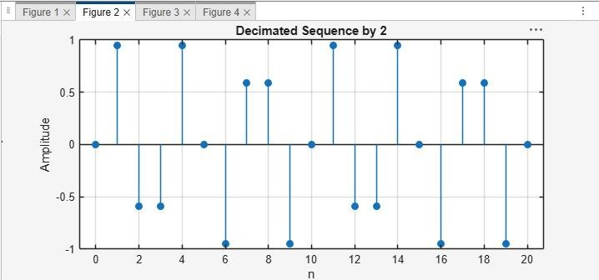

Objective 3:

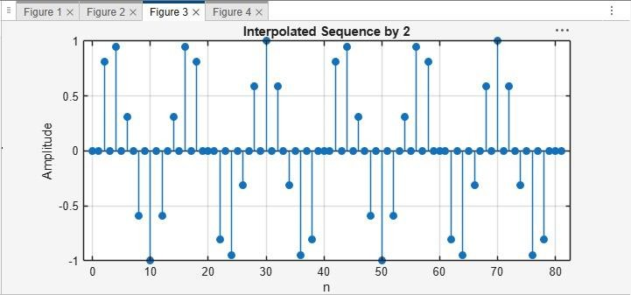

Objective 4:
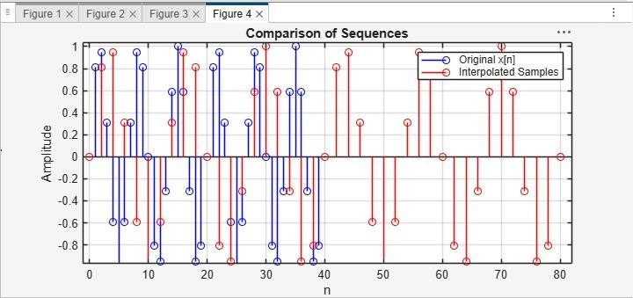

Result :

- A discrete-time sinusoidal sequence was successfully generated for multirate processing.
- The discrete-time sequence was successfully decimated by a factor of 2, reducing the number of samples and the sampling rate.
- The discrete-time sequence was successfully interpolated by a factor of 2, increasing the number of samples and the sampling rate.

- . The effects of downsampling and upsampling were successfully analyzed by comparing the original, decimated, and interpolated signals.

Expt 8 | Multirate Signal Processing
Date: | 8.2 Polyphase Implementation of Decimation and Interpolation Filters Using MATLAB

Objectives:
- To perform sampling rate reduction of a discrete-time signal using a polyphase FIR decimation filter with a decimation factor of 2.
- To perform sampling rate increase of a discrete-time signal using a polyphase FIR interpolation filter with an interpolation factor of 2.
- To reconstruct the original signal from the decimated signal through interpolation and compare the reconstructed signal with the original input signal.
- To demonstrate the computational efficiency and effectiveness of polyphase filter structures in multirate digital signal processing applications.

Procedure
- Generate the Input Signal
- Design the FIR Low-Pass Filter
- Perform Polyphase Decimation Choose the decimation factor 𝑴 = 𝟐.
- Perform Polyphase Interpolation Choose the interpolation factor 𝐿 = 2.
- Analyze the Signals Plot the original signal, decimated signal, and interpolated signal in the time domain.
- Analyze the Frequency Response Obtain the frequency response of the FIR filter using the freqz() function.
- Verify Signal Lengths Display the lengths of the original, decimated, and interpolated signals.
- Verify successful decimation by a factor of 2. Verify successful interpolation by a factor of
- Conclude that polyphase implementation achieves efficient multirate processing with reduced computational complexity.

Program (Matlab coding):
clc; clear; close all;
%% Input Signal
Fs = 1000; % Sampling Frequency
t = 0:1/Fs:1; % Time Vector
% Test Signal
x = sin(2*pi*50*t) + 0.5*sin(2*pi*120*t);

%% FIR Low-Pass Filter Design
N = 20; % Filter Order
Fc = 0.4; % Normalized Cutoff Frequency h = fir1(N,Fc,hamming(N+1));
%% Decimation Factor M = 2;
% Polyphase Decimation y_dec =upfirdn(x,h,1,M);
%% Interpolation Factor L = 2;
% Polyphase Interpolation y_int = upfirdn(y_dec,h,L,1);
%% Adjust Length for Comparison if length(y_int) > length(x)
y_int = y_int(1:length(x)); elseif length(y_int) < length(x)
x = x(1:length(y_int)); end
%% Time Axes
t1 = (0:length(x)-1)/Fs;
t2 = (0:length(y_dec)-1)/(Fs/M); t3 = (0:length(y_int)-1)/Fs;
%% BEST GRAPH OUTPUT
figure('Name','Polyphase Decimation and Interpolation','NumberTitle','off');
% Original Signal subplot(4,1,1) plot(t1,x,'b','LineWidth',1.5) title('Original Input Signal') xlabel('Time (s)')

ylabel('Amplitude') grid on
% Decimated Signal subplot(4,1,2) stem(t2,y_dec,'r','filled') title('Decimated Signal (M = 2)') xlabel('Time (s)') ylabel('Amplitude')
grid on
% Interpolated Signal subplot(4,1,3) plot(t3,y_int,'k','LineWidth',1.5)
title('Interpolated/Reconstructed Signal (L = 2)') xlabel('Time (s)')
ylabel('Amplitude') grid on
% Comparison subplot(4,1,4) plot(t1,x,'b','LineWidth',1.5) hold on
plot(t3,y_int,'r--','LineWidth',1.5)
title('Comparison of Original and Reconstructed Signals') xlabel('Time (s)')
ylabel('Amplitude')
legend('Original Signal','Reconstructed Signal') grid on
%% Display Information
disp(' ');
disp('POLYPHASE DECIMATION & INTERPOLATION');

disp(' ');
fprintf('Original Signal Length = %d\n',length(x)); fprintf('Decimated Signal Length = %d\n',length(y_dec)); fprintf('Interpolated Signal Length = %d\n',length(y_int));
%% Separate Figure for Better Visualization figure;
plot(t1,x,'b','LineWidth',2) hold on
plot(t3,y_int,'r--','LineWidth',2) title('Original vs Reconstructed Signal') xlabel('Time (s)')
ylabel('Amplitude')
legend('Original Signal','Reconstructed Signal') grid on

Output:

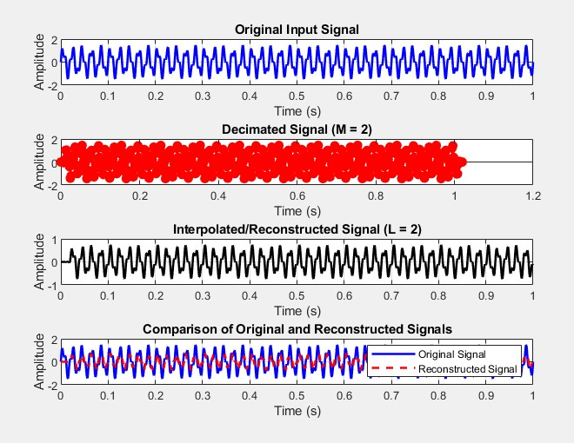

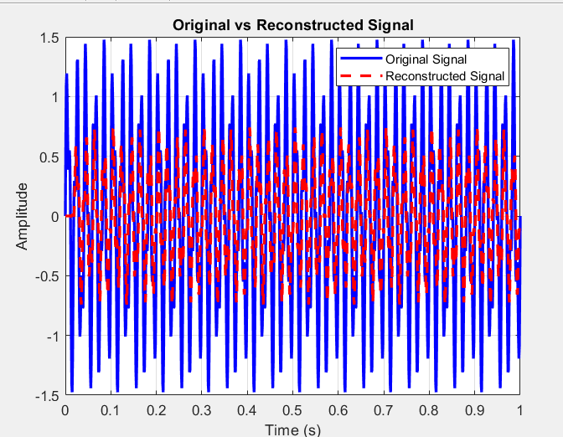

POLYPHASE DECIMATION & INTERPOLATION

Original Signal Length = 1001 Decimated Signal Length = 511 Interpolated Signal Length = 1001 Result :
- The input signal was successfully decimated by a factor of 2 using a polyphase FIR decimation filter.
- The input signal was successfully interpolated by a factor of 2 using a polyphase FIR interpolation filter.
- The original signal was reconstructed from the decimated signal and closely matched the input signal.
- The polyphase filter structure reduced computational complexity and efficiently performed multirate signal processing operations.

