Expt 4 | Design of Low Pass Filter using Windowing Techniques
Date: | 4..1. Design and Analysis of an FIR Low-Pass Filter Using the Rectangular Window Technique in MATLAB

  - Open MATLAB and create a new script file.
  - Initialize the workspace using clc, clear, and close all.
  - Specify the filter design parameters: sampling frequency, cutoff frequency, and filter order.
  - Calculate the normalized cutoff frequency.
  - Design the FIR Low-Pass Filter using the fir1() function with a Rectangular Window (rectwin).
  - Generate and display the FIR filter coefficients.
  - Obtain the magnitude and phase responses using the freqz() function.
  - Plot and analyze the impulse response of the designed filter.
  - Generate the pole-zero plot and examine the filter characteristics.
  - Verify the stability and frequency-selective performance of the FIR Low-Pass Filter.

Program(Matlab Code)
clc; clear; close all;
%% --- Input Parameters ---
fp = 1000; % Passband cutoff (Hz)
fs = 4000; % Sampling frequency (Hz)
N = 50; % Filter order (even number preferred)

wc = fp/(fs/2); % Normalized cutoff frequency (0 to 1)
%% --- 1. FIR Low Pass using Rectangular Window ---b_rect = fir1(N, wc, 'low', rectwin(N+1));
disp('--- Rectangular Window Coefficients ---'); disp(b_rect');
%% --- 2. FIR Low Pass using Hamming Window ---b_hamm = fir1(N, wc, 'low', hamming(N+1));
disp('--- Hamming Window Coefficients ---');disp(b_hamm');
%% --- 3. FIR Low Pass using Hanning Window ---b_hann = fir1(N, wc, 'low', hanning(N+1));
disp('--- Hanning Window Coefficients ---');disp(b_hann');
%% --- Plot Frequency Responses ---figure;
freqz(b_rect,1);
title('Low-pass FIR using Rectangular Window'); figure;
freqz(b_hamm,1);
title('Low-pass FIR using Hamming Window'); figure;
freqz(b_hann,1);
title('Low-pass FIR using Hanning Window'); OUTPUT;

Objective 1:
--- Rectangular Window Coefficients ---0.0126
-0.0000
-0.0137
0.0000

0.0150
-0.0000
-0.0166
0.0000
0.0185
-0.0000
-0.0210
0.0000
0.0242
-0.0000
-0.0286
0.0000
0.0349
-0.0000
-0.0449
0.0000
0.0629
-0.0000
-0.1048
0.0000
0.3145
0.4940
0.3145
0.0000
-0.1048
-0.0000
0.0629
0.0000
-0.0449
-0.0000
0.0349
0.0000
-0.0286
-0.0000
0.0242
0.0000
-0.0210
-0.0000
0.0185
0.0000
-0.0166
-0.0000
0.0150
0.0000

-0.0137
-0.0000
0.0126

Objective 2:
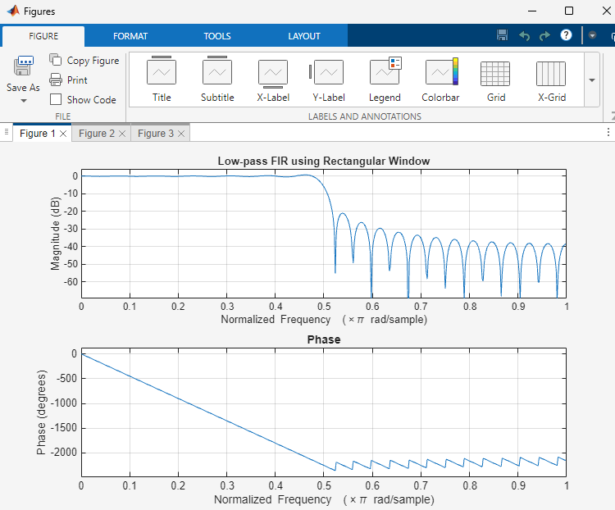

Result
- An FIR Low-Pass Filter was successfully designed using the Rectangular Window technique for the specified cutoff frequency, sampling frequency, and filter order.
- The FIR filter coefficients were successfully generated using MATLAB and the designed filter was implemented.
- The magnitude response and phase response of the designed FIR Low-Pass Filter were obtained and analyzed. The magnitude response exhibited low-pass characteristics, while the phase response demonstrated the expected linear-phase behavior.

Expt 4 | Design of Low Pass Filter using Windowing Techniques
Date: | 4.2. Design and Analysis of an FIR Low-Pass Filter Using the Hamming Window Technique in MATLAB

Procedure

- To design an FIR Low-Pass Filter using the Hamming Window technique for the given cutoff frequency, sampling frequency, and filter order specifications.
- To generate the FIR filter coefficients using the Hamming Window method in MATLAB and implement the designed filter.
- To obtain and analyze the magnitude response and phase response of the FIR Low-Pass Filter designed using the Hamming Window.

  - Open MATLAB and create a new script file.
  - Clear the workspace, command window, and close all figure windows.
  - Specify the sampling frequency, cutoff frequency, and filter order.
  - Calculate the normalized cutoff frequency.
  - Design the FIR Low-Pass Filter using the fir1() function with the Hamming Window (hamming).
  - Generate and display the FIR filter coefficients.
  - Obtain the magnitude and phase responses of the designed filter using the freqz() function.
  - Plot and analyze the frequency response characteristics of the filter.
  - Verify the low-pass filtering behavior by observing the passband and stopband responses.
  - Record the observations and conclude the performance of the FIR Low-Pass Filter designed using the Hamming Window technique.

Program (Matlab Code)
clc; clear; close all;
%% --- Input Parameters ---
fp = 1000; % Passband cutoff (Hz)
fs = 4000; % Sampling frequency (Hz)
N = 50; % Filter order (even number preferred) wc = fp/(fs/2); % Normalized cutoff frequency (0 to 1)
%% --- FIR Low Pass using Hamming Window ---

b_hamm = fir1(N, wc, 'low', hamming(N+1)); disp('--- Hamming Window Coefficients ---'); disp(b_hamm');
%% --- Plot Frequency Responses ---figure;
freqz(b_hamm,1);
title('Low-pass FIR using Hamming Window'); Output
--- Hamming Window Coefficients ---0.0010
-0.0000
-0.0013
0.0000
0.0021
-0.0000
-0.0034
0.0000
0.0055
-0.0000
-0.0084
0.0000
0.0125
-0.0000
-0.0181
0.0000
0.0260
-0.0000
-0.0379
0.0000
0.0580
-0.0000
-0.1026
0.0000
0.3168
0.4995
0.3168
0.0000
-0.1026
-0.0000
0.0580

0.0000
-0.0379
-0.0000
0.0260
0.0000
-0.0181
-0.0000
0.0125
0.0000
-0.0084
-0.0000
0.0055
0.0000
-0.0034
-0.0000
0.0021
0.0000
-0.0013
-0.0000

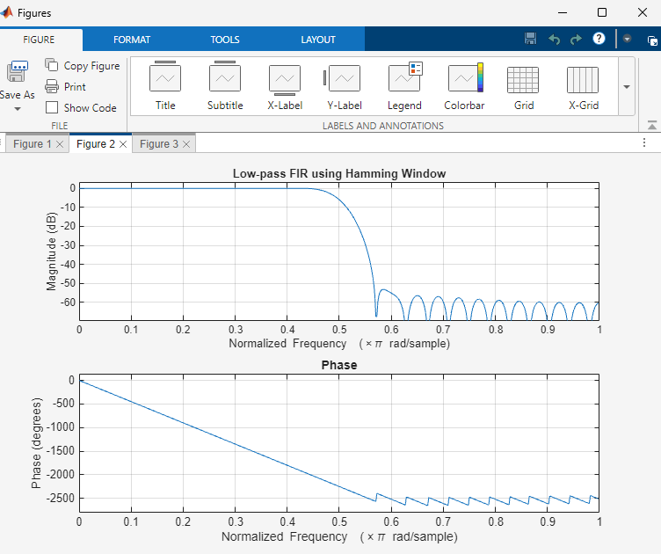
0.0010

Result
- The FIR Low-Pass Filter was successfully designed using the Hamming Window technique for the specified filter parameters.
- The FIR filter coefficients were generated and implemented successfully in MATLAB.
- The magnitude and phase responses of the designed filter were obtained and analyzed.
- The filter exhibited the desired low-pass characteristics with improved stopband attenuation compared to the Rectangular Window method.

Expt 4 | Design of Low Pass Filter using Windowing Techniques
Date: | 4.3. Design and Analysis of an FIR Low-Pass Filter Using the Hanning Window Technique in MATLAB

Procedure

- To design an FIR Low-Pass Filter using the Hanning Window technique for the given cutoff frequency, sampling frequency, and filter order specifications.
- To generate the FIR filter coefficients using the Hanning Window method in MATLAB and implement the designed filter.
- To obtain and analyze the magnitude response and phase response of the FIR Low-Pass Filter designed using the Hanning Window.

  - Open MATLAB and create a new script file.
  - Clear the workspace, command window, and close all figure windows.
  - Specify the sampling frequency, cutoff frequency, and filter order.
  - Calculate the normalized cutoff frequency.
  - Design the FIR Low-Pass Filter using the fir1() function with the Hanning (Hann) Window (hanning).
  - Generate and display the FIR filter coefficients.
  - Obtain the magnitude response and phase response of the designed filter using the freqz() function.
  - Plot and analyze the frequency response characteristics of the filter.
  - Verify the low-pass filtering behavior by observing the passband and stopband regions.
  - Record the observations and conclude the performance of the FIR Low-Pass Filter designed using the Hanning Window technique.

Program (Matlab Code):
clc; clear; close all;
%% --- Input Parameters ---
fp = 1000; % Passband cutoff (Hz)
fs = 4000; % Sampling frequency (Hz)
N = 50; % Filter order (even number preferred) wc = fp/(fs/2); % Normalized cutoff frequency (0 to 1)

%% --- FIR Low Pass using Hanning Window ---b_hann = fir1(N, wc, 'low', hanning(N+1));
disp('--- Hanning Window Coefficients ---');disp(b_hann');
%% --- Plot Frequency Responses ---figure;
freqz(b_hann,1);
title('Low-pass FIR using Hanning Window'); OUTPUT;
--- Hanning Window Coefficients ---0.0000
-0.0000
-0.0004
0.0000
0.0013
-0.0000
-0.0028
0.0000
0.0050
-0.0000
-0.0081
0.0000
0.0122
-0.0000
-0.0179
0.0000
0.0259
-0.0000
-0.0378
0.0000
0.0580
-0.0000
-0.1027
0.0000
0.3172
0.5000
0.3172
0.0000
-0.1027

-0.0000
0.0580
0.0000
-0.0378
-0.0000
0.0259
0.0000
-0.0179
-0.0000
0.0122
0.0000
-0.0081
-0.0000
0.0050
0.0000
-0.0028
-0.0000
0.0013
0.0000
-0.0004
-0.0000
0.0000

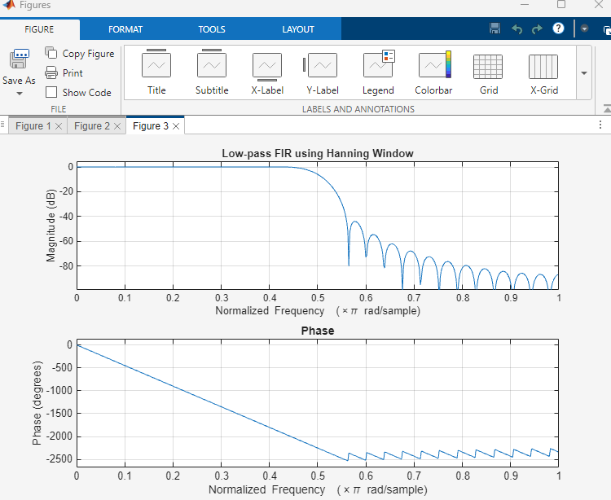

Result
- The FIR Low-Pass Filter was successfully designed using the Hanning Window technique for the specified filter parameters.
- The FIR filter coefficients were generated and implemented successfully in MATLAB.
- The magnitude and phase responses of the designed filter were obtained and analyzed.
- The filter exhibited the desired low-pass characteristics with reduced sidelobes and improved stopband attenuation compared to the Rectangular Window method.

