Expt 10 | Digital Speech Processing and Noise Reduction
Date: | 10.1 Implementation of Spectral Subtraction for Speech Noise Reduction

Objectives:

- To generate a noisy speech signal by adding noise to a clean speech signal.
- To estimate the noise spectrum and implement the Spectral Subtraction algorithm.
- To obtain and analyze the magnitude spectra of the noisy and enhanced speech signals.
- To evaluate the performance of spectral subtraction in speech enhancement.

Procedure:

- Open MATLAB and initialize the workspace using clc, clear, and close all.
- Generate or load a clean speech signal and add Gaussian noise to create a noisy speech signal.
- Divide the noisy speech signal into frames and compute the FFT of each frame.
- Estimate the noise spectrum from the noisy signal.
- Apply spectral subtraction by subtracting the estimated noise spectrum from the noisy speech spectrum.
- Reconstruct the enhanced speech signal using the inverse FFT.
- Plot the noisy speech signal, enhanced speech signal, and their spectra.
- Analyze the noise reduction performance and speech quality improvement.

Program (Matlab Code):
clc; clear; close all;

Fs=8000; t=0:1/Fs:3;

x=sin(2*pi*200*t)+0.5*sin(2*pi*400*t); % Clean signal xn=x+0.3*randn(size(x)); % Noisy signal

Y=fft(xn); N=fft(0.3*randn(size(x)));
xe=real(ifft(max(abs(Y)-abs(N),0).*exp(1j*angle(Y))));

% Signals figure;
subplot(311),plot(t,x),title('Clean Speech') subplot(312),plot(t,xn),title('Noisy Speech') subplot(313),plot(t,xe),title('Enhanced Speech')

% Spectrograms figure;
subplot(311),spectrogram(x),title('Clean Spectrogram') subplot(312),spectrogram(xn),title('Noisy Spectrogram') subplot(313),spectrogram(xe),title('Enhanced Spectrogram')

% Magnitude Spectra figure;
subplot(311),plot(abs(fft(x))),title('Clean Spectrum') subplot(312),plot(abs(fft(xn))),title('Noisy Spectrum') subplot(313),plot(abs(fft(xe))),title('Enhanced Spectrum')Output

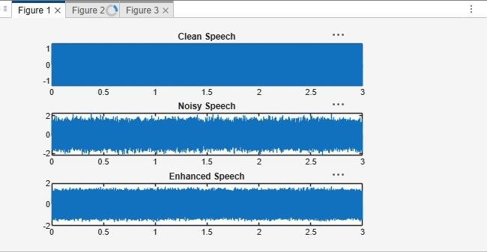

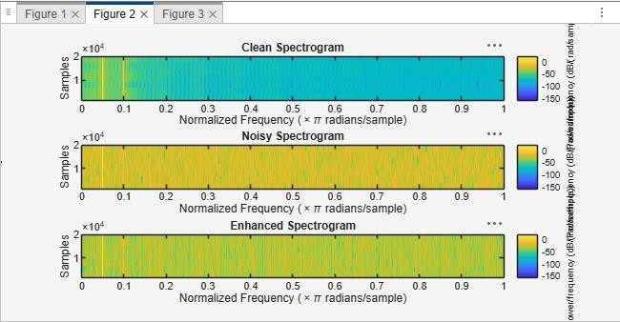

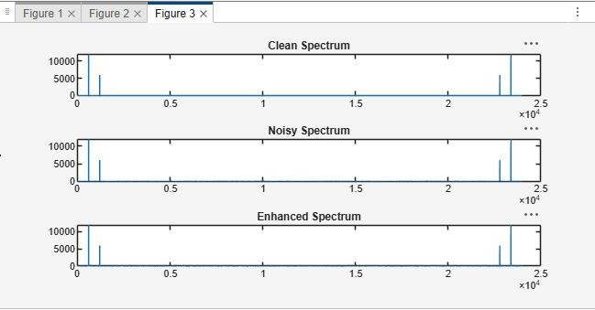

Result
- A noisy speech signal was successfully generated by adding noise to the clean speech signal.
- The noise spectrum was estimated and the Spectral Subtraction algorithm was successfully implemented.
- The magnitude spectra of the noisy and enhanced speech signals were obtained and analyzed, showing a reduction in noise components after enhancement.
- The performance of spectral subtraction was evaluated, and the enhanced speech signal exhibited improved speech quality and intelligibility compared to the noisy speech signal.

