Expt 5 | Design of High Pass Filter using Windowing Techniques
Date: | 5.1 Generate the coefficients of an FIR High-Pass filter using Rectangular windowing techniques.

Objectiv:

1.To design an FIR High-Pass Filter using the Hamming Window technique for Given cutoff frequency, sampling frequency, and filter order specifications.

To generate the FIR filter coefficients using the Hamming Window method I,MATLAB and implement the designed filter.

To obtain and analyze the magnitude response and phase response of the FIR High-Pass Filter designed using the Hamming Window.

Procedure

- To design an FIR High-Pass Filter using the Rectangular Window technique for the given cutoff frequency, sampling frequency, and filter order specifications.
- To generate the FIR filter coefficients using the Rectangular Window method in MATLAB and implement the designed filter.

- To obtain and analyze the magnitude response and phase response of the FIR High-Pass Filter designed using the Rectangular Window.

  - Open MATLAB and create a new script file.
  - Clear the workspace, command window, and close all figure windows.
  - Specify the sampling frequency, cutoff frequency, and filter order.
  - Calculate the normalized cutoff frequency.
  - Design the FIR High-Pass Filter using the fir1() function with the 'high' option and a Rectangular Window (rectwin).
  - Generate and display the FIR filter coefficients.
  - Obtain the magnitude response and phase response of the designed filter using the freqz() function.
  - Plot and analyze the frequency response characteristics of the filter.
  - Verify the high-pass filtering behavior by observing the attenuation of low-frequency components and the passage of high-frequency components.
  - Record the observations and conclude the performance of the FIR High-Pass Filter designed using the Rectangular Window technique.

Program (Matlab Code):
clc; clear; close all;
%% --- Input Parameters ---
fp = 1000; % High-pass cutoff frequency (Hz) fs = 8000; % Sampling frequency (Hz)
N = 50; % Filter order

wc = fp/(fs/2); % Normalized cutoff (0–1)

%% --- 1. FIR High Pass using Rectangular Window ---b_rect = fir1(N, wc, 'high', rectwin(N+1));
disp('--- High-Pass Coefficients (Rectangular Window) ---'); disp(b_rect');

%% --- 2. FIR High Pass using Hamming Window ---b_hamm = fir1(N, wc, 'high', hamming(N+1));
disp('--- High-Pass Coefficients (Hamming Window) ---'); disp(b_hamm');
%% --- 3. FIR High Pass using Hanning Window ---b_hann = fir1(N, wc, 'high', hanning(N+1));
disp('--- High-Pass Coefficients (Hanning Window) ---'); disp(b_hann');
%% --- Frequency Response Plots ---figure;
freqz(b_rect,1);
title('High-pass FIR using Rectangular Window'); figure;
freqz(b_hamm,1);
title('High-pass FIR using Hamming Window'); figure;
freqz(b_hann,1);
title('High-pass FIR using Hanning Window');

OUTPUT:
--- High-Pass Coefficients (Rectangular Window) ---
-0.0089

-0.0000
0.0097
0.0143
0.0106
-0.0000
-0.0117
-0.0175
-0.0131
-0.0000
0.0148
0.0225
0.0171
-0.0000
-0.0202
-0.0314
-0.0247
-0.0000
0.0318
0.0524
0.0445
-0.0000
-0.0741
-0.1572
-0.2223
0.7407
-0.2223
-0.1572
-0.0741
-0.0000
0.0445
0.0524
0.0318
-0.0000
-0.0247
-0.0314
-0.0202
-0.0000
0.0171
0.0225
0.0148
-0.0000
-0.0131
-0.0175
-0.0117

-0.0000
0.0106
0.0143
0.0097
-0.0000
-0.0089

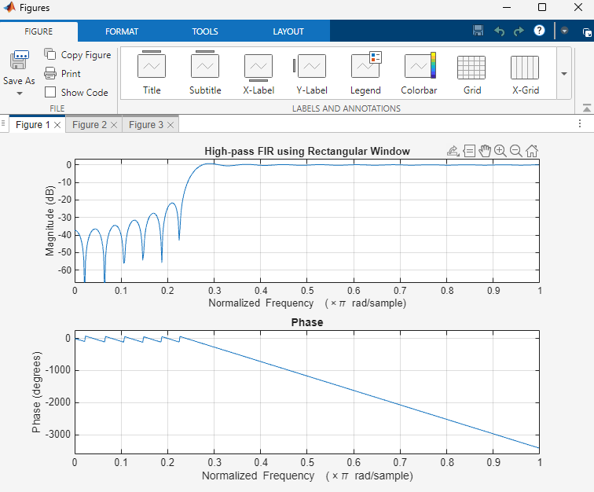

Result
- The FIR High-Pass Filter was successfully designed using the Rectangular Window technique for the specified cutoff frequency, sampling frequency, and filter order.
- The FIR filter coefficients were successfully generated using MATLAB and the designed filter was implemented.
- The magnitude response and phase response of the designed FIR High-Pass Filter were obtained and analyzed. The magnitude response showed attenuation of low-frequency components and passage of high-frequency components, confirming the desired high-pass

filtering behavior. The phase response exhibited the expected linear-phase characteristics of an FIR filter.

Expt 5 | Design of High Pass Filter using Windowing Techniques
Date: | 5.2. Generate the coefficients of an FIR High-Pass filter using Hamming windowing techniques

Procedure

- To design an FIR High-Pass Filter using the Hamming Window technique for the given cutoff frequency, sampling frequency, and filter order specifications.
- To generate the FIR filter coefficients using the Hamming Window method in MATLAB and implement the designed filter.
- To obtain and analyze the magnitude response and phase response of the FIR High-Pass Filter designed using the Hamming Window.

  - Open MATLAB and create a new script file.
  - Clear the workspace, command window, and close all figure windows.
  - Specify the sampling frequency, cutoff frequency, and filter order.
  - Calculate the normalized cutoff frequency.
  - Design the FIR High-Pass Filter using the fir1() function with the 'high' option and a Hamming Window (hamming).
  - Generate and display the FIR filter coefficients.
  - Obtain the magnitude response and phase response of the designed filter using the freqz() function.
  - Plot and analyze the frequency response characteristics of the filter.
  - Verify the high-pass filtering behavior by observing the attenuation of low-frequency components and the passage of high-frequency components.
  - Record the observations and conclude the performance of the FIR High-Pass Filter designed using the Hamming Window technique.

Program (Matlab Code):
clc; clear; close all;
%% --- Input Parameters ---
fp = 1000; % High-pass cutoff frequency (Hz) fs = 8000; % Sampling frequency (Hz)
N = 50; % Filter order
wc = fp/(fs/2); % Normalized cutoff (0–1)
%% --- FIR High Pass using Hamming Window ---b_hamm = fir1(N, wc, 'high', hamming(N+1));

disp('--- High-Pass Coefficients (Hamming Window) ---'); disp(b_hamm');
%% --- Frequency Response Plots ---figure;
freqz(b_hamm,1);
title('High-pass FIR using Hamming Window'); title('High-pass FIR using Hanning Window');
--- High-Pass Coefficients (Hamming Window) ---
-0.0007
-0.0000
0.0009
0.0016
0.0015
-0.0000
-0.0024
-0.0044
-0.0039
-0.0000
0.0060
0.0103
0.0088
-0.0000
-0.0128
-0.0217
-0.0184
-0.0000
0.0268
0.0464
0.0410
-0.0000
-0.0725
-0.1567
-0.2240
0.7493
-0.2240
-0.1567
-0.0725
-0.0000
0.0410
0.0464

0.0268
-0.0000
-0.0184
-0.0217
-0.0128
-0.0000
0.0088
0.0103
0.0060
-0.0000
-0.0039
-0.0044
-0.0024
-0.0000
0.0015
0.0016
0.0009
-0.0000
-0.0007

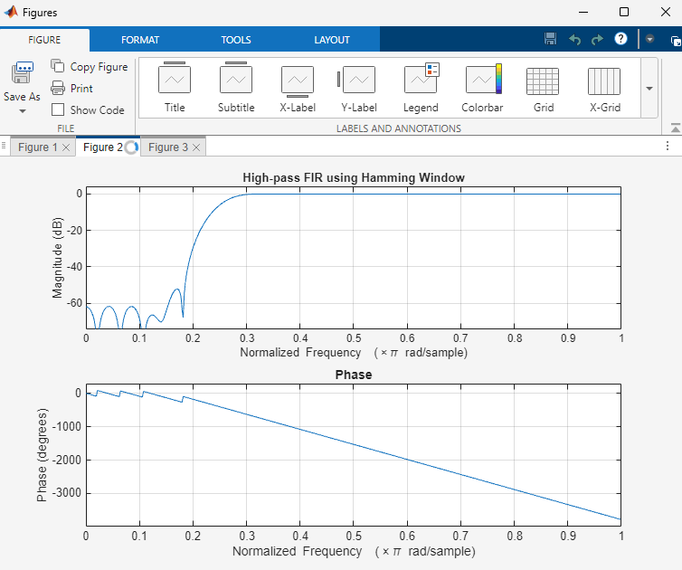

Result:
- The FIR High-Pass Filter was successfully designed using the Hamming Window technique for the specified cutoff frequency, sampling frequency, and filter order.
- The FIR filter coefficients were successfully generated using the Hamming Window method in MATLAB and the filter was implemented.
- The magnitude response and phase response of the designed FIR High-Pass Filter were obtained and analyzed. The magnitude response showed effective attenuation of low-frequency components and passage of high-frequency components, confirming the desired high-pass filtering behavior. The phase response exhibited the expected linear-phase characteristics of an FIR filter.

Expt 5 | Design of High Pass Filter using Windowing Techniques
Date: | 5.3. Generate the coefficients of an FIR High-Pass filter using Hanning windowing techniques

Procedure:

- To design an FIR High-Pass Filter using the Hanning Window technique for the given cutoff frequency, sampling frequency, and filter order specifications.
- To generate the FIR filter coefficients using the Hanning Window method in MATLAB and implement the designed filter.
- To obtain and analyze the magnitude response and phase response of the FIR High-Pass Filter designed using the Hanning Window.

  - Open MATLAB and create a new script file.
  - Clear the workspace, command window, and close all figure windows.
  - Specify the sampling frequency, cutoff frequency, and filter order.
  - Calculate the normalized cutoff frequency.
  - Design the FIR High-Pass Filter using the fir1() function with the 'high' option and a Hanning (Hann) Window (hanning).
  - Generate and display the FIR filter coefficients.
  - Obtain the magnitude response and phase response of the designed filter using the freqz() function.
  - Plot and analyze the frequency response characteristics of the filter.
  - Verify the high-pass filtering behavior by observing the attenuation of low-frequency components and the passage of high-frequency components.
  - Record the observations and conclude the performance of the FIR High-Pass Filter designed using the Hanning Window technique.

Program (Matlab Code)
clc; clear; close all;

%% --- Input Parameters ---
fp = 1000; % High-pass cutoff frequency (Hz) fs = 8000; % Sampling frequency (Hz)
N = 50; % Filter order

wc = fp/(fs/2); % Normalized cutoff (0–1)
%% --- FIR High Pass using Hanning Window ---

b_hann = fir1(N, wc, 'high', hanning(N+1));
disp('--- High-Pass Coefficients (Hanning Window) ---'); disp(b_hann');
%% --- Frequency Response Plots ---figure;
freqz(b_hann,1);
title('High-pass FIR using Hanning Window'); Output:
--- High-Pass Coefficients (Hanning Window) ---
-0.0000
-0.0000
0.0003
0.0008
0.0009
-0.0000
-0.0020
-0.0038
-0.0035
-0.0000
0.0057
0.0100
0.0087
-0.0000
-0.0127
-0.0216
-0.0183
-0.0000
0.0267
0.0464
0.0410
-0.0000
-0.0726
-0.1568
-0.2243
0.7500
-0.2243
-0.1568
-0.0726
-0.0000
0.0410

0.0464
0.0267
-0.0000
-0.0183
-0.0216
-0.0127
-0.0000
0.0087
0.0100
0.0057
-0.0000
-0.0035
-0.0038
-0.0020
-0.0000
0.0009
0.0008
0.0003
-0.0000
-0.0000

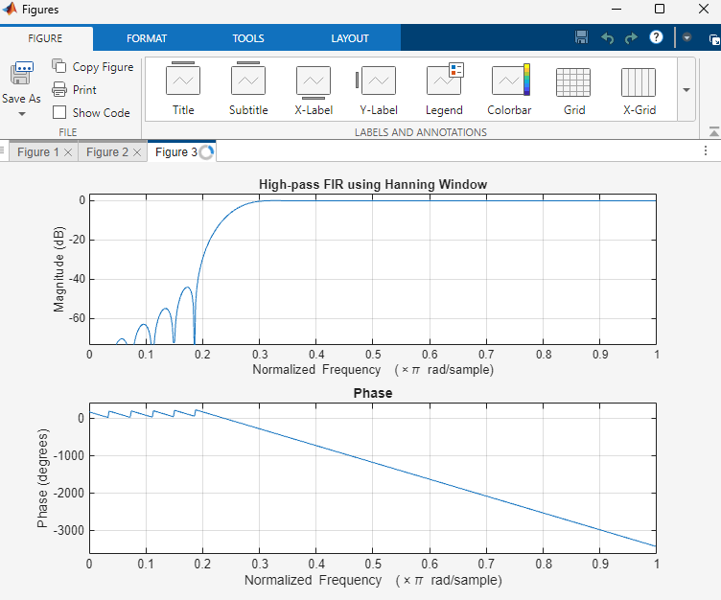
>>

Result
- The FIR High-Pass Filter was successfully designed using the Hanning Window technique for the specified cutoff frequency, sampling frequency, and filter order.
- The FIR filter coefficients were successfully generated using MATLAB and the designed filter was implemented.
- The magnitude response and phase response of the designed FIR High-Pass Filter were obtained and analyzed. The magnitude response exhibited attenuation of low-frequency components and passage of high-frequency components, confirming the desired high-pass filtering characteristics. The phase response demonstrated the expected linear-phase behavior of the FIR filter.

