Expt 3 | Performance Analysis of IIR Filters
Date | 3.1 Design and Comparative Analysis of Butterworth and Chebyshev Type-I IIR Band-Pass Filters Using MATLAB

Objectives
- To design Butterworth and Chebyshev Type-I IIR Band-Pass Filters in MATLAB for the given passband, stopband, ripple, attenuation, and sampling frequency specifications.
- To determine the minimum filter order and corresponding cutoff frequencies and obtain the filter coefficients for both IIR filter designs.
- To analyze and compare the frequency-domain characteristics of the Butterworth and Chebyshev Type-I filters using magnitude response, phase response, and group delay plots.
- To evaluate the stability and performance of the designed filters using pole-zero plots, impulse responses, and pole magnitude analysis.

Procedure
- Open MATLAB and create a new script file.
- Define the filter specifications, including sampling frequency, passband frequencies, stopband frequencies, passband ripple, and stopband attenuation.
- Normalize the passband and stopband frequencies with respect to the Nyquist frequency
(𝐹_{𝑠}/2).
- Use the buttord() function to determine the minimum order and cutoff frequencies of the Butterworth Band-Pass Filter.
- Design the Butterworth Band-Pass Filter using the butter() function and obtain its numerator and denominator coefficients.
- Use the cheb1ord() function to determine the minimum order and cutoff frequencies of the Chebyshev Type-I Band-Pass Filter.
- Design the Chebyshev Type-I Band-Pass Filter using the cheby1() function and obtain its numerator and denominator coefficients.
- Display the filter order, cutoff frequencies, and filter coefficients for both filters.

- Plot and analyze the frequency responses of the Butterworth and Chebyshev Type-I filters using the freqz() function.
- Compare the magnitude responses and phase responses of both filters using frequency response plots.
- Generate pole-zero plots using the zplane() function and observe the pole and zero locations.
- Obtain and compare the group delay characteristics using the grpdelay() function.
- Plot the impulse responses of both filters using the impz() function.
- Determine the pole magnitudes using the roots() function and verify filter stability by checking whether all poles lie inside the unit circle.
- Analyze and compare the overall performance of the Butterworth and Chebyshev Type-I Band-Pass Filters based on their frequency responses, group delay, impulse response, and stability characteristics.

Program (Matlab)
clc; clear; close all;
% Specifications Fs=2000; Rp=1; Rs=40; Wp=[300 600]/(Fs/2); Ws=[200 700]/(Fs/2);

% Butterworth Filter [n1,W1]=buttord(Wp,Ws,Rp,Rs);
[b1,a1]=butter(n1,W1,'bandpass');

% Chebyshev Type-I Filter [n2,W2]=cheb1ord(Wp,Ws,Rp,Rs); [b2,a2]=cheby1(n2,Rp,W2,'bandpass');

% Magnitude Response figure;
freqz(b1,a1); title('Butterworth Filter');

figure;
freqz(b2,a2); title('Chebyshev Type-I Filter');

% Group Delay figure;
grpdelay(b1,a1); hold on; grpdelay(b2,a2); legend('Butterworth','Chebyshev-I');

% Pole-Zero Plot figure;
subplot(121),zplane(b1,a1),title('Butterworth') subplot(122),zplane(b2,a2),title('Chebyshev-I')

% Impulse Response figure;
subplot(211),impz(b1,a1),title('Butterworth Impulse') subplot(212),impz(b2,a2),title('Chebyshev Impulse')

% Pole Magnitude figure;
subplot(121),stem(abs(roots(a1)),'filled') title('Butterworth Pole Magnitude')

subplot(122),stem(abs(roots(a2)),'filled') title('Chebyshev Pole Magnitude')

disp(['Butterworth Order = ',num2str(n1)]) disp(['Chebyshev Order = ',num2str(n2)])

Output:
Butterworth Order = 9 Chebyshev Order = 5
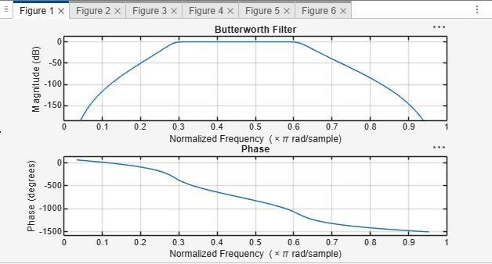
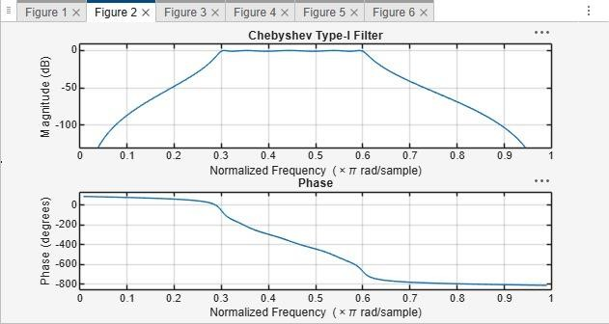

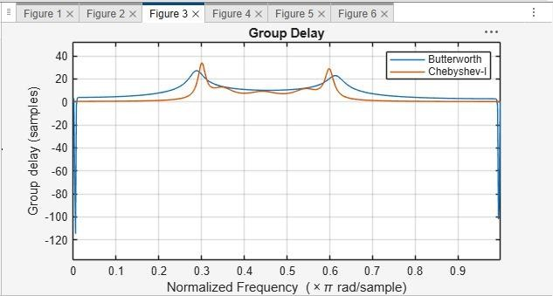
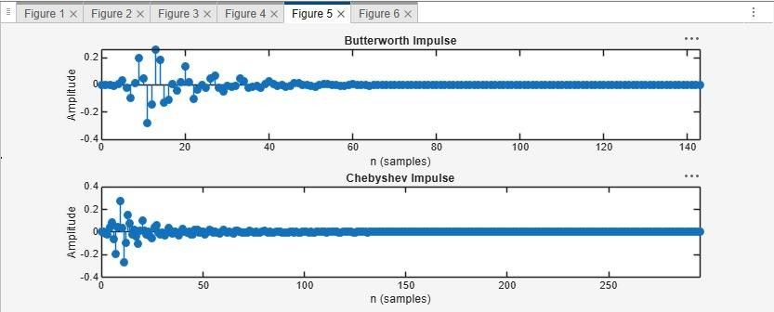

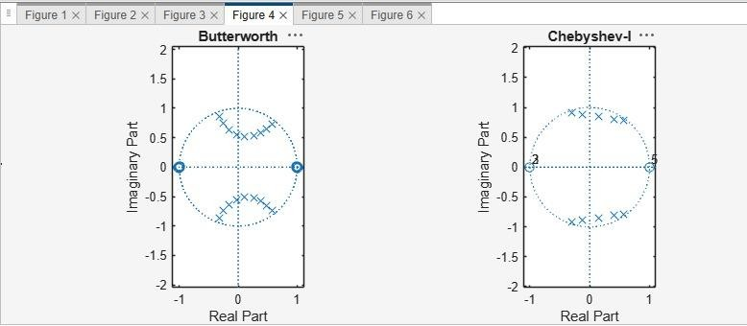
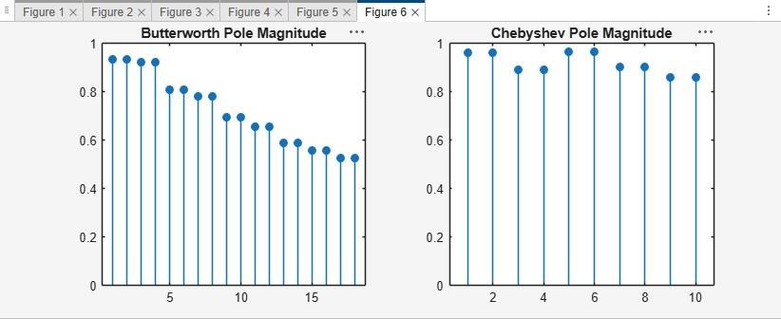

Results:
- Butterworth and Chebyshev Type-I IIR Band-Pass Filters were successfully designed and implemented in MATLAB.
- The minimum filter orders and cutoff frequencies were obtained for both filters.
- The frequency responses were analyzed and compared; the Chebyshev filter provided a sharper transition, while the Butterworth filter showed a smoother response.
- Pole-zero analysis confirmed that both filters are stable and satisfy the given design specifications.

