EX NO:1 | Butterworth IIR Filters
DATE: | 1.1. Design and Analysis of a Butterworth IIR Low-Pass Filter Using MATLAB.

Objectives

- To determine the minimum filter order and cutoff frequency, required to satisfy the design constraints.
- To design and analyze the magnitude response, phase response, characteristics of the Butterworth IIR low-pass filter for the given passband and stopband specifications.
- To analyze the impulse response, step response and group delay characteristics of the Butterworth IIR low-pass filter for the given passband and stopband specifications.
- To examine the pole-zero plot and verify the stability and performance of the designed low-pass filter.

Procedure
- Open MATLAB and create a new script file in the MATLAB Editor.
- Define the filter specifications such as passband ripple (𝑅_{𝑝}), stopband attenuation (𝑅_{𝑠}), passband frequency (𝐹_{𝑝}), stopband frequency (𝐹_{𝑠𝑏}), and sampling frequency (𝐹_{𝑠}).
- Calculate the normalized passband and stopband frequencies with respect to the Nyquist frequency (𝐹_{𝑠}/2).
- Use the buttord() function to determine the minimum order (𝑁) and normalized cutoff frequency (𝑊_{𝑛}) required for the Butterworth low-pass filter.
- Design the Digital IIR Butterworth Low-Pass Filter using the butter() function and obtain the numerator (𝑏) and denominator (𝑎) filter coefficients.
- Display the filter order and cutoff frequency obtained from the design process.
- Compute the frequency response of the designed filter using the freqz() function.
- Plot the magnitude response of the filter and observe the passband characteristics and stopband attenuation.
- Plot the phase response of the filter and analyze the phase variation over the frequency range.
- Generate the pole-zero plot using the zplane() function to verify the stability of the designed IIR filter.
- Create a test signal consisting of low-frequency and high-frequency components.
- Apply the designed IIR low-pass filter to the test signal using the filter() function.

Program (Matlab Code)
clc; clear

Fs=10000; Fp=1000; Fst=1500;
[N,Wn]=buttord(Fp/(Fs/2),Fst/(Fs/2),1,60); [b,a]=butter(N,Wn);

freqz(b,a) % Magnitude & Phase

figure [h,n]=impz(b,a,50);
…title('Impulse Response')

figure stepz(b,a)

figure zplane(b,a)

fprintf('Minimum Filter Order (N) = %d\n',N); fprintf('Cutoff Frequency (Wn) = %.4f\n',Wn); Input:
- Passband Ripple (𝑅_{𝑝}) = 1 dB
- Stopband Attenuation (𝑅_{𝑠}) = 20 dB
- Passband Frequency (𝐹_{𝑝}) = 1000 Hz
- Stopband Frequency (𝐹_{𝑠}) = 3000 Hz
- Sampling Frequency (𝐹_{𝑠𝑎𝑚𝑝𝑙𝑖𝑛𝑔}) = 8000 Hz
- Filter Choice = Low-Pass Filter (LPF)

Output:
Objective 1:
Minimum Filter Order (N) = 17 Cutoff Frequency (Wn) = 0.2083

Objective 2:
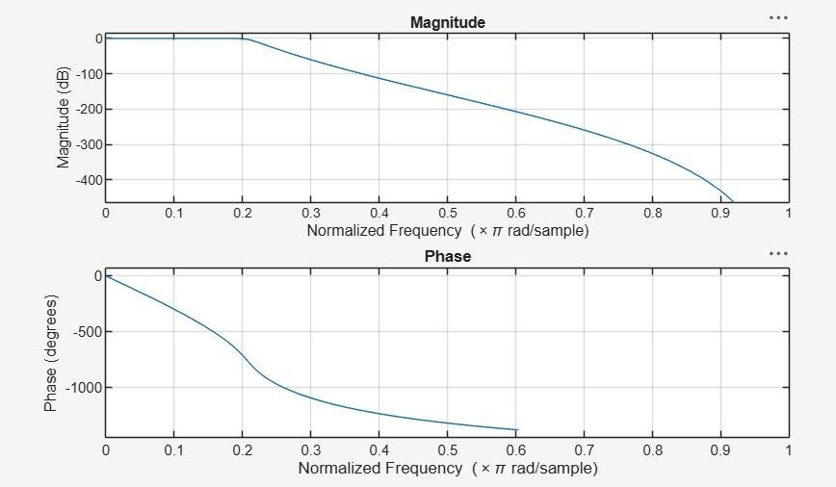
.

Objective 3:
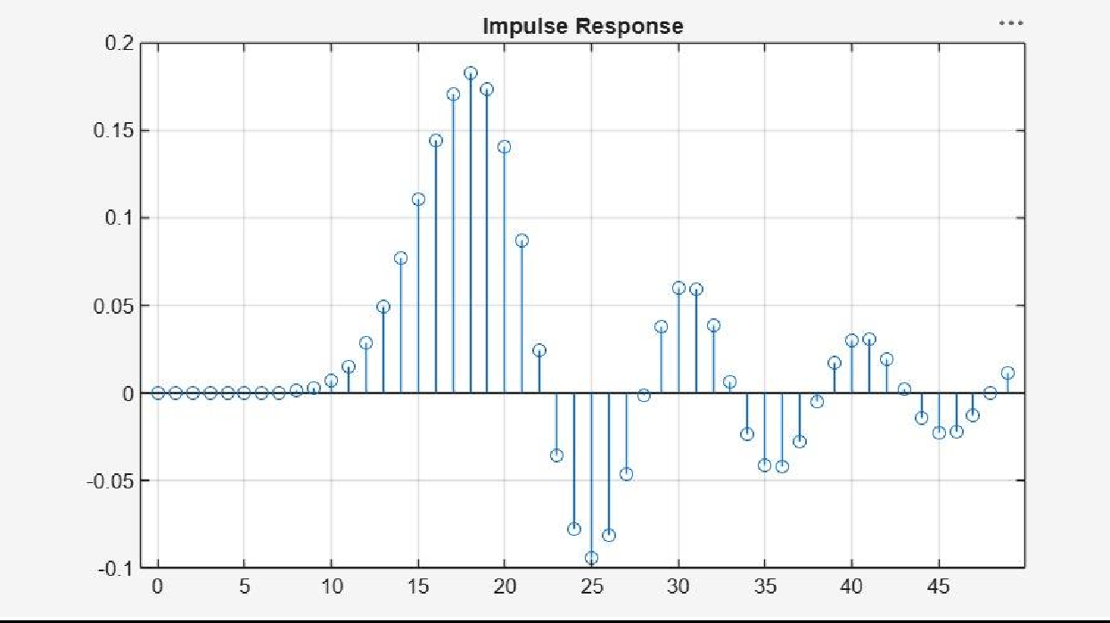

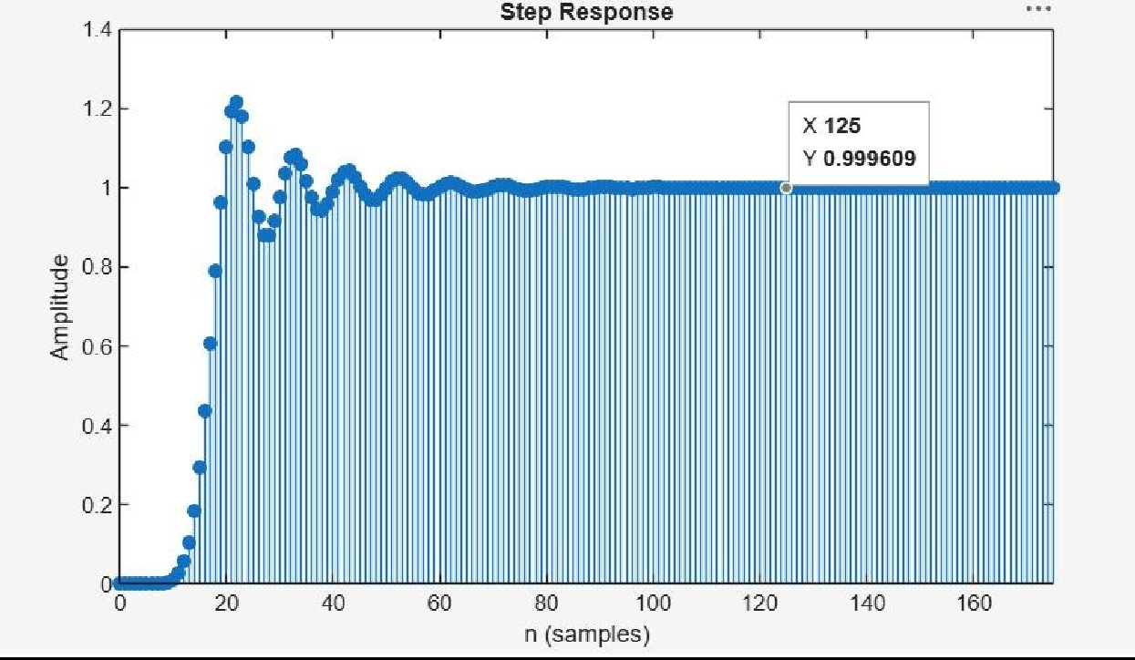
Objective 4:
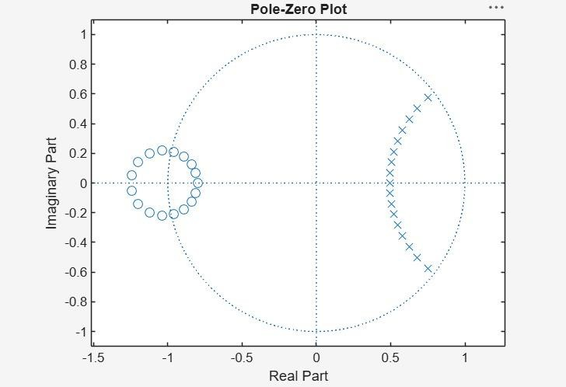

Result:
- The minimum filter order and cutoff frequency satisfying the given specifications were determined successfully.
- The magnitude and phase responses of the Butterworth IIR low-pass filter were obtained and analyzed.
- The impulse response, step response, and group delay characteristics were evaluated successfully.
- The pole-zero plot confirmed the stability and proper performance of the designed filter.

EX NO:1 | Butterworth IIR Filters
DATE: | 1.2. Design and Analysis of a Butterworth IIR High-Pass Filter Using MATLAB.

Objective

  - To determine the minimum filter order and cutoff frequency, required to satisfy the design constraints.
  - To design and analyze the magnitude response, phase response, characteristics of the Butterworth IIR High-pass filter for the given passband and stopband specifications.
  - To analyze the impulse response, step response and group delay characteristics of the Butterworth IIR High-pass filter for the given passband and stopband specifications.
  - To examine the pole-zero plot and verify the stability and performance of the designed High-pass filter.

Procedure

- Open MATLAB and create a new script file.
- Enter the filter specifications: passband ripple (𝑅_{𝑝}), stopband attenuation (𝑅_{𝑠}), passband frequency (𝐹_{𝑝}), stopband frequency (𝐹_{𝑠}), and sampling frequency (𝐹_{𝑠𝑎𝑚𝑝𝑙𝑖𝑛𝑔}).
- Normalize the passband and stopband frequencies with respect to the Nyquist frequency
(𝐹𝑠𝑎𝑚𝑝𝑙𝑖𝑛𝑔/2).
- Use the buttord() function to determine the minimum filter order and cutoff frequency for the Butterworth high-pass filter.
- Design the IIR Butterworth high-pass filter using the butter() function and obtain the numerator and denominator coefficients.
- Display the filter order and cutoff frequency.
- Compute the frequency response of the filter using the freqz() function.
- Plot the magnitude response and verify that low-frequency components are attenuated while high-frequency components are passed.
- Plot the phase response and analyze the phase characteristics.
- Generate the pole-zero plot using the zplane() function and verify that all poles lie inside the unit circle.
- Create a test signal consisting of low-frequency and high-frequency sinusoidal components.
- Apply the designed high-pass filter to the test signal using the filter() function.
- Plot and compare the input and filtered output signals.
- Analyze the filter performance in terms of frequency selectivity and stability.
- Verify that the designed filter satisfies the given specifications.

Program (Matlab Code)
clc; clear

Fs=10000; Fp=3000; Fst=2000;
[N,Wn]=buttord(Fp/(Fs/2),Fst/(Fs/2),1,60);
[b,a]=butter(N,Wn,'high');

% Magnitude & Phase freqz(b,a)

% Impulse Response figure [h,n]=impz(b,a,50); stem(n,h), grid on title('Impulse Response')

% Step Response figure
stepz(b,a)
title('Step Response')

% Group Delay figure grpdelay(b,a) title('Group Delay')

% Pole-Zero Plot figure zplane(b,a)
title('Pole-Zero Plot')

fprintf('Minimum Filter Order (N) = %d\n',N); fprintf('Cutoff Frequency (Wn) = %.4f\n',Wn); Output:

Objective 1:
Minimum Filter Order (N) = 12 Cutoff Frequency (Wn) = 0.5807

Objective 2:

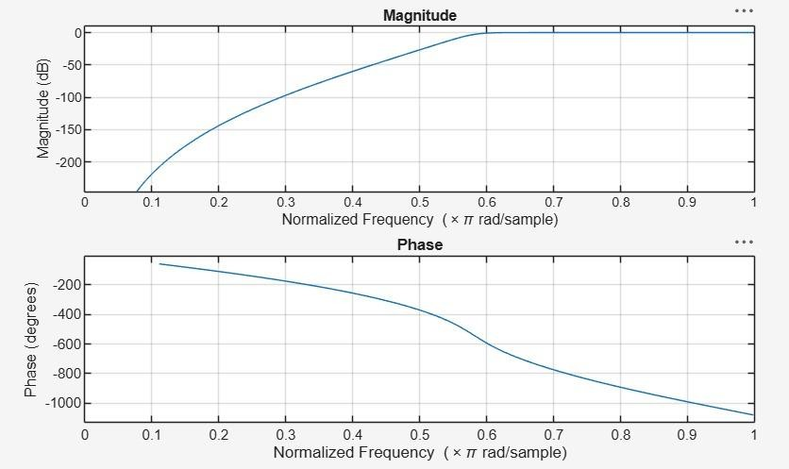

Objective 3:
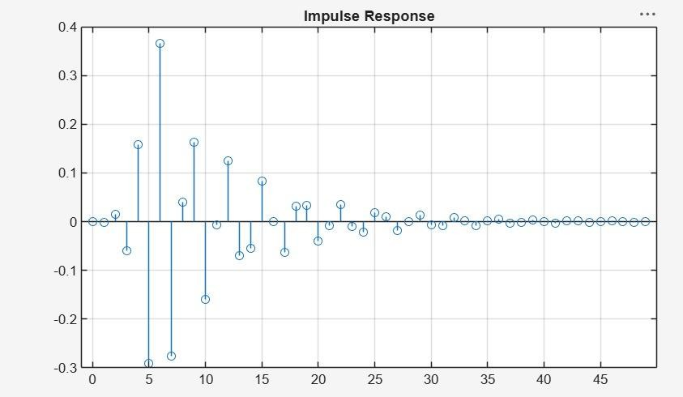

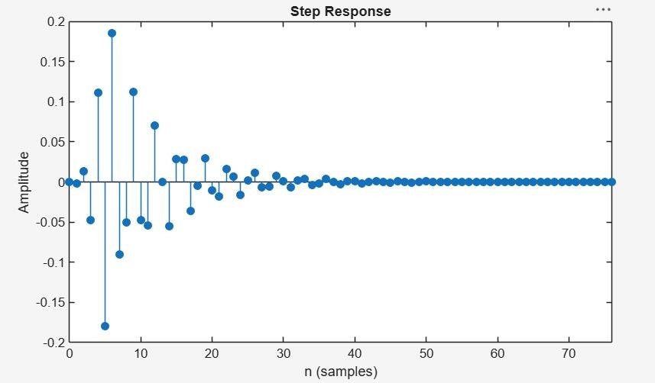

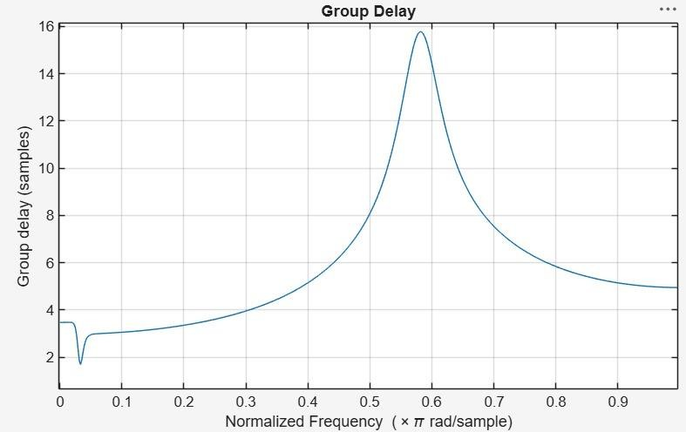

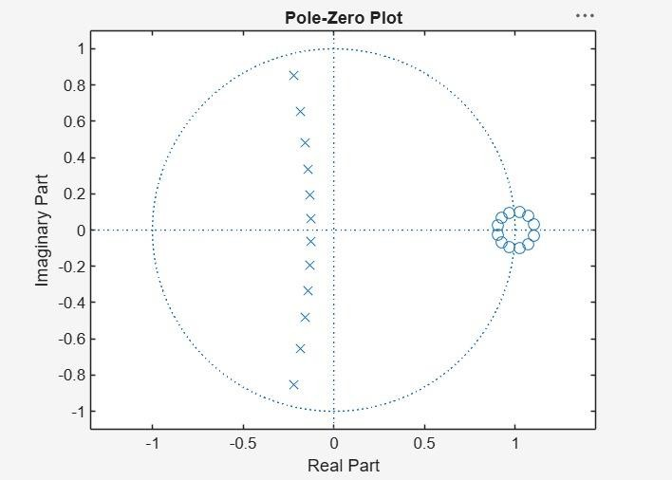
Objective 4:

Result:
- The minimum filter order and cutoff frequency satisfying the given specifications were determined successfully.
- The magnitude and phase responses of the Butterworth IIR High-pass filter were obtained and analyzed.
- The impulse response, step response, and group delay characteristics were evaluated successfully.
- The pole-zero plot confirmed the stability and proper performance of the designed filter.

