DATA DESIGN AND ANALYSIS ALGORITHMS
(23CSE211)

LAB-4

NAME: LOHITH BEJUGAM
R.NO: CH.SC.U4CSE24204
SEC: CSE-C
PRIMS ALGORITHM:
#include <stdio.h>
#include <limits.h>
#define V 5
int min_key(int key[], int mst_set[]) {
int min = INT_MAX, min_index;
for (int v = 0; v < V; v++) {
if (mst_set[v] == 0 && key[v] < min) {
min = key[v];
min_index = v;
}
}
return min_index;
}
void prim(int graph[V][V]) {
int parent[V];
int key[V];
int mst_set[V];
for (int i = 0; i < V; i++) {
key[i] = INT_MAX;
mst_set[i] = 0;
}
key[0] = 0;
parent[0] = -1;
for (int count = 0; count < V - 1; count++) {
int u = min_key(key, mst_set);
mst_set[u] = 1;
for (int v = 0; v < V; v++) {
if (graph[u][v] && mst_set[v] == 0 && graph[u][v] <
key[v]) {
key[v] = graph[u][v];
parent[v] = u;
}
}
}
printf("Edge \tWeight\n");
for (int i = 1; i < V; i++) {
printf("%d - %d \t%d\n", parent[i], i, graph[i][parent[i]]);
}
}
int main() {
int graph[V][V] = {
{0, 2, 0, 6, 0},
{2, 0, 3, 8, 5},
{0, 3, 0, 0, 7},
{6, 8, 0, 0, 9},
{0, 5, 7, 9, 0}
};
prim(graph);
return 0;
}
OUTPUT:
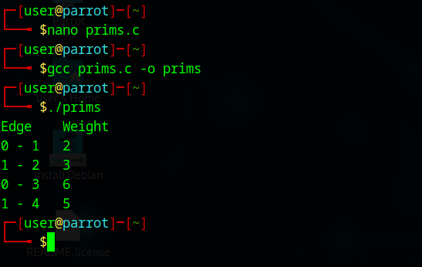
2.KRUSKAL’S ALGORITHM:
PROGRAM:
#include <stdio.h>
#include <stdlib.h>
#define V 5
#define E 7
typedef struct {
int u, v, weight;
} Edge;
int find(int parent[], int i) {
if (parent[i] == -1)
return i;
return find(parent, parent[i]);
}
void union_set(int parent[], int x, int y) {
int xroot = find(parent, x);
int yroot = find(parent, y);
parent[xroot] = yroot;
}
int compare(const void *a, const void *b) {
return ((Edge*)a)->weight - ((Edge*)b)->weight;
}
void kruskal(Edge edges[], int parent[]) {
qsort(edges, E, sizeof(Edge), compare);
int mst_weight = 0;
printf("Edge \tWeight\n");
for (int i = 0; i < E; i++) {
int u = edges[i].u;
int v = edges[i].v;
int w = edges[i].weight;
int x = find(parent, u);
int y = find(parent, v);
if (x != y) {
printf("%d - %d \t%d\n", u, v, w);
mst_weight += w;
union_set(parent, x, y);
}
}
printf("Total weight of MST: %d\n", mst_weight);
}
int main() {
Edge edges[] = {
{0, 1, 2},
{0, 3, 6},
{1, 2, 3},
{1, 4, 5},
{2, 4, 7},
{3, 4, 9},
{2, 3, 8}
};
int parent[V];
for (int i = 0; i < V; i++) {
parent[i] = -1;
}
kruskal(edges, parent);
return 0;
}
OUTPUT:
