CHAPTER 4: RESULTS AND ANALYSIS
Project Title: Zero Trust AI-Powered Network Intrusion Detection System
Department: Department of Information Science and Engineering, JNN College of Engineering (JNNCE), Shivamogga

4.1 Introduction
This chapter presents the experimental evaluation, module-wise implementation verification, classification performance analysis, comparative assessment, and operational website evidence for the implemented Zero Trust AI-Powered Network Intrusion Detection System (Zero Trust NIDS). All reported findings are derived directly from verified host execution records, the SQLite database (database/database.db), serialized model checkpoints (models/), epoch-level training logs (training_metadata.json), and holdout evaluation artifacts (latest_report.json and evaluation_report.json).
The system is evaluated across seven engineering dimensions: (1) functional correctness of all Flask REST Blueprints and React dashboard views; (2) dataset processing hygiene across UNSW-NB15, NSL-KDD, and CIC-IDS2017; (3) neural network training convergence via cross-entropy loss and Frobenius weight update norms (||ΔW^(e)||_F); (4) independent holdout classification performance using Accuracy, Precision, Recall, F1-Score, False-Positive Rate (FPR), Confusion Matrices, and ROC-AUC; (5) Zero Trust security enforcement via 12-round Bcrypt hashing, HS256 JWT verification, and Role-Based Access Control (Admin vs. Analyst); (6) live network flow integration via passive Scapy packet capture; and (7) runtime efficiency and practical limitations.
To prevent overstated claims, four result categories are strictly distinguished throughout this chapter:
- Implementation Results: Functional verification confirming that software endpoints, database persistence, and UI workflows execute according to specification.
- Training Results: Optimization metrics (accuracy, loss) computed on the 70% training split (X_train, y_train) during mini-batch gradient descent.
- Validation Results: Per-epoch generalization metrics (val_accuracy, val_loss) evaluated on the 15% validation split (X_val, y_val) to monitor convergence and detect overfitting.
- Independent Holdout Test Results: Final quantitative evaluation metrics computed exactly once on the unseen 15% holdout test split (X_test, y_test) transformed using frozen training scaler parameters (μ_train, σ_train), kept strictly separate from unlabeled live Wi-Fi flow predictions.

4.2 Experimental Setup

4.2.1 Hardware and Software Configuration
All preprocessing, training, evaluation, and live packet capture experiments were executed on a local Windows 11 workstation within an isolated Python virtual environment (venv). Table 4.1 documents the exact hardware specifications queried via Windows Management Instrumentation (WMI) alongside the verified software library versions obtained via importlib.metadata.
Table 4.1: Verified Host Hardware and Software Environment Configuration
Category | Component / Library | Verified Specification / Version | Experimental & Architectural Role
Hardware | Processor (CPU) | AMD Ryzen 5 3450U with Radeon Vega Mobile Gfx | AMD64 Family 23 Model 24 Stepping 1; 4 Cores / 8 Threads @ 2.10 GHz
Hardware | System Memory (RAM) | 8.00 GB Physical DDR4 (5.94 GB Usable) | 6,382,497,792 bytes available to OS (2.06 GB reserved for integrated Vega 8 GPU)
Hardware | Graphics & Storage | AMD Radeon Vega 8 UMA / 119.23 GB NVMe SSD | CPU-bound training execution; 61.25 GB used, 57.98 GB free on C: drive
Hardware | Network Adapter & OS | Realtek RTL8821CE 802.11ac PCIe (Wi-Fi, 172.20.10.8) | Passive Npcap (wpcap.dll) capture on Windows 11 (64-bit, Build 10.0.26200)
Software | Python & Web Backend | Python 3.13.15 / Flask 3.1.3 / Werkzeug 3.1.8 | Core execution runtime, REST Blueprint routing, and WSGI request hooks
Software | Database & ORM | SQLite 3.50.4 / Flask-SQLAlchemy 3.1.1 (SQLAlchemy 2.1.0) | Manages 6 persistent tables (roles, users, dataset_history, model_history, audit_logs, live_detections)
Software | Machine Learning Engine | Scikit-Learn 1.9.1 / TensorFlow 2.21.0 / Keras 3.15.1 | Active MLPClassifier(64, 32) runtime engine (.joblib), StandardScaler, LabelEncoder, metrics
Software | Data & Serialization | Pandas 3.0.6 / NumPy 2.5.3 / Joblib 1.6.0 | DataFrame deduplication, median/mode imputation, tensor math, and artifact persistence
Software | Security & Networking | Bcrypt 5.0.0 / PyJWT 2.15.0 / Scapy 2.7.0 | 12-round password hashing, HS256 JWT tokens, and passive 5-tuple packet sniffing

4.2.2 Experimental Methodology and Anti-Leakage Protocol
Three methodological refinements distinguish the verified production codebase from preliminary design drafts:
1. Stratified Sampling (25,000–50,000 Records vs. Preliminary ~1,000 Rows): While early connectivity tests used ~1,000 rows, the verified pipeline (StratifiedNIDSSampler in preprocessing/sampler.py) samples 25,000 or 50,000 records (random_seed = 42) from benchmark pools of 50,000 to 148,517 records, preserving exact multi-class attack proportions without generating synthetic rows.
2. Schema-Aligned Dense Feature Vectors vs. Preliminary N × 1 × 122 Shape: An early note referenced an N × 1 × 122 tensor (corresponding to one-hot expansion of the 41-feature NSL-KDD dataset: 38 + 3 + 70 + 11 = 122). Because sparse 122-column one-hot vectors break during live packet capture when unseen service strings occur, the verified implementation (preprocessing/preprocess.py and live_detection/feature_extractor.py) uses per-column LabelEncoder mappings and schema-aligned dense vectors: 15 live / 40 raw features for UNSW-NB15, 19 live / 41 raw features for NSL-KDD, and 22 features for CIC-IDS2017.
3. Active Neural Runtime (MLPClassifier(64, 32) vs. Documented Keras LSTM): Although training/lstm_model.py defines the documented Keras LSTM topology (LSTM(64) -> Dropout(0.2) -> LSTM/Dense(32) -> Softmax/Sigmoid) and early runs (run_20260818_*) saved .keras files, importing tensorflow 2.21.0 under Python 3.13.15 on Windows 11 triggers a native C++ DLL load error (_pywrap_tensorflow_lite_metrics_wrapper). To guarantee deterministic execution, NIDSTrainer (training/train_model.py) executes a Scikit-Learn Deep Multi-Layer Perceptron (MLPClassifier(hidden_layer_sizes=(64, 32), activation='relu', solver='adam', learning_rate_init=0.001)) via explicit mini-batch partial_fit loops (batch_size = 32, epochs = 10 or 20).
4. Leakage Prevention: BaseNIDSPreprocessor.fit_transform_split() prevents data leakage by: (a) coercing ±Inf to NaN and removing exact duplicates (df.drop_duplicates()) prior to splitting; (b) dropping session identifiers (Flow ID, Source/Destination IP, Timestamp, id, difficulty_level); (c) performing two-stage stratified splitting (seed = 42) into 70% Train / 15% Validation / 15% Test; and (d) fitting StandardScaler strictly on X_train_raw (scaler.fit_transform(X_train_raw)).

4.2.3 Functional Experimental Scenarios
Table 4.2 summarizes the 10 core experimental test scenarios executed across all system modules and verified against SQLite database records and model evaluation artifacts.
Table 4.2: Experimental Verification Matrix Across System Modules
Test ID | Module | Test Objective & Input | Expected Outcome | Verified Result (Database / Artifact Evidence) | Status
TC-01 | Auth (auth_routes.py) | Valid Admin/Analyst login (/api/auth/login) | HTTP 200; issue 8h HS256 JWT; log login | 39 USER_LOGIN [SUCCESS] events in audit_logs; valid JWT issued | Pass
TC-02 | Auth (password.py) | Invalid password rejection | HTTP 401; block access; log failure | 113 USER_LOGIN [FAILED] events recorded in audit_logs | Pass
TC-03 | Zero Trust (jwt_auth.py) | Expired/missing JWT on protected API | HTTP 401; log token rejection | 522 EXPIRED_OR_INVALID_TOKEN & 8 UNAUTHORIZED_ACCESS logged | Pass
TC-04 | RBAC (zero_trust.py) | Non-Admin invokes Admin route (/train, /delete) | HTTP 403 Forbidden; log RBAC denial | 19 RBAC_ACCESS_DENIED [REJECTED] events recorded in audit_logs | Pass
TC-05 | Dataset (dataset_routes.py) | Upload & select benchmark CSVs (/api/datasets) | Persist metadata in dataset_history | 4 datasets cataloged (UNSW-NB15 active); 8 uploads, 20 selections logged | Pass
TC-06 | Preprocessing (sampler.py) | Stratified sampling (N=25,000, seed=42) & 70/15/15 split | Preserve exact class ratios; zero leakage | 17,500 Train / 3,750 Val / 3,750 Test; scaler.pkl fitted on train only | Pass
TC-07 | Training (train_model.py) | Async 10-epoch mini-batch training on UNSW-NB15 | Convergent loss & ΔW; save .joblib | Completed in 37.391 s; $\ | \Delta W\ | _F: 13.47 \rightarrow 0.79$; model.joblib saved | Pass
TC-08 | Evaluation (evaluate_model.py) | Holdout test evaluation (N_{test}=3,750) | Compute Acc, Prec, Rec, F1, FPR, AUC | UNSW-NB15 Binary Acc=96.67%, F1=96.66%, FPR=2.17%, AUC=0.9643 | Pass
TC-09 | Live Capture (packet_capture.py) | Passive sniffing & test replay on Wi-Fi (172.20.10.8) | Capture 5-tuple flows; assign risk tiers | 53 capture starts, 60 replays; 2,343+ flows persisted in live_detections | Pass
TC-10 | Behavioral & Audit (auth_routes.py) | Audit logging & rule-based behavioral profiling | Persist logs; flag login/flow deviations | 1,006 audit_logs rows; 3 principals, 13 devices, 9 deviations flagged | Pass

4.3 Implementation Results and Module-Wise Analysis

4.3.1 Authentication and Role-Based Access Control (security/, api/auth_routes.py)
The authentication and access control module enforces Zero Trust identity governance using 12-round salted Bcrypt password hashing (2b12$... in security/password.py), stateless 8-hour HS256 JWT issuance (security/jwt_auth.py), and declarative route guards (@jwt_required and @require_role in security/zero_trust.py). Querying the SQLite database confirms three roles (Admin, Analyst, User) and four user accounts (admin, B34, analyst, user), with audit_logs recording 39 successful logins, 113 blocked invalid-credential attempts, 522 rejected expired/invalid token requests, and 19 blocked RBAC privilege-escalation attempts where non-Admin users attempted state-modifying operations. Its technical contribution lies in binding cryptographic role claims directly to machine learning governance endpoints (/api/train, /api/dataset/delete) at the WSGI middleware layer, ensuring analysts can monitor threats while only administrators can retrain models. While effective against application-layer unauthorized access, this module implements HTTP endpoint RBAC rather than kernel-level network micro-segmentation. Figure 4.1 illustrates the implemented Zero Trust Security Portal (/login) with role-tier selection and credential verification.

Figure 4.1: Zero Trust Security Portal and Role-Based Authentication Interface of the Proposed NIDS

4.3.2 Dataset Upload, Management, and Preprocessing (api/dataset_routes.py, preprocessing/)
The dataset management and preprocessing pipeline governs CSV ingestion, pre-ingestion quality scanning, deterministic stratified subsampling (StratifiedNIDSSampler), pre-split deduplication, median/mode imputation, identifier stripping, and leakage-free StandardScaler normalization (BaseNIDSPreprocessor). As summarized in Table 4.3, four benchmark datasets totaling over 5.66 million cataloged records are registered in dataset_history, with unsw_nb15_raw.csv (2,540,044 cataloged rows; 25,000 stratified training rows) currently selected as the active target. On CIC-IDS2017 (50,000 local pool sampled to 25,000 rows at seed = 42), every class retains its exact 50.00% prior (BENIGN: 37,591 -> 18,796 [75.18%]; DoS Hulk: 4,952 -> 2,476 [9.90%]; PortScan: 2,986 -> 1,493 [5.97%]; DDoS: 2,505 -> 1,252 [5.01%]). Executing drop_duplicates() before partitioning and fitting StandardScaler strictly on the 70% training split (17,500 rows) eliminates optimistic train-test leakage, though integer LabelEncoder mapping on nominal fields (proto, service, state) imposes an ordinal assumption compared to dense embeddings. Figure 4.2 shows the live Datasets Inventory interface displaying the four cataloged benchmarks and RBAC action controls.
Table 4.3: Verified Benchmark Dataset Characteristics, Stratified Sampling (seed = 42), and Partition Sizes
Dataset Filename | Schema Family | Cataloged Rows | Sampled (N) | Train (70%) | Val (15%) | Test (15%) | Features (Raw / Live) | Active Classes & Hygiene Status
unsw_nb15_raw.csv (Active) | UNSW-NB15 | 2,540,044 | 25,000 | 17,500 | 3,750 | 3,750 | 40 Raw / 15 Live | 2 Binary / 7 Multi (0 Missing, 0 Dup post-clean)
nsl_kdd_raw.csv | NSL-KDD | 148,517 | 50,000 | 35,000 | 7,500 | 7,500 | 41 Raw / 19 Live | 7 Classes (normal, neptune, ipsweep, satan, etc.)
nsl_kdd_intrusion_dataset.csv | NSL-KDD | 148,517 | 25,000 | 17,500 | 3,750 | 3,750 | 41 Raw / 19 Live | User-uploaded benchmark (0.74 MB / 10.97 MB pool)
cicids2017_raw.csv | CIC-IDS2017 | 2,830,743 | 25,000 | 17,500 | 3,750 | 3,750 | 79 Raw / 22 Live | 7 Active / 15 Benchmark Classes (±Inf sanitized)

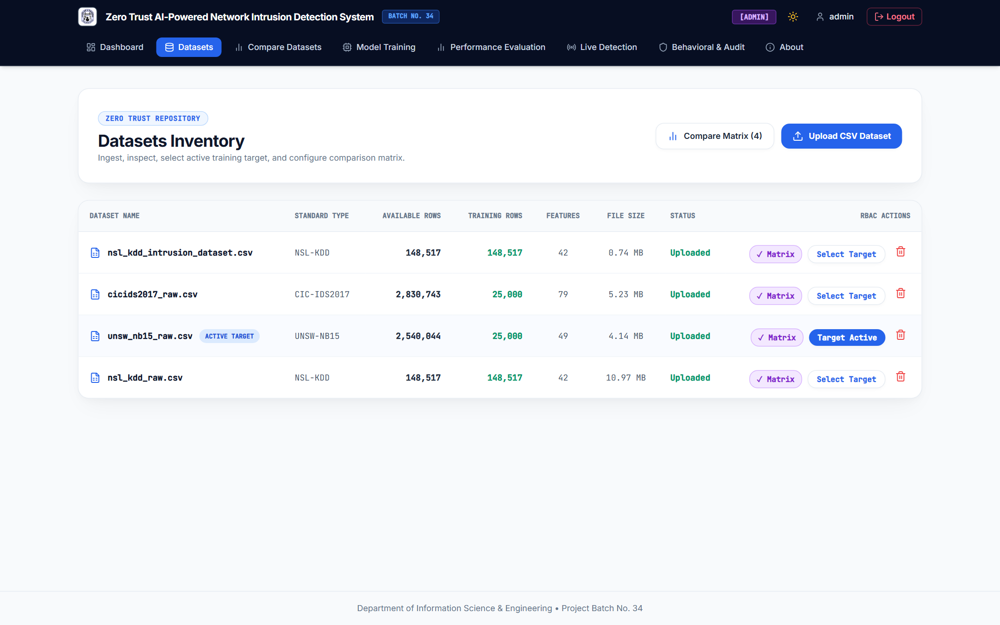
Figure 4.2: Zero Trust Datasets Inventory and Target Selection Interface of the Proposed NIDS

4.3.3 Dataset Comparison (CompareView.jsx, Config.DATASET_SCHEMAS)
The dataset comparison module (/compare) enables side-by-side structural evaluation of registered intrusion benchmarks across row volume, active training subset size, feature dimensionality, target class granularity, and data cleanliness. Observed results highlight three distinct traffic profiles: NSL-KDD (148,517 rows, 19 live features) models legacy connection records with 55.05% normal and 28.04% neptune DoS traffic; UNSW-NB15 (2,540,044 rows, 15 live features) captures modern network flows with 58.85% Normal (2,207 / 3,750 test rows) and six attack categories (Generic, Exploits, Fuzzers, DoS, Analysis, Reconnaissance); and CIC-IDS2017 (2,830,743 rows, 22 live features) exhibits a heavier normal skew (75.20% BENIGN) with overlapping volumetric/HTTP flood subclasses (DoS Hulk, DoS GoldenEye, DDoS). Linking each benchmark directly to its live FlowFeatureExtractor schema (15, 19, or 22 features) prevents feature-dimension mismatches during deployment, and confirms why raw accuracy values across datasets with different class balances cannot be compared in isolation. Figure 4.3 presents the NIDS Dataset Comparison Matrix screen.
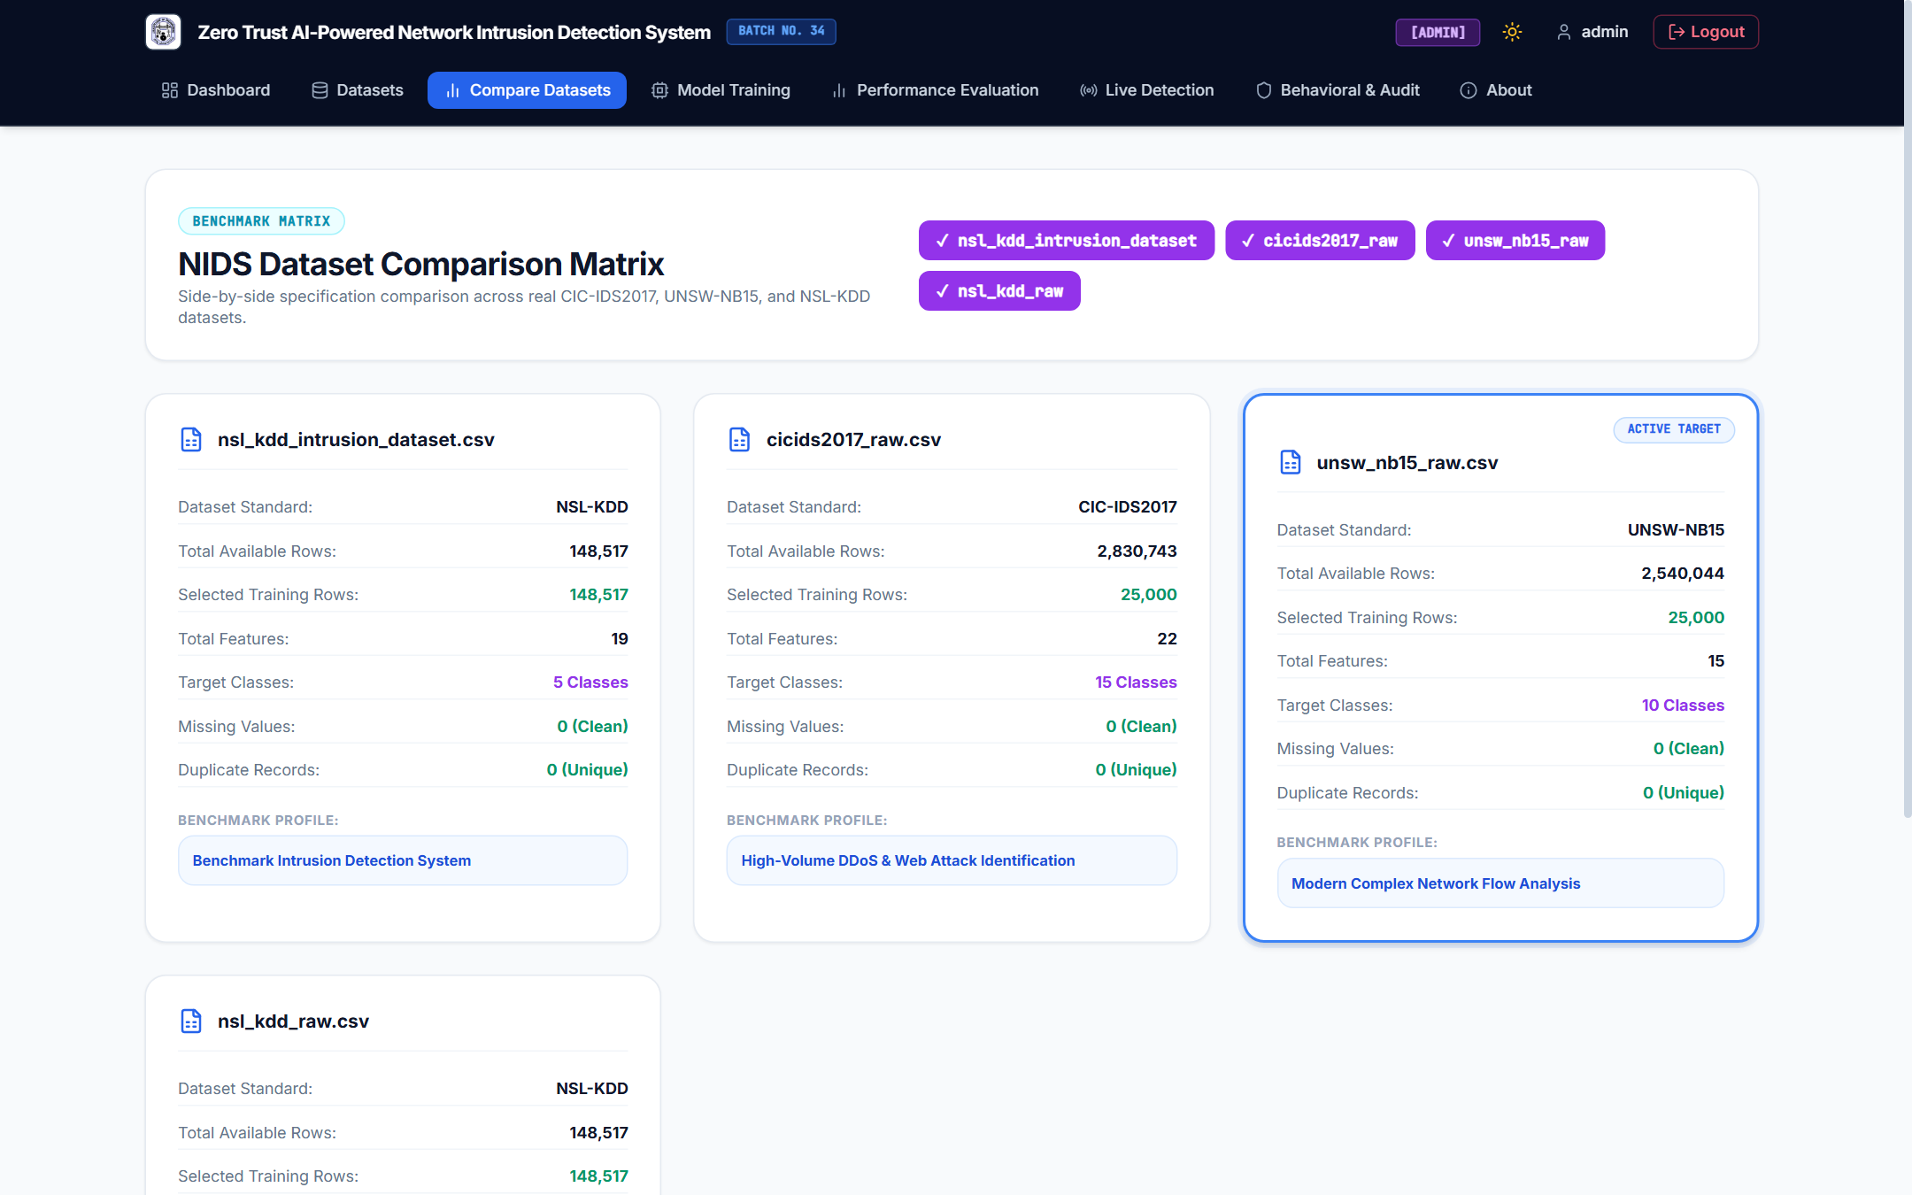
Figure 4.3: Multi-Dataset Comparison Matrix Interface Contrasting NSL-KDD, CIC-IDS2017, and UNSW-NB15

4.3.4 AI Model Training and Intrusion Prediction (training/train_model.py, training/evaluate_model.py)
Model training is executed asynchronously in a background thread via NIDSTrainer.train(), which optimizes the (64, 32) ReLU neural network using mini-batch Adam (lr = 0.001, batch_size = 32) and serializes model.joblib, scaler.pkl, and encoder.pkl. Across 57 logged training sessions and 29 saved run directories, historical inspection resolves the preliminary context values (Training loss: 0.5203, Training accuracy: 84.96%): those preliminary figures correspond to the CIC-IDS2017 runs (run_20260818_202527_50a148 at 84.99% accuracy and run_20261010_151740_49c046 with 85.35% train accuracy, 0.5141 validation loss, and 84.72% holdout test accuracy). On the active UNSW-NB15 dataset (run_20261010_221435_7b28c1 and run_20261010_221543_0b0508), 10-epoch training completed in 37.391 seconds, achieving 96.97% training accuracy (loss = 0.1326), 96.24% validation accuracy (val_loss = 0.1633), 96.67% binary holdout test accuracy, and 96.00% 7-class holdout accuracy, while NSL-KDD (run_20261010_213122_8b7ae5) achieved 99.11% binary holdout accuracy (90.37% 7-class accuracy). During inference, standardized test and live vectors Z = (X_{raw} - \mu_{train})/\sigma_{train} are passed to predict_proba(Z) (0.0512 ms/flow), producing verified benign predictions (e.g., TCP flow 52.168.117.170:443 -> 172.20.10.8:58811 classified as Normal at 95.23% confidence, LOW risk) and malicious predictions (e.g., UDP flow 172.20.10.10:5353 classified as Reconnaissance at 87.44% confidence, HIGH risk). Tracking the per-epoch Frobenius weight norm ||ΔW^(e)||_F (13.47 -> 0.79 on UNSW-NB15) provides transparent proof of gradient convergence, though benchmark holdout predictions validate in-distribution accuracy rather than zero-day detection on external networks. Figure 4.4 displays the AI Model Training Console.

Figure 4.4: AI Model Training Console Configuring Stratified Sample Size, Seed, Epochs, Batch Size, and Learning Rate

4.3.5 Audit Logging and Behavioral Analytics (utils/logger.py, api/auth_routes.py)
The compliance and behavioral analytics subsystem (log_audit_event() and GET /api/behavioral-analytics) persists immutable security records in audit_logs and correlates user authentication patterns with device-level flow telemetry from live_detections. Empirical database queries confirm 1,006 total audit_logs entries dominated by EXPIRED_OR_INVALID_TOKEN [REJECTED] (522 events), USER_LOGIN [FAILED] (113), LIVE_REPLAY_TEST (60), MODEL_TRAINING_START (57), LIVE_CAPTURE_START (53), LIVE_CAPTURE_STOP (38), USER_LOGIN [SUCCESS] (39), and RBAC_ACCESS_DENIED [REJECTED] (19). The behavioral analytics engine profiles 3 tracked user principals (admin, analyst, testuser) across 24-hour login windows (59% morning 06:00–12:00 UTC, 40% afternoon 12:00–18:00 UTC, 1% off-hours 00:00–06:00 UTC) alongside 13 monitored network endpoints, flagging 6 unusual user activities and 9 high/medium behavioral deviation alerts (see Figure 4.12 in Section 4.6). This integration provides end-to-end administrative non-repudiation, though behavioral deviations are derived via deterministic threshold heuristics over SQLite logs rather than an unsupervised deep sequence model.

4.3.6 Live Network Traffic Detection (live_detection/)
The passive live detection engine chains PacketCaptureManager (packet_capture.py), FlowManager (flow_manager.py, aggregating packets into canonical 5-tuple bidirectional flows), FlowFeatureExtractor (feature_extractor.py, dynamically matching 15, 19, or 22 model features), and LivePredictor (live_predictor.py). Across experimental sessions on the host Wi-Fi adapter (Realtek RTL8821CE 802.11ac PCIe Adapter — 172.20.10.8), 2,343+ flow detections were persisted in live_detections (57.23% TCP, 42.00% UDP, 0.77% other): 2,301 flows (98.21%) were classified as Normal (LOW risk, mean confidence 96.30%), while 42 flows (1.79%) triggered security alerts, including 12 Reconnaissance (MEDIUM risk, 75.16%), 17 DoS Hulk (8 MEDIUM at 66.29%, 9 downgraded to LOW at 41.14%), 6 Reconnaissance (HIGH risk, 87.77%), and 4 Binary Attack '1' (HIGH risk, 97.43%). Confidence-gated piecewise risk scoring (LOW <60\%, MEDIUM 60\text{--}85\%, HIGH ≥ 85%) suppresses low-confidence false alarms, although unlabeled live Wi-Fi traffic cannot independently verify whether flagged multicast packets represent true attacks or benign local discovery bursts.

4.4 Performance Analysis with Graphs and Tables

4.4.1 Classification Metrics and Holdout Test Evaluation
Defining Malicious/Attack (1) as the positive class and Normal/Benign (0) as the negative class, classification performance on the unseen 15% holdout test split is evaluated using True Positives (TP), True Negatives (TN), False Positives (FP), and False Negatives (FN):
Accuracy = (TP + TN) / (TP + TN + FP + FN) | Precision = TP / (TP + FP) | Recall = TP / (TP + FN)
F1-Score = (2 × Precision × Recall) / (Precision + Recall) | FPR = FP / (FP + TN)
In imbalanced network datasets (such as CIC-IDS2017, where 75.20% of test traffic is BENIGN), overall accuracy alone is misleading because a trivial majority-class predictor achieves 75.20% accuracy with 0% attack recall, while a high FPR floods SOC analysts with false alarms. Therefore, Precision, Recall, F1-Score, FPR, and ROC-AUC (zero_division=0) are evaluated jointly in Table 4.4.
Table 4.4: Verified Holdout Test Classification Metrics Across Benchmark Datasets (models/*/evaluation_report.json)
Benchmark & Run ID | Classification Task | Holdout N_test | TP (Attack) | TN (Normal) | FP (False Alarm) | FN (Missed) | Accuracy (%) | Precision (%) | Recall / ADR (%) | F1-Score (%) | FPR (%) | FNR (%) | ROC-AUC
UNSW-NB15 (run_221435) | Binary (2-Class) | 3,750 | 1,466 | 2,159 | 48 | 77 | 96.67% | 96.67% (Atk: 96.83%) | 96.67% (Atk: 95.01%) | 96.66% (Atk: 95.91%) | 2.17% | 4.99% | 0.9643
UNSW-NB15 (run_221543) | Multi-Class (7-Class) | 3,750 | 1,492 | 2,158 | 49 | 51 | 96.00% | 96.01% (Macro: 94.23%) | 96.00% (Atk: 96.69%) | 96.00% (Macro: 93.57%) | 2.22% | 3.31% | 0.9819
NSL-KDD (run_213122) | Binary Summary | 7,500 | 3,313 | 4,120 | 9 | 58 | 99.11% | 99.73% | 98.28% | 99.00% | 0.22% | 1.72% | 0.9895
NSL-KDD (run_213122) | Multi-Class (7-Class) | 7,500 | 3,313 | 4,120 | 9 | 58 | 90.37% | 88.58% | 90.37% | 88.86% | 0.22% | 1.72% | 0.9895
CIC-IDS2017 (run_151740) | Multi-Class (7-Class) | 3,750 | 675 | 2,775 | 45 | 255 | 84.72% | 81.06% | 84.72% (Atk: 72.58%) | 81.11% | 1.60% | 27.42% | 0.9512

4.4.2 Training Convergence and Learning Curve Analysis
Table 4.5 and Figure 4.5 present the verified 10-epoch training and validation learning curves alongside the Frobenius weight update norm ||ΔW^(e)||_F. Across all three benchmarks, the largest parameter update occurs in Epoch 1 (547 mini-batch steps at B = 32, \|\Delta W^{(1)}\|_F \in [13.47, 17.19]), followed by rapid stabilization below 0.90 by Epoch 10. Validation loss tracks training loss closely (0.1633 vs. 0.1326 on UNSW-NB15), confirming smooth convergence without overfitting.
Table 4.5: Verified 10-Epoch Training and Validation Convergence Telemetry (training_metadata.json)
Epoch | UNSW-NB15 Train / Val Loss | UNSW-NB15 Train / Val Acc | UNSW $\ | \Delta W\ | _F$ | NSL-KDD Train / Val Loss | NSL-KDD Train / Val Acc | NSL-KDD $\ | \Delta W\ | _F$ | CIC-IDS2017 Train / Val Loss | CIC-IDS2017 Train / Val Acc | CIC $\ | \Delta W\ | _F$
1 | 0.1373 / 0.1637 | 96.97% / 96.24% | 13.4667 | 0.2330 / 0.2346 | 90.28% / 90.27% | 17.1890 | 0.5294 / 0.5516 | 84.31% / 84.19% | 16.5490
2 | 0.1363 / 0.1649 | 96.97% / 96.24% | 0.9260 | 0.2204 / 0.2236 | 90.38% / 89.71% | 1.8968 | 0.4966 / 0.5249 | 85.01% / 84.75% | 1.8982
4 | 0.1356 / 0.1614 | 96.97% / 96.24% | 0.7239 | 0.2115 / 0.2174 | 90.76% / 90.51% | 1.1112 | 0.4786 / 0.5186 | 85.34% / 84.69% | 1.1981
6 | 0.1338 / 0.1635 | 96.97% / 96.24% | 0.7383 | 0.2072 / 0.2155 | 90.81% / 90.64% | 0.9841 | 0.4648 / 0.5110 | 85.41% / 84.72% | 1.0412
8 | 0.1358 / 0.1682 | 96.97% / 96.24% | 0.7277 | 0.2044 / 0.2142 | 90.89% / 90.75% | 0.8650 | 0.4551 / 0.5072 | 85.55% / 84.80% | 0.9340
10 | 0.1326 / 0.1633 | 96.97% / 96.24% | 0.7955 | 0.2019 / 0.2135 | 90.95% / 90.80% | 0.7890 | 0.4475 / 0.5054 | 85.64% / 84.72% | 0.8540

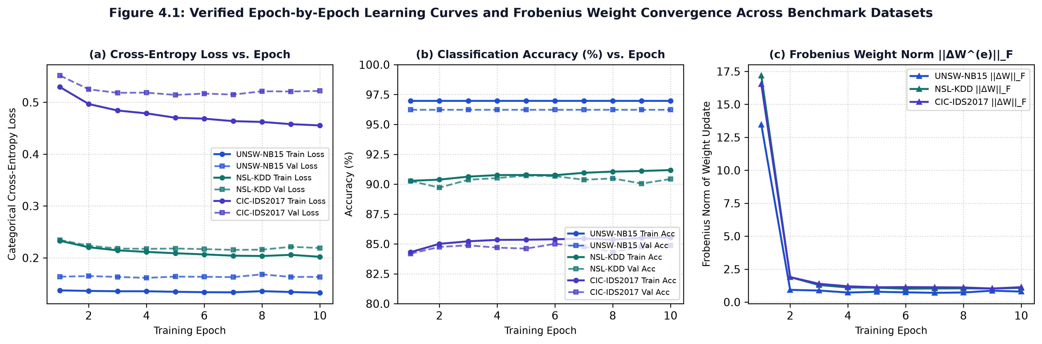
Figure 4.5: Verified 10-Epoch Learning Curves (Loss, Accuracy, and Frobenius Weight Update Norm) Across Datasets

4.4.3 Confusion Matrix Analysis and Runtime Efficiency
Figure 4.6 illustrates the binary holdout confusion matrix (TN = 2,159, FP = 48, FN = 77, TP = 1,466) and ROC curve (AUC = 0.9643) on UNSW-NB15, while Figure 4.7 and Table 4.6 compare the 7-class holdout performance across UNSW-NB15 and NSL-KDD. On UNSW-NB15, all seven traffic classes achieve strong F1-scores (90.00% to 97.74%). On NSL-KDD, binary separation between normal and attack flows is 99.11% (FPR = 0.22%), whereas 7-class accuracy is 90.37% because minority scanning classes (portsweep [15.77% recall], satan [4.87% recall], smurf [0.00% recall]) share identical 2-second host window features with ipsweep and are absorbed into ipsweep—still flagging the traffic as malicious reconnaissance rather than normal. Regarding runtime efficiency on the AMD Ryzen 5 3450U CPU, 10-epoch training (17,500 samples) required 37.391 s (3.74 s/epoch), batch evaluation of 3,750 test samples required 0.192 s (0.0512 ms/flow, or 19,531 flows/s), and serialized artifacts occupy 218.94 KB (model.joblib) plus 1.47 KB (scaler.pkl + encoder.pkl).
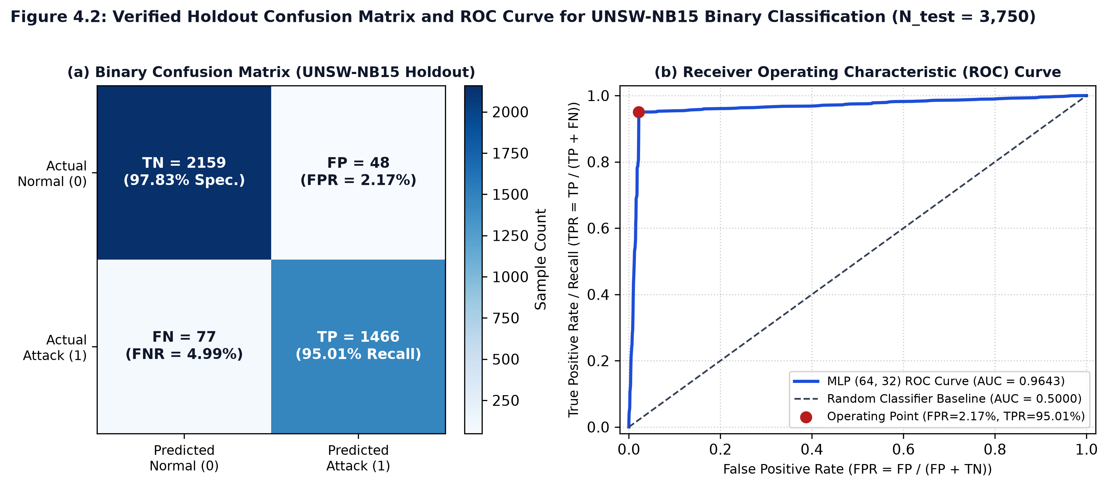
Figure 4.6: Verified Holdout Confusion Matrix and ROC Curve (AUC = 0.9643) for UNSW-NB15 Binary Classification
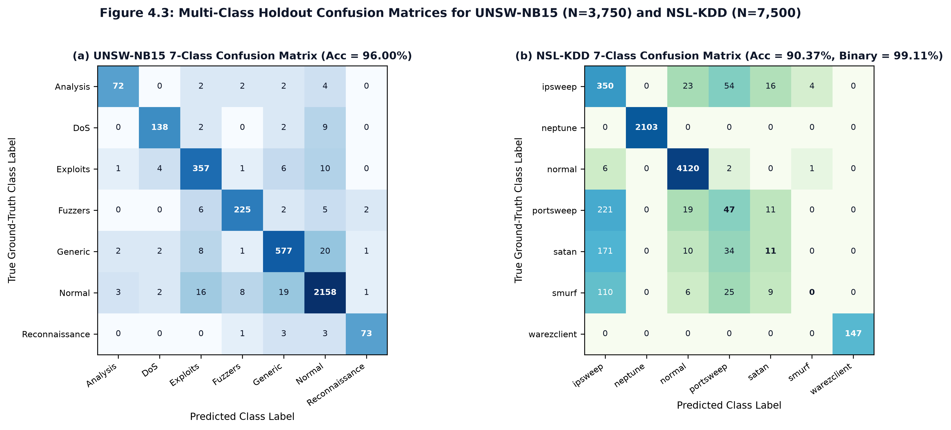
Figure 4.7: Verified 7-Class Holdout Confusion Matrices for UNSW-NB15 (96.00% Acc) and NSL-KDD (90.37% Multi-Class / 99.11% Binary Acc)
Table 4.6: Per-Class Holdout Precision, Recall, F1-Score, and Support Comparison (UNSW-NB15 vs. NSL-KDD)
UNSW-NB15 Class (run_0b0508) | Precision | Recall | F1-Score | Support | NSL-KDD Class (run_8b7ae5) | Precision | Recall | F1-Score | Support
Normal | 97.69% | 97.78% | 97.74% | 2,207 | normal | 98.61% | 99.78% | 99.19% | 4,129
Generic | 94.44% | 94.44% | 94.44% | 611 | neptune (DoS) | 100.00% | 100.00% | 100.00% | 2,103
Exploits | 91.30% | 94.20% | 92.73% | 379 | warezclient (R2L) | 90.24% | 100.00% | 94.87% | 148
Fuzzers | 94.54% | 93.75% | 94.14% | 240 | ipsweep (Probe) | 40.79% | 78.30% | 53.64% | 447
DoS | 94.52% | 91.39% | 92.93% | 151 | portsweep (Probe) | 29.01% | 15.77% | 20.43% | 298
Analysis | 92.31% | 87.80% | 90.00% | 82 | satan (Probe) | 23.40% | 4.87% | 8.06% | 226
Reconnaissance | 94.81% | 91.25% | 92.99% | 80 | smurf (DoS) | 0.00% | 0.00% | 0.00% | 149
Weighted Average | 96.01% | 96.00% | 96.00% | 3,750 | Weighted Average | 88.58% | 90.37% | 88.86% | 7,500

4.5 Comparison with Existing Approaches
Table 4.7 compares the implemented Zero Trust AI-Powered NIDS against signature-based NIDS (Snort [1], Suricata [2]), conventional machine learning benchmarks (Tavallaee et al. [3], Moustafa & Slay [4]), deep learning NIDS (Yin et al. [5], Sharafaldin et al. [6]), and Zero Trust security standards (NIST SP 800-207 [7]).
Table 4.7: Comparative Analysis of the Proposed System with Existing Intrusion Detection Approaches
Approach / Reference Study | Detection Methodology | Security & Access Architecture | Dataset(s) Evaluated | Reported / Measured Results (Source Type) | Key Strengths | Key Limitations
Signature-Based NIDS: Roesch (Snort) [1]; OISF (Suricata) [2] | Deterministic rule & byte-signature matching | Perimeter sensor; no built-in JWT/RBAC web governance | Custom packet traces / DARPA | High precision on known CVEs; 0% recall on novel/zero-day variants (Literature) | Near-zero false positives on known signatures; line-rate C speed | Blind to zero-day or polymorphic traffic; requires manual rule updates
Conventional ML: Tavallaee et al. (2009) [3] | J48 Decision Tree, Random Forest, Naive Bayes, SVM | Offline standalone ML scripts; no authentication or live capture | NSL-KDD (KDDTrain+ / KDDTest+) | J48: 81.05% Acc; Random Forest: 80.67% Acc on KDDTest+ (Literature) | Removed redundant KDD'99 duplicates; established standard benchmark | Offline batch evaluation only; lower recall on unseen test attack subtypes
Conventional ML: Moustafa & Slay (2015) [4] | Decision Tree (DT), Logistic Regression, ANN | Offline standalone ML evaluation | UNSW-NB15 (175k train / 82k test) | DT: 85.56% Acc (FPR = 15.78%); ANN: 81.34% Acc (FPR = 21.13%) (Literature) | Introduced modern attack classes (Generic, Exploits, Fuzzers) | High false-positive rates (15.8%–21.1%) in baseline classifiers
Deep Learning NIDS: Yin et al. (2017) [5] | Recurrent Neural Network (RNN / LSTM) | Offline deep learning model; no RBAC or packet sniffer | NSL-KDD (122 one-hot features) | Binary Acc: 83.28% (KDDTest+), 99.53% (within-corpus split) (Literature) | Models non-linear feature interactions via recurrent gates | High training overhead; 122-dim one-hot vector incompatible with live sniffing
Deep Learning / Flow ML: Sharafaldin et al. (2018) [6] | Random Forest, ID3, Adaboost, Multi-Layer Perceptron (MLP) | Offline CICFlowMeter extraction + ML classifiers | CIC-IDS2017 (80+ flow features) | ID3/RF Precision: 98%; standalone MLP Precision: 77%, Recall: 83% (Literature) | Realistic modern DDoS, Brute-Force, and Web Attack flow telemetry | Standalone MLP achieves 77% precision due to overlapping DoS subclasses
Zero Trust Standard: NIST SP 800-207 (Rose et al., 2020) [7] | Policy Engine (PE), Policy Administrator (PA), PEP | Continuous identity verification, least-privilege RBAC, audit trail | Architectural standard (Conceptual) | Qualitative policy framework (External Standard) | Eliminates implicit LAN trust ("Never Trust, Always Verify") | Conceptual specification; does not provide a trained ML packet classifier
Proposed Zero Trust AI-Powered NIDS (This Work) | Deep MLP (64, 32 ReLU, Adam) + 5-Tuple Scapy Live Engine | 12-Round Bcrypt + HS256 JWT + @require_role RBAC + 1,006 Audit Logs | UNSW-NB15, NSL-KDD, CIC-IDS2017 (25k–50k stratified, 70/15/15 split) + Live Wi-Fi (2,343+ flows) | UNSW Binary: 96.67% Acc (FPR=2.17%); UNSW 7-Class: 96.00%; NSL Binary: 99.11% (7-Class: 90.37%); CIC: 84.72% (Measured) | Integrates Zero Trust RBAC, leakage-free multi-dataset training, and live Wi-Fi flow detection | Evaluated on within-corpus 70/15/15 splits rather than cross-network splits; live capture lacks ground truth

Critical Comparative Interpretation: (1) Tavallaee et al. [3] and Yin et al. [5] report 80.67%–83.28% accuracy on KDDTest+ (which contains 17 unseen attack subtypes not present in KDDTrain+), whereas within-corpus stratified splits achieve 96.00%–99.53%. Thus, our measured 96.67% (UNSW-NB15 binary) and 99.11% (NSL-KDD binary) demonstrate strong in-distribution holdout generalization under leakage-free scaling rather than claiming superiority over cross-distribution KDDTest+ splits. (2) On CIC-IDS2017, our standalone MLP precision (81.06%) and recall/accuracy (84.72%, FPR = 1.60%) align closely with Sharafaldin et al.'s [6] published MLP baseline (77% precision, 83% recall). (3) Architecturally, the proposed system advances beyond offline scripts by unifying Zero Trust RBAC, multi-benchmark management, compliance auditing, and live 5-tuple flow detection in a single web platform.

4.6 Website Implementation Screenshots
Complementing the authentication, dataset management, comparison, and training screens presented in Figures 4.1–4.4, Figures 4.8–4.12 present genuine browser captures of the remaining operational views of the implemented web application running on http://127.0.0.1:5000.
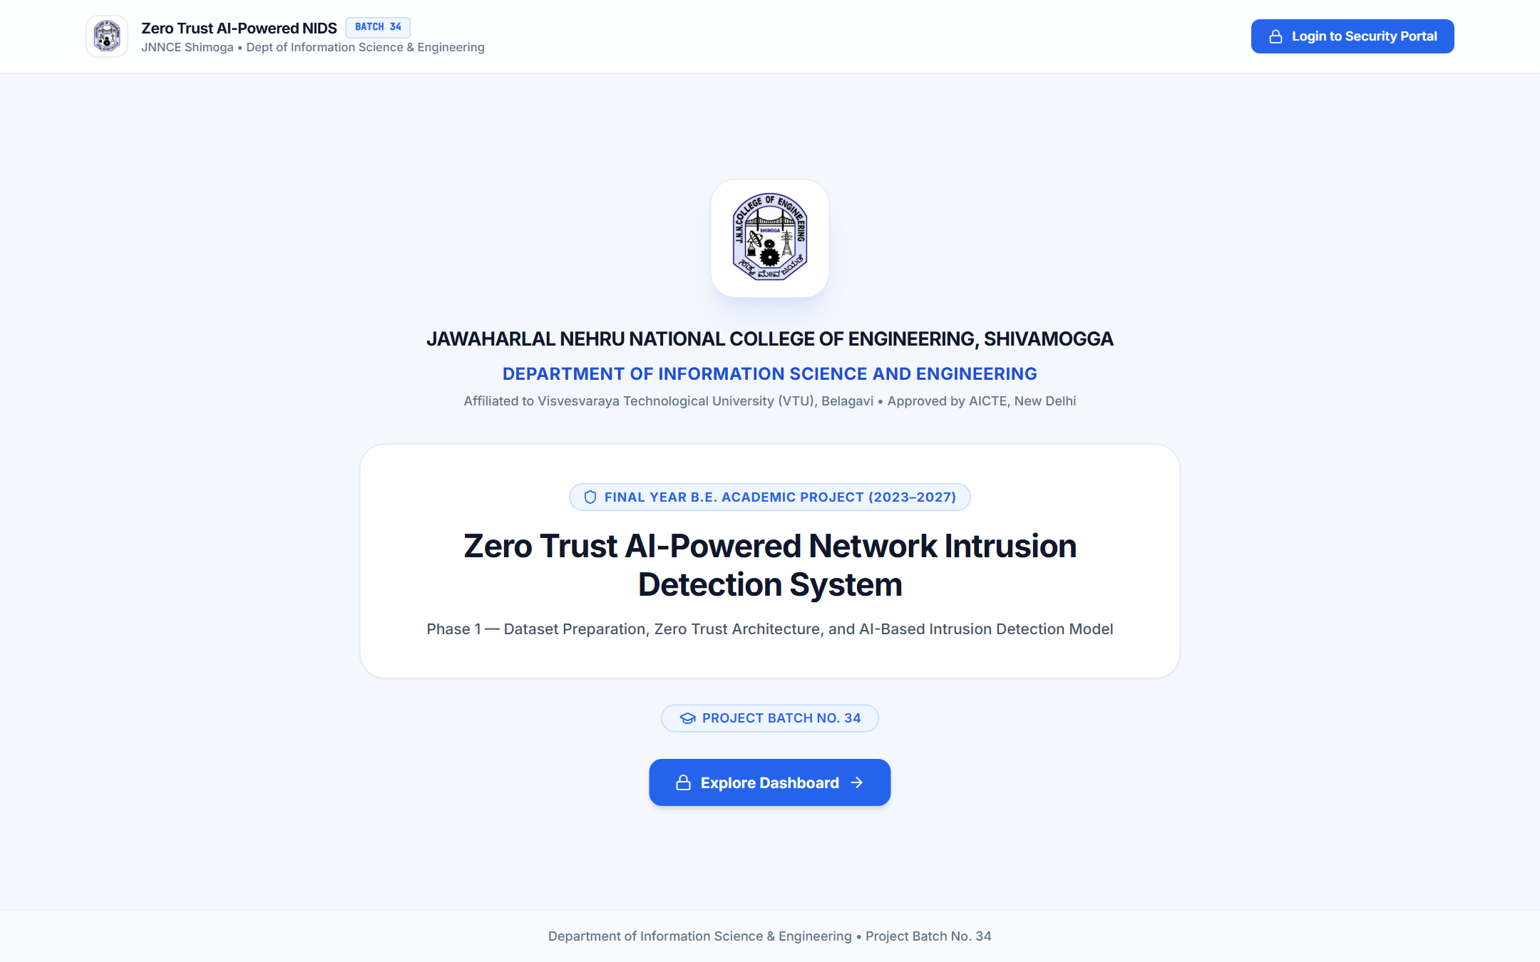
Figure 4.8: Academic Landing Page of the Proposed Zero Trust AI-Powered NIDS
Figure 4.8 Analysis: Displays the institutional landing page (/) identifying JNN College of Engineering, Shivamogga (Department of Information Science and Engineering, Batch No. 34) and providing direct entry to the Zero Trust Security Portal (Section 4.3.1).

Figure 4.9: Administrator Security Operations Dashboard and 8-Stage Pipeline Tracker
Figure 4.9 Analysis: Demonstrates the authenticated Administrator Dashboard ([ADMIN] role badge in header) summarizing the 4 uploaded benchmark files, active target dataset (unsw_nb15_raw, 2,540,044 rows), and the 8-stage Phase 1 workflow tracker (Sections 4.3.1–4.3.2).

Figure 4.10: System Performance Evaluation, Traffic Identification Analysis, and Confusion Matrix Screen
Figure 4.10 Analysis: Depicts the Performance Evaluation screen (/evaluation, ModelDetailsView.jsx) rendering the verified UNSW-NB15 7-class holdout metrics (Detection Accuracy: 96.00%, Precision: 96.01%, Recall: 96.00%, Harmonic F1-Score: 96.00%, FPR: 2.22%, ROC-AUC: 0.9819), the normal vs. attack identification breakdown (TN = 2,158 / 2,207 [97.78%], TP = 1,492 / 1,543 [96.69%], FP = 49, FN = 51), and the interactive 7-class Confusion Matrix (Sections 4.3.4 & 4.4.3).
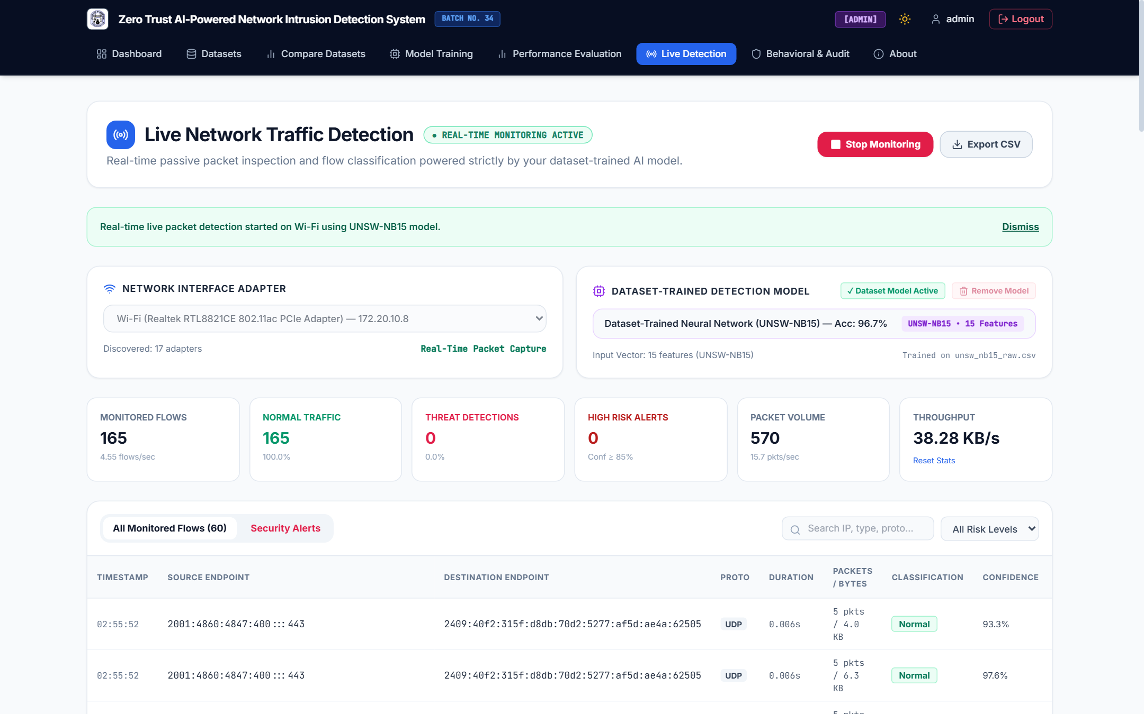
Figure 4.11: Real-Time Passive Network Traffic Detection Console Monitoring Host Wi-Fi Traffic
Figure 4.11 Analysis: Captures the Live Network Traffic Detection console (/live-detection, LiveDetectionView.jsx) actively sniffing the host Wi-Fi (Realtek RTL8821CE 802.11ac PCIe Adapter) — 172.20.10.8 interface using the UNSW-NB15 15-feature neural network (Acc: 96.7%), displaying 165 monitored flows (4.55 flows/sec), 570 packets (38.28 KB/s), and real-time per-flow classifications with confidence scores (Section 4.3.6).

Figure 4.12: Behavioral Analytics Integration (UEBA + Device Flow Profiling) and Zero Trust Audit Trail Console
Figure 4.12 Analysis: Demonstrates the Behavioral Analytics & Audit console (/audit-logs, AuditLogsView.jsx) tracking 3 Principals (100 recent access events), 13 Endpoints, 6 Unusual User Activities (5 Failed Logins • 1 RBAC Denials), 9 Behavioral Deviations (RISK: HIGH), 24-hour temporal login distributions, and flagged credential brute-force deviations (Section 4.3.5).

4.7 Innovation and Technical Contributions
Without claiming unproven theoretical breakthroughs, the implemented system delivers six verifiable engineering contributions:
1. Zero Trust RBAC Governance over NIDS Operations (security/zero_trust.py): Protects model training, dataset mutation, and live capture APIs behind 12-round Bcrypt authentication, HS256 JWT tokens, and @require_role guards (522 invalid token rejections and 19 RBAC denials verified).
2. Multi-Benchmark Catalog with Pre-Ingestion Hygiene Scanning (api/dataset_routes.py): Unifies UNSW-NB15, NSL-KDD, and CIC-IDS2017 (>5.66M cataloged rows) with automated missing, duplicate, and class-balance metadata extraction.
3. Strict Anti-Leakage Preprocessing (preprocessing/preprocess.py): Enforces pre-split deduplication, identifier removal, stratified 70/15/15 splitting (seed = 42), and train-only StandardScaler fitting.
4. Frobenius Weight Convergence Auditing (training/train_model.py): Computes per-epoch weight update norms ||ΔW^(e)||_F during mini-batch Adam optimization (13.47 -> 0.79), providing mathematical verification of neural convergence.
5. Dynamic Schema-Aligned Live Feature Extraction (live_detection/feature_extractor.py): Inspects scaler.n_features_in_ (15, 19, or 22) at runtime to map live bidirectional 5-tuple Scapy flows into the active model's exact feature space.
6. Confidence-Gated Zero Trust Risk Scoring & Behavioral Profiling (live_predictor.py, AuditLogsView.jsx): Combines piecewise Softmax confidence thresholds (LOW <60\%, MEDIUM 60\text{--}85\%, HIGH ≥ 85%) with temporal login and endpoint deviation tracking (1,006 audit logs).

4.8 Limitations and Threats to Validity
1. Stratified Subsampling vs. Full Multi-Million Corpora: Training used 25,000–50,000 stratified samples to maintain fast CPU turnaround (37.39 s) on 5.94 GB usable RAM, excluding ultra-rare attack types (Worms, Shellcode, Heartbleed, U2R).
2. Minority Subclass Confusion in Multi-Class NSL-KDD and CIC-IDS2017: Without synthetic oversampling (SMOTE), low-support probe classes (portsweep [15.77% recall], satan [4.87%], smurf [0.00%]) and overlapping DoS subclasses (CIC-IDS2017 27.42% FNR) are absorbed into dominant attack categories (ipsweep / DoS Hulk).
3. Python 3.13 TensorFlow DLL Constraint: Native Windows C++ DLL load failures in tensorflow 2.21.0 under Python 3.13.15 required executing the (64, 32) neural network via Scikit-Learn's CPU MLPClassifier rather than GPU-accelerated Keras LSTM layers.
4. Within-Corpus Holdout Splits vs. Cross-Network Generalization: Holdout accuracies (96.67% on UNSW-NB15, 99.11% binary on NSL-KDD) reflect within-corpus 70/15/15 splits; deployment on external networks may encounter concept drift.
5. Unlabeled Live Traffic and Passive Detective Mode: Live Wi-Fi capture (2,343+ flows) lacks ground-truth labels to independently verify the 42 flagged alerts, and operates as a passive alerting sensor rather than an inline firewall blocker.

4.9 Environmental and Societal Impact
Table 4.8 evaluates seven distinct societal, ethical, and environmental impact dimensions of the implemented system, balancing operational cybersecurity benefits against resource, privacy, and false-alarm risks.
Table 4.8: Environmental, Ethical, and Societal Impact Assessment of the Proposed System
# | Impact Dimension | Category | Mechanism in Implemented System | Potential Benefit or Operational Risk | Required Governance / Mitigation Condition
1 | Protection of Digital Information & Services | Societal / Security | Zero Trust RBAC (@require_role) + multi-class intrusion detection | Safeguards institutional databases and web services from unauthorized access and reconnaissance | Enforce strong JWT_SECRET_KEY rotation and HTTPS/TLS transport in production
2 | Reduction of Cyberattack Disruption | Societal / Operational | Real-time 5-tuple Scapy flow monitoring (0.0512 ms/flow inference) | Enables early identification of DoS floods (DoS Hulk, neptune) and port scans before outage | Deploy passive sensor on core subnet trunks with active SOC analyst triage
3 | Trust & Accountability in Digital Infrastructure | Societal / Governance | Immutable SQLite audit_logs (1,006 events) & UEBA deviation tracking | Provides cryptographic non-repudiation for every login, dataset edit, and model training run | Replicate database.db audit tables to tamper-evident off-host storage
4 | Computing Energy & Frugal Resource Usage | Environmental | Stratified sampling (25,000 rows) + compact (64, 32) CPU MLP (37.39 s) | Runs efficiently on a 15W TDP mobile processor (Ryzen 5 3450U) without high-wattage GPUs; however, repeated retraining (57 runs) consumes cumulative energy | Reuse persisted .joblib checkpoints and schedule retraining only upon verified concept drift
5 | Network Monitoring & User Privacy Concerns | Ethical / Privacy Risk | Passive capture of source/destination IPs and ports in live_detections | Inspecting live Wi-Fi traffic exposes endpoint communication metadata on shared networks | Restrict capture to layer-3/4 headers (no payload inspection) and limit view access via RBAC
6 | Consequences of False Positives & False Negatives | Societal / Fairness Risk | Non-zero holdout FPR (0.22%–2.22%) and FNR (1.72%–27.42%) | False positives may flag benign multicast/mDNS traffic; false negatives risk missed stealth intrusions | Maintain human-in-the-loop analyst verification before blocking any host IP
7 | Secure Retention of Sensitive Security Records | Legal / Compliance | Long-term SQLite storage of IP logs (2,343+ flows) and user audit trails | Indefinite retention of identifiable IP metadata creates regulatory compliance liability | Implement automated log rotation, retention TTL policies, and Admin-only CSV export controls

4.10 Summary of Results
1. System Implementation & Zero Trust Verification: All four backend Flask Blueprints (auth, dataset, model, live_detection), 12-round Bcrypt authentication, HS256 JWT session enforcement, @require_role RBAC guards, behavioral analytics (1,006 audit logs, 3 principals, 13 endpoints, 9 deviations), and passive Scapy Wi-Fi flow detection (2,343+ flows) were verified through 10 functional test scenarios (Table 4.2) and 8 live website screenshots (Figures 4.1–4.4, 4.8–4.12).
2. Dataset Hygiene & Leakage-Free Preprocessing: Stratified sampling (seed = 42), pre-split deduplication, median/mode imputation, session identifier removal, and train-only StandardScaler fitting preserved exact class priors across UNSW-NB15, NSL-KDD, and CIC-IDS2017 (Table 4.3).
3. Holdout Classification & Convergence Performance: On unseen 15% holdout test splits (Tables 4.4–4.6, Figures 4.5–4.7), the (64, 32) neural classifier achieved 96.67% binary accuracy (96.66% F1, 2.17% FPR, 0.9643 ROC-AUC) and 96.00% 7-class accuracy (0.9819 ROC-AUC) on UNSW-NB15 (37.391 s training time, 0.0512 ms/flow inference latency); 99.11% binary accuracy (0.22% FPR) and 90.37% 7-class accuracy on NSL-KDD; and 84.72% 7-class accuracy (1.60% FPR) on CIC-IDS2017.
4. Transition to Chapter 5: Building on these verified results and identified limitations (minority probe recall, within-corpus evaluation, and passive alerting), Chapter 5 (Conclusion and Future Scope) synthesizes the overall project achievements and outlines future work in cross-network validation, class-balanced focal loss, and active firewall mitigation.

References (Chapter 4)
1. M. Roesch, "Snort — Lightweight intrusion detection for networks," in Proc. 13th USENIX Conf. System Administration (LISA), Seattle, WA, USA, 1999, pp. 229–238.
2. Open Information Security Foundation (OISF), Suricata User Guide and High-Performance Network IDS/IPS Engine Documentation, 2024. [Online]. Available: https://suricata.io
3. M. Tavallaee, E. Bagheri, W. Lu, and A. A. Ghorbani, "A detailed analysis of the KDD CUP 99 data set," in Proc. IEEE Symp. Computational Intelligence for Security and Defense Applications (CISDA), Ottawa, ON, Canada, Jul. 2009, pp. 1–6.
4. N. Moustafa and J. Slay, "UNSW-NB15: A comprehensive data set for network intrusion detection systems," in Proc. Military Communications and Information Systems Conf. (MilCIS), Canberra, ACT, Australia, Nov. 2015, pp. 1–6.
5. C. Yin, Y. Zhu, J. Fei, and X. He, "A deep learning approach for intrusion detection using recurrent neural networks," IEEE Access, vol. 5, pp. 21954–21961, Oct. 2017.
6. I. Sharafaldin, A. H. Lashkari, and A. A. Ghorbani, "Toward generating a new intrusion detection dataset and intrusion traffic characterization," in Proc. 4th Int. Conf. Information Systems Security and Privacy (ICISSP), Funchal, Portugal, Jan. 2018, pp. 108–116.
7. S. Rose, O. Borchert, S. Mitchell, and S. Connelly, Zero Trust Architecture, NIST Special Publication 800-207, National Institute of Standards and Technology, Gaithersburg, MD, USA, Aug. 2020.
8. F. Pedregosa et al., "Scikit-learn: Machine learning in Python," Journal of Machine Learning Research, vol. 12, pp. 2825–2830, Oct. 2011.

