Image Captioning: A Comparative Study

Gowri Galgali Lohith R Gowda

1RVU22CSE060 1RVU22CSE09

Course Instructor: Dr. Shobana P
Abstract
Image captioning is a problem that revolves around both computer vision and natural language processing, which aims to generate descriptive textual captions for given images. This report presents a comparison study of image captioning using three deep learning models: (1) vgg16 with LSTM, (2) ResNet50 with LSTM, and InceptionV3 with LSTM (3). These models were trained and evaluated on the Flickr8k dataset. The performance of these models was compared using standard metrics BLEU to assess caption quality and relevance. Additionally, the computational efficiency, scalability, and robustness of each model were analyzed to understand their suitability for real-world applications.
The study highlights the strengths and limitations of each model, identifying the most effective approach for generating accurate and contextually appropriate captions. The BLEU scores comparison was very close by, BLEU 1 ranging from 0.50-0.51 and BLEU 2 ranges form 0.28 -0.29.

Keywords
Image Captioning, Computer Vision, LSTM, BLEU, Captions, Dataset

Introduction
Image Captioning is a task that includes the integration of two major domains of deep learning Computer Vision and Natural Language Processing (NLP) which aims to describe the visuals that have been analysed. This technology has various applications in areas where there is a requirement for assistance such as for the visually impaired, image-based content retrieval, etc.
This project aims to explore and compare different deep learning approaches to understand the almost idealistic approach to the problem. The three deep-learning approaches to image captioning dealt with in this are:

ResNet50: Known for its residual connections, enabling deep networks to mitigate vanishing gradient issues and extract robust features.
VGG16: A simpler architecture with a deep stack of convolutional layers, providing high-quality feature representations.
InceptionV3: Utilizes a more complex design with multiple-sized convolutional filters, allowing the model to capture diverse spatial features efficiently.
The extracted features from these CNNs are fed into an LSTM network, which is trained to generate captions by learning the sequential dependencies between words. Using the Flickr8k dataset, the project compares the performance of these three CNN-LSTM combinations in generating accurate and fluent captions.

Related Work
Captioning images has been an intense research topic in computer vision and natural language processing, with recent progress in combining deep learning models with attention mechanisms to generate the most effective text.

Object-Transforming Approach: The paper Image Captioning: Transforming Objects into Words describes an architecture that focus on transforming the objects detected into coherent textual descriptions. This model makes use of object detectors, transformers, and contextual embeddings and demonstrates stronger scores for CIDEr and SPICE on datasets like MS COCO. This is important especially for capturing relationships among objects for the captioning of semantically richer captions. [1]
Captioning: SciCap emphasizes caption generation in scientific figures and the specific linguistic and visual features of scientific data. Combining domain-specific knowledge and neural architectures, SciCap effectively generates descriptions tailored to technical audiences, underlining the adaptability of techniques in image captioning into specialized domain . [2]
Distributions: The set of experiments using the MS COCO dataset has demonstrated 15.04% improvement in the evaluation of CIDEr compared to the state-of-the-art models. Results such as this further underscore the utility of the dataset in benchmarking captioning models, with active driving of architectures that better align with human judgment metrics. [3]

Methodology
The implementation is divided into distinct stages:
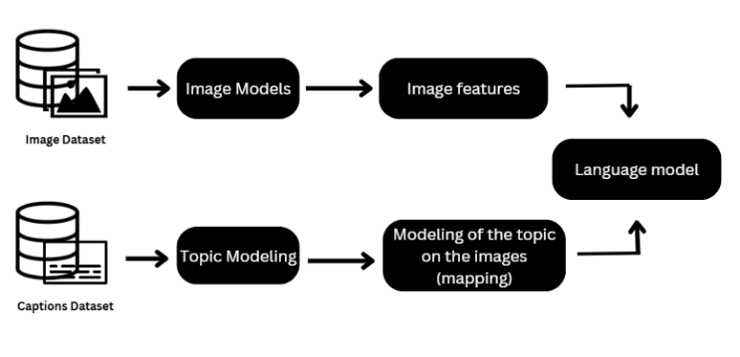

- Implementation of the project.
About Dataset
Flickr8k dataset comprises 8,092 images with 5 captions for each image written by a human.
The images cover a wide range of range of diversity. Classified as best for small experiments.
Data Preparation and Preprocessing:
The image dataset was resized and normalized for input into CNN models. The captions were tokenized, lowercase, and padded to ensure consistent sequence length and a vocabulary was built from the unique tokens in the captions.
Feature Extraction:
CNN models are used to extract features from the images:
ResNet50: Utilizes residual connections to facilitate the training of deep networks and extract robust features.
VGG16: Known for its uniform convolutional layers, offering rich feature extraction at a higher computational cost.
InceptionV3: Employs inception modules to capture multi-scale features efficiently.
Features were extracted from the penultimate layer of each CNN and saved for subsequent use.
Caption Generation with LSTM:
An LSTM network was designed to generate captions based on extracted features and word embeddings.
The model incorporated:
- Input Layer: Combines CNN features and token embeddings.
- LSTM Layers: Capture temporal dependencies between words in captions.
- Output Layer: Produces word probabilities at each time step using a softmax function.
The architecture also included dropout layers to mitigate overfitting and a categorical cross-entropy loss function for optimization.
Training and Optimization:
- Training: The models were trained in parallel making it easier for evaluation, with 20 epochs.
- Evaluation Metrics: The generated captions were evaluated using BLEU ensuring alignment with human-annotated captions.
Design and Implementation
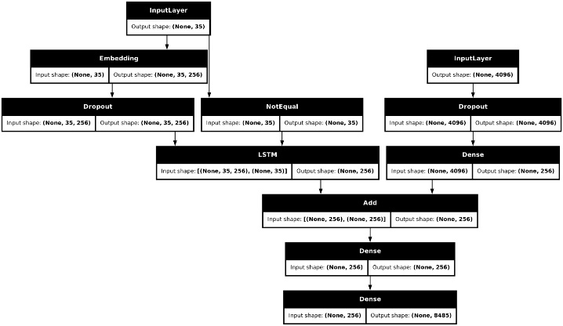
- Design of the model
Dataset and Preprocessing
Dataset: The Flickr8k dataset is used which comprises 8,000 images, each annotated with five captions, and is loaded in with image processing that is Images are resized to a fixed shape 224x224 (For Vgg16 and ResNet50 )and 299x299 ( based on the CNN model requirements. Pixel values are normalized to the range [0, 1].
Tokenization: Captions are split into words and padded to a fixed length.
Vocabulary Creation: The unique words are indexed, and a mapping of word-to-index and index-to-word is created to make sure there is appropriate mapping.
Sequence Conversion: Captions are converted to sequences of word indices.
Feature Extraction
Pre-trained CNN models are loaded from TensorFlow/Keras, with the top (fully connected) layers removed.Extracted features from the penultimate layer are saved as compressed arrays for efficiency.
Caption Generation Model
The LSTM receives:
Visual features: Extracted from CNNs and passed through a dense layer for dimensionality reduction.
Model Architecture:
Dense layer for CNN features: Maps features to the LSTM-compatible space.
Embedding layer: Encodes the input word sequences.
LSTM layer: Generates sequences based on the image features and previous words.
Dense output layer with softmax activation: Predicts the next word in the sequence.
Training and Optimization
Loss Function: Categorical cross-entropy, computed between the predicted and actual word sequences.
Optimizer: Adam optimizer with an initial learning rate of 0.001.
Batch Size: 32
Epochs: 20
Model converges well on these inputs.
Result and Analysis
BLEU (Bilingual Evaluation Understudy) is a metric used to evaluate the quality of text generated by a machine (like image captions or translations) compared to a reference (human-generated text). It measures the overlap between n-grams in the generated and reference captions.
BLEU-1: Measures unigram (word-level) precision.
BLEU-2: Measures bigram (two-word sequence) precision.
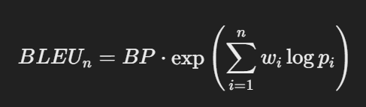
- BLEU formula

The BLEU 1 and 2 were almost similar but there was a slight variation.
Model Name | BLEU-1 | BLEU-2
Vgg16+LSTM | 0.5044 | 0.2793
ResNet50+LSTM | 0.5143 | 0.2872
InceptionV3+LSTM | 0.5176 | 0.2963
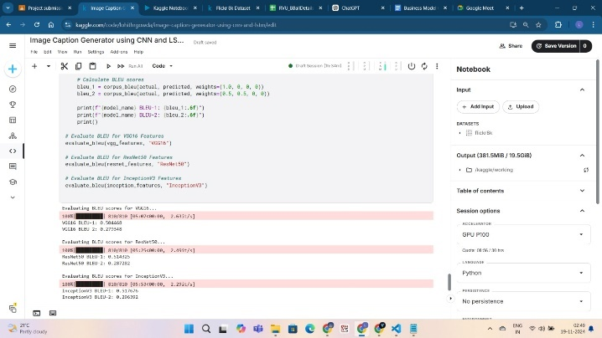
Table 1: Results of the project
- Model Results.

It can be analysed that the InceptionV3+LSTM gives out the best results in comparision.

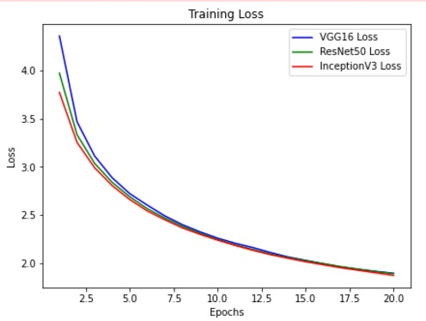
The training loss graph provides an understanding of how the models start off with different high losses but end converging at the end of the 20 epochs.
Conclusion
This study implemented and compared three CNN + LSTM-based architectures—ResNet50, VGG16, and InceptionV3—for image captioning, utilizing the Flickr8k dataset. The models were evaluated using a systematic methodology based on quantitative metrics (BLEU), qualitative analysis, and computational efficiency.
Future Work
Different NLP-based architectures given below:
Transformer-Based Model: Leverages the self-attention mechanism to capture dependencies between image features and textual tokens. Transformers have revolutionized natural language processing and are increasingly being applied to vision tasks.
Vision-Language Pretrained (VLP) Model: Employs large-scale pretraining on vision-language datasets to align image and text representations, providing state-of-the-art performance in many vision-language tasks.

References

[1] Neural Image Caption Generation with Visual Attention (https://arxiv.org/pdf/1502.03044v3)
[2] Image Captioning: Transforming Objects into Words (https://proceedings.neurips.cc/paper_files/paper/2019/file/680390c55bbd9ce416d1d69a9ab4760d-Paper.pdf)
[3] https://paperswithcode.com/paper/scicap-generating-captions-for-scientific

