Standard Python vs NumPy: Performance Comparison
Example: Product Price Analytics

1. Problem Statement
A retailer needs to summarize product prices and calculate discounted prices and prices including an illustrative tax. This project implements identical calculations using standard Python and NumPy, verifies result equivalence, and compares runtime and estimated input memory.

2. Dataset and Operations
A reproducible synthetic dataset of 500,000 prices was generated using NumPy's random generator with seed 42. Prices range from 1 to 500 arbitrary currency units. Both approaches use exactly the same values.
- Sum, mean, minimum, and maximum
- Element-wise 10% discount: price × 0.90
- Element-wise illustrative 18% tax: price × 1.18

3. Implementation Without NumPy
The standard Python version uses a list, built-in aggregation functions, and list comprehensions:
def standard_python_ops(prices):
total = sum(prices)
mean = total / len(prices)
minimum = min(prices)
maximum = max(prices)
discounted = [price * 0.90 for price in prices]
with_tax = [price * 1.18 for price in prices]
return total, mean, minimum, maximum, discounted, with_tax

4. Implementation With NumPy
The NumPy version uses array functions and vectorized element-wise operations:
def numpy_ops(prices):
total = np.sum(prices)
mean = np.mean(prices)
minimum = np.min(prices)
maximum = np.max(prices)
discounted = prices * 0.90
with_tax = prices * 1.18
return total, mean, minimum, maximum, discounted, with_tax

5. Performance Methodology
- Dataset size: 500,000 prices.
- Each approach was timed 5 times after a small warm-up run.
- Runtime measured with time.perf_counter().
- Median runtime reported to reduce the effect of one unusually fast or slow run.
- Timing includes aggregation and creating discounted/tax-adjusted results.
- Memory estimate compares the Python list container plus float objects with the NumPy input array buffer; it excludes output arrays/lists and other temporary allocations.

6. Results From This Run
Metric | Standard Python | NumPy
Median runtime (seconds) | 0.114386 | 0.005213
Sum | 125,109,442.803544 | 125,109,442.803544
Mean | 250.218886 | 250.218886
Minimum | 1.001216 | 1.001216
Maximum | 499.998934 | 499.998934
Input memory estimate (MiB) | 15.26 | 3.81
Observed NumPy speedup: approximately 21.94× by median runtime. Results equivalent within floating-point tolerances: True.
Timings depend on hardware, Python/NumPy versions, and system load. Run the supplied script on your own computer for a local comparison.
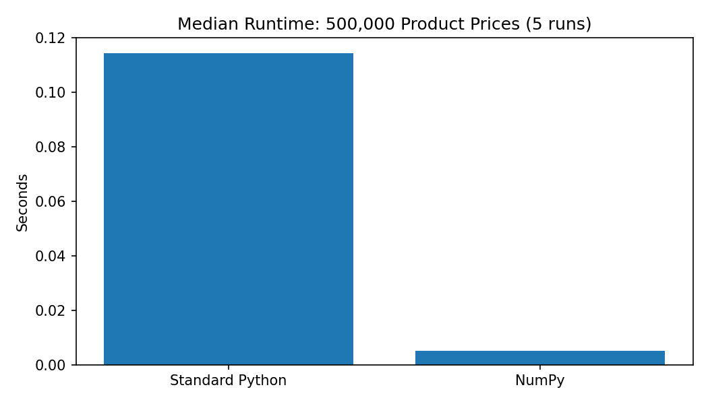

7. Comparison
Aspect | Standard Python | NumPy
Code style | Built-ins and list comprehensions | Concise array functions and vectorized expressions
Element-wise operations | Usually loop/list comprehension | Direct arithmetic on entire arrays
Execution time | Often slower for large numerical workloads | Often faster due to optimized compiled operations
Memory | List references plus individual float objects | Compact homogeneous numeric buffer
Dependencies | Built into Python | Requires NumPy
Best suited for | Small tasks and general logic | Large numerical datasets and repeated calculations

8. Limitations
- Synthetic data is used; it is reproducible but not a real retailer's private dataset.
- Floating-point results may differ by tiny rounding amounts because summation order can differ.
- Memory values are estimates for input storage only.
- NumPy vectorized operations may allocate output arrays, so memory still matters for very large datasets.

9. Conclusion
Both implementations perform the same operations and produce equivalent results within a numerical tolerance. Standard Python is a good choice for small datasets and simple scripts. NumPy generally provides more concise code, faster numerical operations, and compact storage for large homogeneous numeric arrays. Use the included benchmark to verify performance in your own environment.

10. How to Run
- Install Python 3.10 or later.
- Run: pip install numpy pandas matplotlib openpyxl
- Run: python python_vs_numpy_product_prices.py
- Open outputs/performance_comparison.xlsx and outputs/runtime_comparison.png.

