* 1. **Given an array of strings words, return the first palindromic string in the array. If there is no such string, return an empty string "". A string is palindromic if it reads the same forward and backward**.

**Aim**: To return the first string in a given array that is a palindrome (i.e., it reads the same forwards and backwards). If none exists, return an empty string "".

**Algorithm: First Palindromic String in an Array**

1. **Start** with the first string in the array.
2. For each string in the array:
   * Check if the string is a **palindrome**.
     + A string is a palindrome if it reads the same forwards and backwards.
   * If it is a palindrome, **return it immediately**.
3. If **no palindromic string** is found after checking all strings, return an **empty string** "".

**Code:**

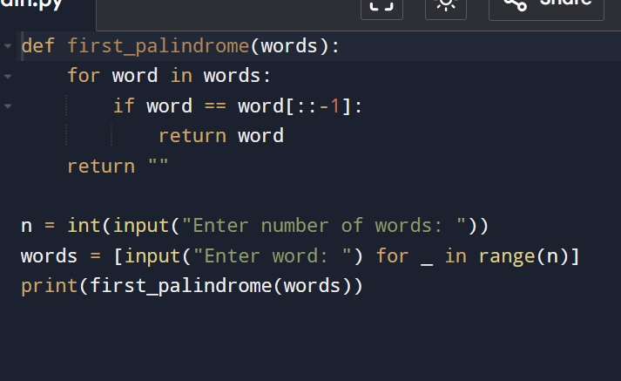

**Input**:

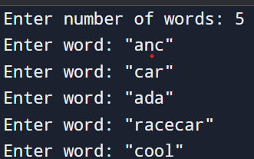

**Output:**

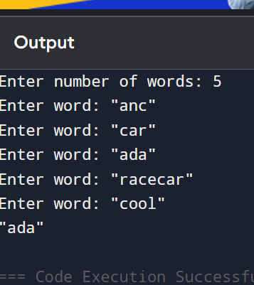

**Performance analysis:**

**Time complexity**:O(n * m)

**Space complexity**:O(n * m)