* 1. **Given an m x n grid and a ball at a starting cell, find the number of ways to move the ball out of the grid boundary in exactly N steps.**

**Example:**

**· Input: m=2, n=2, N=2, i=0, j=0 · Output: 6**

**· Iinput: m=1, n=3, N=3, i=0, j=1 · Output: 12**

**Aim:**

To find how many different ways a ball can move out of an m x n grid in exactly N steps starting from a given position (i, j).

**Algorithm:**

1. Use recursive DFS with memorization to explore all possible moves from the current position.
2. At each step, try moving the ball in 4 directions: up, down, left, right.
3. If the ball moves outside the grid, count it as one valid way.
4. If the number of steps left is zero and the ball is still inside, return 0.
5. Use a dictionary to memorize already computed states to avoid recomputation.
6. Return the total number of valid paths modulo 109+7109+7.

**Code:**

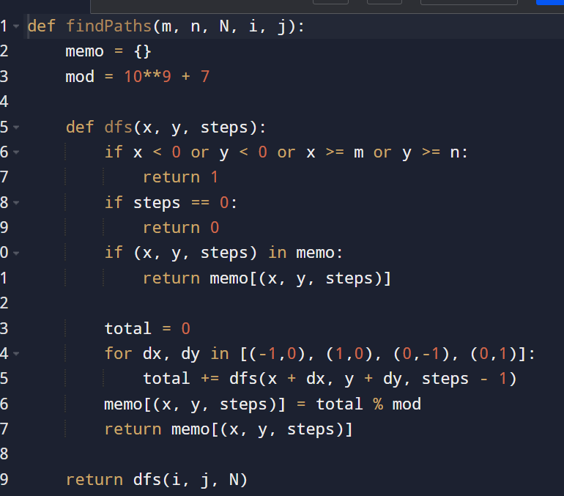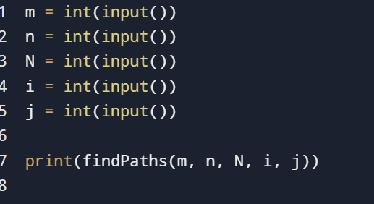

**Input:**

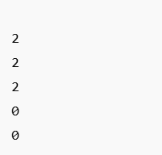

**Output:**



**Result:** givenCounting the Number of Ways to Move a Ball Out of a Grid in N Steps

**Performance analysis:**

* **Time Complexity: O(N×m×n) *O* (*N*×*m*×*n*)**
* **Space Complexity: O(N×m×n) *O*(*N*×*m*×*n*)**