**14.A robot is located at the top-left corner of a m×n grid .The robot can only move either down or right at any point in time. The robot is trying to reach the bottom-right corner of the grid. How many possible unique paths are there?**

**Examples:**

**Input: m=7, n=3 Output: 28**

**Input: m=3, n=2 Output: 3**

**Aim:**

To calculate the number of unique paths a robot can take from the top-left corner to the bottom-right corner of an m × n grid, moving only right or down at any step.

**Algorithm**:

This is a combinatorics and dynamic programming problem.

Mathematical Logic (Efficient):

* The robot has to move:
  + m-1 times down
  + n-1 times right
* So, total moves = (m - 1 + n - 1) = m + n - 2
* The number of ways to arrange these moves =

(m+n−2m−1) =(m+n−2)! (m−1)! ⋅(n−1)! (*m*−1*m*+*n*−2​) = (*m*−1)!⋅ (*n*−1)!(*m*+*n*−2)!​

This is the most efficient solution using the combinations formula.

**Code:**

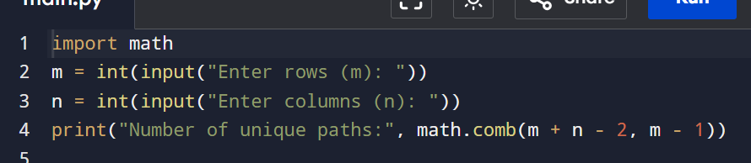

**Input and output:**

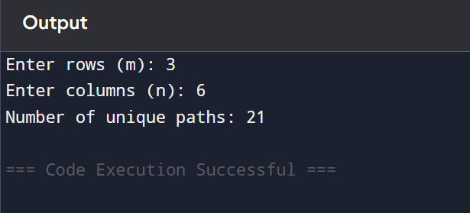

**Result: given Unique Paths in a Grid (Robot Movement from Top-Left to Bottom-Right) is executed successfully and output is verified.**

**Performance analysis:**

**Time Complexity: O (1)O(1)  
Space Complexity: O (1)O(1)**