**15. In a string S of lowercase letters, these letters form consecutive groups of the same character. For example, a string like s = "abbxxxxzyy" has the groups "a", "bb", "xxxx", "z", and "yy". A group is identified by an interval [start, end], where start and end denote the start and end indices (inclusive) of the group. In the above example, "xxxx" has the interval [3,6]. A group is considered large if it has 3 or more characters. Return the intervals of every large group sorted in increasing order by start index.**

**Example 1:**

**Input: s = "abbxxxxzzy"**

**Output: [[3,6]]**

**Explanation: "xxxx" is the only large group with start index 3 and end index 6.**

**Example 2:**

**Input: s = "abc"**

**Output: []**

**Explanation: We have groups "a", "b", and "c", none of which are large groups.**

**Aim:**

To find all **large groups** in a given string where a large group is defined as a group of **three or more consecutive identical characters**, and return the list of their **[start, end] indices**.

**Algorithm:**

1. Initialize start = 0 to track the beginning of a group.
2. Iterate through the string from index 1 to end:
   * If the current character is different from the previous, check if the group length is ≥ 3.
   * If yes, add [start, i - 1] to the result.
   * Then update start = i to start a new group.
3. After the loop, check the last group as it may be a large group.

**Code:**

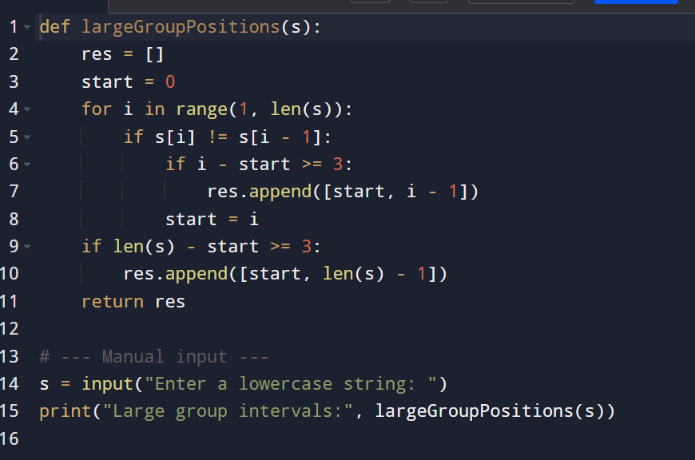**\**

**Input and output:**

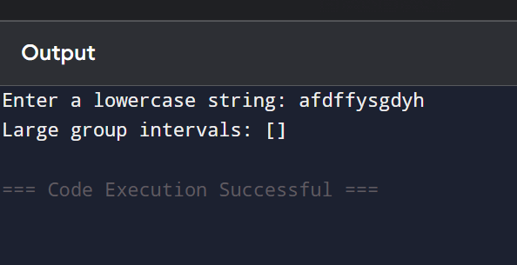

**Result: given large array finding is executed successfully and output is verified**

**Performance analysis:**

**Time Complexity: O(n)*O*(*n*)  
Space Complexity: O(1)*O*(1) *(excluding output list)***