**1.2** You are given two integer arrays nums1 and nums2 of sizes n and m, respectively. Calculate the following values: answer1 : the number of indices i such that nums1[i] exists in nums2. answer2 : the number of indices i such that nums2[i] exists in nums1 Return [answer1,answer2].

**AIM:**

**ALGORITHM:**

**Start**

· Convert nums2 into a **set** (for O(1) lookup).

· Initialize answer1 = 0.

* For each element in nums1:
  + If element exists in set(nums2), increment answer1.

· Convert nums1 into a **set** (for O(1) lookup).

· Initialize answer2 = 0.

* For each element in nums2:
  + If element exists in set(nums1), increment answer2.

Return [answer1, answer2].

**End**

**PROGRAM:**

def count_matches(nums1, nums2):

set1, set2 = set(nums1), set(nums2)

answer1 = sum(1 for x in nums1 if x in set2)

answer2 = sum(1 for x in nums2 if x in set1)

return [answer1, answer2]

# Example

nums1 = [2, 3, 2]

nums2 = [1, 2]

print(count_matches(nums1, nums2))

**INPUT AND OUTPUT:**

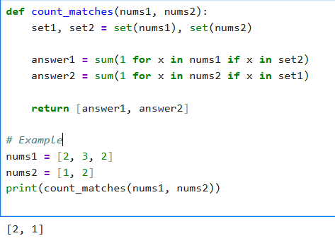

**RESULT:**

Thus the program to Find Indices with Elements Present in Both Arrays excuted successfully and output is verified.