**1.4** Given a 0-indexed integer array nums of length n and an integer k, return *the number of pairs* (i, j) *where* 0 <= i < j < n, *such that* nums[i] == nums[j] *and* (i * j) *is divisible by* k.

**AIM:**

Count Equal Pairs with Index Product Divisible by k

**ALGORITHM:**

* Initialize count = 0.
* Loop through all pairs (i, j) with i < j.
* If nums[i] == nums[j] and (i * j) % k == 0, increment count.
* Return count.

**PROGRAM:**

def count_pairs(nums, k):

n = len(nums)

count = 0

for i in range(n):

for j in range(i + 1, n):

if nums[i] == nums[j] and (i * j) % k == 0:

count += 1

return count

nums = [3,1,2,2,2,1,3]

k = 2

print(count_pairs(nums, k))

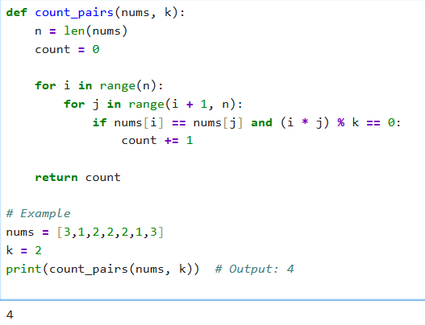**INPUT AND OUTPUT:**

**RESULT:**

Thus the program to find Count Equal Pairs with Index Product Divisible by k

Executed successfully and output is verified.