**1.5** Write a program FOR THE BELOW TEST CASES with least time complexity.

**AIM:**

Program to find Least time complexity

**ALGORITHM:**

· Initialize maxVal = nums[0].

· Traverse the array once.

* If nums[i] > maxVal, update maxVal = nums[i].

· After loop ends, return maxVal.

**PROGRAM:**

def find_max(arr):

return max(arr)

# Test cases

print(find_max([1, 2, 3, 4, 5])) # 5

print(find_max([7, 7, 7, 7, 7])) # 7

print(find_max([-10, 2, 3, -4, 5]))

**INPUT AND OUTPUT:**

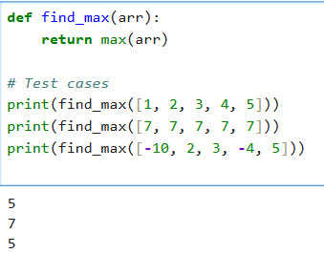

**RESULT:**

Thus the program to find least time complexity executed successfully and output is verified.