**1.6 You have an algorithm that process a list of numbers. It firsts sorts the list using an efficient sorting algorithm and then finds the maximum element in sorted list. Write the code for the same.**

**Aim:**

To sort a list of numbers using an efficient algorithm and find the maximum element from the sorted list.

**Algorithm:**

1. Read the number of elements (n).
2. Read n integers and store them in a list.
3. Sort the list using an efficient sorting algorithm (like Timsort).
4. Return the last element of the sorted list as the maximum.

**Code:**

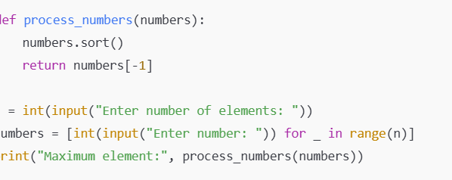

**Input:**

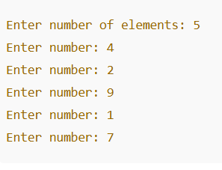

**Output:**

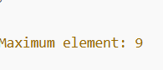

**Performance analysis:**

**Time Complexity: (n log n)**

**Space Complexity: O(n)**