* 1. **Write a program that takes an input list of n numbers and creates a new list containing only the unique elements from the original list. What is the space complexity of the algorithm?**

Test Cases

Some Duplicate Elements

Input: [3, 7, 3, 5, 2, 5, 9, 2]

Expected Output: [3, 7, 5, 2, 9] (Order may vary based on the algorithm used)

Negative and Positive Numbers

Input: [-1, 2, -1, 3, 2, -2]

Expected Output: [-1, 2, 3, -2] (Order may vary)

List with Large Numbers

Input: [1000000, 999999, 1000000]

Expected Output: [1000000, 999999]

**Aim:**

To create a new list containing only the unique elements from the input list.

**Algorithm:**

1. Read a list of n numbers.
2. Initialize an empty set to store seen elements.
3. Traverse the list:
   * If an element is not in the set, add it to the result list and mark it as seen.
4. Return the result list of unique elements.

**Python Code:**

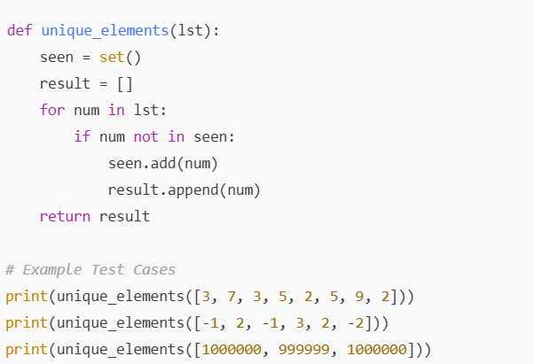

**Input:**

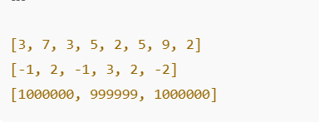

**Output:**

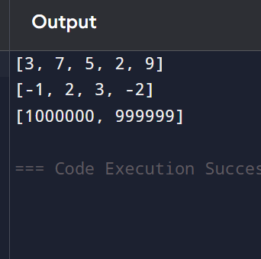

**Performance analysis:**

**Time Complexity:O(n)**

**Space Complexity: O(n)**