1. **Write a program to perform the following**

**An empty list**

**A list with one element**

**A list with all identical elements**

**A list with negative numbers**

**Test Cases:**

1. **Input: []**
   * **Expected Output: []**
2. **Input: [1]**
   * **Expected Output: [1]**
3. **Input: [7, 7, 7, 7]**
   * **Expected Output: [7, 7, 7, 7]**
4. **Input: [-5, -1, -3, -2, -4]**
   * **Expected Output: [-5, -4, -3, -2, -1]**

**Aim:**

To write a Python program that handles various types of lists including:

* An empty list
* A list with one element
* A list with all identical elements
* A list with negative numbers  
  The program should return the list as-is for the first three cases, and sort the list for the fourth case with negative numbers.

**Algorithm:**

1. Start the program.
2. Take list input from the user.
3. Check the type of input list:
   * If the list is empty or has one element, return it as-is.
   * If all elements in the list are identical, return it as-is.
   * If list contains negative numbers, sort the list.
4. Print the result.
5. End the program.

**Code:**

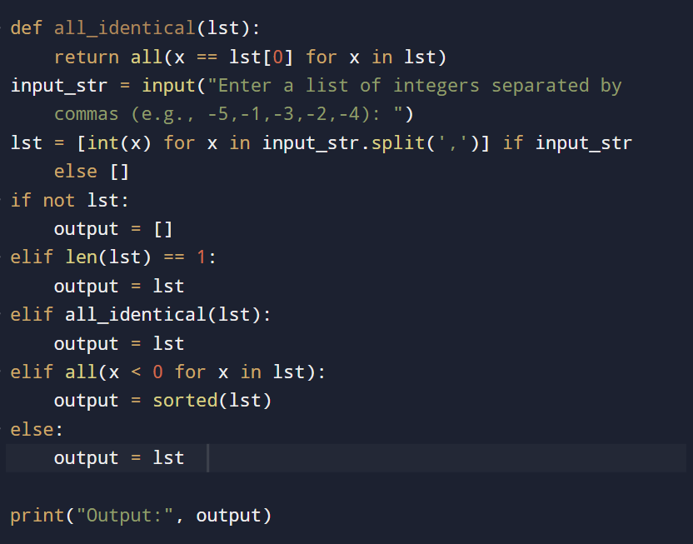

**Input and output:**

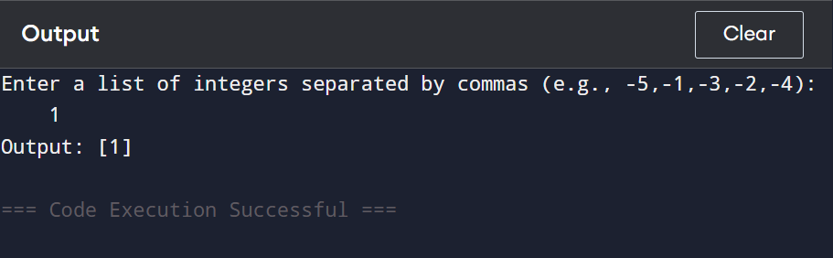

**Result: given Python Program to Handle Various List Inputs and Sort Negative Numbers is executed successfully and output is verified**

**Performance analysis:**

**Time Complexity:**

* **Best Case (empty, one element, or identical elements): O(n)**
* **Worst Case (sorting required): O(n log n)**

**Space Complexity:**

* **O(n)**