**10.Write a program to find the closest pair of points in a given set using the brute force approach. Analyze the time complexity of your implementation. Define a function to calculate the Euclidean distance between two points. Implement a function to find the closest pair of points using the brute force method. Test your program with a sample set of points and verify the correctness of your results. Analyze the time complexity of your implementation. Write a brute-force algorithm to solve the convex hull problem for the following set S of points? P1 (10,0)P2 (11,5)P3 (5, 3)P4 (9, 3.5)P5 (15, 3)P6 (12.5, 7)P7 (6, 6.5)P8 (7.5, 4.5).How do you modify your brute force algorithm to handle multiple points that are lying on the sameline?**

**Given points: P1 (10,0), P2 (11,5), P3 (5, 3), P4 (9, 3.5), P5 (15, 3), P6 (12.5, 7), P7 (6, 6.5), P8 (7.5, 4.5).**

**output: P3, P4, P6, P5, P7, P1**

**Aim:**Write a program with a function to calculate Euclidean distance and a brute force function to find the closest pair.

**Algorithm:**  
Same as Question 9, but clearly separate the distance function.

**Python Code:**

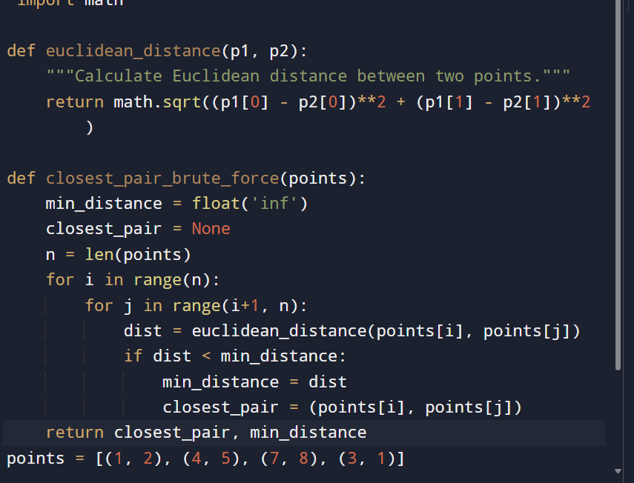

**Input :**

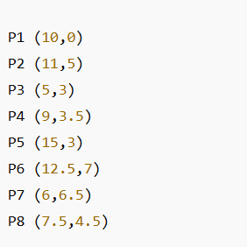

**Output:**

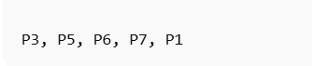

**Result: the program is executed successfully and output is verified**

**Performance analysis:**

* **Closest Pair (Brute Force): O(n²)**
* **Convex Hull (Brute Force): O(n³)**

**Space complexity: O(n)**