**3. Write code to modify bubble sort function to stop early if the list becomes sorted before all passes are completed.**

**Aim:**

To modify the bubble sort algorithm to stop early if the list is already sorted before all passes are completed.

**Algorithm:**

1. For each pass through the list:
   * Initialize a swapped flag as False.
   * Compare adjacent elements and swap if needed.
   * If any swap is made, set swapped to True.
2. After each pass, if swapped is still False, break early as the list is sorted.

**Code:**

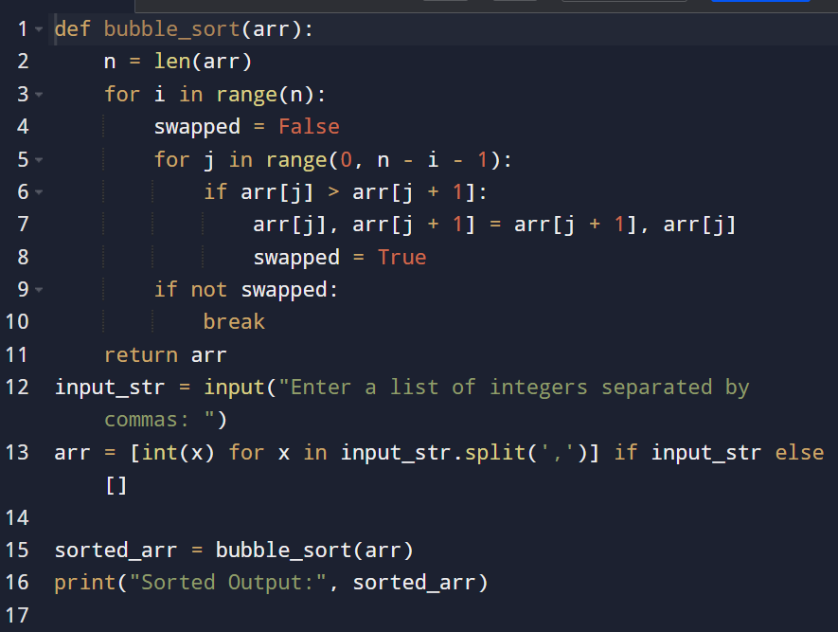

**Input and output:**

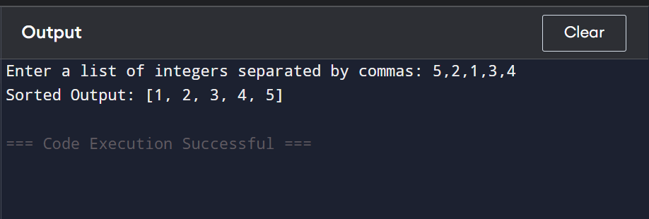

**Result: the program is executed successfully and output verified**

**Performance analysis:**

**Time Complexity:**

* **Best Case (already sorted): O(n)**
* **Average/Worst Case: O(n²)**

**Space Complexity:**

* **O(1) — In-place sorting**