**5.Given an array arr of positive integers sorted in a strictly increasing order, and an integer k. return the kth positive integer that is missing from this array.**

**Example 1:**

**Input: arr = [2,3,4,7,11], k = 5**

**Output: 9**

**Explanation: The missing positive integers are [1,5,6,8,9,10,12,13,...]. The 5th missing positive integer is 9.**

**Example 2:**

**Input: arr = [1,2,3,4], k = 2**

**Output: 6**

**Aim:**

To find the kth missing positive number from a strictly increasing array of positive integers.

**Algorithm:**

1. Initialize a counter for missing numbers and an index for array traversal.
2. Iterate from number 1 upward, checking if it's in the array.
3. If not in the array, increment the missing count.
4. When missing count equals k, return that number.

**Code:**

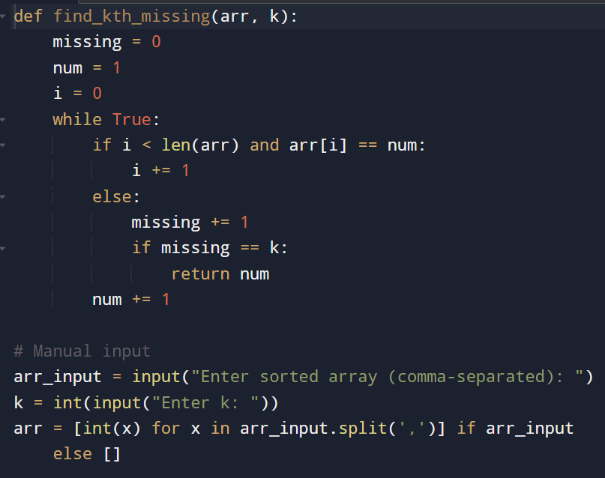

**Input and output:**

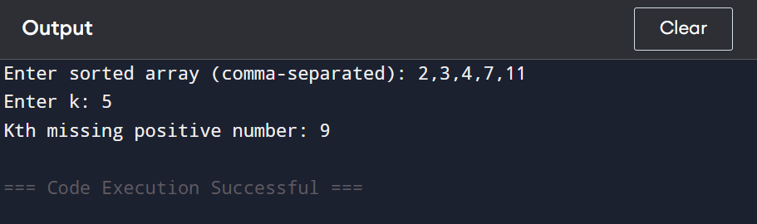

**Result: the given program is executed successfully**

**Performance analysis:**

**Time Complexity:**

* **O(n + k) — At most we check up to k missing numbers and n array elements.**

**Space Complexity:**

* **O(1) — No extra space used.**