**7.Given two strings needle and haystack, return the index of the first occurrence of needle in haystack, or -1 if needle is not part of haystack.**

**Example 1:**

**Input: haystack = "sadbutsad", needle = "sad"**

**Output: 0**

**Explanation: "sad" occurs at index 0 and 6.**

**The first occurrence is at index 0, so we return 0.**

**Example 2:**

**Input: haystack = "leetcode", needle = "leeto"**

**Output: -1**

**Aim:**

To find the index of the first occurrence of the substring needle in the string haystack, or return -1 if it is not present.

**Algorithm:**

1. Check if needle is an empty string. If so, return 0.
2. Iterate through haystack from index 0 to len(haystack) - len(needle).
3. For each index, check if the substring starting at that index and of length equal to needle matches needle.
4. If a match is found, return the current index.
5. If no match is found after the loop, return -1.

**Code:**

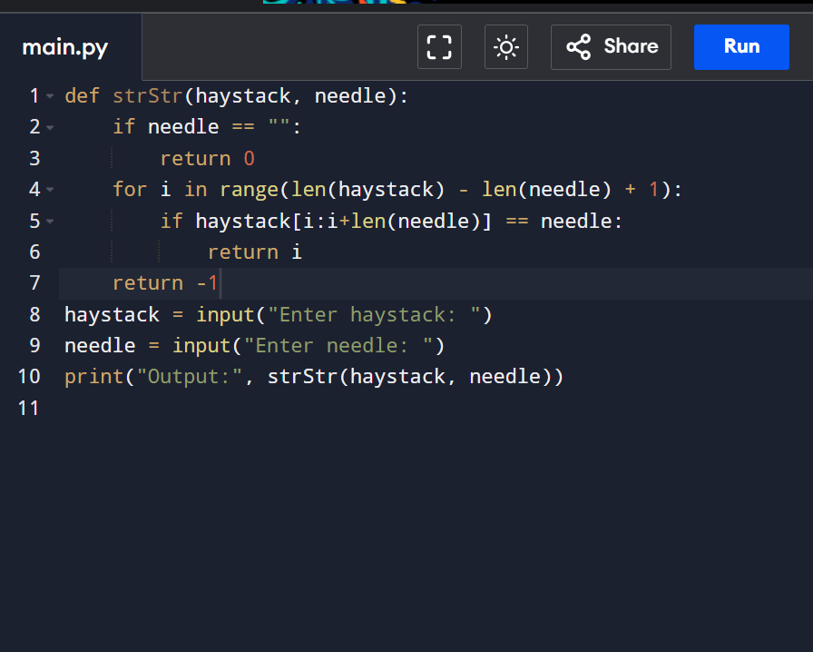

**Input and output:**

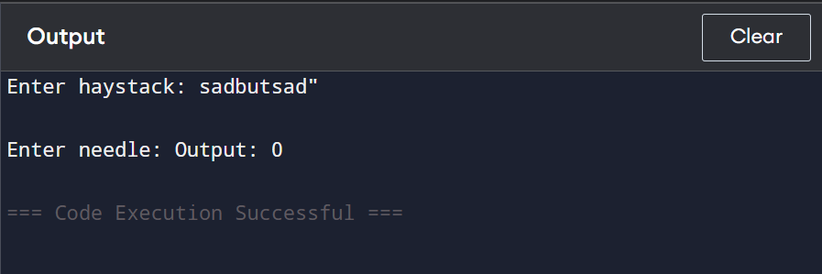

**Result: the program is executed successfully**

**Performance analysis:**

**Time Complexity:**

**O((N - M + 1) * M)  
Where N is the length of haystack and M is the length of needle.**

**Space Complexity:**

**O(1) (No extra space used apart from input and loop variables)**