**Given an array of string words, return all strings in words that is a substring of another word. You can return the answer in any order. A substring is a contiguous sequence of characters within a string**

**Example 1:**

**Input: words = ["mass","as","hero","superhero"]**

**Output: ["as","hero"]**

**Explanation: "as" is substring of "mass" and "hero" is substring of "superhero".**

**["hero","as"] is also a valid answer.**

**Example 2:**

**Input: words = ["leetcode","et","code"]**

**Output: ["et","code"]**

**Explanation: "et", "code" are substring of "leetcode".**

**Example 3:**

**Input: words = ["blue","green","bu"]**

**Output: []**

**Aim:**To find all strings in the array that are substrings of any other string in the array.

**Algorithm:**

1. Initialize an empty list result.
2. Iterate over each word in the array.
3. For each word, iterate over all other words in the array.
4. If the current word is not the same and is a substring of any other word, add it to result.
5. Return the result.

**Code:**

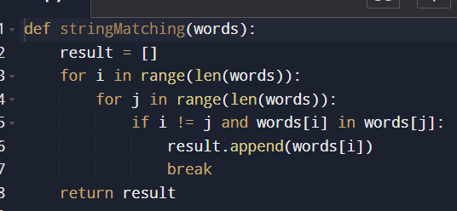

**Input and output:**

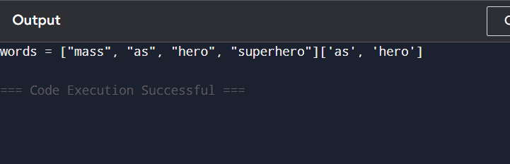

**Result: the program is executed successfully and output is verified**

**Performance analysis:**

**Time Complexity: O(n² * k)**

**Space Complexity: O(m)**