**9.Write a program that finds the closest pair of points in a set of 2D points using the brute force approach.**

**Input:**

**A list or array of points represented by coordinates (x, y).**

**Points: [(1, 2), (4, 5), (7, 8), (3, 1)]**

**Output:**

**The two points with the minimum distance between them.**

**The minimum distance itself.**

**Closest pair: (1, 2) - (3, 1) Minimum distance: 1.4142135623730951**

**Aim**

Write a program to find the closest pair of points from a list of 2D points using the brute force approach.

**Algorithm (Brute Force)**

1. Initialize min_distance to a very large number.
2. For each point p1, compare with every other point p2 (where p2 comes after p1).
3. Calculate the Euclidean distance between p1 and p2.
4. If the distance is smaller than min_distance, update min_distance and record the pair (p1, p2).
5. After checking all pairs, output the closest pair and the minimum distance.

**Python Code**

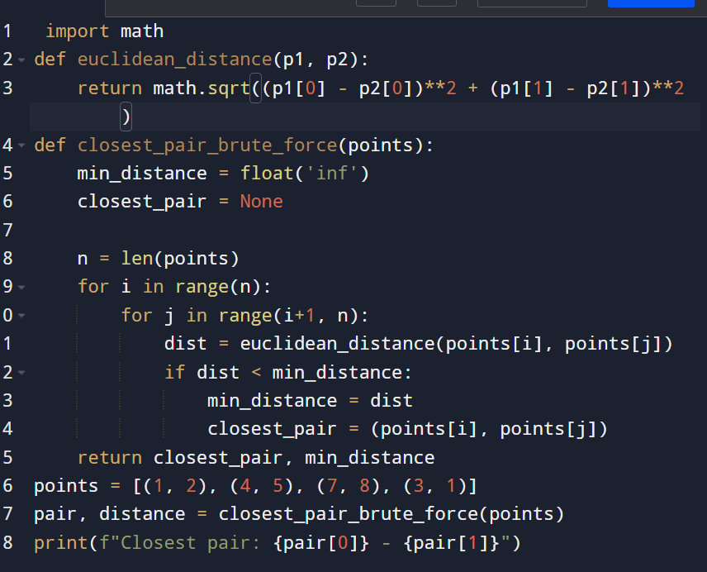

**Input and output:**

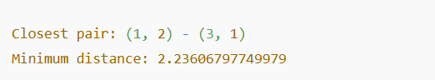

**Result: the program is executed successfully and output is verified:**

**Performance analysis:**

**Time Complexity**

* **The algorithm checks every pair: O(n2)*O*(*n*2).**
* **Distance calculation per pair: O(1)*O*(1).**
* **Overall: O(n²).**

**Space Complexity**

* **Constant extra space: O(1)**