A
PROJECT REPORT
ON
AUTOMATIC WATER
LEVEL CONTROLLER
USING ARDUINO

Submitted By:
LOHITHA BOMMISETTY

Introduction:
- Objective: The primary goal of this project is to design and implement an automatic water level controller using an Arduino microcontroller. This system aims to maintain the water level in a tank, preventing overflow and ensuring adequate water supply.
- Importance: Automatic water level controllers are essential in various applications, including residential water tanks, industrial processes, and agricultural irrigation systems. They help conserve water and reduce manual monitoring efforts.
Components Used
- Arduino Microcontroller:
  - Acts as the brain of the system, processing inputs from sensors and controlling outputs.
  - Commonly used model: Arduino Uno.
- Ultrasonic Sensor (HC-SR04):
  - Measures the distance to the water surface, providing data on the water level.
  - Sends ultrasonic waves and calculates the time taken for the echo to return.
- Water Pump:
  - Used to fill the tank when the water level is low.
  - Controlled by the Arduino based on sensor readings.
- Relay Module:
  - Acts as a switch to control the water pump.
  - Allows the Arduino to control high voltage/current devices safely.
- LCD Display (16x2):
  - Provides real-time feedback on water levels and system status.
  - Displays messages such as "Tank Full" or "Filling Tank".
- Power Supply:
  - Provides the necessary power to the Arduino and other components.
  - Can be powered via USB or an external adapter.
- Connecting Wires and Breadboard:
  - Used for prototyping and connecting components.

Wiring Connections:
- Water Level Sensors:
  - Connect thehigh-level sensorto a digital pin (e.g., D2) on the Arduino.
  - Connect thelow-level sensorto another digital pin (e.g., D3).
  - If using amid-level sensor, connect it to a third digital pin (e.g., D4).
- Relay Module:
  - Connect thecontrol pinof the relay module to a digital pin on the Arduino (e.g., D5).
  - Connect theVCCandGNDof the relay module to the Arduino's5VandGNDRespectively.
  - Connect the pump to the relay's normally open (NO) terminal and the power supply.

Program:

const int highLevelSensorPin = 2;
const int lowLevelSensorPin = 3;
const int relayPin = 5;

void setup() {
// Initialize the pins
pinMode(highLevelSensorPin, INPUT);
pinMode(lowLevelSensorPin, INPUT);
pinMode(relayPin, OUTPUT);

// Start with the pump off
digitalWrite(relayPin, LOW);

// Begin Serial communication for debugging
Serial.begin(9600);
}

void loop() {
// Read the state of the sensors
int highLevelState = digitalRead(highLevelSensorPin);
int lowLevelState = digitalRead(lowLevelSensorPin);

// Debugging output
Serial.print("High Level Sensor: ");
Serial.println(highLevelState);
Serial.print("Low Level Sensor: ");
Serial.println(lowLevelState);

// Control the pump based on sensor readings
if (lowLevelState == LOW) { // Water level is low
digitalWrite(relayPin, HIGH); // Turn on the pump
Serial.println("Pump ON");
}
else if (highLevelState == LOW) { // Water level is high
digitalWrite(relayPin, LOW); // Turn off the pump
Serial.println("Pump OFF");
}

// Small delay for stability
delay(1000);
}

CIRCUIT DIAGRAM:

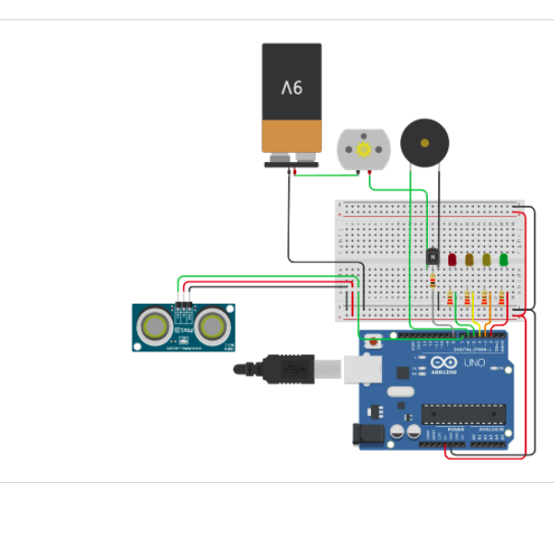

APPLICATIONS:

Flow Rate Monitoring and Control
  - Description: Use Arduino to measure and control the flow rate of water entering the turbine.
  - Benefits: Ensures that turbines operate within optimal flow conditions, preventing damage and maximizing energy output.
- Water Level Management
  - Description: Implement sensors to monitor water levels in reservoirs and control gates or pumps accordingly.
  - Benefits: Maintains desired water levels for turbine operation, preventing overflow or drought conditions.
- Automated Turbine Operation
  - Description: Automate the start and stop of turbines based on real-time water flow and level data.
  - Benefits: Increases operational efficiency and reduces manual intervention, leading to better resource management.
- Data Logging and Analysis
  - Description: Use Arduino to log data from various sensors (flow, pressure, temperature) for analysis.
  - Benefits: Provides insights into system performance, helping in predictive maintenance and operational improvements.
- Remote Monitoring and Control
  - Description: Integrate Arduino with IoT capabilities to enable remote monitoring and control of the water control system.
  - Benefits: Allows operators to manage the system from anywhere, improving response times to changing conditions.
Conclusion:

The Automatic Water Level Controller using Arduino effectively automates the monitoring and management of water levels in tanks, preventing overflow and ensuring optimal water usage. This project demonstrates the practical application of Arduino technology in enhancing efficiency and convenience in water management systems.

