Lab Assignment- 1

Source Code

Task1:

def lengthOfLongestSubstring(s):

"""

:type s: str

:rtype: int

"""

res=[]

dict = {}

str = ""

final_str = ""

i = 0

while i < len(s):

if s[i] in dict:

if len(str) > len(final_str):

final_str = str

res = [(final_str, len(final_str))]

elif len(str) == len(final_str):

res.append((str, len(str)))

i = dict[s[i]]

dict.clear()

str = ""

else:

dict[s[i]] = i

str = str + s[i]

i = i + 1

if len(str) > len(final_str):

final_str = str

res=[(final_str,len(final_str))]

elif len(str)== len(final_str):

res.append((str,len(str)))

return res

str=input("Enter the string")

print(lengthOfLongestSubstring(str))

Task2:

n=int(input("Enter the number of records"))

list=[]

dict={}

for i in range(n):

print("Record "+str(i+1)+" : ")

name=str(input("Enter name "))

subject = str(input("Enter subject "))

j = 1

while (j):

try:

marks=float(input("Enter marks "))

j = 0

except ValueError:

print('Non-numeric data.')

list.append((name,(subject,marks)))

print("\nEntered input data")

print(list)

for i in list:

if i[0] in dict:

dict[i[0]].append(i[1])

else:

dict[i[0]]=[i[1]]

print("\n----------------------------------------------------------------------\n")

print("Data stored in dictionary\n")

print(dict)

Task3:

class Person:

__per_count=0

def _init_(self,name,age,family):

self.__name=name

self.__age=age

self.__family=family

Person._per_count=Person._per_count+1

@classmethod

def get_persons_count(self):

return Person.__per_count

def get_name(self):

return self.__name

def get_family(self):

return self.__family

def get_age(self):

return self.__age

class Employee (Person):

__emp_count = 0

__avg_sal = 0.0

def _init_(self, name, age, family, department,salary,EID):

self.__salary=salary

self.__department=department

self.__EID=EID

Employee._emp_count=Employee._emp_count+1

Employee._avg_sal=Employee._avg_sal+salary

Person._init_(self,name,age,family)

@classmethod

def average_salary(self):

if Employee.__emp_count>0:

return Employee._avg_sal / Employee._emp_count

else:

return 0

@classmethod

def get_employees_count(self):

return Employee.__emp_count

def get_department(self):

return self.__department

def get_salary(self):

return self.__salary

def get_EID(self):

return self.__EID

class Passenger (Person):

__pas_count = 0

def _init_(self, name, age, family, PID):

Passenger._pas_count=Passenger._pas_count+1

Person._init_(self,name,age,family)

self.__PID=PID

def get_PID(self):

return self.__PID

@classmethod

def get_passengers_count(self):

return Passenger.__pas_count

class Flight :

__flights_count = 0

def _init_(self,name, FID, seats_count):

Flight._flights_count=Flight._flights_count+1

self.__FID=FID

self.__fname=name

self.__seats_count=seats_count

self.__passengers={}

self.__available_seats_count=seats_count

def get_FID(self):

return self.__FID

def get_seats_count(self):

return self.__seats_count

def get_available_seats_count(self):

return self.__available_seats_count

def get_fname(self):

return self.__fname

@classmethod

def get_flights_count(self):

return Flight.__flights_count

def assign_passenger(self,p,pid):

if(self.__available_seats_count>0):

self.__passengers[pid]=p

self._available_seats_count=self._available_seats_count-1

print('Passenger added')

else:

print('No seats available')

def remove_passengers(self,p,pid):

if(pid in self.__passengers):

#self.__passengers.remove(p)

self.__passengers.pop(pid)

self._available_seats_count=self._available_seats_count+1

print('Passenger removed')

else:

print('No Passenger')

def get_passengers_list(self):

return self.__passengers

print("Select from below")

print("Case 1 :Create Employee class object\nCase 2 :Create Passenger class object\nCase 3 :Create Flight class object\n 4 :View average salary of Emplyees\n"

+"Case 5 :View Flights count\nCase 6 :View Employees count\nCase 7 :View Passengers count\nCase 8 :View Employee Deails\nCase 9 :View Flight Details\nCase 10 :View Passengers Details\n"

"Case 11 :View Flight Passengers\nCase 12 :Add Passenger\n Case 13 :Remove Passenger\nCase 14 :Exit")

bool=1

employees_list={}

passengers_list={}

flights_list={}

def addEmployee():

name=str(input("Enter name"))

EID = str(input("Enter EID"))

j = 1

while (j):

try:

age = int(input("Enter age"))

j = 0

except ValueError:

print('Non-numeric data.')

j = 1

while(j):

try:

salary=float(input("Enter salary"))

j=0

except ValueError:

print('Non-numeric data.')

department=str(input("Enter department"))

family=str(input("Enter family"))

E1=Employee(name,age,family,department,salary,EID)

employees_list[EID]=E1

print("Employee added")

def addPassenger():

name=str(input("Enter name"))

j = 1

while(j):

try:

age=int(input("Enter age"))

j=0

except ValueError:

print("Non-numeric data")

pid = str(input("Enter PID"))

family=str(input("Enter family"))

P1=Passenger(name,age,family,pid)

passengers_list[pid]=P1

print("Passenger added")

def addFlight():

name=str(input("Enter name"))

fid=str(input("Enter fid"))

j = 1

while (j):

try:

seats_count = int(input("Enter seats count"))

j = 0

except ValueError:

print("Non-numeric data")

F1=Flight(name,fid,seats_count)

flights_list[fid]=F1

print("Flight added")

def EmployeeAvgSal():

print("Employee Average Salary: "+str(Employee.average_salary()))

def EmpCount():

print("Employee Count: " + str(Employee.get_employees_count()))

def FlightsCount():

print("Flights Count: " + str(Flight.get_flights_count()))

def passengerCount():

print("Passenger Count: " + str(Passenger.get_passengers_count()))

def ViewEmployee():

if(len(employees_list)>0):

for key in employees_list:

print(str(key))

name=str(input("Select Employee"))

if(name in employees_list):

print("Name : "+employees_list[name].get_name()+"\nSalary :"+str(employees_list[name].get_salary())+"\n Department : "+employees_list[name].get_department()+"\n Family : "+employees_list[name].get_family()+"\n Age : "+str(employees_list[name].get_age())+"\n EID : "+name)

else:

print("invalid employee ID")

else:

print("No employees to view")

def ViewPassenger():

if(len(passengers_list)>0):

for key in passengers_list:

print(str(key))

name=str(input("Select Passenger"))

if(name in passengers_list):

print("Name : "+passengers_list[name].get_name()+"\n Age : "+str(passengers_list[name].get_age())+"\n Family : "+passengers_list[name].get_family()+"\n PID : "+name)

else:

print("invalid passenger ID")

else:

print("No passengers to view")

def ViewFlight():

if(len(flights_list)>0):

for key in flights_list:

print(str(key))

name=str(input("Select Flight"))

if(name in flights_list):

print("Name : "+flights_list[name].get_fname()+"\n Seats Count : "+str(flights_list[name].get_seats_count())+"\n Available Seats Count : "+str(flights_list[name].get_available_seats_count())+"\n FID : "+name)

else:

print("invalid flight ID")

else:

print("No flights to view")

def AddPassenger():

if(len(flights_list)>0):

for key in flights_list:

print(str(key))

name=str(input("Select Flight"))

if(name in flights_list):

print('Selected Flight : '+flights_list[name].get_fname())

if(len(passengers_list)>0):

for key in passengers_list:

print(str(key))

pname = str(input("Select Passenger"))

if (pname in passengers_list):

print('Selected passenger : ' + passengers_list[pname].get_name())

if(pname not in flights_list[name].get_passengers_list()):

flights_list[name].assign_passenger(passengers_list[pname],pname)

else:

print('Passenger already in flight')

else:

print("Invalid Passenger")

else:

print('No Passengers to add')

else:

print("invalid flight ID")

else:

print("No flights available")

def RemovePassenger():

if(len(flights_list)>0):

for key in flights_list:

print(str(key))

name=str(input("Select Flight"))

if(name in flights_list):

print('Selected Flight : '+flights_list[name].get_fname())

if(len(flights_list[name].get_passengers_list())>0):

for key in flights_list[name].get_passengers_list():

print(key)

pname = str(input("Select Passenger"))

if (pname in flights_list[name].get_passengers_list()):

flights_list[name].remove_passengers(passengers_list[pname],pname)

else:

print("Invalid Passenger")

else:

print('No Passengers to remove')

else:

print("invalid flight ID")

else:

print("No flights available")

def ViewFlightPassengers():

if (len(flights_list) > 0):

for key in flights_list:

print(str(key))

name = str(input("Select Flight"))

if (name in flights_list):

for i in flights_list[name].get_passengers_list():

print(i)

else:

print("invalid flight ID")

else:

print("No flights available")

def Exit():

global bool

bool=0

def choices(argument):

switcher = {

1: addEmployee,

2: addPassenger,

3: addFlight,

4: EmployeeAvgSal,

5: FlightsCount,

6: EmpCount,

7: passengerCount,

8: ViewEmployee,

9: ViewFlight,

10: ViewPassenger,

11: ViewFlightPassengers,

12: AddPassenger,

13: RemovePassenger,

14: Exit

}

# Get the function from switcher dictionary

func = switcher.get(int(argument), lambda: "Invalid choice")

func()

while(bool!=0):

choice =input("Enter your choice")

choices(choice)

Task4:

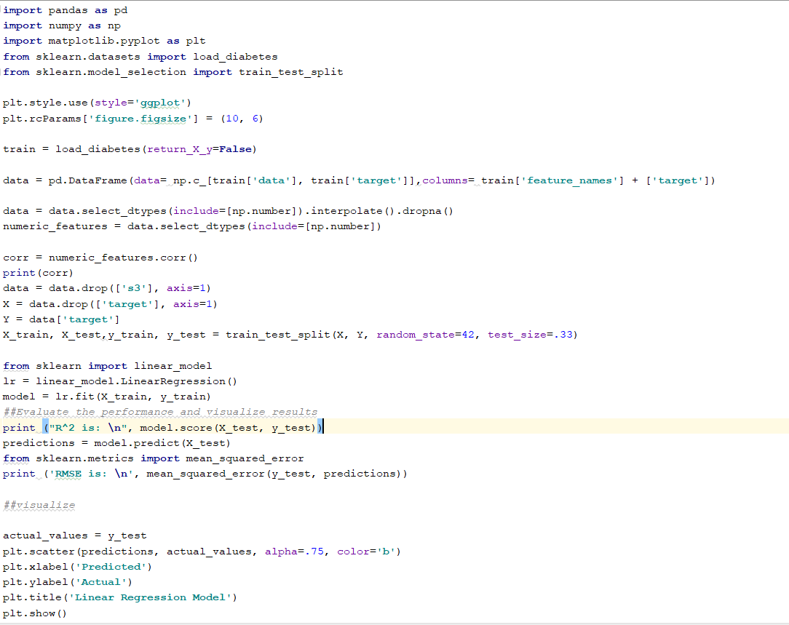

Task5:

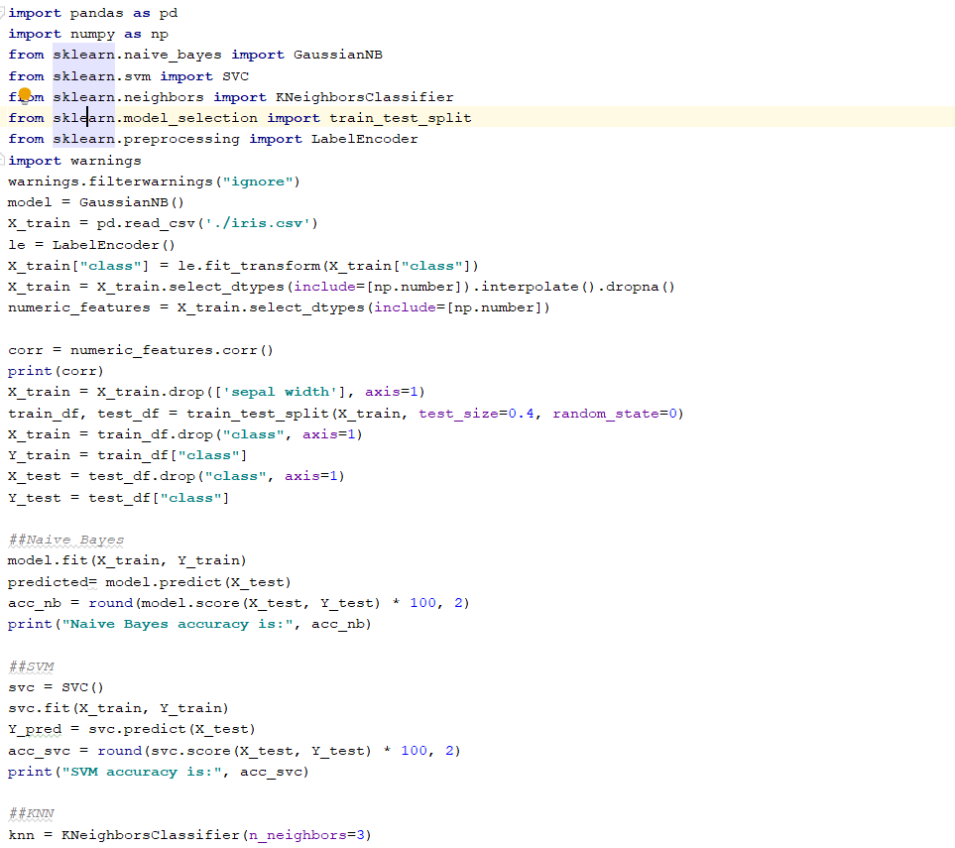

Task6:

