Lab Assignment- 2

Source Code

T1:

task1_train_data, task1_x_valid, task1_test_data, task1_y_valid = training_testing_split(task1.data.iloc[:,0:12], task1_data.iloc[:,12],  
 test_size=0.3, random_state=87)

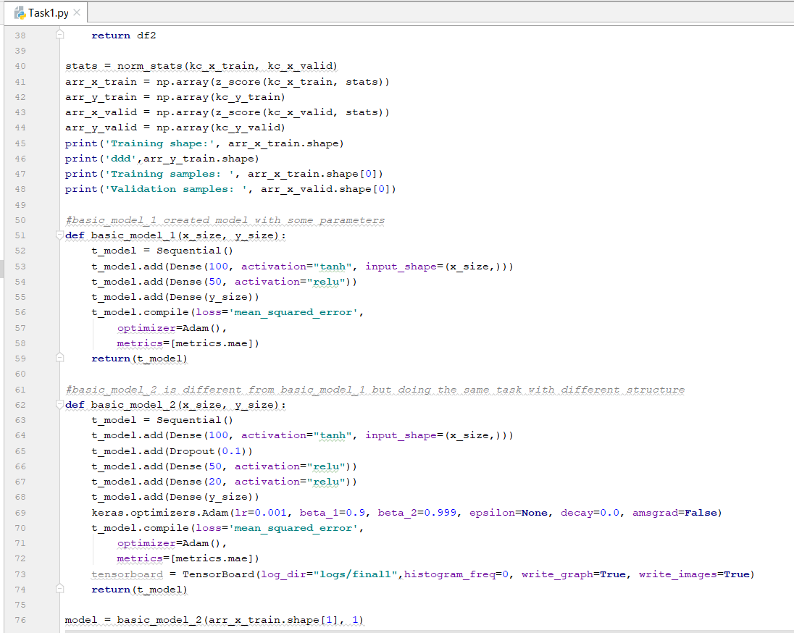

T2:

Task2_X_train, task2_X_test, task2_y_train, task2_y_test = training_testing_split(padded_docs, y, test_size=0.25, random_state=1000)

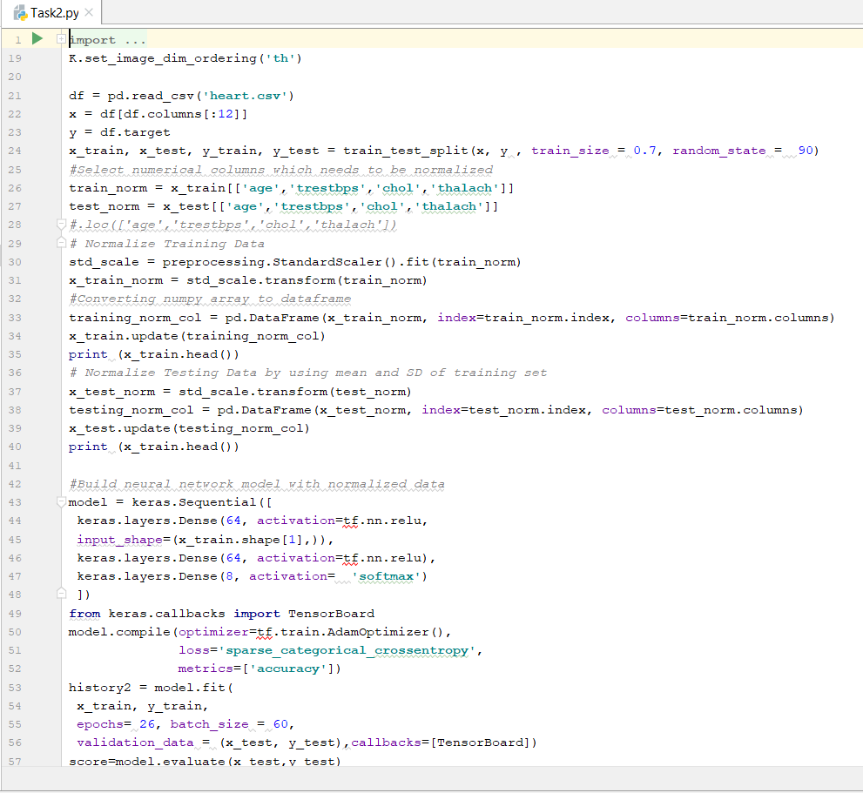

T3:

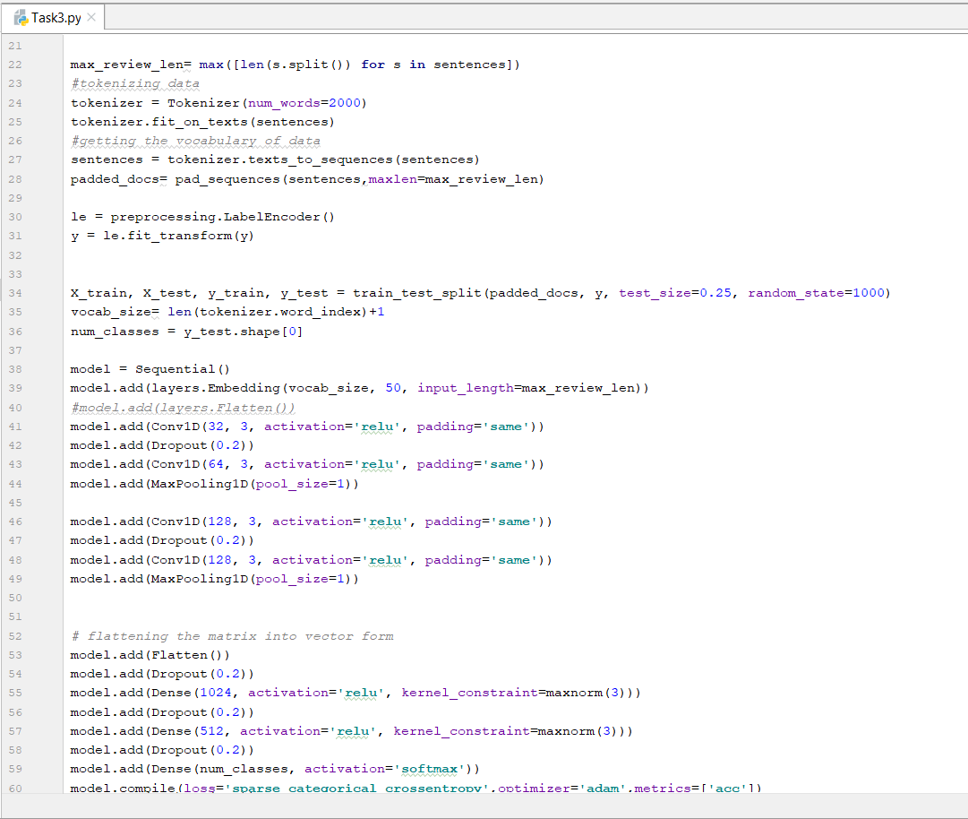

T4:

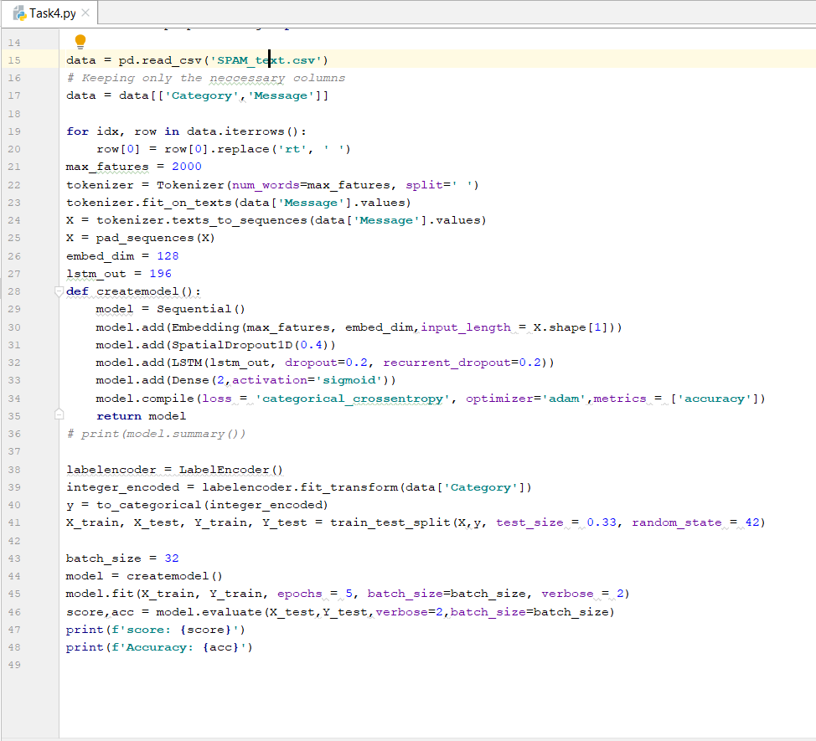

T6:

