Advanced Javascript Skills Test

Objective

Test your ability to create a good Javascript architecture by using latest available framework and techniques.
The test should not take more than 1 day for an experimented developer and 2 days for a beginner in Javascript .

In the Javascript world, there’s 1000 paths to complete this app, good, bad and sometimes… ugly.

Take time to read blogs, books, documentation, you can found a list of interesting resources at the end of this test.

The application has to be delivered trough GIT, you can use github or other solutions.

Test application

The app is a contact list, with features to add/remove entries, store them in localStorage with some additional features like filters and validators.

The application is totally offline, no need any connection to third part or even an internet connection.
It’s only required to work on Webkit browser, I recommend to use Chrome during your developments.

Datas

A Contact is defined with some attributes:
- Firstname
- Lastname
- Birthday
- Address
- ZipCode
- Phone

Validator

- Firstname and Lastname required at least 2 characters
- Birthday need to follow this format: YYY/MM/DD, date can’t be over 2010
- Phone number allow only numbers and dot characters
- Other fields have no rules and are not required.

Mockup

Main view
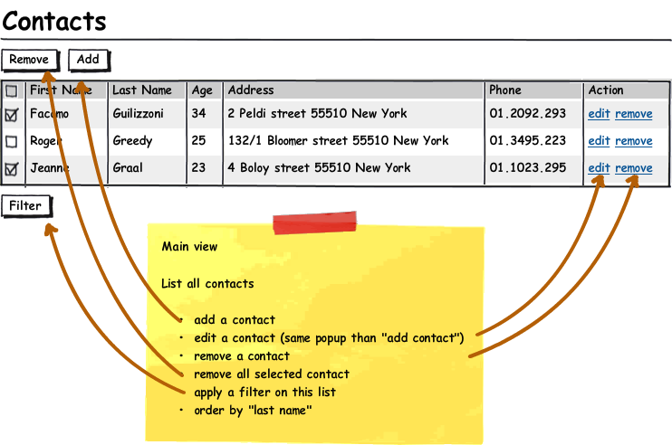

Add/edit view

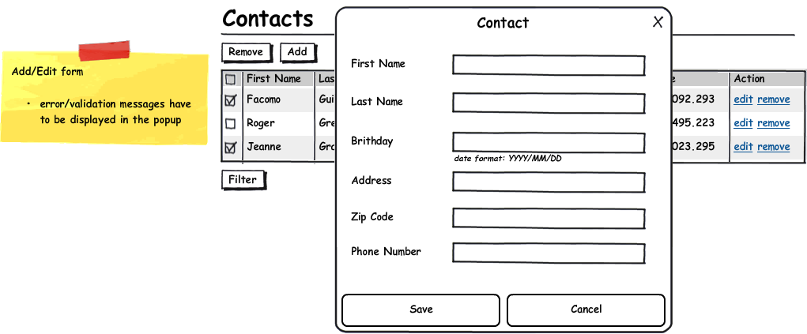

Filter view

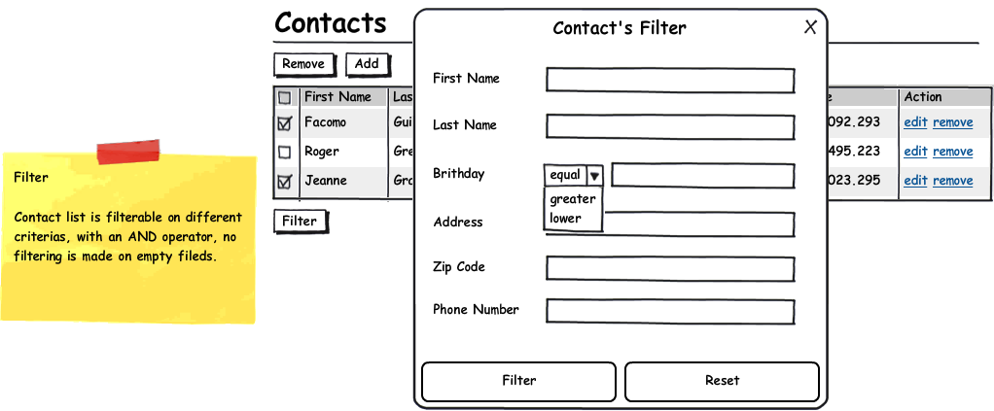

UI

Simply respect the layout defined in the mockup above, you can use “homemade” css or even a bootstrap.

Javascript Architecture

- AMD or a loader system is required
- Layout and datas have to be clearly separated

Resources

Frameworks
http://backbonejs.org/
http://emberjs.com/
http://canjs.us/
http://angularjs.org/

Bootstrap
http://twitter.github.com/bootstrap/
http://www.initializr.com/

Others
http://requirejs.org/
http://www.jsunit.net/
http://jqueryui.com/
https://github.com/
https://github.com/amdjs/amdjs-api/wiki/AMD

Blogs
http://addyosmani.com/blog/
http://hakim.se/
http://thechangelog.com/
http://www.webappers.com/
http://www.alistapart.com/

