Table des matières

AngularJS – Basics 2

Create a new angular project 2

Global architecture of a angular-cli project 2

Generate a new component via angular-cli 2

Update HTML and the CSS of a component 3

Data binding 3

Conditions if/else 3

Event click 4

For syntax 4

Class binding 4

OnInit method 4

# AngularJS – Basics

## Create a new angular project

*Creates a new project called PROJECT-NAME*

*Goes to the new project folder you just created*

*Opens a server with a default callback on localhost:4200*

ng new PROJECT-NAME

cd PROJECT-NAME

ng serve --open

## Global architecture of a angular-cli project

*Contains installed packages*

*Folder for the app component*

* *App component CSS*
* *App component HTML*
* *Unknown*
* *App component data & methods*
* *Global configuration, imports, router*

*Folder which contains images, fonts etc.*

*Website icon on the navigation search bar*

*Default HTML template page which contains <app-root>, app tag*

*Global styles of the application*

*Contains every packages which needs to be installed via npm install*

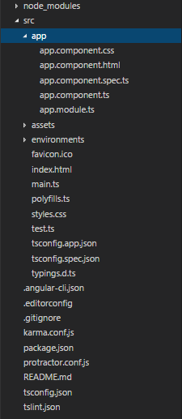

## Generate a new component via angular-cli

*Creates a new folder in src names my-new-component which contains the 4 files: CSS, HTML, SPEC.TS and TS.*

*Also updates the app-module to import the new component*

ng g component my-new-component

## Update HTML and the CSS of a component

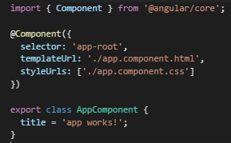

*Default app.component.ts file*

*By default, HTML is in a .html file to avoid fluzzy code in the .ts file. The templateUrl provides the link of the HTML file.*

*If you just want to make a liitle change on your HTML, you can directly put it in the .ts file with the template syntax :*

*template: `<h1>Hey</h1>`*

## Data binding



*app.component.ts app.component.html*

## Conditions if/else

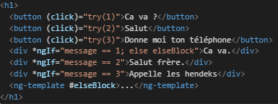

*The simplest way is to show a component simply with a *ngIf, but you also can also set differents properties to the if condition as shown.*

*You can set a elseBlock if the if condition isn’t respected, which allow the ng-template showing up.*

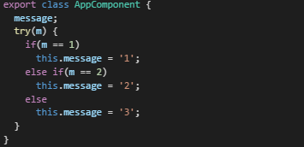

## Event click



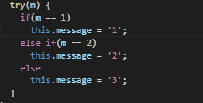

## For syntax

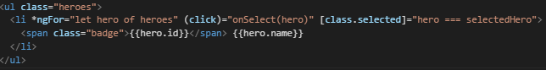

## Class binding



*Here we want to set the class .selected if hero equals to selectedHero.*

## OnInit method

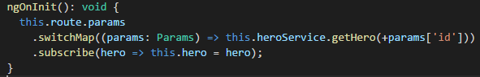

*Allows you to do some stuff when the component is called*

*Import { OnInit ] from ‘@angular/core’;*