Lois Darlyn Naa Koshie Mills
Lab Title: Design and evaluate an AWS Solution Using the Well-Architected and Cloud Adoption Frameworks

TASK 1
- Components of workload:
Frontend (Application Tier)
The frontend consists of a web server running on on-premises infrastructure that handles user requests and communicates directly with the backend database.
Backend (Database Tier)
The backend is an on-premises database responsible for storing and managing application data and supporting read and write operations.
Networking
The application uses a local on-premises network with static configurations, resulting in a tightly coupled and inflexible network setup.
Storage
Data is stored on local disks attached to application and database servers, making availability dependent on physical hardware.
Operations and Management
Deployments, monitoring, and backups are largely manual, with limited centralized logging and operational visibility.

- Potential Risks or Weaknesses:
Reliability Risks
If there were only one server for the frontend or database, the system could stop working if that server failed.
Security Risks
If the frontend were to communicate directly with the database, the chance of a security breach would increase should the frontend be compromised. Having the frontend and database closely connected would make it harder to protect the data. Weak access controls and no encryption could also increase security risks.
Backup and Data Risks
If there were no proper backup or disaster recovery plan, data could be permanently lost if something went wrong.
Performance and Scaling Risks
If the system needed to handle more users or heavier traffic, it could struggle to cope. High load on the frontend could slow down the database.
Operational, Maintenance, and Cost Risks
If tasks like updates and monitoring were done manually, mistakes would be more likely. Changes in the database could require changes in the frontend, making maintenance harder. Hardware that is overused or underused could lead to wasted money and energy.
TASK 2
AWS WAF ASSESSMENT TABLE
Pillar | Observation (Strength) | Improvement Recommendation | Supporting AWS Service
Operational Excellence | The application has a clearly defined two-tier structure, making it easier to monitor and manage once migrated. | Introduce automation for deployments, monitoring, and incident response to reduce manual operations. | AWS CloudWatch
Security | Separation of frontend and database tiers limits direct user access to sensitive data. | Implement least-privilege access, secure network boundaries, and encrypt data at rest and in transit. | AWS IAM, Amazon VPC (Security Groups & NACLs), AWS KMS
Reliability | The application logic and data tiers are logically separated, enabling independent improvement. | Eliminate single points of failure by deploying resources across multiple Availability Zones and enabling backups. | Amazon RDS (Multi-AZ)
Performance Efficiency | The application’s simple architecture allows straightforward performance tuning. | Use managed, scalable services and enable auto-scaling to handle variable workloads efficiently. | Amazon EC2 Auto Scaling
Cost Optimization | Current on-premises environment avoids usage-based overconsumption. | Adopt pay-as-you-go pricing and right-size resources to avoid overprovisioning. | AWS Cost Explorer, AWS Budgets, EC2 Auto Scaling
TASK 3
1. Business Perspective
If the organization were to migrate to the cloud, it could potentially improve reliability, scalability, and operational efficiency. While there might be a desire to modernize IT, measurable business goals such as cost savings, reduced downtime, or faster deployment might not yet be fully defined. Without clear objectives, tracking migration success could be challenging, and resources might not deliver maximum value. To improve readiness, it would likely be necessary to establish clear business outcomes and link them to cloud adoption efforts. If KPIs such as system availability, deployment speed, or operational cost reduction were defined, the organization could better evaluate progress. Aligning cloud initiatives with overall business strategy might help ensure that IT decisions support strategic goals rather than isolated improvements. Early planning could also consider potential business risks, such as downtime or service interruptions. By following the CAF Business perspective, the organization might prioritize investments, justify resource allocation, and measure the impact of cloud adoption more effectively, helping technology investments deliver tangible outcomes and support long-term growth.
2. People Perspective
If the organization’s technical staff were to manage cloud workloads, they might face challenges due to limited hands-on cloud experience, particularly with AWS services and automation practices. Without proper training and role definition, migration efforts could become error-prone, and the team might struggle to manage cloud resources efficiently. Readiness would likely depend on developing cloud skills, fostering collaboration, and introducing a DevOps mindset. If staff received training on AWS services such as EC2, RDS, VPC, IAM, and monitoring tools, along with Infrastructure as Code concepts, they would probably be better prepared. Encouraging automation for deployments, monitoring, and scaling could reduce human error. Leadership would ideally support cultural change, emphasizing shared responsibility for operations, security, and performance. The first set of migrations might allow staff to gain confidence and test processes. As adoption scaled, embedding these skills and practices could prepare the workforce to operate efficiently, respond to incidents, and optimize resources, potentially reducing operational risk and accelerating cloud adoption.
3. Governance Perspective
If governance processes were applied during cloud adoption, the organization could potentially manage costs, compliance, and resource usage more effectively. Currently, there might be a lack of structured policies, which could result in uncontrolled spending, inconsistent access control, and compliance gaps. Establishing governance frameworks defining account structures, tagging policies, cost allocation, and approval workflows might mitigate these risks. Using AWS tools like Cost Explorer and Budgets could help track usage and enforce spending limits. Policies covering operational standards, regulatory compliance, and accountability for resource changes could improve readiness. During the Envision and Align phases, documenting requirements would likely ensure stakeholders understood responsibilities. Pilot workloads could test governance in practice, and automated enforcement might maintain consistency as adoption scaled. Strong governance could allow the organization to expand cloud operations safely, maintain control, and reduce operational and financial risk while aligning cloud adoption with business objectives.
4. Platform Perspective
If the organization were to migrate the two-tier application, it could benefit from cloud-native services, although tight coupling between frontend and database layers might limit scalability and flexibility. Platform readiness would likely require redesigning the architecture to use managed services. Creating a secure landing zone with Amazon VPC, public and private subnets, and deploying frontend servers on EC2 with Auto Scaling could improve flexibility. Migrating the database to Amazon RDS with Multi-AZ replication might increase availability. Using Infrastructure as Code with CloudFormation or Terraform could ensure consistent deployments. Pilot migrations could test performance, connectivity, and redundancy, providing insights for optimization. Selecting appropriately sized instances, managed services, and load balancing might improve performance efficiency. By adopting this platform approach, the organization could potentially scale dynamically, reduce operational overhead, and maintain reliability while supporting growth and modernization goals.
5. Security Perspective
If security practices were strengthened, the organization could reduce vulnerabilities associated with direct frontend-to-database communication, broad network access, and limited access controls. Proactive measures such as enforcing least-privilege access with IAM, encrypting data at rest and in transit, segmenting networks using Security Groups and private subnets, and monitoring with CloudWatch and GuardDuty could help protect workloads. Pilot workloads might validate these measures, and continuous monitoring during scale-up could detect anomalies or breaches. Assigning security responsibilities would likely reduce risk. Regular testing, compliance verification, and automated alerting could improve readiness. By embedding these controls from the beginning, the organization could potentially protect sensitive data, prevent unauthorized access, and maintain trust while safely achieving cloud adoption objectives.
6. Operations Perspective
If operations were automated and standardized, the organization could reduce reliance on manual processes and improve monitoring, patching, and incident response. Without these measures, scaling and managing the environment might become difficult as usage increases. Implementing CloudWatch and Systems Manager for monitoring and alerting could provide better visibility. Standardized operational procedures for deployments and incident response might reduce errors. Pilot migrations could identify bottlenecks and test operational processes. By embedding automation and monitoring, the organization could potentially improve response times, maintain high availability, and continuously optimize cloud operations. Collaboration across teams and a culture of proactive management would likely ensure operations are consistent, efficient, and aligned with business needs, supporting long-term growth in the cloud.

TASK 4
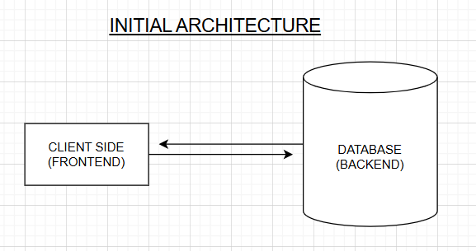

PROPOSED ARCHITECTURE
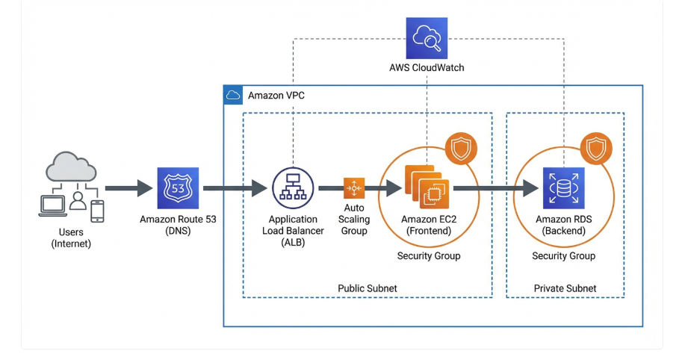
This architecture represents a two-tier web application deployed on AWS designed to improve scalability, reliability, and security compared to an on-premises system. External users access the application through the internet, where Amazon Route 53 resolves the domain and directs traffic to an Application Load Balancer. The load balancer distributes requests across multiple Amazon EC2 instances within an Amazon EC2 Auto Scaling group located in a public subnet, ensuring the application can handle varying traffic loads. These EC2 instances host the frontend application and communicate securely with a backend database hosted on Amazon RDS in a private subnet. Security groups restrict access between components to protect the system from unauthorized traffic. The entire architecture operates within an Amazon VPC to isolate network resources. Monitoring and performance tracking are handled using Amazon CloudWatch, allowing administrators to detect issues and maintain system reliability.

