**AI_Smadhan_Problem-5**

**Test Case Documentation for Smart Mark Distribution System**

**1. Test Case: Attendance Bonus Allocation**

**Objective:** Verify that attendance bonus marks are allocated correctly to help students pass subjects.

* **Input:**
  + Theory Marks: [30, 32]
  + Practical Marks: [33, 30]
  + Combined Marks: Theory: 16, Practical: 18
  + Bonus Marks: 20
* **Expected Outcome:**
  + Theory Marks should be >= 35
  + Practical Marks should be >= 35
  + Combined Theory and Practical should be >= 17.5 each

**2. Test Case: HoD Bonus Allocation**

**Objective:** Ensure HoD bonus is allocated only when a student fails one subject by 1 or 2 marks.

* **Input:**
  + Theory Marks: [34]
  + Practical Marks: [36]
* **Expected Outcome:**
  + Theory Marks should be >= 35 after allocation

**3. Test Case: Extra Bonus Allocation**

**Objective:** Confirm that extra bonus marks are allocated when a student passes all subjects without HoD bonus.

* **Input:**
  + Theory Marks: [40, 42]
  + Practical Marks: [50, 55]
* **Expected Outcome:**
  + Theory Marks increase by 2
  + Practical Marks increase by 2

**4. Test Case: SPI Maximization**

**Objective:** Ensure that SPI is maximized after distributing attendance and bonus marks.

* **Input:**
  + Subject Credits: [3, 4]
  + Grade Points: [6, 7]
* **Expected Outcome:**
  + SPI should be maximized (greater than 6.5)

**5. Test Case: Edge Case - Minimum Marks**

**Objective:** Check the system behavior when a student has zero marks.

* **Input:**
  + Theory Marks: [0]
  + Practical Marks: [0]
  + Bonus Marks: 5
* **Expected Outcome:**
  + Marks remain below passing criteria

**6. Test Case: Edge Case - Maximum Marks**

**Objective:** Validate that bonus marks do not exceed 100.

* **Input:**
  + Theory Marks: [100]
  + Practical Marks: [100]
  + Bonus Marks: 10
* **Expected Outcome:**
  + Marks remain ≤ 100

**7. Test Case: Boundary Case - Passing Marks**

**Objective:** Check the boundary condition when a student is exactly on the passing threshold.

* **Input:**
  + Theory Marks: [34]
  + Practical Marks: [34]
  + Combined Marks: Theory: 17, Practical: 17.5
  + Bonus Marks: 1
* **Expected Outcome:**
  + Theory and Practical Marks should reach 35
  + Combined Theory and Practical should be ≥ 17.5

**Screen Short**

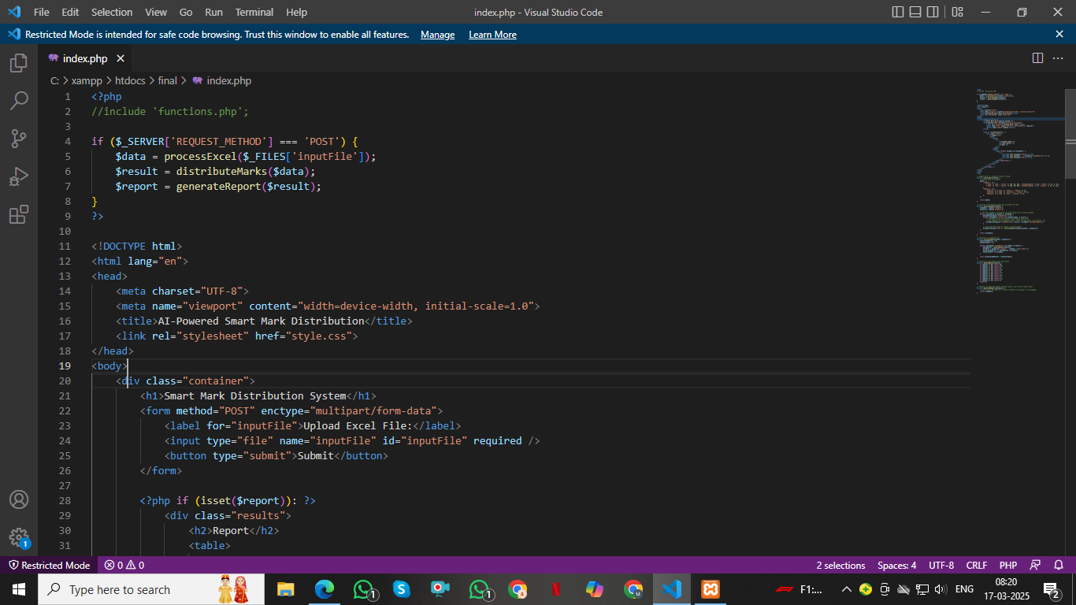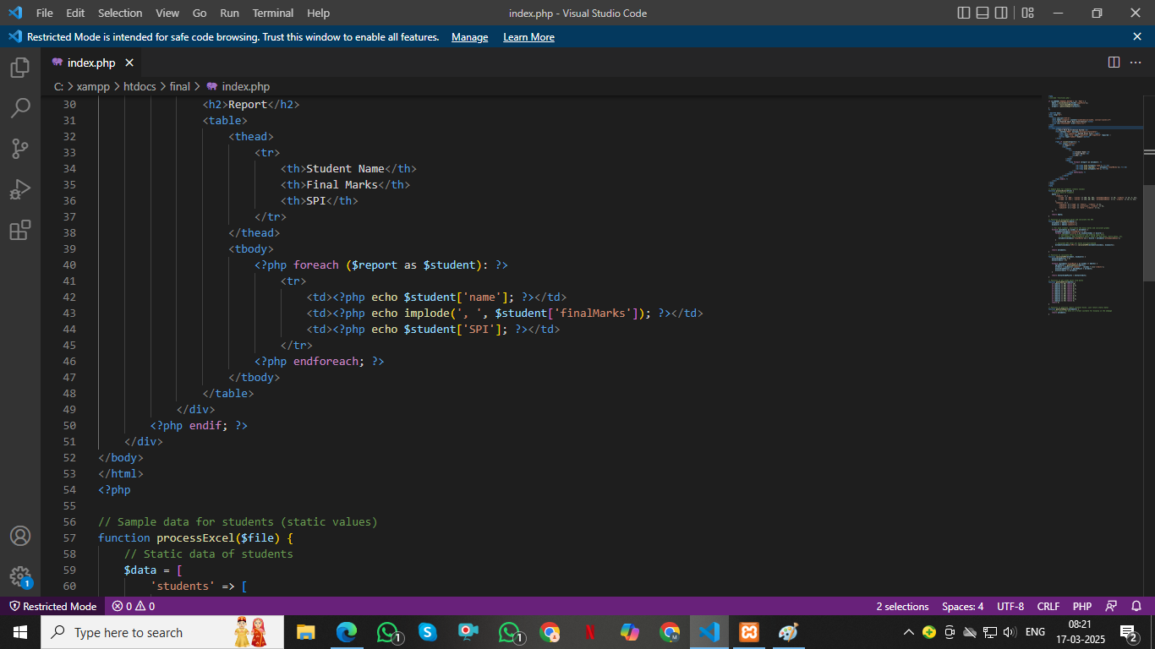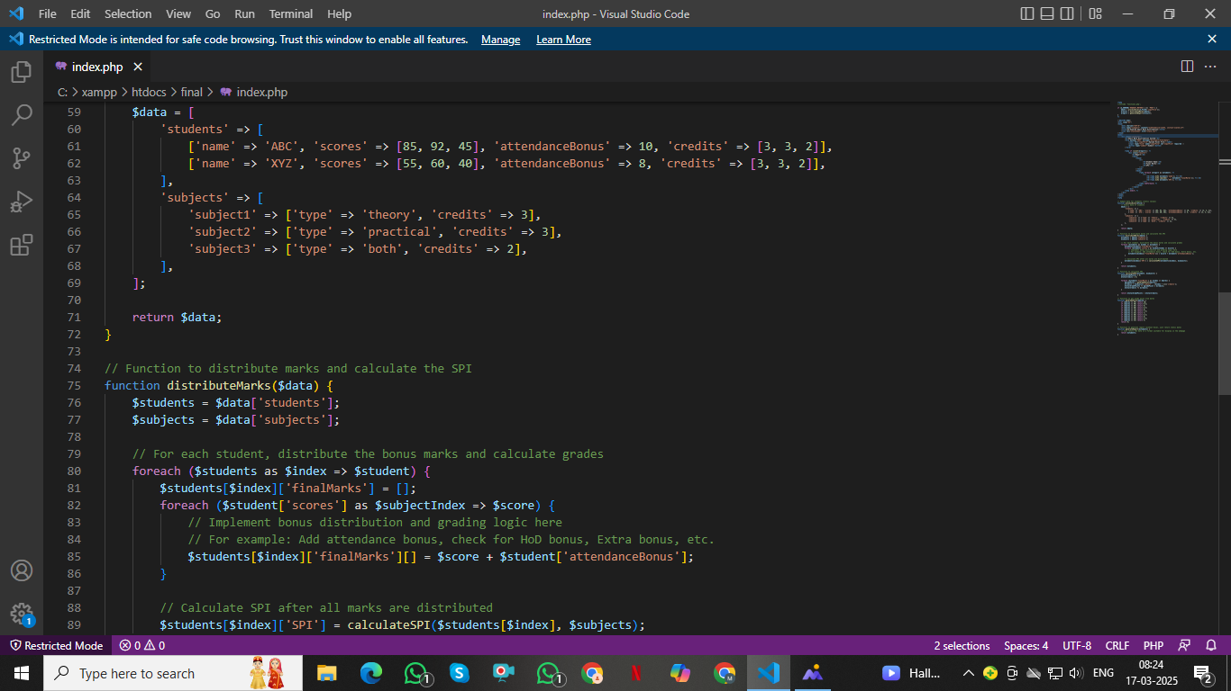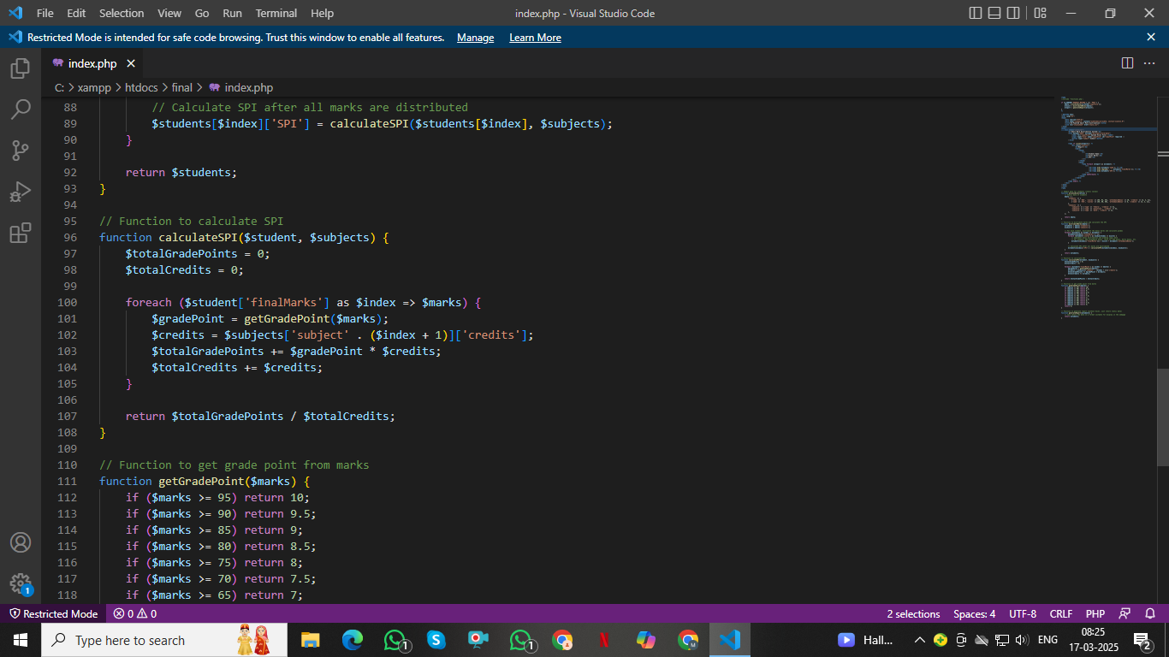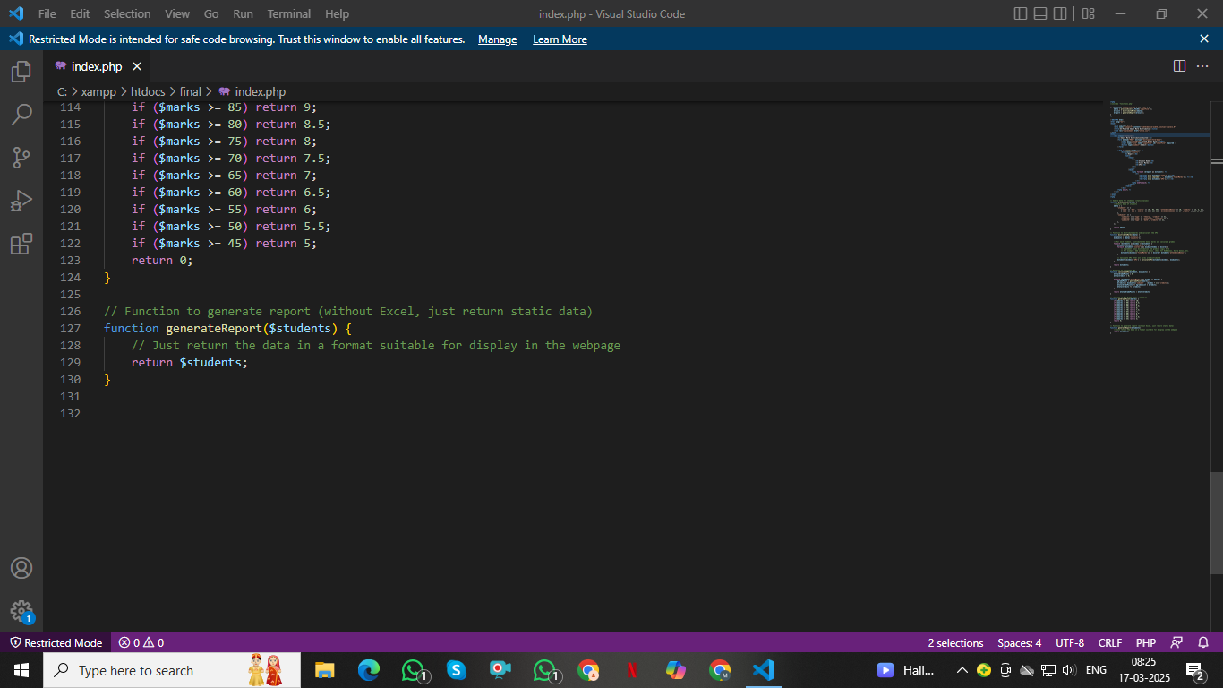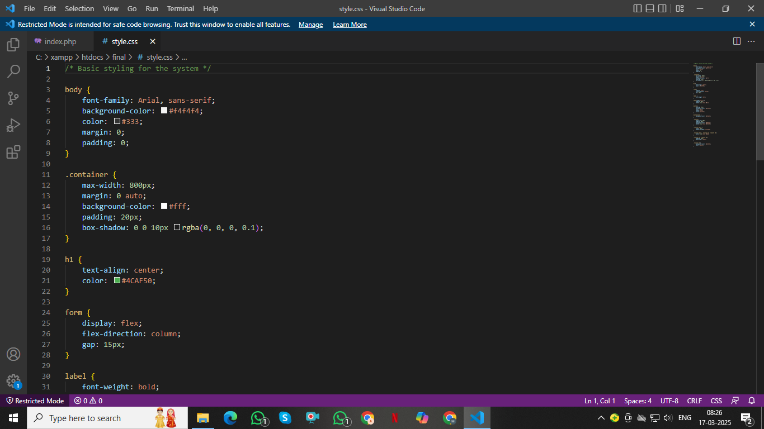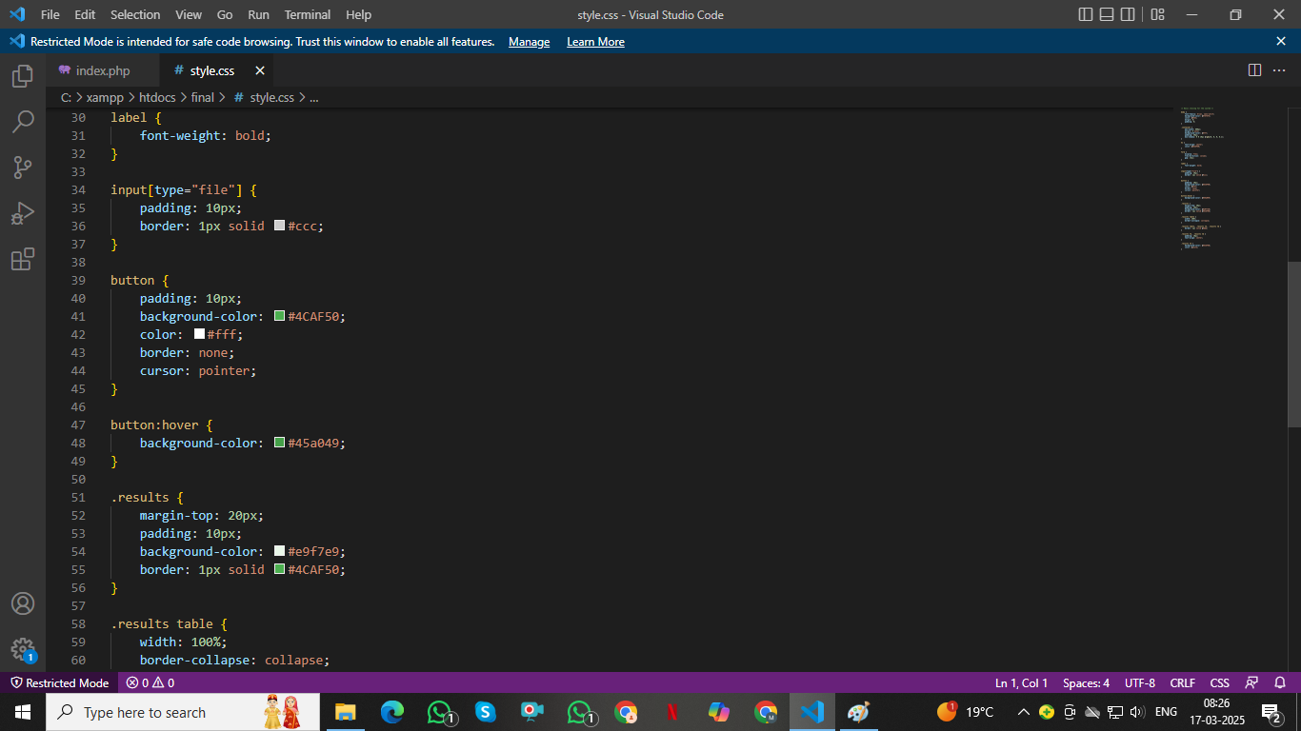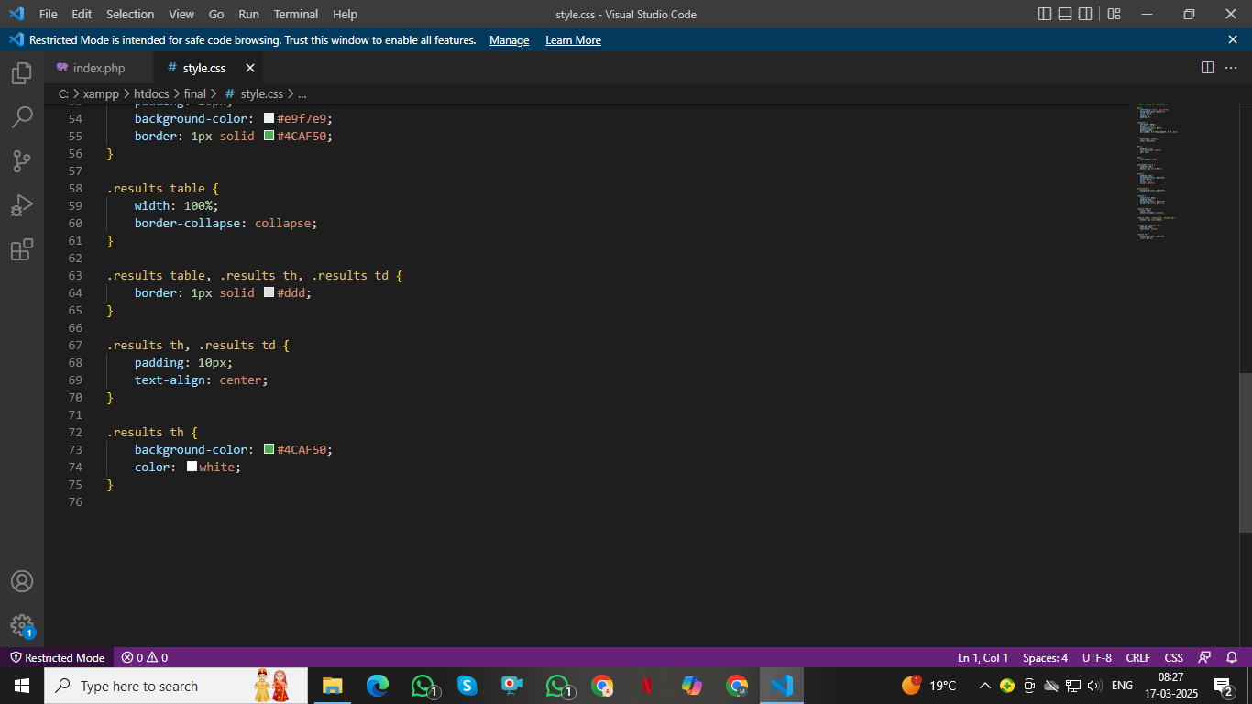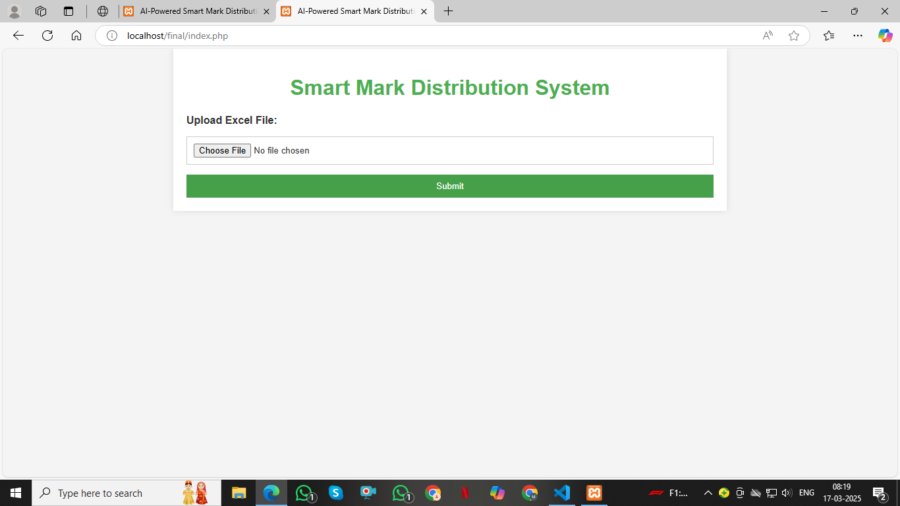**s**