EXPT-10

Develop an application to change the font and color of the text and display toast message when the user presses the button.

**AIM:**

Develop an application to change the font and color of the text and display toast message when the user presses the button.

**CODE:**

**activity_main.xml:**

xml

&lt;?xml version=&quot;1.0&quot; encoding=&quot;utf-8&quot;?&gt;

&lt;LinearLayout xmlns:android=&quot;http://schemas.android.com/apk/res/android&quot;

android:layout_width=&quot;match_parent&quot;

android:layout_height=&quot;match_parent&quot;

android:orientation=&quot;vertical&quot;

android:gravity=&quot;center&quot;

android:padding=&quot;24dp&quot;&gt;

&lt;TextView

android:id=&quot;@+id/sampleText1&quot;

android:layout_width=&quot;wrap_content&quot;

android:layout_height=&quot;wrap_content&quot;

android:text=&quot;@string/hello_kotlin&quot;

android:textSize=&quot;24sp&quot;

android:textColor=&quot;#000000&quot;

android:layout_marginBottom=&quot;20dp&quot; /&gt;

&lt;Button

android:id=&quot;@+id/changeButton&quot;

android:layout_width=&quot;wrap_content&quot;

android:layout_height=&quot;wrap_content&quot;

android:text=&quot;@string/change_font_color&quot; /&gt;

&lt;TextView

android:id=&quot;@+id/sampleText2&quot;

android:layout_width=&quot;wrap_content&quot;

android:layout_height=&quot;wrap_content&quot;

android:text=&quot;@string/hello&quot;

android:fontFamily=&quot;@font/lobster_regular&quot; /&gt;

&lt;/LinearLayout&gt;

**strings.xml:**

&lt;resources&gt;

&lt;string name=&quot;app_name&quot;&gt;CustomFontApp&lt;/string&gt;

&lt;string name=&quot;hello_kotlin&quot;&gt;Hello Kotlin!&lt;/string&gt;

&lt;string name=&quot;change_font_color&quot;&gt;Change Font &amp;amp; Color&lt;/string&gt;

&lt;string name=&quot;hello&quot;&gt;Hello&lt;/string&gt;

&lt;/resources&gt;

**lobster_regular.ttf**

• Place your font file here and rename it to lobster_regular.ttf (lowercase +

underscores).

• Make sure the folder is res/font/.

**/MainActivity.kt:**

package com.example.expt10

import android.graphics.Typeface

import android.os.Bundle

import android.widget.Button

import android.widget.TextView

import androidx.appcompat.app.AppCompatActivity

class MainActivity : AppCompatActivity() {

override fun onCreate(savedInstanceState: Bundle?) {

super.onCreate(savedInstanceState)

setContentView(R.layout.activity_main)

val textView = findViewById&lt;TextView&gt;(R.id.sampleText2)

val button = findViewById&lt;Button&gt;(R.id.changeButton)

// Load custom font

val typeface = resources.getFont(R.font.lobster_regular)

// Set font and color on click

button.setOnClickListener {

textView.typeface = typeface

textView.setTextColor(getColor(android.R.color.holo_red_dark))

}

}

}

**OUTPUT:**

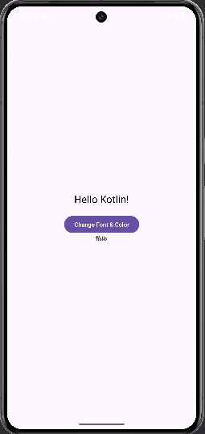 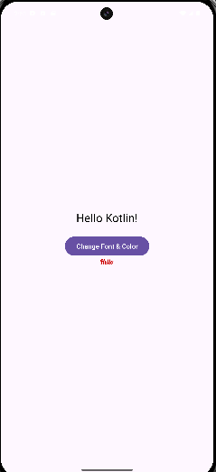

**RESULT:**

Thus an application has been developed to change the font and color of the text and display toast message when the user presses the button.