**EXPT-11**

**SD CARD**

**AIM:**

To implement an application that writes data to the SD card.

**CODE:**

<!DOCTYPE html>

<html lang="en">

<head>

<meta charset="UTF-8" />

<meta name="viewport" content="width=device-width, initial-scale=1.0"/>

<title>Write to SD Card</title>

<link href="https://fonts.googleapis.com/css2?family=Roboto:wght@400;700&display=swap" rel="stylesheet">

<style>

* {

box-sizing: border-box;

font-family: 'Roboto', sans-serif;

}

body {

margin: 0;

padding: 0;

height: 100vh;

background: linear-gradient(to right, #83a4d4, #b6fbff);

display: flex;

justify-content: center;

align-items: center;

}

.container {

width: 100%;

max-width: 420px;

background: #f0f4f8;

border-radius: 18px;

box-shadow: 6px 6px 12px #d1d9e6, -6px -6px 12px #ffffff;

padding: 30px 25px;

display: flex;

flex-direction: column;

align-items: center;

}

.title {

font-size: 1.5rem;

font-weight: 700;

margin-bottom: 20px;

color: #333;

}

button {

background: #4285f4;

color: white;

border: none;

padding: 12px 20px;

font-size: 1rem;

border-radius: 12px;

box-shadow: 2px 2px 8px rgba(0, 0, 0, 0.15);

cursor: pointer;

transition: 0.3s;

margin-bottom: 20px;

}

button:hover {

background: #3367d6;

transform: scale(1.03);

}

textarea {

width: 100%;

height: 120px;

padding: 14px;

font-size: 1rem;

border: none;

border-radius: 12px;

background: #e8f0fe;

color: #333;

resize: none;

outline: none;

margin-bottom: 15px;

box-shadow: inset 2px 2px 6px #cfd8e3, inset -2px -2px 6px #ffffff;

}

.status {

font-size: 0.95rem;

margin-bottom: 10px;

color: #444;

text-align: center;

}

.status.success {

color: #2e7d32;

}

.status.error {

color: #c62828;

}

.output-box {

display: none;

background: #ffffff;

border-left: 5px solid #4285f4;

padding: 14px;

width: 100%;

border-radius: 10px;

font-size: 0.95rem;

box-shadow: 2px 2px 6px rgba(0, 0, 0, 0.1);

}

.output-box.show {

display: block;

}

</style>

</head>

<body>

<div class="container">

<div class="title">📤 Write to SD Card</div>

<button onclick="writeToCard()">Write</button>

<textarea id="dataInput" placeholder="Type something..."></textarea>

<div class="status" id="statusText">Waiting for input...</div>

<div class="output-box" id="outputBox">

<strong>✅ Output:</strong>

<div id="writtenContent"></div>

</div>

</div>

<script>

function writeToCard() {

const input = document.getElementById('dataInput').value.trim();

const status = document.getElementById('statusText');

const outputBox = document.getElementById('outputBox');

const contentDisplay = document.getElementById('writtenContent');

if (input === "") {

status.textContent = "Please enter some text!";

status.className = "status error";

outputBox.classList.remove("show");

} else {

status.textContent = "Data written successfully (simulated).";

status.className = "status success";

contentDisplay.textContent = input;

outputBox.classList.add("show");

}

}

</script>

</body>

</html>

**OUTPUT:**

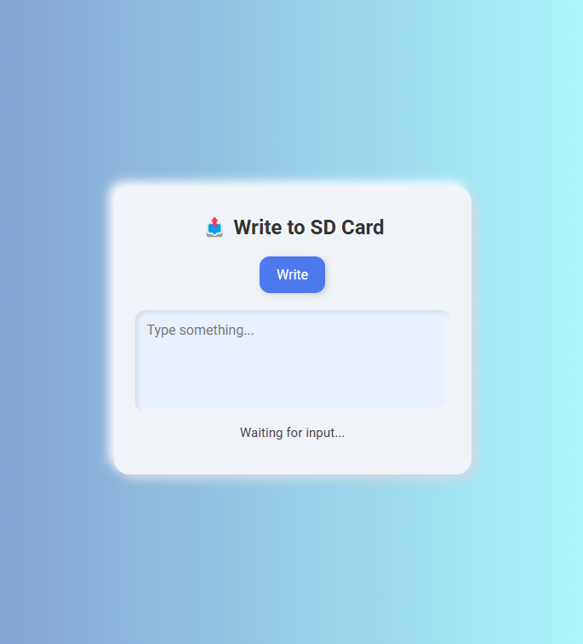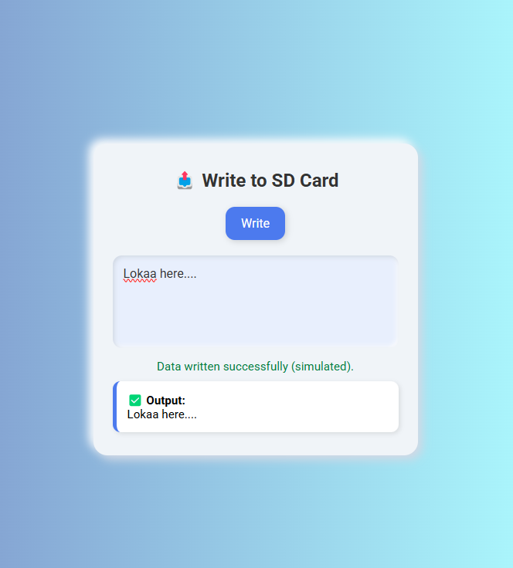

**RESULT:**

Thus an application that writes data to the SD card has been executed.