**EXPT-12**

**EMAIL SENDER APP**

**AIM:**

To create an email sender app in android studio

**CODE:**

activity_main.xml:

<?xml version="1.0" encoding="utf-8"?>  
<LinearLayout  
    xmlns:android="<http://schemas.android.com/apk/res/android>"  
    android:layout_width="match_parent"  
    android:layout_height="match_parent"  
    android:orientation="vertical"  
    android:padding="16dp">  
  
    <EditText  
        android:id="@+id/editTextEmail"  
        android:layout_width="match_parent"  
        android:layout_height="wrap_content"  
        android:minHeight="48dp"  
        android:hint="@string/recipient_email"  
        android:inputType="textEmailAddress"  
        android:autofillHints="emailAddress"  
        android:textColorHint="#888888" />  
  
    <EditText  
        android:id="@+id/editTextSubject"  
        android:layout_width="match_parent"  
        android:layout_height="wrap_content"  
        android:minHeight="48dp"  
        android:hint="@string/subject"  
        android:inputType="text"  
        android:autofillHints="username"  
        android:textColorHint="#888888" />  
  
    <EditText  
        android:id="@+id/editTextMessage"  
        android:layout_width="match_parent"  
        android:layout_height="150dp"  
        android:minHeight="48dp"  
        android:gravity="top"  
        android:hint="@string/message"  
        android:inputType="textMultiLine"  
        android:autofillHints="username"  
        android:textColorHint="#888888" />  
  
    <Button  
        android:id="@+id/buttonSend"  
        android:layout_width="match_parent"  
        android:layout_height="wrap_content"  
        android:minHeight="48dp"  
        android:text="@string/send_email"  
        android:layout_marginTop="16dp" />  
</LinearLayout>

AndroidManifest.xml:

<?xml version="1.0" encoding="utf-8"?>  
<manifest xmlns:android="http://schemas.android.com/apk/res/android"  
    xmlns:tools="http://schemas.android.com/tools"  
    package="com.example.emailsenderapp">  
  
    <application  
        android:allowBackup="true"  
        android:label="@string/app_name"  
        android:icon="@mipmap/ic_launcher"  
        android:roundIcon="@mipmap/ic_launcher_round"  
        android:supportsRtl="true"  
        android:theme="@style/Theme.EmailSenderApp">  
  
        <activity  
            android:name=".MainActivity"  
            android:exported="true">  
            <intent-filter>  
                <action android:name="android.intent.action.MAIN" />  
                <category android:name="android.intent.category.LAUNCHER" />  
            </intent-filter>  
        </activity>  
  
    </application>  
  
</manifest>

MainActivity.kt:

package com.example.emailsenderapp  
  
import android.content.Intent  
import android.os.Bundle  
import android.widget.Button  
import android.widget.EditText  
import android.widget.Toast  
import androidx.appcompat.app.AppCompatActivity  
import androidx.core.net.toUri  
  
class MainActivity : AppCompatActivity() {  
  
override fun onCreate(savedInstanceState: Bundle?) {  
super.onCreate(savedInstanceState)  
setContentView(R.layout.*activity_main*)  
  
val editTextEmail = findViewById<EditText>(R.id.*editTextEmail*)  
val editTextSubject = findViewById<EditText>(R.id.*editTextSubject*)  
val editTextMessage = findViewById<EditText>(R.id.*editTextMessage*)  
val buttonSend = findViewById<Button>(R.id.*buttonSend*)  
  
buttonSend.setOnClickListener **{**val email = editTextEmail.*text*.toString()  
val subject = editTextSubject.*text*.toString()  
val message = editTextMessage.*text*.toString()  
  
sendEmail(email, subject, message)  
**}**}  
  
private fun sendEmail(email: String, subject: String, message: String) {  
val intent = Intent(Intent.*ACTION_SENDTO*).*apply* **{***data* = "mailto:".*toUri*()  
putExtra(Intent.*EXTRA_EMAIL*, *arrayOf*(email))  
putExtra(Intent.*EXTRA_SUBJECT*, subject)  
putExtra(Intent.*EXTRA_TEXT*, message)  
**}**try {  
startActivity(Intent.createChooser(intent, "Send email via:"))  
} catch (_: Exception) {  
Toast.makeText(this, "No email client installed.", Toast.*LENGTH_SHORT*).show()  
}  
}  
}

strings.xml:

<?xml version="1.0" encoding="utf-8"?>  
<resources>  
<string name="recipient_email">Recipient Email</string>  
<string name="subject">Subject</string>  
<string name="message">Message</string>  
<string name="send_email">Send Email</string>  
<string name="app_name">Email Sender App</string>  
</resources>

**OUTPUT:**

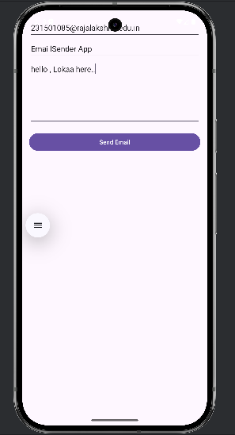

**RESULT:**

Thus email sender app has been created.