**EXPT-5**

**Write a Servlet to demonstrate the difference between HTTP GET and POST methods by creating a**

**form and handling requests accordingly**.

**AIM:**

To write a Servlet to demonstrate the difference between HTTP GET and POST methods by creating a wtmaform and handling requests accordingly.

**CODE:**

package com.example;

import java.io.IOException;

import java.io.PrintWriter;

import jakarta.servlet.ServletException;

import jakarta.servlet.annotation.WebServlet;

import jakarta.servlet.http.HttpServlet;

import jakarta.servlet.http.HttpServletRequest;

import jakarta.servlet.http.HttpServletResponse;

@WebServlet("/GetPostServlet")

public class GetPostServlet extends HttpServlet {

private static final long serialVersionUID = 1L;

protected void doGet(HttpServletRequest request, HttpServletResponse response) throws ServletException, IOException {

response.setContentType("text/html");

PrintWriter out = response.getWriter();

out.println("<html><head><title>GET Method</title></head><body>");

out.println("<h2>GET Method Invoked</h2>");

out.println("<p>Name: " + request.getParameter("name") + "</p>");

out.println("</body></html>");

}

protected void doPost(HttpServletRequest request, HttpServletResponse response) throws ServletException, IOException {

response.setContentType("text/html");

PrintWriter out = response.getWriter();

out.println("<html><head><title>POST Method</title></head><body>");

out.println("<h2>POST Method Invoked</h2>");

out.println("<p>Name: " + request.getParameter("name") + "</p>");

out.println("</body></html>");

}

}

<!DOCTYPE html>

<html>

<head>

<title>GET vs POST</title>

</head>

<body>

<h2>GET vs POST Example</h2>

<form action="GetPostServlet" method="GET">

<label>Enter Name (GET):</label>

<input type="text" name="name">

<input type="submit" value="Submit GET">

</form>

<br>

<form action="GetPostServlet" method="POST">

<label>Enter Name (POST):</label>

<input type="text" name="name">

<input type="submit" value="Submit POST">

</form>

</body>

</html>

Web.xml

<servlet>

<servlet-name>GetPostServlet</servlet-name>

<servlet-class>com.example.GetPostServlet</servlet-class>

</servlet>

<servlet-mapping>

<servlet-name>GetPostServlet</servlet-name>

<url-pattern>/GetPostServlet</url-pattern>

</servlet-mapping>

**OUTPUT:**

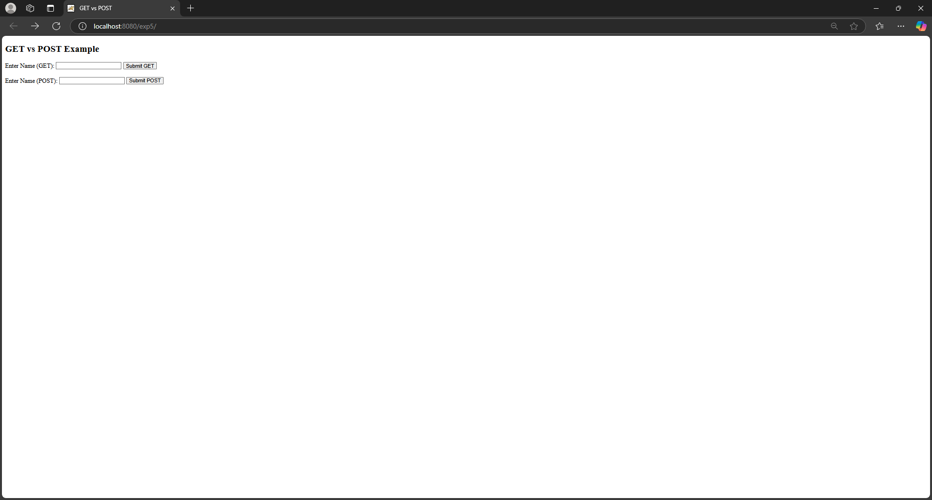

**RESULT:**

Thus the given experiment has been executed using apache netbeans.Bottom of Form