**EXPT-6**

**Write a Servlet to demonstrate session tracking using HttpSession. Implement a simple login system where the users session is tracked.**

**AIM:**

To write a Servlet to demonstrate session tracking using HttpSession. Implement a simple login system where the users session is tracked.

**CODE:**

Servlets:

import java.io.IOException;

import java.io.PrintWriter;

import javax.servlet.ServletException;

import javax.servlet.annotation.WebServlet;

import javax.servlet.http.HttpServlet;

import javax.servlet.http.HttpServletRequest;

import javax.servlet.http.HttpServletResponse;

import javax.servlet.http.HttpSession;

@WebServlet("/DashboardServlet")

public class DashboardServlet extends HttpServlet {

@Override

protected void doGet(HttpServletRequest request, HttpServletResponse response) throws ServletException, IOException {

response.setContentType("text/html");

PrintWriter out = response.getWriter();

HttpSession session = request.getSession(false);

if (session != null && session.getAttribute("user") != null) {

String username = (String) session.getAttribute("user");

out.println("<html><body>");

out.println("<h2>Dashboard</h2>");

out.println("<p>Welcome, " + username + "!</p>");

out.println("<a href='LogoutServlet'>Logout</a>");

out.println("</body></html>");

} else {

response.sendRedirect("index.html"); // Redirect to login page if session doesn't exist

}

}

}

import java.io.IOException;

import java.io.PrintWriter;

import javax.servlet.ServletException;

import javax.servlet.annotation.WebServlet;

import javax.servlet.http.HttpServlet;

import javax.servlet.http.HttpServletRequest;

import javax.servlet.http.HttpServletResponse;

import javax.servlet.http.HttpSession;

@WebServlet("/DashboardServlet")

public class DashboardServlet extends HttpServlet {

@Override

protected void doGet(HttpServletRequest request, HttpServletResponse response) throws ServletException, IOException {

response.setContentType("text/html");

PrintWriter out = response.getWriter();

HttpSession session = request.getSession(false);

if (session != null && session.getAttribute("user") != null) {

String username = (String) session.getAttribute("user");

out.println("<html><body>");

out.println("<h2>Dashboard</h2>");

out.println("<p>Welcome, " + username + "!</p>");

out.println("<a href='LogoutServlet'>Logout</a>");

out.println("</body></html>");

} else {

response.sendRedirect("index.html"); // Redirect to login page if session doesn't exist

}

}

}

import java.io.IOException;

import javax.servlet.ServletException;

import javax.servlet.annotation.WebServlet;

import javax.servlet.http.HttpServlet;

import javax.servlet.http.HttpServletRequest;

import javax.servlet.http.HttpServletResponse;

import javax.servlet.http.HttpSession;

@WebServlet("/LogoutServlet")

public class LogoutServlet extends HttpServlet {

@Override

protected void doGet(HttpServletRequest request, HttpServletResponse response) throws ServletException, IOException {

HttpSession session = request.getSession(false);

if (session != null) {

session.invalidate(); // Destroy session

}

response.sendRedirect("index.html"); // Redirect to login page

}

}

HTML:

<!DOCTYPE html>

<html lang="en">

<head>

<meta charset="UTF-8">

<meta name="viewport" content="width=device-width, initial-scale=1.0">

<title>Login Page</title>

<style>

body {

font-family: Arial, sans-serif;

background: linear-gradient(to right, #4facfe, #00f2fe);

display: flex;

justify-content: center;

align-items: center;

height: 100vh;

margin: 0;

}

.login-container {

background: white;

padding: 30px;

border-radius: 10px;

box-shadow: 0px 0px 10px rgba(0, 0, 0, 0.1);

width: 300px;

text-align: center;

}

h2 {

margin-bottom: 20px;

color: #333;

}

.input-group {

margin-bottom: 15px;

text-align: left;

}

label {

font-size: 14px;

font-weight: bold;

color: #555;

display: block;

margin-bottom: 5px;

}

input {

width: 100%;

padding: 10px;

border: 1px solid #ddd;

border-radius: 5px;

font-size: 14px;

}

button {

background: #4facfe;

color: white;

border: none;

padding: 10px;

width: 100%;

border-radius: 5px;

font-size: 16px;

cursor: pointer;

transition: 0.3s;

}

button:hover {

background: #00c6ff;

}

.register-link {

margin-top: 15px;

font-size: 14px;

}

.register-link a {

color: #4facfe;

text-decoration: none;

font-weight: bold;

}

.register-link a:hover {

text-decoration: underline;

}

</style>

</head>

<body>

<div class="login-container">

<h2>Login</h2>

<form action="LoginServlet" method="POST">

<div class="input-group">

<label>Username</label>

<input type="text" name="username" required>

</div>

<div class="input-group">

<label>Password</label>

<input type="password" name="password" required>

</div>

<button type="submit">Login</button>

</form>

<div class="register-link">

Don't have an account? <a href="#">Register</a>

</div>

</div>

</body>

</html>

WEB.XML:

<web-app xmlns="http://java.sun.com/xml/ns/javaee"

xmlns:xsi="http://www.w3.org/2001/XMLSchema-instance"

xsi:schemaLocation="http://java.sun.com/xml/ns/javaee

http://java.sun.com/xml/ns/javaee/web-app_3_0.xsd"

version="3.0">

<servlet>

<servlet-name>LoginServlet</servlet-name>

<servlet-class>com.example.LoginServlet</servlet-class>

</servlet>

<servlet-mapping>

<servlet-name>LoginServlet</servlet-name>

<url-pattern>/LoginServlet</url-pattern>

</servlet-mapping>

<servlet>

<servlet-name>DashboardServlet</servlet-name>

<servlet-class>com.example.DashboardServlet</servlet-class>

</servlet>

<servlet-mapping>

<servlet-name>DashboardServlet</servlet-name>

<url-pattern>/DashboardServlet</url-pattern>

</servlet-mapping>

<servlet>

<servlet-name>LogoutServlet</servlet-name>

<servlet-class>com.example.LogoutServlet</servlet-class>

</servlet>

<servlet-mapping>

<servlet-name>LogoutServlet</servlet-name>

<url-pattern>/LogoutServlet</url-pattern>

</servlet-mapping>

</web-app>

**OUTPUT:**

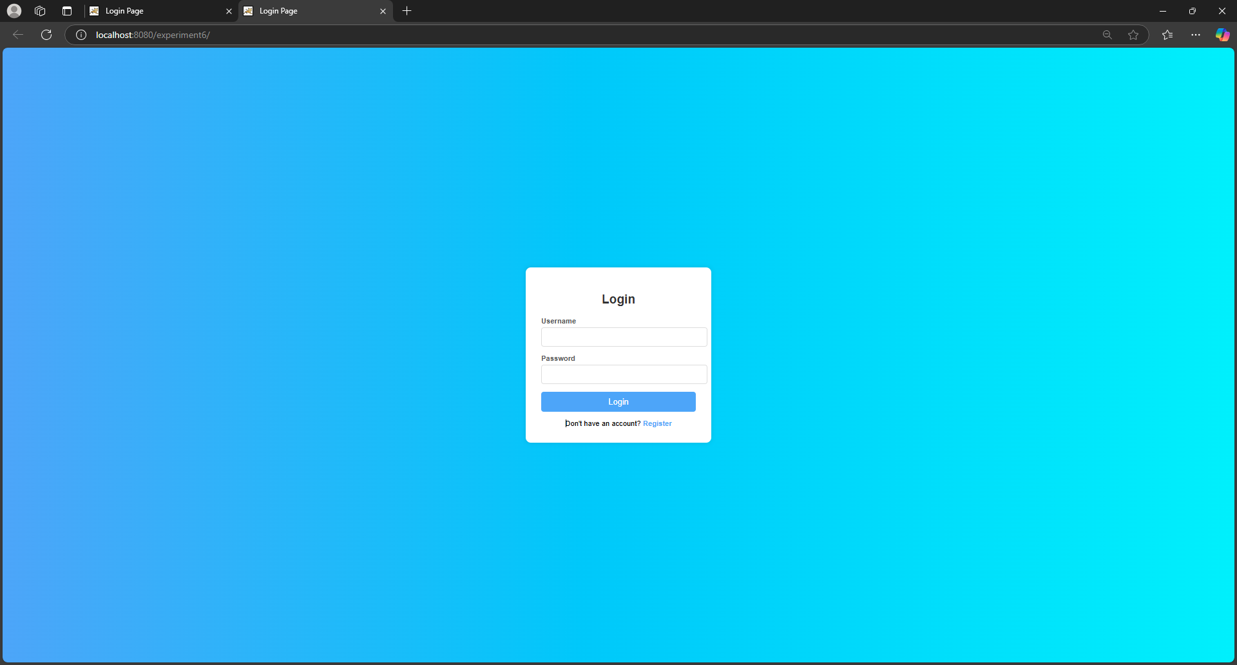

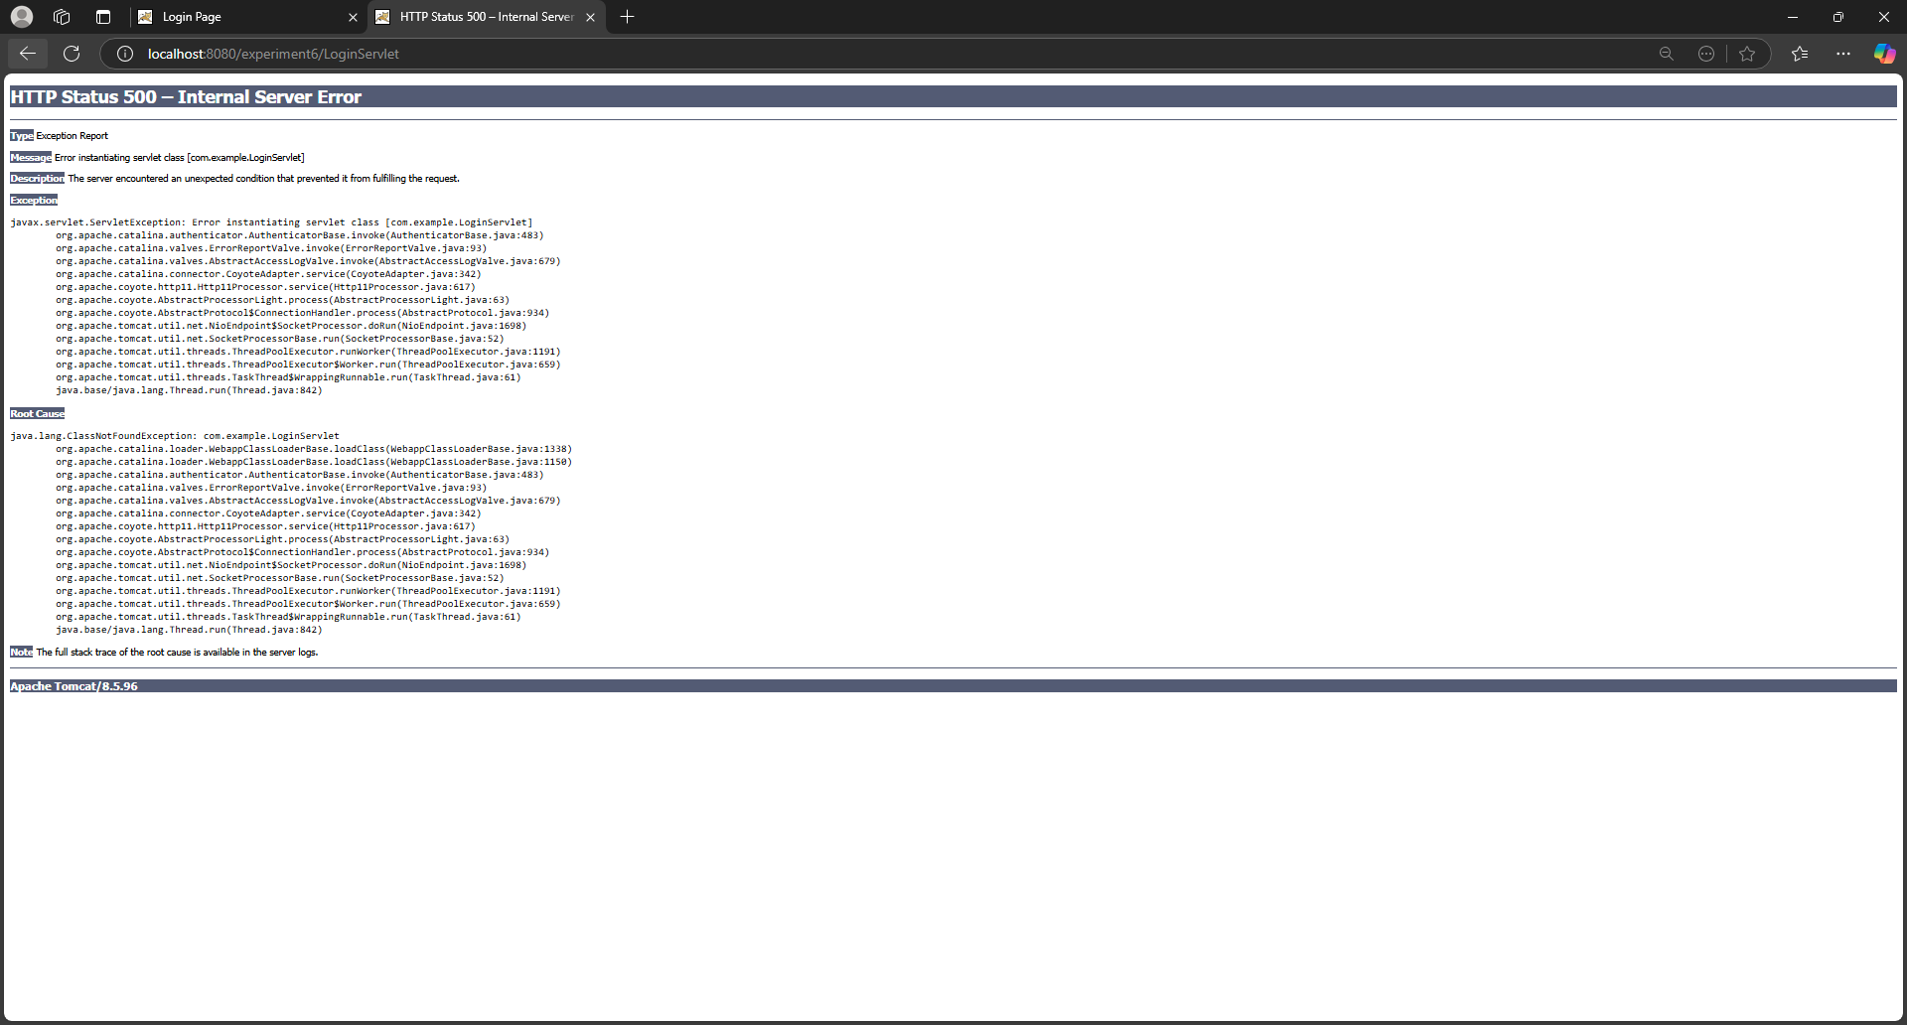

**RESULT:**

Thus the login and logout page has been created using servlets and html in apache netbeans.